Fermilab Overview
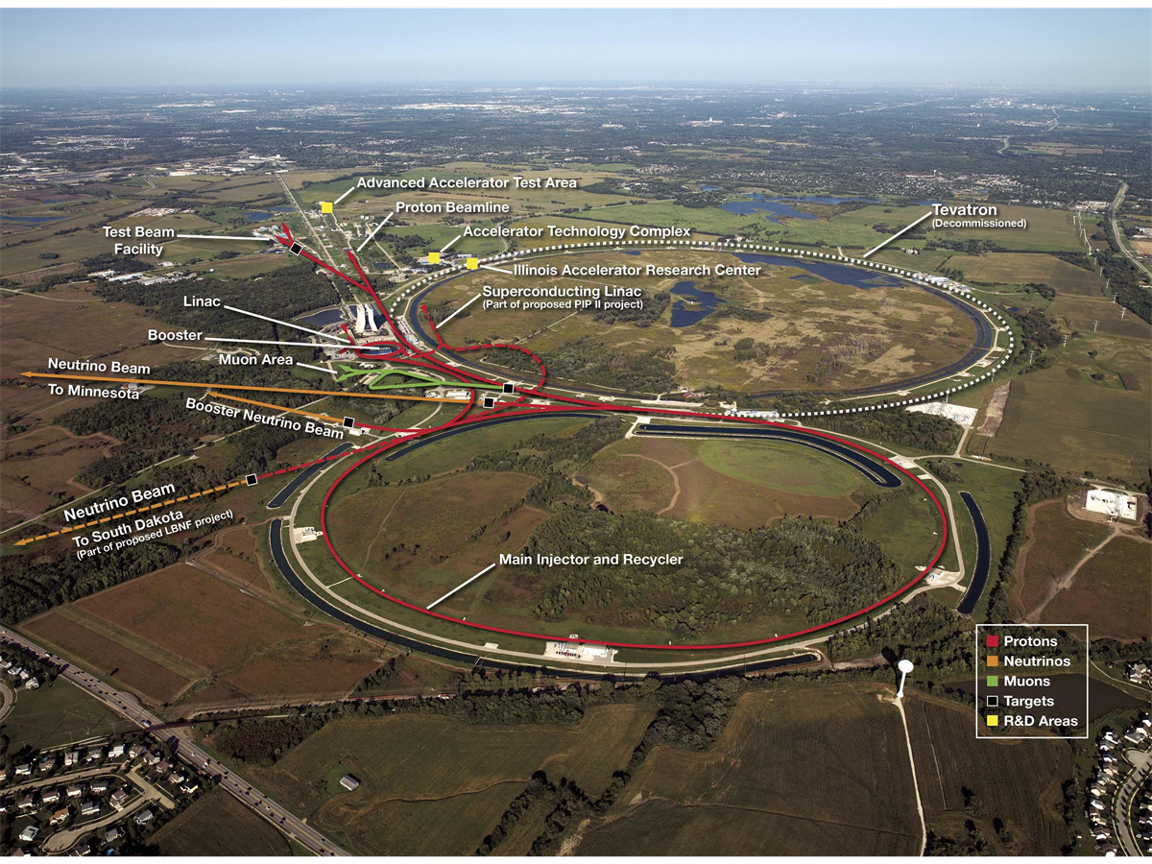

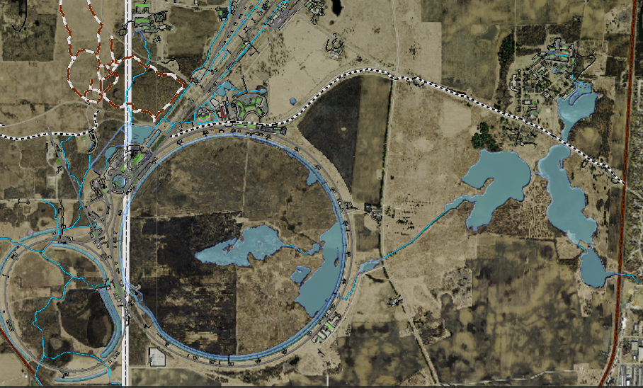
Fixed Target
Main Injector
WH, Linac, Booster
Village

https://www.youtube.com/watch?v=XksxmdWu1eY

