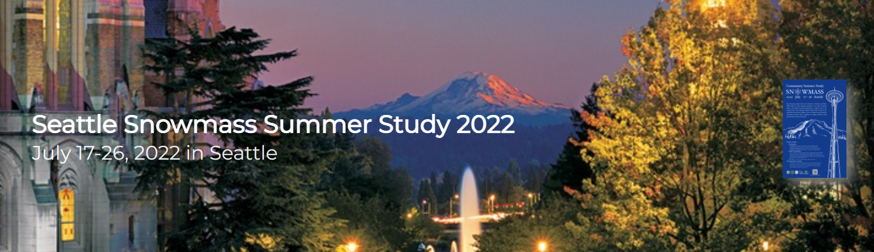

Snowmass Community Summer Study

Second Bulletin
We are looking forward to seeign you in Seattle, July 17-26, 2022! There is lots of information in this bulletin, including information about registration, dorm rooms and hotels, social events, DOE visit, and DANCE. Full details can be found at our website: http://seattlesnowmass2021.net/, which we are up dating regularly as new information becomes available.

Please register now and plan your travel as soon as you can. Early-bird registration is open until June 5, 2022. Plane flights and lodging are all increasing in price.

Lodging
Dorm room booking is now open! The starting place is our lodging page: http://seattlesnowmass2021.net/lodging/. The dorm rooms at UW are block reservations, with some small flexibility at the start and end days. Double ($660) and Single ($1095) occupancy rooms are available, and there is limited possibility for children to stay. Prices are for a full stay. We have a lot of rooms on hold - however, we will need to release them around June 15th!

We have also added new hotel options, both high and medium range, to our lodging page. Hotels very close to the University are bound to book up quickly.

Schedule
We are busy getting the indico schedule ready, but until then there are two block schedules available to aid in your planning.

A block-schedule overview of the full week can be found here. At the start and the end are plenary sessions. Between 7 days of parallel sessions and the afternoons are larger gatherings designed to be inclusive across frontiers. Some highlights:

- Sessions from each frontier describing the work, challenges they see over the next 10 years, and avenues forward for R&D. Possible recommendations to come out of the Snowmass process will be discussed as well.
- National and International HEP Research sessions are planned.

The second schedule shows the morning parallel sessions in much more detail, as well as details about the afternoon sessions. The sessions are color coded by frontier, with the exception of the cross frontier sessions.

Lunches are two hours each day, which is enough time to leave campus and eat at a local eatery if one desires. Using your favorite mapping program to find the University of Washington, and then searching restaurants near-by will tell you how rich your options are for local eateries! It is also possible to pre-order boxed lunches if one wants to remain on campus.

Our social program is further filling out:
- Workshop Reception - Monday, July 17. Join us all after the first day of parallel sessions to celebrate the start of the workshop!
- Workshop Dinner - Friday July 22 (please select and pay during registration). Will include dinner, dessert, and non-alcholic beverages. There will be a cash bar.
- Physics Slam - Thursday, July 21. Watch as four Physicists compete to give the most entertaining explanation of some of the most exciting issues in physics today.
- Colliderscope - Saturday, July 23. Listen to, dance along with, and marvel at the DJ stylings and oscilloscope wonderment of Larry Lee and Nikola Whallon.
- Mariners Baseball theme night - Monday, July 25. Join the game with Texas Rangers with a variety of specially-themed games “Christmas in July.”

Other News
Some other recent news:

- A computational and data science software training event, DANCE: CoDaS, which stands for Dark Matter and Neutrino Computation Explored: Computational Data Science fo rHigh Energy Physics School, is co-located at Snowmass and is targeted at early career members of our community. . Selected applicants will receive travel and lodging support. The schedue of activities allows particpants time to attend many Snowmass activities. Please see this page to apply (by May 25 for full consideration, you can find this under Events on our website).
- The DOE and NSF will be hosting PI meetings during the week, much as they did during 2013. Both small and large group gatherings are planned.
- All poster acceptances have been sent out. We’ve had reports of spam blockers suppressing them - check the indico site to double check.
- What else belongs here?

COVID-19
Omicron's rapid rise taught the community that it is impossible to plan very far in advance. Our host, the University of Washington, will assist us in providing a safe environment, employing all required and in some cases additional, measures and precautions. The Local Organizing Committee will monitor developments in the pandemic and keep you informed of any new developments. We will make whatever changes are necessary to the conference format to maintain the health and safety of participants, which is our highest priority.

Text from last time in case cribbing is needed

We’d like to thank our partners who are helping to sponsor the event: NVIDIA, RadiaBeam, and Universe.

Notes/Logistics
This section should be removed before this is sent out (or not copied!)

Distribution:
- Main snowmass email list
- Slack
- Snowmass2021 website
- DPF and possibly APS announcement, and all other divisions of APS that are relavent.

People that need to look at this (in no particular order)

- DPF chair line, EC
- Snowmass Program Committee
- All Conveners (perhaps in tandem with SPC)
- Steering Group

