PIP-II AccU-BSTR -Dampers-CHG0

Technical Requirements Specification

Document number:

Document Approval

|  |  |
| --- | --- |
| Signatures Required | Date Approved |
| Author/Owner: AccU-BSTR-L3 David Johnson | - |
| Level 5 Activity Manager – Michelle A. Ibrahim |  |
|  |  |
| Reviewer: Alex Martinez, Integration Coordinator | Concurrence in TC |
| Approver: L2 Manager is typically the approver | Approved in TC |

Revision History

|  |  |  |
| --- | --- | --- |
| Revision | Date of Release | Description of Change |
| - | 1-20-2021 | Initial Release. |
|  |  |  |
|  |  |  |

Page left intentionally blank.

Table of Contents

1. PURPOSE 4

2. SCOPE 4

3. ASSUMPTIONS 4

4. ACRONYMS, TERMS, AND DEFINITIONS 5

5. REFERENCED DOCUMENTS 6

6. ROLES AND RESPONSIBILITIES 6

6.1. Originator 6

6.2. Reviewer 6

6.3. Approver 6

7. BOOSTER BCM SYSTEM 7

7.1. System Definition 7

7.2. High Level Operations Concepts/Scenarios 7

7.3. Booster BCM Pickup 7

7.4. Booster BCM Cable 8

7.5. Booster BCM Electronics 8

7.6. Booster BCM Interfaces 8

8. Technical Requirement 9

9. TRANSPORTABILITY 12

10. TESTING, VALIDATION, ACCEPTANCE 12

11. RELIABILITY, MAINTAINABILITY, AND AVAILABILITY 13

12. SAFETY 13

13. DESIGN & CONSTRUCTION STANDARDS 13

14. QUALITY CONTROL PROVISIONS 13

# PURPOSE

Technical Requirements Specification (TRS) document describes the design specifications needed for a system architecture to meet its functional requirements.

TRS statements are upwards traceable to the associated Global Requirements Documents (GRDs)[3], Physics Requirements Documents (PRDs)[4][5], and Functional Requirements Specifications(FRSs)[6], where applicable.

# SCOPE

This TRS addresses the technical requirements of the new Booster Beam Current Monitor (BCM) systemof the **AccU – Booster-Damper-CHG0 Task**, 121.05.04.04.03 PIP-II Project. The main purpose of this task is to replace the existing B:CHG0 with a detector with a higher charge range to accommodate the continued increase in cycle intensity and to provide for a finer resolution and linearity due to the strict requirement for increased acceleration efficiency to the 98% range for PIP-II.

For the purposes of this document, a pickup refers to components of the system installed inside the accelerator enclosure. Furthermore, electronics refer to components, which will terminate, distribute, condition with analog circuitry, digitize, and process the signals from the pickups to present current measurements to the control system.

This TRS includes the technical requirements for the mechanical, electrical, signal conditioning, data acquisition, and digital signal processing needed to install, instrument, and operate pickups and their accompanying electronics.

Digital signal processing includes both firmware and software for modules within the Booster BCM system. However, requirements for applications and services beyond the front-end interface between the BCM System and the Controls System, that will be necessary to present, archive, or otherwise utilize current measurements, are not within the scope of this document.

Requirements for information-passing interfaces between the Booster BCM System and the PIP-II Control~~s~~ System, Global Timing System, and LLRF System are also included.

# ASSUMPTIONS

The Booster BCM systems shall abide by requirements outlined in FEM [1]. Key cost, schedule, technical and programmatic assumptions are provided in PIP-II Project Assumptions [2].

# ACRONYMS, TERMS, AND DEFINITIONS

|  |  |
| --- | --- |
| BCM | Beam Current Monitor |
| BI | Beam Instrumentation |
| CAM | Control Account Manager |
| DCCT | DC Current Transformer |
| FEM | Fermilab Engineering Manual |
| FESHM | Fermilab ES&H Manual |
| FNAL | Fermi National Accelerator Lab |
| FRCM | Fermilab Radiological Control Manual |
| FRS | Functional Requirements Specification |
| GRD | Global Requirements Document |
| L2M | Level 2 Manager |
| L3M | Level 3 Manager |
| LLRF | Low Level Radio Frequency |
| PIP-II | Proton Improvement Plan II Project |
| PRD | Physics Requirements Document |
| QA | Quality Assurance |
| QC | Quality Control |
| TRS | Technical Requirement Specification |

# REFERENCED DOCUMENTS

|  |  |  |
| --- | --- | --- |
| # | Reference | Document # |
|  | [Fermilab Engineering Manual](http://directorate-docdb.fnal.gov/cgi-bin/RetrieveFile?docid=34) (FEM) | - |
|  | PIP-II Project Assumptions | PIP-II docDB 144 |
|  | PIP-II Global Requirements Document (GRD) | ED0001222 |
|  | PIP-II Parameters Physics Requirements Document (PRD) | ED0010216 |
|  | PIP-II Booster BCM Physics Requirements Document (PRD) | ED000xxxx |
|  | PIP-II Booster BCM Functional Requirements Specification (FRS) | ED00xxxxx |
|  | PIP-II Booster BCM Interface Specification Document (ISD) | ED00xxxxx |

# ROLES AND RESPONSIBILITIES

## Originator

Responsible for TRS preparation, including layout, proper format, requirement identification, requirement verification expectations, requirement traceability, and additional descriptive detail, as appropriate. The originator is expected to engage subject matter experts as needed to ensure technical content is appropriately assessed and captured.

## Reviewer

Responsible for review of the TRS content, ensuring accuracy and completeness of all requirements and supplemental descriptive detail, as applicable.

## Approver

The L2 Manager will evaluate the basis for requirements definition, ensure that requirements are properly articulated, and ensure that they align with higher level requirements specifications, as applicable. The L2M will ensure that CAMs, associated engineering staff, and other Systems Managers are properly engaged and notified of the document’s technical implications. Only the System Manager responsible for the work product addressed in the specification is expected to provide approval.

# BOOSTER BCM SYSTEM

## System Definition

The Booster BCM system comprises of 2 main components : a noninvasive pickup installed in Booster Long10 and a set of electronics installed in the Booster gallery.

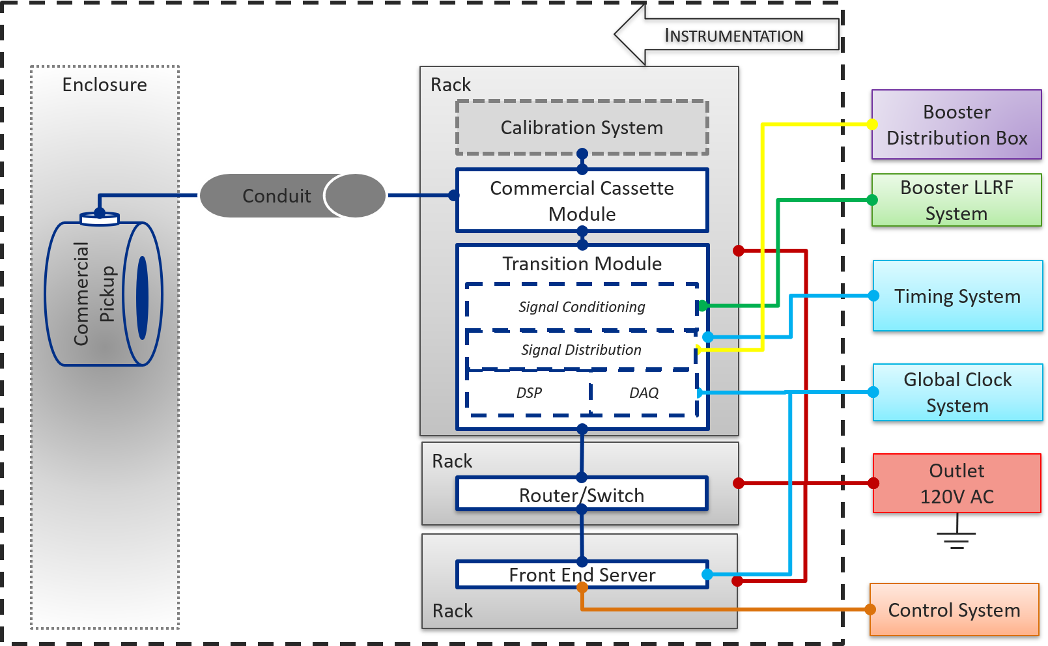

Figure 7‑1. Booster BCM System Block Diagram.

## High Level Operations Concepts/Scenarios

The Booster BCM system shall provide beam current measurements throughout the Booster ramp at rate up to 20Hz. Furthermore, these measurements will be used to measurement injection, transfer, and extraction efficiency as the beam enters, accelerates, and then leaves the Booster ring. Consequently, the requirements for the NPCT are stringent because the losses in the Booster have to be carefully controlled. The transfer efficiency from injection to extraction is expected to be in the 98% range during the PIPII era and so the beam current measurement accuracy will have to better than 0.1% for the entire Booster ramp.

Functional requirements are provided in the Booster BCM FRS[6].

## Booster BCM Pickup

As an ensemble of charged particles in motion, the beam is an electric current and generates a corresponding magnetic field. Non-invasive BCM pickups are designed to interact with these magnetic fields, offering a non-destructive way to observe and quantify important properties of the beam itself. Magnetic pickup signal amplitude is also independent of beam travel direction; signal polarity is determined by the product of particle charge and direction of travel, i.e. the sign of electric current.

The noninvasive pickup selected for the Booster BCM will be the Bergoz NPCT sensor, which is a commercial in flange DC Current Transformer (DCCT).

## Booster BCM Cable

One multiconductor interconnect cable will connect between the pickup in the enclosure and electronics in the gallery. In addition, in the gallery, other standard differential and coaxial cables will connect the Booster BCM electronics to other subsystems.

## Booster BCM Electronics

The set electronics includes the following modules:

* Commercial NPCT electronic chassis, which provides the drive and sense circuitry for the sensor
* Analog conditioning circuitry, which will receive the output signal from the NPCT electronics and the LLRF system
* Data Acquisition, which will convert analog signals to digital signals for processing
* Digital Signal Processing, which provide frequency-normalized current measurements
* Front End Processor, which is primary interface between the Booster BCM system and control system

## Booster BCM Interfaces

Booster BCM system interfaces shall include the following:

* Mechanical between pickup assemblies and the accelerator beam line
* Mechanical between electronics assemblies to the equipment racks
* Environmental interfaces for both pickup and electronic assemblies
* Electrical between BCM electronics and power/grounding system
* Building related to cable penetrations and trays
* Conventional facilities related to space and occupancy
* Signals from the Booster LLRF to the BCM electronics
* Signals between the BCM and Control System
* Signals from the Global Timing System to the BCM.

Details of these interfaces are described in the PIP-II Booster BCM ISD [7].

# Technical Requirement

The table below enumerates the technical requirements for all components of the Booster BCM System. These requirements flow from PRD, FRS, as well as best practices.

Table ‑. Technical Requirements

|  |  |
| --- | --- |
| Requirement # | Requirement Statement |
| **Performance** | |
| T-ED00xxxxx-A001 | The output of commercial DCCT electronics shall have 10V/2A sensitivity to average beam currents. |
| T-ED00xxxxx-A002 | The commercial DCCT pickup shall withstand peak currents up to 20A. |
| T-ED00xxxxx-A004 | The commercial DCCT system shall have a minimum useable rise time of 50µsec. |
| T-ED00xxxxx-A005 | Booster BCM system shall provide absolute accuracy of at least 1%. |
| **Physical Characteristics** | |
| T-ED00xxxxx -B001 | The current transformer and ceramic break of the pickup shall be embedded in a pair of flanges, which will have a shape and bolt pattern compatible with Long10 section. |
| T-ED00xxxxx -B002 | The commercial pickup shall not have inner diameters less than Long10 beam pipe aperture of 3.5”. |
| T-ED00xxxxx -B003 | The commercial DCCT pickups shall be UHV compatible and maintain vacuum requirements of <1e-7 Torr. |
| T-ED00xxxxx -B004 | Flange-to-flange lengths of the commercial pickups shall not exceed slot length of 1m. |
| T-ED00xxxxx -B005 | The commercial DCCT pickups shall be constructed from corrosion-resistant materials and/or be protected with corrosion-resistant coatings. |
| T-ED00xxxxx -B006 | The commercial DCCT pickups shall incorporate magnetic shielding to minimize errors induced by other near beamline components. |
| T-ED00xxxxx-B007 | The commercial DCCT pickups shall be constructed from radiation-resistant materials to withstand the radiation levels for given enclosure locations. |
| T-ED00xxxxx-B008 | Load-bearing support structures shall be provided to mechanically support and electrically isolate the pickups from the vacuum beam pipe. |
| T-ED00xxxxx-B009 | Feedthroughs for cable connections shall remain accessible in the installed configuration. |
| T-ED00xxxxx-B010 | A vendor-terminated interconnect cable shall be run between the commerical pickup and vendor-assembled electronics chassis. |
| T-ED00xxxxx-B011 | The interconnect cable runs should follow the most direct path from the pickup to the nearest penetrations via grounded cable trays. |
| T-ED00xxxxx-B012 | The interconnect cable should not share conduits and cable trays with high voltage cables, magnet power supply cables, or high-power RF cables. |
| T-ED00xxxxx-B013 | The interconnect cable should pass through metallic electrical conduits, if the cable path is in a high RFI environment. |
| T-ED00xxxxx-B014 | Electronic components shall not be installed in the enclosure. |
| T-ED00xxxxx-B015 | The electronics shall be designed for mounting in a 19” rack. |
| T-ED00xxxxx-B016 | Booster BCM system shall distribute the analog signals to the Booster Distribution box. |
| T-ED00xxxxx-B017 | Booster BCM system shall receive signals from the Global Clock and Timing system for event-based triggering and synchronization. |
| T-ED00xxxxx-B018 | Booster BCM system shall receive signals from the Booster LLRF system. |
| T-ED00xxxxx-B019 | Booster BCM system shall have an input sampling clock of at least 1MSPS. |
| T-ED00xxxxx-B020 | Booster BCM system shall digitize signals with a resolution of at least 14 “true” bits. |
| T-ED00xxxxx-B021 | Booster BCM system shall provide status indicators for successful power up, Ethernet connectivity, and valid Clock/Timing/LLRF signals. |
| **Reliability, Maintainability, and Availability** | |
| T-ED00xxxxx-C001 | All printed circuit boards (PCBs) shall meet IPC2221B standard. All wiring and chassis design shall meet UL61010 standard. |
| T-ED00xxxxx-C002 | Booster BCM system shall be calibrated at least once a year with a reproducible calibration procedure, which does not require entry into the enclosure. |
| T-ED00xxxxx-C003 | Certified calibrations and servicing of BCM calibration equipment shall be performed regularly and tracked in a database. |
| T-ED00xxxxx-C006 | Booster BCM system shall have standard interfaces for troubleshooting and programming firmware and software components. |
| T-ED00xxxxx-C007 | Vendor-assembled components requiring maintenance or repair shall be returned to the vendor via a US distributor for service or modifications. |
| T-ED00xxxxx-C008 | Vendor-assembled components shall have unique serial numbers. |
| T-ED00xxxxx-C009 | Warranty policy on vendor assembled components shall be provided by the vendor. |
| **Environmental Conditions** | |
| T-ED00xxxxx-D001 | The Booster BCM pickups shall not operate at the temperatures above 100ºC. |
| T-ED00xxxxx-D002 | The Booster BCM electronics shall be able to operate within the temperature (-40ºC – 100ºC) and non-condensing humidity conditions of the gallery. |
| **Transportability** | |
| T-ED00xxxxx-E001 | Connections within BCM electronics shall be designed to withstand normal transport. |
| T-ED00xxxxx-E002 | BCM chassis shall be sturdy enough to handle transport shocks and not require special handling when being moved. |
| T-ED00xxxxx-E003 | Any special handling to prevent physical damage (cracks, scrapes, etc.) of pickup assemblies shall be documented. |
| T-ED00xxxxx-E004 | A US-based distributor shall handle all logistics regarding shipping of components from the overseas vendor to Fermilab. |
| **Firmware/Software** | |
| T-ED00xxxxx-F001 | BCM systems shall decode signals from Global Clock System. |
| T-ED00xxxxx-F002 | BCM systems shall comply with Ethernet network requirements. |
| T-ED00xxxxx-F003 | BCM systems shall connect to the Control System via Ethernet. |
| T-ED00xxxxx-F004 | BCM systems shall include data acquisition and storage components to achieve archival and plotting rates of client applications in the Control System. |
| T-ED00xxxxx-F005 | BCM system settings shall be restorable after a reboot of the system. |
| T-ED00xxxxx-F006 | BCM systems shall provide adjustable parameters, including but limited to channel delay, gating width, and filter coefficients, for customized configuration. |
| T-ED00xxxxx-F007 | BCM systems shall be able to store and retrieve digitized waveforms in memory. |
| **Safety** | |
| T-ED00xxxxx-G001 | Electronics shall have safeguards to prevent unintentional exposure to electrical contact. |
| T-ED00xxxxx-G002 | Electrical components shall be operated from the mains power supply and ultimately grounded by way of the grounding conductor in the power cord. |
| T-ED00xxxxx-G004 | Cover panels for vendor-assembled chassis shall not be removed while it is powered on. |
| T-ED00xxxxx-G005 | Vendor-assembled DCCT shall not be operated without the cover panels properly installed. |

# TRANSPORTABILITY

Transport of purchased Booster BCM components to Fermilab will be coordinated between BI and US distributors. Any international shipping rules and custom regulations will be handled by the US distributors. After delivery to Shipping & Receiving, the components will be transported to a location, designated by BI. BI will perform verification and acceptance procedures on all received components.

Then, BI shall coordinate with Mechanical Support to prepare pickup for installation. Mechanical Support shall have alignment and vacuum crews verify placement and integration. If needed, non-magnetic fiducials should be used with non-invasive pickups.

In addition, BI shall coordinate with Conventional Facilities for any cable pulls and terminations.

# TESTING, VALIDATION, ACCEPTANCE

Vendor-assembled pickups and electronics shall undergo factory testing, for which the results are provided by the vendor. Upon delivery, these units will be visually inspected and tested to validate electrical checks, performance specifications, and vacuum certification.

Other electronic modules assembled in house shall be tested and verified incrementally as components are procured, populated, and then integrated into fully operational DAQ systems.

In addition, all firmware and software elements will be tested on the targeted hardware, as needed to properly satisfy each component’s primary function.

# RELIABILITY, MAINTAINABILITY, AND AVAILABILITY

The Booster BCM system shall be designed for a minimum service lifetime consistent with that of the PIP-II project. Calibrations and testing shall be planned for at least annually, but more frequently as operational requirements demand. Component replacement due to failure or for upgrades shall be possible.

# SAFETY

The BCM systems will follow the safety, FESHM, and FRCM requirements, provided in the PIP-II Booster BCM FRS [6]. Any changes in the applicability or adherence to these standards and requirements require the approval and authorization of the PIP-II Technical Director or designee.

# DESIGN & CONSTRUCTION STANDARDS

The BCM systems will follow the design and construction standards, provided in the PIP-II Booster BCM FRS [6]. Any changes in the applicability or adherence to these standards and requirements require the approval and authorization of the PIP-II Technical Director or designee.

# QUALITY CONTROL PROVISIONS

The Booster BCM system shall follow QC provisions provided in the PIP-II Booster BCM FRS [6].