U.S. HL-LHC Accelerator Upgrade Project

Disposition of Non-Conforming Insulated Cables

Prepared by:  Elizabeth Lee, HL-LHC AUP Cable CAM Deputy  Michael Naus, HL-LHC AUP Cable L3 Deputy  Ian Pong, HL-LHC AUP Cable L3 Manager | Organization  LBNL  LBNL  LBNL | Contact  ipong@lbl.gov  (510) 486-7866
Approved by:  Ian Pong, HL-LHC AUP Cable L3 Manager  Miao Yu, HL-LHC AUP Coil Parts L3 Manager  Fred Nobrega, HL-LHC AUP Coil Fabrication at FNAL, Manager  Jesse Schamlzle, HL-LHC AUP Coil Fabrication at BNL, Manager  Giorgio Ambrosio, HL-LHC AUP MQXFA Magnets L2, Manager  James Blowers, HL-LHC AUP QA Manager, FNAL | Organization  LBNL  FNAL  FNAL  BNL  FNAL  FNAL | Contact

Revision History

Rev. | Date | Description | Section | Author
A.1 | 02-Dec-2020 | Initial Draft | All | I. Pong and E. Lee
1 | 19-July-2021 | First approved version

TABLE OF CONTENTS

1 Introduction 4
2 Applicable documents 4
3 Insulation Artifacts 4
4 Requirements 8

Introduction
This document describes the potential non-conformances or discrepancies that may occur or be discovered in the insulated cables during cable respooling for coil preparation and the repair guidance and disposition recommendations.

Applicable documents
- US HiLumi Doc. 74 “Specification for Quadrupole Magnet Nb₃Sn Cable”
- US HiLumi Doc. 75 “Specification for Quadrupole Magnet Cable Insulation”
- US HiLumi Doc 1061 “Internal Interface Control Document WBS 302.2.03 – 302.2.04”
- US HiLumi Doc 2140 “Disposition of Non-Conforming Plasma Coated Parts”
- US HiLumi Doc 2484 “Handling of Discrepancies and Nonconformances”

Insulation Artifacts
Per U.S. HiLumi Doc. 75 § 4.4.3, all cables delivered from the insulation vendor should be as free from insulation artifacts as reasonably achievable. The following sections provide guidance on how to treat individual artifacts and deformities in delivered superconducting cables.

Tears and Gaps in Insulation Braid

Definition
When the braid applied does not cover the bare cable and Cu can be seen by naked eyes, it is considered a tear or a gap. This may occur on the broad faces or edges. Examples are shown below. The decision whether to make a repair in the case of “low” severity level must be made by the coil fabrication L3. In case the decision is not to make the repair, the assessment must be documented in the traveler.
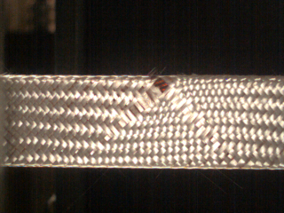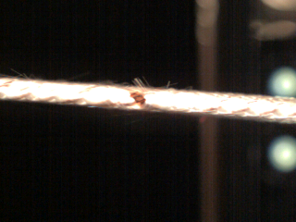

Classes of Severity
Table 1: Defect Guidance for Tears and Gaps
Frequency | Severity Level | Disposition
<20 | Low | Repair (DR) or L3 decision
 | Medium | L2 determination
> 50 | High | Reject

Repair Guidance
Remove part of the local non-uniformities if necessary and apply glass fibre cloths/tapes of appropriate materials and thickness over the exposed section with appropriate overlap such that electrical insulation is sufficient and no bare cable is visible. Apply ceramic binder and cure with heat gun.

Solid Particulates

Definition
Solid particulates are any foreign objects (e.g. bits of plastic or other material) which may be present on or underneath the surface of the fiberglass insulation braid when it is delivered to the coil winding site. An example is shown below.
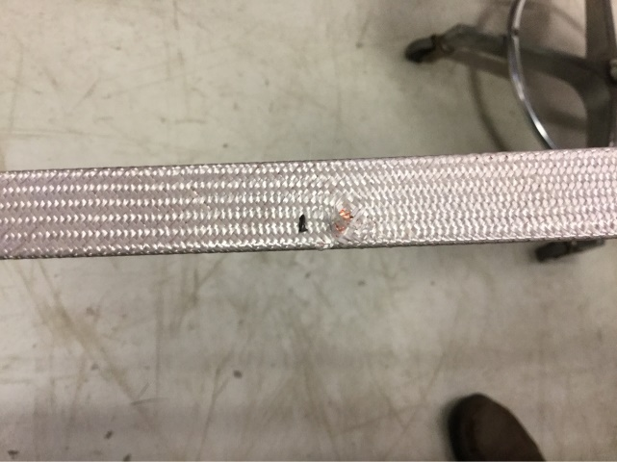

Classes of Severity
Table 2: Defect Guidance for Solid Particulates
Frequency | Severity Level | Disposition
<10 | Low | Repair (DR)
 | Medium | L2 determination
>25 | High | Reject

Repair Guidance
Retrieve the foreign object(s) carefully with tweezers. If after the removal, bare cable is exposed, then follow repairing procedure described in §3.1.3.

Exterior Staining of Insulation Braid:

Definition
Exterior staining refers to unusual pigmentation present on the fiberglass insulation braid surface. Typical cause is oil stain from braiding machine lubrication. The oil appears black against the white braid surface. An example is shown below. The decision whether to make a repair in the case of “low” severity level must be made by the coil fabrication L3. In case the decision is not to make the repair, the assessment must be documented in the traveler.
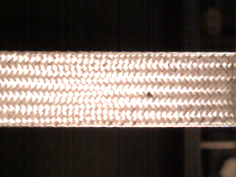

Classes of Severity
Table 3: Defect Guidance for Exterior Staining of Insulation Braid
Frequency | Severity Level | Disposition
<10 | Low | L3 determination
 | Medium | L2 determination
>25 | High | Reject

Repair Guidance
Wipe and clean with ethanol or acetone until the stain is no longer or barely visible.

Popped Strands Under the Braid

Definition
Popped strands refers to the displacement of an individual strand (wire) from the bare cable assembly beyond a few cable twist pitches from the cut ends. Strands popped during bare cable fabrication would most likely cause a collapse and would have failed CMM measurements. Therefore, bare cables shipped from LBNL to the braiding vendor should not have popped strands. However, strand popping may occur due to handling such as during insulation and cable respooling, especially when the cable is not straight (e.g. bent either in the “easy” or “hard” way).
“Mild” instances are cases where popped strands can be pushed and seated back in the cable under the braid by finger pressure.
“Severe” instances are cases where the popped strands cannot be pushed and seated back in the cable under the braid by finger pressure, requiring cable tension reduction and use of tools. Removal of insulation shall not be required.
“Roped” instances are cases where the cable collapses. Repair can only be done with insulation removed.
Strand popping within three cable twist pitches is considered one instance.
An example of a “roped” cable is shown below:
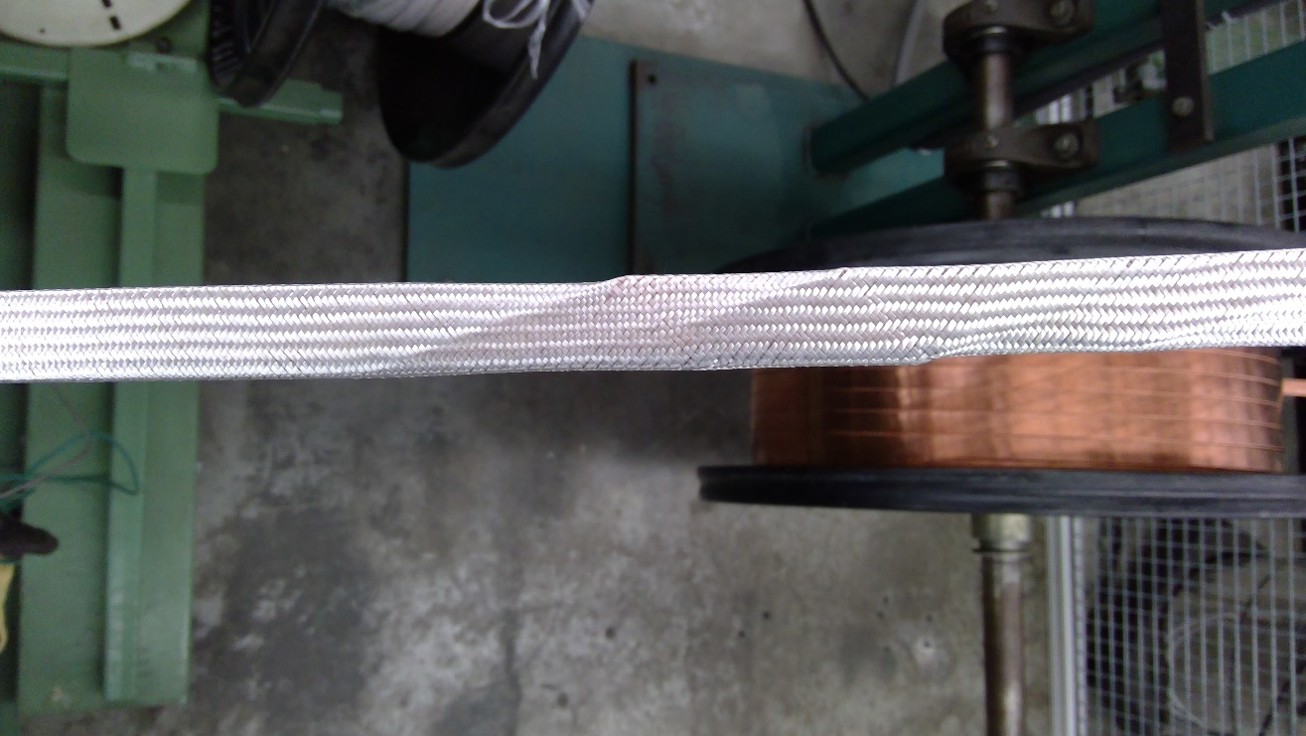
An example of a popped strand is shown below:
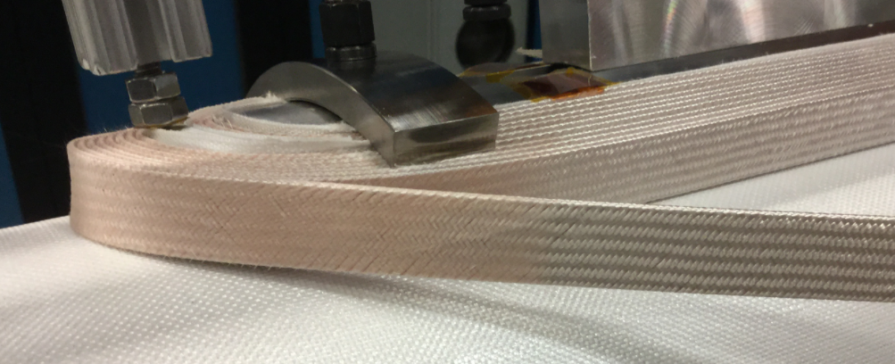

Classes of Severity
Table 4: Defect Guidance for Popped Strands during Respooling
Frequency | Severity Level | Disposition
<10 mild instances  <3 severe instances | Low | Repair
 | Medium | Complete respooling and quarantine for L2 determination
>50 mild instances  >10 severe instances | High | Wind back and quarantine for L2 determination
Roping | High | Repair, wind back, and quarantine for L2 determination

Repair Guidance
“Mild” instances: Push and seat the popped strands back in the cable under the braid by finger pressure or with tools as an option.
“Severe” instances: Push and seat the popped strand back in the cable using tools. Cable tension may or may not have to be reduced. Cable insulation does not have to be removed.
“Roped” instances: Cut open the braid and use hand tools (with no sharp contact edges) to push and seat the popped strands back in the cable (massaging the cable where necessary), followed by braid repairing as described in §3.1.3.

Requirements
Use of this procedure for acceptance of insulated cables issues shall be documented in a manner traceable on Vector.

