 |  | Work Package:
Technical Coordination  Integration Office |  | Group(s): | SP-PDS  JT-HV
 |  | Doc. Type:
EDMS Document No. 2088721 | Created: 7/18/19 |  | Pages:
 | Modified:  17-August-2022 |  | Rev. No.: 2.3

DUNE Interface Document:
JT-HV to SP-PD Interface Control Document

Prepared by:  D. Warner  B. Yu  D. Martinez  Z. Djurcic  S. Magill | Checked by:  D. Warner  E. Segreto  F. Terranova  B. Yu  F. Pietropaolo  K. Zeug  T. Shaw | Approved by:  E. James  M. Nessi

- Introduction
This document describes the necessary interfaces between the APA and JT-HV consortia regarding design, prototyping, component fabrication and installation (including schedule), and installation. The primary interactions are:
- Mounting of SP-PD monitoring system diffusing flashers to the Cathode Plane Assemblies (CPAs)
- Routing of diffusing flasher optical fibers along the CPA to a junction point at the top of the CPA
- Installation of the SP-PD system underground.
- Design
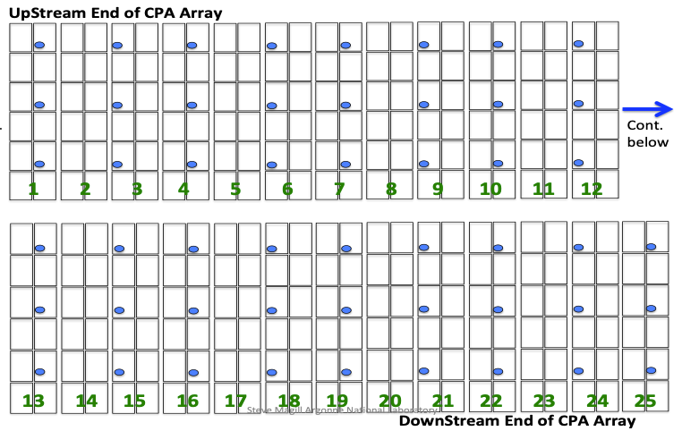
The monitoring system for the SP-PD consists of 204 diffusing light sources mounted to the CPAs in positions selected to provide uniform illumination to the SP-PD light collector modules (See Figure 1, and drawing in EDMS 2088721). A pulsed UV-light system will provide a uniform illumination of the SP-PD modules in the detector, allowing for cross-calibration and monitoring of the detectors. As noted above, the diffusers are installed on the CPA, and therefore will be at the same electrical potential as the CPA. Quartz optical fibers within a stainless steel flexible conduit are used to transport light from optical feedthroughs (at the cryostat top), to fiber junctions above the ground plane. These fibers are then connected to additional quartz optical fibers routed along the CPA and optically connected to diffusers located on the CPA panels. The quartz optical fibers with Polyimide and/or Tefzel coating are electrical insulators. SP-PDS monitoring system design requirements include specification of a sufficiently high electrical resistance for the fiber/jacket to ensure the cathode is protected from shorting out due to fiber conductivity.
Figure 1. locations of the diffusers (blue) on one of the cathode arrays. The grid pattern represents the cathode module structure. There are 51 diffusers on each face.

Figure 2. (Left) Diffuser location in the CPA field shaping strip (FSS) notches. (Right) PEEK 3D printed diffuser
Primary design responsibilities will be distributed as follows:
JT-HV Consortium:
- Cathode module design, including diffuser mounting features (Fig. 2) and field cage pass through as needed
- SP-PD optical fiber routing along the CPA frame, including required access holes in frame and fiber tie down points.
SP-PD Consortium:
- Optical diffusers
- Optical fiber and connector selection
- Required hardware and assembly/installation tooling
- Testing and Prototyping

Monitoring system component testing:
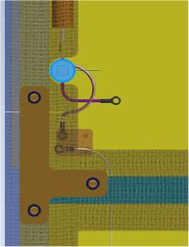
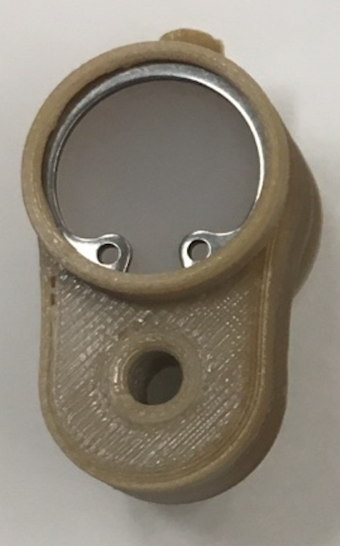
Prototype versions of the SP-PD monitoring system components are currently being tested in ProtoDUNE. Additional component tests will be managed between the PDS and JT-HV consortia if necessary. Final-design pre-production monitoring system components will be tested in cryostatic test stands including the materials test stand and HV tests at FNAL. Quartz optical fibers with Polymide and Tefzel coatings will be included in these tests. ProtoDUNE and ProtoDUNE 2 will verify HV design and operation without discharges that could cause light emission observed by PDS should this be a concern.
SP-PD to JT-HV interface prototyping:
Primary testing of the SP-PD to JT-HV interface will occur in interface trials in a ProtoDUNE 2 run at CERN. Testing will involve insertion of a fully-functional final design SP-PD monitoring system into the CPA. Following insertion, the full system will be tested operationally in the ProtoDUNE cryostat, representing a final pre-production test of the SP-PD to JT-HV interface. A prototyping plan for ProtoDUNE-2 will be generated prior to CD-2.
- Component Fabrication
The SP-PD Consortium will be responsible for fabrication and QA/QC testing of all photon-detector components including:
- Diffuser blocks
- Optical fibers
- Connector mounting hardware
- Tooling and hardware for SP-PD monitoring hardware installation
The JT-HV Consortium will be responsible for fabrication of all JT-HV components including:
- CPA and field cage frame features required for monitoring system mounting
- SP-PD fiber tie-down hardware to CPA and field cage.
Fabrication of components under SP-PD Consortium control may impact JT-HV Consortium fabrication scheduling. These schedule links will be included in the DUNE project master schedule, which represents the controlling schedule document between the consortia.
All QA/QC for fabricated components are the responsibility of the consortium responsible for fabrication of those items. This includes all QA/QC tooling required for those items, and responsibility for transmitting those QA/QC results to the project quality database. A full QA/QC plan for interface components will be agreed between the consortia prior to the relevant production readiness reviews for those components.
- Installation
Attaching the SP-PD light diffusers and fibers to the CPA frames prior to insertion into the cryostat, using the installation tools, fixtures, and QC/QA equipment supplied by the SP-PD consortium, are the responsibility of the JT-HV Consortium. Post-installation verification using light, if deemed necessary, will be performed by the JT-HV team with instructions and tools provided by SP-PDS.
Tooling required for CPA handling are the responsibility of the JT-HV Consortium.
Prior to the deployment of the field cage modules inside the cryostat, but after the installation of TPC cable bundles, SP-PD consortium will supervise routing of the calibration fibers inside stainless steel flexible conduit on the ground plane support beams up the PDS flange. Note that the ground plane system has been moved to DSS (I&I). Routing of the fibers and the metal conduit become an interface item between SP-PD and I&I.
- Grounding
The SP-PD Consortium will follow grounding guidelines from the grounding and shielding committee and project management. No electrical connection (including ground connection) will be made between the PD modules or cable harness and the CPA and Field Cage modules.
- Safety
All parties have the responsibility to follow responsible safety engineering for all interface components. All parties must follow the LBNF/DUNE integrated safety plan. Each consortium assumes responsibility for safety of all components under their direct responsibility for component design. Prior to CD-2 an evaluation of system safety (including installation plans) will be conducted including the technical leads for each consortium and a representative of the DUNE project safety team.
- References
- Installation Prototyping Proposal: EDMS 2169069
- Interface drawings: See attached drawings in EDMS 2088721
- DUNE FD integrated schedule
- Action Items
- Signed and controlled interface drawings need to be completed
- Ash river proposal will be finished along with any other prototyping plans if they are deemed needed.
- Jacketed fiber and final diffuser design need to be validated in cryogenic test stands

- Revision History
2.0 March 13, 2020 Finalized the quantity and locations of the diffuser.
2.1 March 19, 2020 Accepted most changes, final edits from PD side
2.2 April 8, 2020 Accepted all changes, represents final edit from PD side
2.3 August 16, 2022 Revisions to reflect current interface status implemented

