PIP-II Vacuum
Interface Specification Document (ISD)

Document number: ED0016361-A

Document Approval

Signatures Required | Date Approved
Author/Owner: Raul Campos | -
Author/Owner: Lucy Nobrega | -
Reviewer: Chris Becker, Integration Coordinator | Checker in TC
Reviewer: Jeremy Nudell, PIP-II Project Engineer | Checker in TC
Approver: Jeremiah Holzbauer, Accelerator Systems L2 Manager | Approver in TC
Stakeholder Reviews performed off-line using ISD Metadata sheet | Dataset in TC

Revision History

Revision | Date of Release | Description of Change
- | January 2021 | Initial Release.
A

Page left intentionally blank.

Table of Contents
1. Purpose 4
2. Scope 4
3. Roles and Responsibilities 5
3.1. Author(s) 5
3.2. Owner 5
3.3. Reviewer 5
3.4. Approver 5
3.5. Stakeholder 5
4. Acronyms 6
5. Summary Table 6
6. Warm Front End Interfaces with Vacuum 13
7. Warm Units Interfaces 15
8. Insulating Vacuum Interfaces 17
9. Beam Transfer Line and Beam Absorber Line Vacuum Interfaces 18
10. Booster Injection Interfaces with Vacuum 20
11. Laser Optical Transport Line with Vacuum 22
12. TBD Resolution Milestone Table 22
13. Reference Documents 23

Purpose
Interface Specification Documents (ISDs) contain the information necessary to define all of the external interfaces for the given system. Interfaces are defined globally in the PIP-II Master Interface Control Document which then reference the pertinent ISDs which contain the particular interface details. The ISD contains all the information or references to the information that is necessary to fully define and complete the given interface.

Scope
This document describes the details of the external interfaces for the Vacuum Systems of the PIP-II Project. This ISD covers the physical, electrical signal, vacuum specifications, and fluid flow interfaces between Vacuum and the systems that it interfaces with.

Roles and Responsibilities

Author(s)
Responsible for ISD preparation, including layout, proper format, interface identification, interface verification expectations, interface traceability, and additional descriptive detail, as appropriate. The author is expected to engage subject matter experts as needed to ensure technical content is appropriately assessed and captured. The author is also expected to identify all applicable stakeholders to their noted interface(s). In some cases, the author can also have the role of the document Owner.

Owner
Primary stakeholder and responsible for identifying the goals, objectives, and roles/responsibilities pertaining to the document and for assuring activities/expectations are performed as described. This is typically the Level 3 Manager of the sub-system to which this ISD belongs. The document owner is responsible for maintaining document content, revisions, and updates. An Owner is considered a “Checker” in Teamcenter workflow release when they are not the document Author.

Reviewer
Technical Integration Office (TIO) reviewers are responsible for ensuring ISD format is consistent with project standards, the appropriate document owner/author/reviewer/approver have been identified, the appropriate review process was implemented, and the appropriate document release process is executed. The TIO reviewers are required to be aware that the ISD document exists and is maintained within the framework of the project Document Management and Control Procedure. A Reviewer is considered a “Checker” in the Teamcenter workflow release.

Approver
The L2 Manager will evaluate the basis for interface definition, ensure that interfaces are properly articulated, and ensure that they align with higher level interfaces. The L2M will ensure that CAMs, associated engineering staff, and other Systems Managers are properly engaged and notified of the document’s technical implications. Only the System Manager responsible for the work product addressed in the specification is expected to provide approval. The Approver is an “Approver” in the Teamcenter workflow release.

Stakeholder
Each ISD includes a metadata sheet which lists each ISD interface individually and assigns stakeholders to each. A stakeholder is the associated L3 or subject matter expert that the interface connects or interfaces to and as a result has a direct stake in the interface. Identified stakeholders are expected to be reviewers, ensuring accuracy and completeness, and general agreement of the interface and content applicable to them. Stakeholder reviewers ensure a record of decision is made offline for accepting, rejecting, or modifying the interfaces assigned to them within the ISD metadata sheet (included as a dataset in Teamcenter).

Acronyms

BAL | Beam Abort Line
BTL | Beam Transfer Line
CM | Cryomodule
DPI | Differential Pumping Insert
EPDM | Engineering Process Document Management
FAV | Fast Acting Valve
FEM | Fermilab Engineering Manual
FESHM | Fermilab ES&H Manual
FRCM | Fermilab Radiological Control Manual
FRS | Functional Requirements Specification
HEBT | High Energy Beam Transport
HV | High Vacuum
HWR | Half Wave Resonator
IS | Ion Source
LEBT | Low Energy Beam Transport
MEBT | Medium Energy Beam Transport
PIP-II | Proton Improvement Plan II Project
RFQ | Radio Frequency Quadrupole
SRF | Superconducting Radio Frequency
TC | Teamcenter
TRS | Technical Requirements Specification
UHV | Ultrahigh Vacuum
WBS | Work Breakdown Structure
WFE | Warm Front End
WU | Warm Unit

Summary Table
The following table summarizes each interface by Master ICD ID number and provides additional verification details.

Table 5-1. Interface Summary Table
# | Master ICD ID # | Interface Name | ISD Section | External Reference
1 | 1774-001 | HWR Turbo Pump Beam Line Controls Interface with Vacuum | 7 | ED0001313 HWR FRS,  ED0002529 HWR ISD, ED0013681 PIP-II Vacuum Systems TRS
2 | 1774-002 | HWR CM Insulating Vacuum Systems | 7, 8 | ED0001313 - HWR CM FRS; ED000xxx - HWR Cavity FRS; ED0004250 - PIP-II MPS FRS, PIP-II Vacuum Systems TRS ED0013681 ,  ED0002529 - HWR ISD  Vacuum TRS ED0013681
3 | 1774-003 | HWR Beam Line Vacuum Systems | 7 | ED0001313 - HWR FRS, ED0013681 - PIP-II Vacuum Systems TRS, ED0002529 - HWR ISD
4 | 1836-001 | SSR Insulating Vacuum Interface | 8 | ED0001316 - SSR1 CM FRS; ED0001829 - SSR2 CM FRS; ED0004250 - PIP-II MPS FRS, ED0004129 - SSR1 prototype CM ISD, ED00011908 - SSR1 production CM ISD, ED0010943 - SSR2 pre-production CM ISD, ED0011911 - SSR2 production CM ISD, Vacuum TRS number ED0013681  SSR1 TRS number ED0011907
5 | 1836-002 | SSR Beam Line Connection with Vacuum | 7 | ED0001316 - SSR1 CM FRS; ED0001829 - SSR2 CM FRS; ED0004250 - PIP-II MPS FRS, ED0004129 - SSR1 prototype CM ISD, ED00011908 - SSR1 production CM ISD, ED0010943 - SSR2 pre-production CM ISD, ED0011911 - SSR2 production CM ISD, SSR1 TRS number ED0011907  Vacuum TRS number ED0013681
7 | 1957-001 | 650MHz Insulating Vacuum Interface | 8 | ED0001830 - LB650 CM FRS; ED0001322 - HB650 CM FRS; ED0004250 - PIP-II MPS FRS, ED0018319 - LB650 CM ISD doc; ED0007562 - HB650 prototype CM ISD; ED0018320 - HB650 production CM ISD, ED0013681 - Vacuum Systems TRS
8 | 1957-002 | 650MHz Beam Line Vacuum Interface | 7 | ED0001830 - LB650 CM FRS; ED0001322 - HB650 CM FRS; ED0004250 - PIP-II MPS FRS, ED0018319 - LB650 CM ISD doc; ED0007562 - HB650 prototype CM ISD; ED0018320 - HB650 production CM ISD,  Vacuum TRS number ED0013681
 | 2502-001 | CTS 325 MHz input coupler vacuum status (Vac) | 7 | TBD
 | 2502-002 | CTS 650 MHz input coupler vacuum status (Vac) | 7 | TBD
 | 2551-001 | RFQ vacuum system status to LLRF | 6 | TBD
11 | 2599-001 | BTL Dipole magnet vacuum beam tube and flanges | 9 | ED0013225 - BTL Magnets and Power Supplies ISD,  TBD3 - Magnets engineering drawing  TBD4 - Vacuum Engineering Drawing Number
12 | 2599-002 | Vacuum interface for BTL specialty magnets | 9 | ED0013225 - BTL Magnets and Power Supplies ISD,TBD5 - BTL Magnets Final Design Report .  TBD4 - Vacuum Engineering Drawing  TBD6 - Magnet Preliminary design
13 | 2599-003 | VAC-MagPS | 7 | ED0004444 PXIE Vacuum Requirements, ED0013224 - Linac Warm Magnet ISD, Vacuum TRS number ED0013681, BTL Magnets Final Design Report - "Doublet for 650 MHz section of Linac, Final Magnet Design"
14 | 2647-001 | VAC-Cntrl | 6, 7, 8, 9, 10, 11 | ED0004444 PXIE Vacuum Requirements, ED0016515 - Controls ISD TBD7 - Vacuum document with signal parameters  TBD8 - Table of parameters
15 | 2647-002 | Vacuum Control System Interface | 6, 7, 8, 9, 10, 11 | ED0007691 - Vacuum Interface Document, TBD9- Vacuum List of Equipment document
16 | 2649-001 | VAC-BI | 6, 7 | ED0004444, ED0016035 PIP-II BI Invasive BProM ISD ED0016037 PIP-II BI BPM System ISD, Vacuum TRS number ED0013681  BPM TRS ED0013710,  Invasive BProM TRS ED0013713, BProM TRS ED0013714  TBD10 - Vacuum and BI mechanical design drawings
17 | 2649-002 | BTL Instrumentation | 9 | ED0016035 PIP-II BI Invasive BProM ISD ED0016037 PIP-II BI BPM System ISD, Vacuum TRS number ED0013681  ED0010216 PIP-II Parameters PRD  Invasive BProM TRS ED0013713  TBD10 - Vacuum and BI mechanical design drawings
 | 2649-003 | Laser optical transport line vacuum | 11 | ED0016036 - BI Noninvasive BProM ISD
18 | 2650-001 | Vacuum MPS Interface | 6, 7, 8, 9, 10 | ED0016360 - MPS ISD, TBD11 - MPS document of required signals  TBD12 - FAV specs, signal type from FAV controller
19 | 2659-001 | LEBT chopping system vacuum interface | 6 | WFE ISD, LEBT TRS  TBD13 - F10001776 (PIP2IT) equivalent for PIP-II
20 | 2659-002 | MEBT vacuum interface | 6 | WFE ISD, MEBT TRS  MEBT Assy F10001763 (PIP2IT)  TBD14 - F10001776 (PIP2IT) equivalent for PIP-II
21 | 2659-004 | Ion Source vacuum interface | 6 | Vacuum TRS number ED0013681  Ion Source User Manual  TBD 14- F10001776 (PIP2IT) equivalent for PIP-II
22 | 2659-005 | RFQ vacuum interface | 6 | Vacuum TRS number ED0013681  RQF TRS  F10003341
23 | 2659-006 | MEBT bunching cavities vacuum interface | 6 | MEBT Bunching Cavities Engineering drawing  TRS ED0000038
24 | 2659-007 | MEBT kickers vacuum interface | 6 | MEBT Kickers Engineering drawing  TRS ED0002305
25 | 2659-008 | MEBT absorber vacuum interface | 6 | TBD14 - F10001776 (PIP2IT) equivalent for PIP-II
26 | 2659-009 | MEBT Differential Pumping Insert (DPI) vacuum interface | 6 | TBD14 - F10001776 (PIP2IT) equivalent for PIP-II
27 | 2659-010 | MEBT Fast Acting Valve interface | 6 | MEBT TRS  TBD 14- F10001776 (PIP2IT) equivalent for PIP-II
28 | 2659-011 | Kicker Driver Electronics Interface | 6 | ED0014052 PIP-II MEBT Kicker Driver Electronics TRS; ED0008094 PIP-II MEBT Kicker Assembly TRS, ED0013658 PIP-II MEBT Kicker Driver ISD, Vacuum TRS number ED0013681  ISD ED0013658
 | 2659-012 | Vacuum Equipment Mechanical Interface (non-vacuum) | 6 | ED0022346 - PIP-II MEBT ISD, F10101511 - MEBT Drawing
29 | 2660-001 | Portable cleanrooms | 6, 7, 9, 10 | ED0008216 PIP-II Vacuum FRS, TBD15 - Cleanroom specifications
30 | 2661-001 | Power | 6, 7, 8, 9, 10, 11 | ED0014385 - Building Infrastructure Electrical ISD, Room Data Sheet ED0009544
31 | 2661-002 | Cables and Cable Trays | 6, 7, 8, 9, 10, 11 | ED0014385 - Building Infrastructure Electrical ISD, Room Data Sheet ED0009544
32 | 2661-003 | Grounding | 6, 7, 8, 9, 10, 11 | ED0014385 - Building Infrastructure Electrical ISD, Room Data Sheet ED0009544
33 | 2661-004 | Building infrastructure compressed air interface with Vacuum Systems | 6, 7, 8, 9, 10 | ED0013644 Building Infrastructure ISD, PIP-II Instrument Air and Nitrogen Usage Document ED0012529
34 | 2661-005 | Cables for Vac systems | 6, 7, 8, 9, 10, 11 | ED0014385 - Building Infrastructure Electrical ISD, Room Data Sheet ED0009544
35 | 2661-006 | Nitrogen - Portable cleanroom and purge flow | 6, 7, 8, 9, 10 | ED0013644 Building Infrastructure ISD, PIP-II Instrument Air and Nitrogen Usage Document ED0012529
 | 2661-007 | BldgI Rack Interface for Vac Subsystems Chassis | 6, 7, 8, 9, 10 | ED0013644 Building Infrastructure ISD
36 | 2662-001 | Linac/TLBA Interface Gate Valve - delivery | 9 | TBD16 - Beam physics location requirements  Vacuum TRS number ED0013681
37 | 2662-002 | Vac equipment common requirements - rigging | 6, 7, 8, 9, 10, 11 | TBD4 - Vacuum Engineering Drawings  Vacuum TRS number ED0013681
38 | 2662-003 | Vac systems common requirements - alignment referencing | 6, 7, 8, 9, 10 | TBD 4- Vacuum Engineering Drawings
39 | 2662-004 | Vacuum-Structure Interfaces, Warm Units | 7 | F10105038 BPM and HB650 WU ICD, F10150993 SSR CMS and WU ICD, LI Interface Drawing Number  TBD 4- Vacuum Engineering Drawings
40 | 2672-001 | BTL to Booster Connection | 9, 10 | ED0016557 - Booster ISD, TBD17 – Booster Engineering Drawing  TBD4 - Vacuum Engineering Drawings
41 | 2672-002 | VAC-BSTR | 10 | ED0004444 PXIE Vacuum, Vacuum TRS number ED0013681
42 | 2674-001 | VAC-TLBA | 9 | ED0004444 PXIE Vacuum, Vacuum TRS number ED0013681
43 | 2674-002 | TLBA Vacuum (Vac) | 9 | TBD18 - BTL Magnets Final Design Report  TBD 19- BTL Magnets Aperture Dimensions
44 | 2675-001 | Linac to BTL Connection | 7, 9 | TBD20 - Internal interface. Location and configuration, Vacuum TRS number ED0013681

Warm Front End Interfaces with Vacuum
Master ICD interface(s) 2551-001, 2647-001, 2647-002, 2649-001, 2650-001, 2659-001, 2659-002, 2659-004, 2659-005, 2659-006, 2659-007, 2659-008, 2659-009, 2659-010, 2659-011, 2659-012, 2660-001, 2660-002, 2660-003, 2660-004, 2660-005, 2660-006, 2660-007, 2661-001, 2661-002, 2661-003, 2661-004, 2661-005, 2661-006, 2661-007, 2662-002, 2662-003
Interface with LLRF, BI, MPS, WFE, Ctrl, BldgI, LI, TI

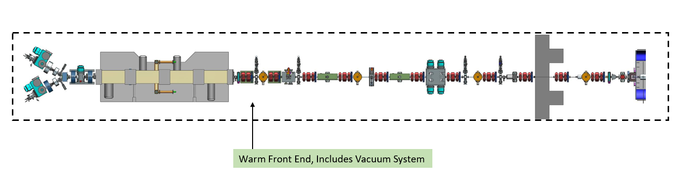Figure 6-1. WFE Vacuum Interfaces

The Warm Front End (WFE) vacuum system (Figure 6-1) includes vacuum pumps, gauges, and beamtube assemblies between accelerator components such as the ion source, RFQ, Kicker, and Beam Instrumentation devices. There are physical, vacuum level, electrical signal, electrical power, and gas flow interfaces between Vacuum and WFE systems.

Physical interfaces: Engineering drawing F10001776 (PIP2IT) details the physical interfaces between vacuum and WFE beamline components. These include flanged connections and structural supports. The WFE mechanical assembly engineering drawing F10001776 (PIP2IT) details dimensions of vacuum spool pieces and their subassembly engineering drawings, which contain flange specifications. Materials requirements are specified in Vacuum TRS number ED0013681.

Vacuum Level: Vacuum TRS number ED0013681 specifies the required vacuum level at each section of the WFE.

Electrical power: The required power of vacuum components for operations are defined in Room Data Sheet ED0009544.

Gas flow: Pneumatic gate valves require instrument air to close or open. The PIP-II Instrument Air and Nitrogen Usage Document ED0012529 specifies the flow requirements.

Electrical signals: PIP-II Controls interfaces with vacuum systems through electrical signals for vacuum levels and status at the controllers for vacuum equipment (gauges, pumps, and valves).

MPS interfaces: The PLC that monitors the Vacuum systems Fast Acting Valves (FAVs) provides open/close status (TTL inputs) to the MPS.

TBD22 - Vacuum equipment installation: Status and certification of equipment installation will be documented in ED0011282 (PIP-II Installation Deliverable List VAC-LI). Vacuum systems engineering drawings will detail lifting and alignment features.

Warm Units Interfaces
Master ICD interface(s) 1774-001, 1774-002, 1774-003, 1836-002, 1957-002, 2502-001, 2502-002, 2599-003, 2647-001, 2647-002, 2649-001, 2650-001, 2660-001, 2661-001, 2661-002, 2661-003, 2661-004, 2661-005, 2661-006, 2661-007, 2662-002, 2662-003, 2662-004, 2675-001
Interface with HWR, SSR, 650MHz, HPRF, MPS, MagPS, Cntrl, BI, TI, BldgI, LI

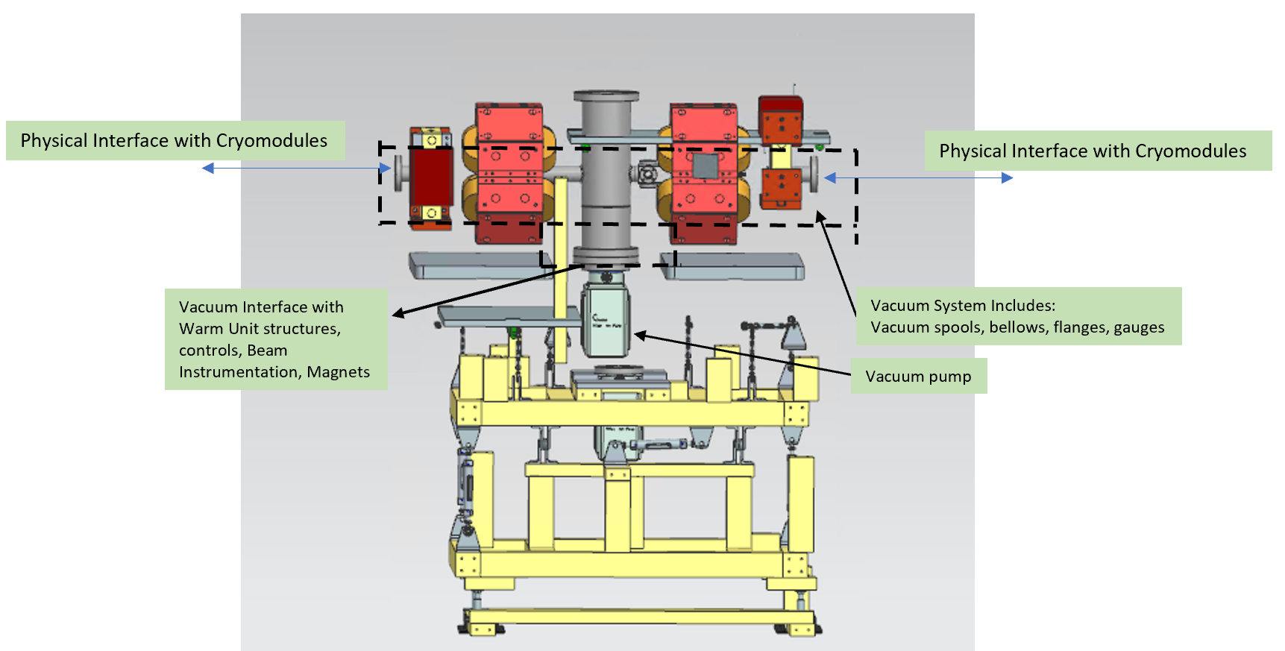
Figure 7-1. Warm Units Interfaces with Vacuum

Vacuum systems warm units provide vacuum beamtube, gauges, and pumps between Cryomodules of the PIP-II Linac. The physical interfaces between the warm units and the cryomodules are defined in the CM’s TRS: HWR TRS number ED000XXXX, SSR1 TRS number ED000011907, SR2 TRS number ED0011910, HB 650MHz CM TRS number ED0013631, and LB 650MHz CM TRS number ED0009658, and their corresponding engineering drawings. Materials specifications for the flanges are defined in the Vacuum TRS number ED0013681.

Beamtube diameter: Dimensions of quadrupole magnet cores at the 650 MHz sections define the vacuum beamtube outer diameter. The “Doublet for 650 MHz section of Linac, Final Magnet Design" report details the magnets core dimensions. The vacuum engineering drawings for vacuum warm units will specify the tube outer diameter (2in) that will interface with these magnet cores.

Warm units configuration: Warm units configurations are dependent on beam instrumentation devices dimensions and location as well as magnets dimensions. ED0010216 PIP-II Parameters PRD includes the location of all beam instrumentation devices, and their dimensions will be defined in their mechanical engineering drawings. Magnets dimensions are described in the “Doublet for 650 MHz section of Linac, Final Magnet Design" report. Vacuum engineering drawings will specify the system configuration and dimensions of these interfaces.

Materials: Warm units beam instrumentation devices interface with the vacuum volume so UHV vacuum-friendly materials as defined in the Vacuum TRS number ED0013681 will be used at this interface. The following TRSs include details on materials between vacuum and BI devices: BCM TRS ED0013712, BPM TRS ED0013710, BLM TRS ED0013711, Invasive BProM TRS ED0013713, BProM TRS ED0013714 TBD23.

Vacuum Level: Vacuum TRS number ED0013681 specifies the required vacuum level at the warm units between cryomodules.

Electrical power: The required power of vacuum components for operations are defined in Room Data Sheet ED0009544

Gas flow: Pneumatic gate valves require instrument air to close or open. The PIP-II Instrument Air and Nitrogen Usage Document ED0012529 specifies the flow requirements.

Electrical signals: PIP-II Controls interfaces with vacuum systems through electrical signals for vacuum levels and status at the controllers for vacuum equipment (gauges, pumps, and valves).

MPS interfaces: The PLC that monitors the Vacuum systems Fast Acting Valves (FAVs) provides open/close status (TTL inputs) to the MPS.

TBD22 - Vacuum equipment installation: Status and certification of equipment installation will be documented in ED0011282 (PIP-II Installation Deliverable List VAC-LI). Vacuum systems engineering drawings will detail lifting and alignment features.

Insulating Vacuum Interfaces
Master ICD interface(s) 1774-002, 1836-001, 1957-001, 2647-001, 2647-002, 2650-001, 2661-001, 2661-002, 2661-003, 2661-004, 2661-005, 2661-006, 2661-007, 2662-002, 2662-003
Interface with HWR, SSR, 650MHz, BldgI, LI, Cntrl, MPS

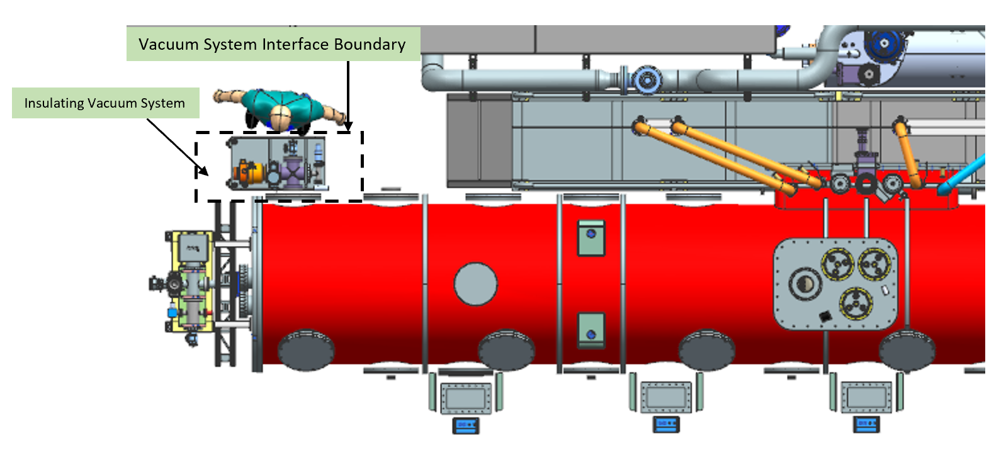
Figure 8-1. Insulating Vacuum Interfaces

Vacuum Systems provide insulating vacuum stations for each cryomodule. The systems have a physical flanged interface with the CM and provide vacuum pumping. Insulating vacuum also interfaces with controls, building infrastructure, and Linac Installation.

Physical Interface with Cryomodules: The physical interfaces between the warm units and the cryomodules are defined in the CM’s TRS: HWR TRS number ED000XXXX, SSR1 TRS number ED000011907, SR2 TRS number ED0011910, HB 650MHz CM TRS number ED0013631, and LB 650MHz CM TRS number ED0009658, and their corresponding engineering drawings. Materials specifications for the flanges are defined in the Vacuum TRS number ED0013681.

Vacuum Level: Vacuum TRS number ED0013681 specifies the required vacuum level for insulating vacuum.

Electrical power: The required power of vacuum components for operations are defined in Room Data Sheet ED0009544

Electrical signals: PIP-II Controls interfaces with vacuum systems through electrical signals for vacuum levels and status at the controllers for vacuum equipment (gauges, pumps, and valves).

TBD22 - Vacuum equipment installation: Status and certification of equipment installation will be documented in ED0011282 (PIP-II Installation Deliverable List VAC-LI). Vacuum systems engineering drawings will detail lifting and alignment features.

Beam Transfer Line and Beam Absorber Line Vacuum Interfaces
Master ICD interface(s) 2599-001, 2599-002, 2647-001, 2647-002, 2649-002, 2650-001, 2660-001, 2661-001, 2661-002, 2661-003, 2661-004, 2661-005, 2661-006, 2661-007, 2662-001, 2662-002, 2662-003, 2672-001, 2674-001, 2674-002, 2675-001,
Interface with BTLI, Cntrl, MPS, TI, LI, BSTR, BI, BldgI, TLBA, MagPS

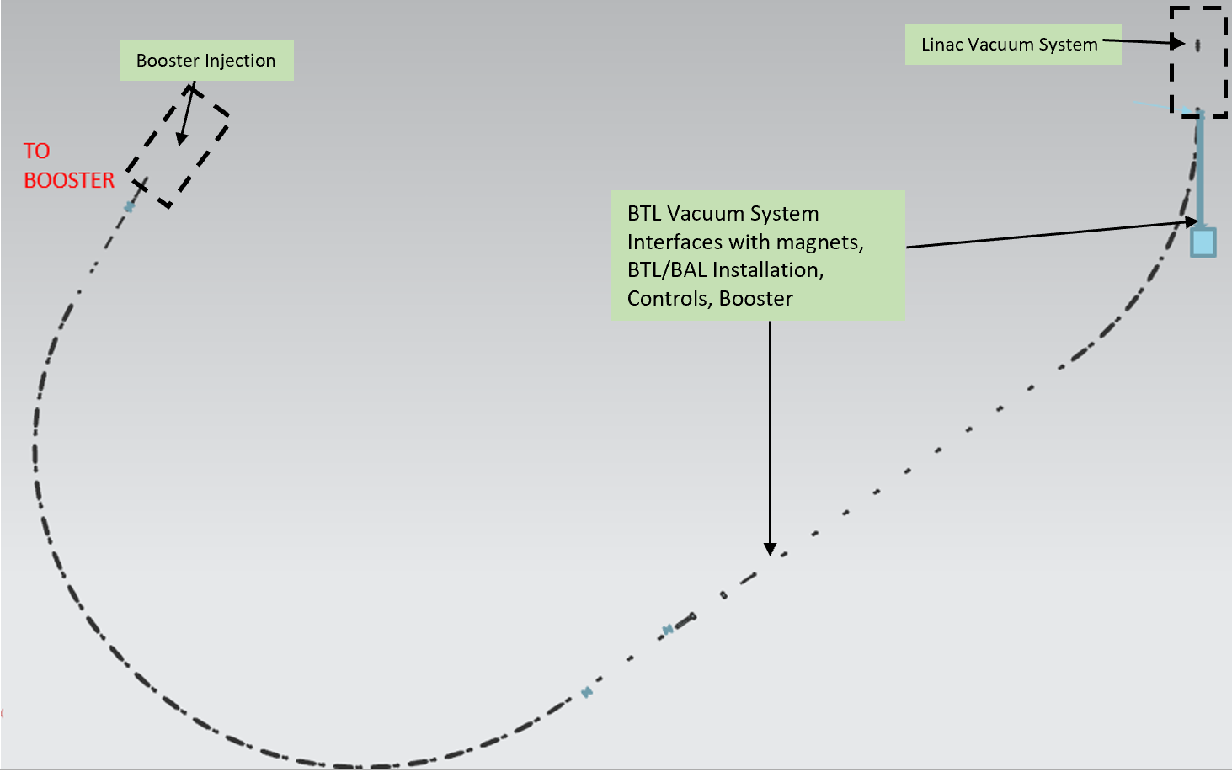
Figure 9-1. BTL and BAL Vacuum Interfaces

Vacuum systems provide vacuum pumps and gauges equipment for the Beam Transfer Line and Beam Absorber Line. Vacuum beamtube diameter and spools configurations are defined by Magnets interfaces as well as interfaces with Linac and Booster vacuum systems.

TBD24 – BTL beamtube diameter: Magnet dimensions and specifications will determine vacuum beamtube diameter and joint specifications. The vacuum engineering drawings for vacuum warm units will specify the tube outer diameter that will interface with these magnet cores.

TBD25 – BTL vacuum spools configuration and dimensions: Vacuum engineering drawings will specify the system configuration and dimensions of these interfaces.

Vacuum Level: Vacuum TRS number ED0013681 specifies the required vacuum level at the BTL and BAL.

Electrical power: The required power of vacuum components for operations are defined in Room Data Sheet ED0009544

Electrical signals: PIP-II Controls interfaces with vacuum systems through electrical signals for vacuum levels and status at the controllers for vacuum equipment (gauges, pumps, and valves).

Gas flow: Pneumatic gate valves that require instrument air to close or open. The PIP-II Instrument Air and Nitrogen Usage Document ED0012529 specifies the flow requirements.

MPS interfaces: The PLC that monitors the Vacuum systems Fast Acting Valves (FAVs) provides open/close status (TTL inputs) to the MPS.

TBD22- Vacuum equipment installation: Status and certification of equipment installation will be documented in a deliverables list to BTL/BAL. Vacuum systems engineering drawings will detail lifting and alignment features.

TBD26 – Absorber line vacuum windows

Booster Injection Interfaces with Vacuum
Master ICD interface(s) 2647-001, 2647-002, 2650-001, 2660-001, 2661-001, 2661-002, 2661-003, 2661-004, 2661-005, 2661-006, 2661-007, 2662-002, 2662-003, 2672-001, 2672-002,
Interface with Cntrl, MPS, TI, BTLI, BSTR, BldgI

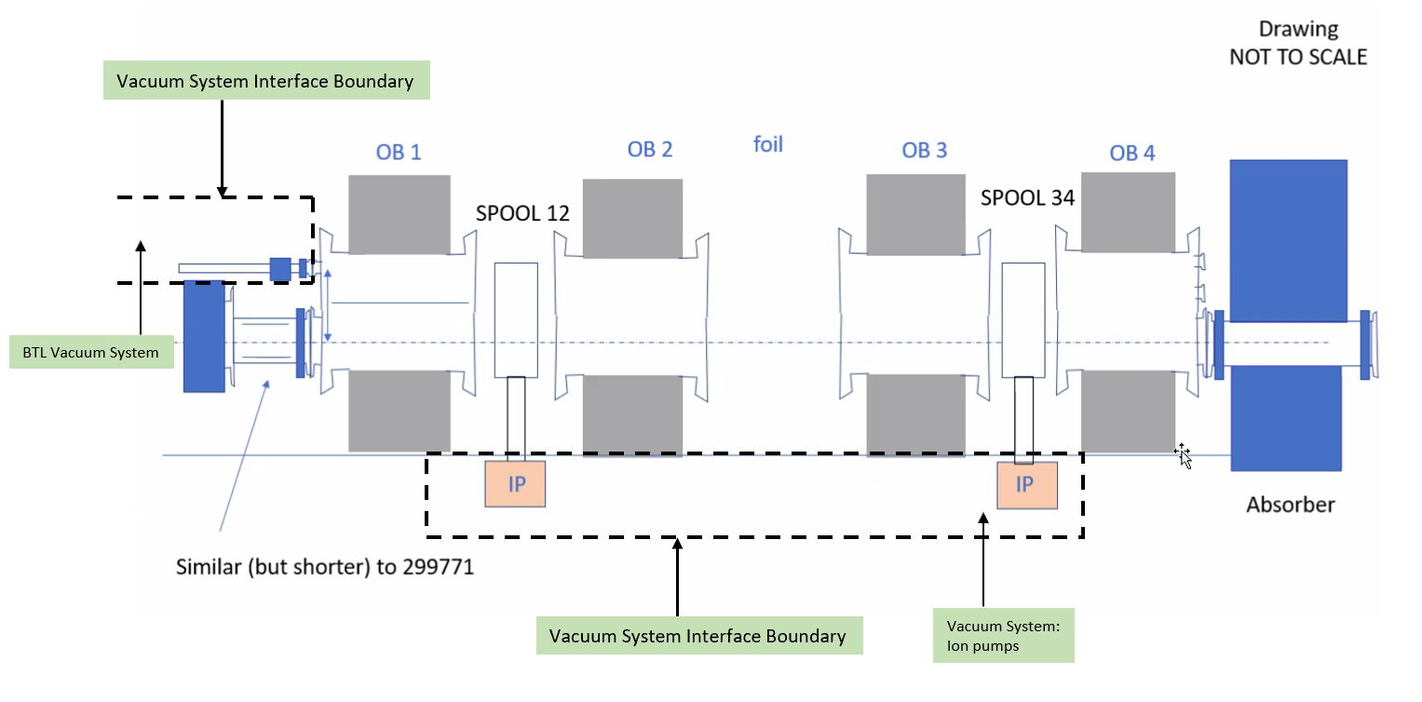Figure 10-1. Insulating Vacuum Interfaces
The PIP-II Vacuum connects to the Booster at the Booster Injection. The downstream end of the BTL interfaces with the Booster Injection system. PIP-II Vacuum will also provide ion pumps for the Booster Injection magnets vacuum chambers.

TBD27 – Physical connection: Booster-style flanged connections will be used to connect to the Booster Injection vacuum chamber. The interface will be detailed in the engineering drawings for the Booster Injection, and the BTL Vacuum. Booster style ion pumps will also be

Vacuum Level: Vacuum TRS number ED0013681 specifies the required vacuum level at the BTL sections.

Electrical power: The required power of vacuum components for operations are defined in Room Data Sheet ED0009544

Gas flow: Pneumatic gate valves require instrument air to close or open. The PIP-II Instrument Air and Nitrogen Usage Document ED0012529 specifies the flow requirements.

Electrical signals: PIP-II Controls interfaces with vacuum systems through electrical signals for vacuum levels and status at the controllers for vacuum equipment (gauges, pumps, and valves).

MPS interfaces: The PLC that monitors the Vacuum systems Fast Acting Valves (FAVs) provides open/close status (TTL inputs) to the MPS.
TBD22 - Vacuum equipment installation: Status and certification of equipment installation will be documented in a deliverables list to BTL/BAL. Vacuum systems engineering drawings will detail lifting and alignment features.

Laser Optical Transport Line with Vacuum
Master ICD interface(s) 2647-001, 2647-002, 2649-003, 2661-001, 2661-002, 2661-003, 2661-005, 2662-002
Interface with Cntrl, BI, BSTR, BldgI

New details here.

TBD Resolution Milestone Table

Green – done
Yellow – bookkeeping
Blue – design work needed
Magenta – TBD

TBD# | TBD Description | Resolution
1 | HWR TRS (lines 1,2,3, and 6 of summary table) | Need to reference TRS
2 | CDS Vacuum Interface (line 10 of summary table) | Removing this interface per MICD comment
3 | Magnets Engineering Drawing (line 11 of Summary table) | Need magnets specs dimensions document, Final drawings needed
4 | Vacuum Engineering Drawing (lines 11, 12, 37, and 40 of summary table) | Updating TC Assy number
5 | BTL Magnets Final Design Report (line 12 of summary table) | Need magnets specs dimensions document, Final drawings needed
6 | Magnet Preliminary Design (line 12 of summary table) | Need magnets specs dimensions document, Final drawings needed
7 | Vacuum Document with signal parameters (line 14 of summary table) | Referencing controls interface
8 | Table of Parameters (line 14 of summary table) | Referencing controls interface
9 | Vacuum List of Equipment Document (line 15 of summary table)
10 | Vacuum and BI Mechanical Design Drawings (lines 16 and 17 of summary table) | Reference BI drawings
11 | MPS Document of Required Signals (Line 18 of Summary Table) | Referencing controls interface
12 | FAV specs (Line 18 of Summary table)
13 | LEBT TRS (Line 19 of Summary table)
14 | ED0001776 equivalent for PIP-II (Lines 20, 25, and 26 in Summary Table)
15 | Cleanroom specifications (line 29 in Summary table)
16 | Beam Physics Location Requirements (Line 36 in Summary Table)
17 | Booster Engineering Drawing (Line 40 in Summary Table) | Have drawing from Dave Johnson
18 | BTL Magnets Final Design Report (Line 43 in Summary Table) | Need magnets specs dimensions document, Final drawings needed
19 | BTL Magnets Aperture Dimensions (Line 43 in Summary Table) | Need magnets specs dimensions document, Final drawings needed
20 | Internal Interface Location and Configuration (Line 44 in Summary Table)
21 | MPS Interfaces (Sections 6, 7, 9, and 10) | Referencing controls interface
22 | Vacuum Equipment installation (Sections 6-10)
23 | Outstanding TRS on Materials (Section 7)
24 | BTL Beamtube diameter (Section 9)
25 | BTL Vacuum Spools Config and Dim (Section 9)
26 | Absorber Line Vacuum Windows (Section 9) | Need design from Absorber line
27 | Booster Flange Physical Connections (Section 10) | Have drawing from Dave Johnson

Reference Documents

# | Reference | Document #
1 | PIP-II Master Interface Control Document | ED0010433
2 | Vacuum TRS | ED0013681
3 | SSR1 TRS | ED0011907
4 | SR2 TRS | ED0011910
5 | HB 650MHz CM TRS | ED0013631
6 | LB 650MHz CM TRS | ED0009658
7 | HB 650MHz CM TRS | ED0013631
8 | PIP-II Parameters PRD | ED0010216
9 | BCM TRS | ED0013712
10 | BPM TRS | ED0013710
11 | BLM TRS | ED0013711
12 | Invasive BProM TRS | ED0013713
13 | BProM TRS | ED0013714
14 | MEBT Assy Drawing (PIP2IT) | F10001763
15 | F10004311 | F10004311
16 | MEBT Bunching Cavities TRS | ED0000038
17 | MEBT Kickers TRS | ED0002305
18 | Room Data Sheet | ED0009544
19 | PIP-II Instrument Air and Nitrogen Usage Document | ED0012529
20 | Nitrogen Usage Document ED0012529 | ED0012529

