

**U.S. HL‑LHC Accelerator Upgrade Project**

**Specification for**

**Quadrupole Magnet Nb3Sn Cable**

|  |  |  |
| --- | --- | --- |
| **Prepared by:**  Date:  Ian Pong, HL‑LHC AUP Cable L3 Manager | **Organization**  LBNL | **Contact**  ipong@lbl.gov  (510) 486‑7866 |
| **Reviewed by:**  Date:  Lance Cooley, HL‑LHC AUP Strand L3 Manager | **Organization**  FNAL | **Contact**  ldcooley@fnal.gov  (630) 840‑6797 |
| **Approved by:**  Date:  Giorgio Ambrosio, HL‑LHC AUP MQXFA L2 Manager | **Organization**  FNAL | **Contact**  giorgioa@fnal.gov  (630) 840‑2297 |

**Revision History**

|  |  |  |  |  |
| --- | --- | --- | --- | --- |
| **Rev.** | **Date** | **Description** | **Section** | **Author** |
| Original Release | 11‑May‑17 | Converting LARP‑MAG‑M‑8008 Rev B to U.S. HL‑LHC AUP specification |  | I. Pong |
| Rev. A | 14‑July‑17 | Updated references to the LBNL procedures | 2 | I. Pong |
| Rev. B | 28‑Feb‑18 | Removed cable R293 K reference value and reporting method.  Updated Cable Test Specimen length.  Updated Archival Sample length.  Added CME Pressure reporting.  Added respooled length reporting.  General formatting and typos. | 3.3.10  7.2.3  5.4  5.5  8.1  8.2 | I. Pong |
| Rev. C | 22-July-20 | Updated XS *I*C test frequency following BCR070 and HT specification reference | 3.3.9, 7 | I. Pong |

TABLE OF CONTENTS

1 Scope 4

2 Applicable Documents 4

3 Requirements: 4

4 Quality Assurance Provision: 8

5 Preparation for Delivery: 9

6 Appendix A: Frequency of Sample Testing 11

7 Appendix B: Verification of Electrical Properties of Nb3Sn Superconducting Cable 12

8 Appendix C: Cable Manufacturing and Measurement Data 15

9 Appendix D: FNAL DWG F10043170 17

10 References 18

# Scope

This specification establishes the requirements for the manufacture, inspection, test, identification and delivery of 40‑strand Rutherford‑type superconductor cables for use in HL‑LHC AUP QXF quadrupole magnets. These cables are to be fabricated from strands of diameter 0.85 mm which meet the specifications of [US‑HiLumi Doc 40 “Specification for Quadrupole Magnet Conductor”](mailto:http://us-hilumi-docdb.fnal.gov:8080/cgi-bin/ShowDocument?docid=40).

The main emphasis of the specification is on adherence to a uniform production method for the cable. Wires manufactured by the same vendor will be selected for use in cables. Wires produced by different vendors shall not be mixed.

The cabling facility (hereinafter LBNL) will be responsible for checking cable mechanical measurements.

# Applicable Documents

The following documents form a part of this specification to the extent specified herein:

* [US‑HiLumi Doc 40 “Specification for Quadrupole Magnet Conductor”](mailto:http://us-hilumi-docdb.fnal.gov:8080/cgi-bin/ShowDocument?docid=40)
* FNAL Dwg. F10043170‑A‑RCD “QXF V2 Bare Cable” (seeAppendix D: FNAL DWG F10043170)
* LBNL SU‑1007‑5014 QXF Cable Ten‑Stack Measurement Procedure
* LBNL SU‑1007‑5016 QXF Cable Residual Twist Measurement Procedure

# Requirements:

## Frequency of Sample Testing:

The expected frequency of cable sample testing by LBNL is summarized in Appendix A: Frequency of Sample Testing. The transmittal of samples to HL‑LHC AUP is given in §5.4 for the cable.

## Manufacturing Data:

HL‑LHC AUP requires regular transmittal of manufacturing data related to cable fabrication electronically, see §4.2. The list of data required is given in §8.

## Cable Performance Requirements:

The superconductor cable must meet the performance requirements described in Table 1 and Table 2, and explained in subsequent paragraphs. Checks of the cable dimensional and mechanical requirements are the responsibility of LBNL. Checks of the cable electrical requirements are the responsibility of LBNL and will be made using the 2 m‑long Cable Test Specimen; see §5.4. The frequency of cable sample testing is given in Appendix A: Frequency of Sample Testing.

Table Cable Dimensional and Mechanical Requirements.

|  |  |  |
| --- | --- | --- |
| Requirement | Value | Defined in |
| Number of Wires in Cable | 40 | ‑‑ |
| Cable Mid‑Thickness | 1.525 ± 0.010 mm | §3.3.1, §3.3.1.1 |
| Cable Width | 18.15 ± 0.05 mm | §3.3.1, §3.3.1.2 |
| Cable Keystone Angle | 0.40 ± 0.1° | §3.3.1, §3.3.1.3 |
| Cable Lay Direction | Left | §3.3.2 |
| Cable Lay Pitch | 109 ± 3 mm. | §3.3.2 |
| Stainless Steel Core Width | 12.0 ± 0.3 mm | §3.3.4 |
| Core Thickness | 0.025 mm | §3.3.4 |
| Maximum Cable Residual Twist | + 150°/m at 12.2 kg and 24 kg | §3.3.5 |
| Cable Subelement Condition | No significant damage (<15% sheared subelements) at the triplet position | §3.3.6 |
| Cable Surface Condition | Clean and free from chips, roughness, sharp edges or burrs; surface uniform to < 25% of a single wire diameter; no broken wires or crossovers. | §3.3.7 |
| Cable Unit Lengths | QXFS Length: 150 m  QXFP Length: 430 m  QXFA Length: 455 m | §3.3.8 |
|  |  |  |

Table Cable Electrical Requirements.

|  |  |  |
| --- | --- | --- |
| Requirement | Value | Defined in |
| Cable Minimum RRR | 100 | §3.3.10, §7 |
| Cable Minimum Critical Current at 15 T (need‑based) | 12578 A | §3.3.9, §7 |
|  |  |  |

Table Cable Electrical Reference Values.

|  |  |  |
| --- | --- | --- |
| For reference only | Value | Described in |
| Cable Minimum Critical Current at 12 T | 24016 A | §3.3.9, §7 |
|  |  |  |

### Cable Dimensions:

The primary measurements of the cable mid‑thickness, width and keystone angle are to be made with a Cable Measuring Machine (CMM) calibrated to a certified reference standard.

The CMM is a computer controlled device which periodically measures the cable dimensions under a stress of 17 MPa on the broad face of the cable. The machine is calibrated against a certified reference standard at the beginning of a run. Normally, this CMM is placed on the production line and it clamps on to the cable as it moves in order to obtain the dimensions. The CMM then releases the cable and retracts to its original position to take another measurement. The tolerances given in Table 1 must be achieved while the tension on the cable is less than 60 lb.

#### Cable Mid‑Thickness:

Mid‑thickness measurements by the CMM shall be considered as the primary measurement but checked periodically off‑line using a ten‑stack measuring fixture. The tooling and methods to make the ten‑stack measurement are described in LBNL SU‑1007‑5014 QXF Cable Ten‑Stack Measurement Procedure. Ten‑stack measurements are to be done to check for consistency of the CMM. Correlation of measurements with CMM data is expected to be within ± 0.008 mm.

#### Cable Width:

Width measurements provided by the CMM shall be considered as the primary measurement. At the start of every run, the CMM machine is checked for its calibration by measuring a certified width gauge. No off‑line checks are necessary.

#### Cable Keystone Angle:

Keystone angle measurements provided by the CMM shall be considered as the primary measurement. At the start of every run, the CMM machine is checked for its calibration by measuring a certified angle gauge. No off‑line checks are necessary.

### Cable Lay Direction and Pitch:

All cables are to be fabricated as left lay so the wires follow the same rotation as a left‑hand screw thread. The cable lay is opposite to the wire twist direction, which reduces the amount of residual twist in the cable(see §3.3.5)—a necessary characteristic for conductor to produce satisfactory coils. The cable lay pitch is to be measured parallel to the cable edge. The lay pitch shall not vary during the individual cable run to the measurement accuracy of this parameter which will be ±3 mm.

### Wire Twist Pitch in Cable:

Since the LBNL cabling machines can add or remove wire twist during cabling, it is necessary to define this parameter. For this 40‑strand cable the wire twist shall be ‑0.57:1.

### Cable Core:

The cable is fabricated with an internal core to minimize the effects of eddy current losses in the cable during field change in the magnet. The core material is specified as annealed 316L type stainless steel ribbon, 12.0 mm wide and 0.025 mm thick. The core is biased toward the major edge in the cable. (Reference: Appendix D: FNAL DWG F10043170)

### Cable Residual Twist:

The cable shall not have excessive twist. The cable tension during measurement shall be 12.2 kg and 24 kg. The tooling and methods to make the cable residual twist measurement are described in LBNL SU‑1007‑5016 QXF Cable Residual Twist Measurement Procedure. The tooling is the responsibility of LBNL.

### Cable Subelement Condition:

The condition of the sub‑elements in individual wires must not show significant breakage as a result of the cabling process. Metallographic samples of a cable piece in the transverse orientation shall be examined at the start of a production run. No more than 15% of subelements may be sheared at the triplet position.

### Cable Surface Condition:

As delivered to HL‑LHC AUP, the cable surface must be thoroughly clean and free from metallic particles or residue. The cable shall not have non‑evaporating lubricating oil on the surface. It is recommended that a vanishing naphtha‑based oil be used. The cable must be free of roughness, sharp edges or burrs that could damage insulation material, and it must be compacted in a stable, uniform manner. In order to avoid "popped wires", it is required that the top surfaces of adjacent wires (forming the wide surface of the cable) lie in the same plane to within 25% of a single wire diameter. This condition should be met when the cable is laid flat with minimal (<2 lb.) tension applied. There shall be no broken wires or crossovers of wires in the cable.

### Cable Lengths:

Length of cable fabricated must be determined with tension < 60 lb. The cable lengths given in Table 1 represent the unit lengths expected to be produced by LBNL and are as measured on the cabling machine at the location of the CMM. The amounts given include the Cable Test Specimens described in §5.4and §6, but not the Archival Sample described in §5.5. Startup lengths which do not meet the cable requirements must be cut off and discarded.

The maximum amount of cable on a spool will be 520 m.

Only continuous, conforming cables at least one unit length long shall be shipped to HL‑LHC AUP; all non‑conformances must be removed by LBNL.

### Cable Critical Current:

This parameter is estimated using *I*C measurements of strands from a cable and is described in §7.

Cable minimum critical current of 12578 A (equivalent to 95% of 331 A per extracted strand) at 15 T, 4.2 K is specified to ensure that the cabling degradation is not excessive. According to LARP experience, the critical current of strands extracted from LARP cables fabricated using the present wire design (RRP®) from LARP vendor does not suffer 5% degradation. Extracted strand critical current measurements will be required at a rate of 3 measurements per cable. The cable critical current will be determined by measuring strands extracted from the cable and reacted using a heat treatment (HT) schedule according to US‑HiLumi Doc 40 section 8.2. A suggested procedure is given in §7.

For reference only, cable critical current should be no less than 24016 A (equivalent to 95% of 632 A per extracted strand) at 12 T, 4.2 K.

### Cable Minimum Residual Resistance Ratio (RRR):

This parameter, given by the ratio R293 K/R18 K, will be estimated by LBNL using IEC 61788‑4 or equivalent RRR measurements on strands extracted from a cable at a rate of 5 extracted strands per cable. A suggested procedure is given in §7.

### Spool Map:

LBNL shall supply a "Spool Map" showing the relative position with identification of the wires used in the cable manufacturing.

### Cold Welds:

The cable lengths in conformance with this specification shall have no cold welds.

# Quality Assurance Provision:

LBNL shall maintain a quality assurance program to insure that each item offered for acceptance or approval conforms to the requirements herein.

## Requirements of QA

The fabrication and measurement procedures shall be documented and controlled. A report in the form of cable fabrication report shall be prepared and kept on a server at LBNL. It shall include the spool map, a list of the critical components, statistics of the cable parameters, and any non‑conformities. Cable electrical measurement data are not required in the cable fabrication report (see §3.3).

Reasonable measures shall be in place to prevent defects, including periodic calibration, critical component checking before cable runs, and analysis of completed cable runs to identify potential issues.

## Data Transmittal:

LBNL shall complete cable manufacturing and measurement data as given in §8. Electronic data transmittal to HL‑LHC AUP (the Vector system managed by FNAL) is required.

# Preparation for Delivery:

## Packaging:

Spools of cable shall be packaged and secured to pallets to assure adequate protection against dirt, chips and handling damage.

## Reels/Spools:

The cable (production unit) must be spooled on LARP‑approved reels with a minimum hub diameter of 12 inches. The spools must be constructed to prevent damage to the cable during spooling and un‑spooling. The spools shall be strapped to a pallet and boxed (e.g. in a rigid crate) to prevent damage during shipment and handling. They must be stacked and shipped with the spool flanges maintained in a vertical orientation (axes horizontal) in order to prevent the cable from settling on the spool.

## Winding Requirements:

During fabrication or transport, the cable must be wound so there are no crossovers of the cable windings. Filler cord may be used at the reel flanges to aid the cable lying flat. For the required winding direction, see Figure 1.

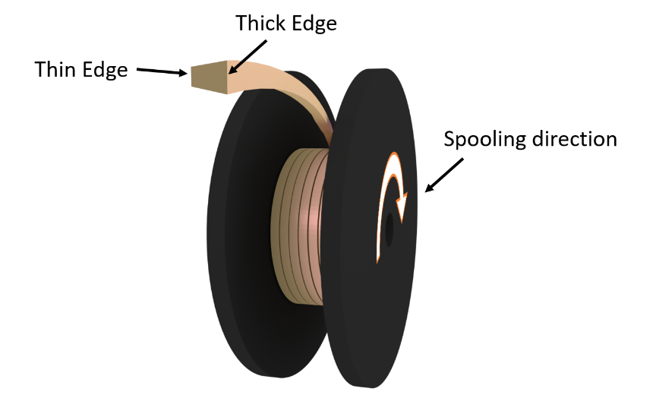

Figure Cable spooling direction

## Cable Test Specimen Submittal:

2 m long samples of cable from one end of every production run shall be supplied to HL‑LHC AUP for extracting strands for coil heat treatment witness. Sample identification shall include the information required by §5.7.

## Archival Sample:

Archival samples of minimum 2 m continuous length from each production unit adjacent to the Cable Test Specimen shall be kept at LBNL.

## Marking Requirements:

Marking labels with cable identification according to §5.7 shall be applied so they are visible on each spool and on the cable top surface. Barcode using code 39 is recommended.

A shipment document with the following information shall accompany every cable spool:

|  |  |
| --- | --- |
| "Superconductor Cable for QXF Quadrupole Magnets”  Specification No. U.S. HL‑LHC AUP Quadrupole Magnet Nb3Sn Cable  FNAL Dwg. F10043170‑A‑RCD | |
| Cable No.:  Length (m):  Gross Weight (kg):  Net Weight (kg):  Tare Weight (kg):  Cable Machine No.:  CMM No.:  Date of Manufacture (YYYY‑MM‑DD): | P99OL9999AA99A |
|  |  |

## Cable Identification Code:

Each cable must be uniquely identified using the scheme described in US‑HiLumi Doc 41 "Material Naming Scheme".

# Appendix A: Frequency of Sample Testing

## Cable Testing – Mechanical

Table Cable dimensional and mechanical requirements. All measurements are to be completed by LBNL.

|  |  |
| --- | --- |
| Requirement | Test Frequency |
| Cable Mid‑Thickness | CMM data taken every 3 m |
| Cable Width |
| Cable Keystone Angle |
| Cable Lay Direction and Pitch | LBNL QC |
| Cable Residual Twist | Every continuous length |
| Cable Subelement Condition | Every continuous length |
| Cable Surface Condition | LBNL QC |
| Cable Unit Lengths | LBNL QC |
|  |  |

## Cable Testing – Electrical

Table Cable Electrical Requirements. All measurements to be completed using the Cable Test Sample.

|  |  |
| --- | --- |
| Requirement | Test Frequency |
| Cable RRR using extracted strands | Every continuous length |
|  |  |

Definitions for Cable Testing:

"LBNL QC" indicates that the Quality Control (QC) of the parameter is the responsibility of LBNL. LBNL must initiate a program to assure control of the parameter within the required tolerance.

# Appendix B: Verification of Electrical Properties of Nb3Sn Superconducting Cable

The facility performing QC tests must first pass the LARP/HL‑LHC AUP benchmarking exercise in order to qualify, and subsequent QC tests must use the same qualified procedures. Modification of the test facility or procedures shall be followed by re‑qualification. LARP/HL‑LHC AUP reserves the right to request a qualified facility to perform on‑demand cross‑checks with other laboratories.

## Wire Critical Current Determination

For determining transport critical currents of short samples of Nb3Sn wires, the methods and procedures based on those developed at BNL and described in IEC 61788‑2 should be considered. These procedures have proven suitable for production testing and have served as a reference for LARP.

### Relation between Wire and Cable Critical Currents

For a multifilamentary composite wire, the critical current *I*C, may be written as

$$I_{C}=J_{C}\frac{πd^{2}}{4\left(1+α\right)}$$

Equation

Where *J*C = critical current density in the non‑Cu area of the wire, A mm‑2,

*d* = wire diameter, mm,

*α* = Cu:non‑Cu volume ratio.

The quantity *J*C provides a figure for comparing wires of different diameter or of different Cu:non‑Cu volume ratios.

Present manufacturing art is such that we may expect to obtain, in multifilamentary composite wires of diameter 0.7 to 1 mm *J*C > 2400 A mm‑2 (*T* = 4.2 K, *B* = 12 T). This value serves as the basis for a wire specification. For a wire, for example, of diameter d = 0.85 mm, *α* = 1.1, we may expect *I*C > 632 A.

The critical current of a cable, *I*C (cable), is somewhat less than the sum of the individual wire values as there is invariably some degradation *D* during the fabrication of the cable. This is expressed as follows:

$$D=1-\frac{I_{C (cable)}}{ΣI_{C (wire)}}$$

Equation

An allowance for degradation, in modern practice, is *D* < 0.05 (= 5%). If we let Σ *I*C (wire) = N × 632 A where N = number of wires in a cable = 40, then *I*C (cable) > 0.95 x 40 x 632 A, > 24,016 A (at 4.2 K, 12 T).

The critical current is a function of temperature, *T*, and magnetic field, *B*.

### Definition of Cable Critical Current

In the absence of direct measurement of a full cable, the critical current of the cable shall be determined by measuring the *I*C of several strands that are extracted from the cable. The cable *I*C is calculated using the following:

$$I_{C (cable)}\left(B_{a}\right)=\left(\frac{40}{n}\right)Σ_{n}I_{C (wire)}\left(B_{a}\right)$$

Equation

Where, *n* is the number of extracted strands that are measured and Σ*n* *I*C (wire) (*B*a) is the sum of the *I*C of the wires at applied field *B*a. No self‑field correction is made.

### Determination of *I*C of Extracted Strands

All wire samples are measured on Ti‑6Al‑4V ITER barrels. The Cu end pieces may use a modified design for high current measurements, but the test facility (including the Cu end pieces) must fulfil the benchmarking requirements specified at the beginning of this section.



Figure Technical drawing of the ITER barrel according to [1].

Extracted strand *I*C shall be measured in accordance with International Standard IEC 61788‑2, "Superconductivity ‑ Part 2: Critical current measurement ‑ DC critical current of Nb3Sn composite superconductors", 2006 edition. *I*C shall be determined using an electric field criterion of 10‑5 V m‑1 and the transition index, *n* value, shall be reported with the *I*C. No correction shall be made for self‑field. The critical current measurement is made at zero applied strain, following the procedures outlined in IEC 61788‑‑2 to avoid straining the sample. In order to facilitate current transfer in these high current wires, so‑called “bridges” or “jumpers” may be added; these are additional superconductor wires attached in parallel to the sample at the ends of the test barrel. The critical current is measured in the field range of 10 T to 15 T, or to the lowest field possible below 12 T before pre‑mature quenching occurs in the sample.

Since the wires that are extracted from the cable are straightened manually before winding on the holder, an uncertain factor is the additional deformation, as well as the eventual strain state of the Nb3Sn after cool down on the barrel. Inter‑laboratory comparisons using standardized Nb3Sn samples indicate that the coefficient of variation can be achieved within a couple of percent.

### Heat Treatment of Wire samples

The wire samples are heat treated in vacuum or flowing argon using a schedule that is used for the magnet coils.

At BNL, samples are reacted on a 304 stainless steel reaction holder. After reaction, the strands are transferred to a Ti‑6Al‑4V measurement holder and soldered to copper rings that are permanently connected to the measurement holder, thereby addressing some of the disadvantages of the standard ITER method.

At LBNL, samples are reacted on the measurement holder, thus removing the post‑reaction handling of the wires. The precision‑machined copper end‑rings in the standard ITER method are replaced by off‑the‑shelf copper plumbing parts, which provide a more economical and reliable current entrance path. Wire movement is mitigated at LBNL by adding small amounts of solder flux between the wire and the barrel.

## Cable R293 K and RRR Determination

To determine residual resistance ratio, RRR, of cables made under this specification, measurements of at least five extracted strands from the cable are required. The procedure described in IEC 61788‑4 should be considered. The resistance is determined at 293 K and at a temperature just above the superconducting transition, about 18 K. The resistance per unit length at these two temperatures is designated R293 K and R18 K, respectively. The residual resistance ratio, RRR, is defined to be R293 K / R18 K.

### RRR measuring system

The same sample assembled for critical current measurements or a fresh sample may be used for the RRR QC test. A barrel or a dedicated holder may be used.

LBNL has developed a system for measuring the RRR of multiple extracted strands at various locations (three straight sections and three kinks per strand). The device is described in LBNL WPC AF‑0109. The room temperature measurement shall be made using a DC current of about 0.1 A, lower if necessary to avoid heating.

The low temperature measurement shall be made using a DC current of about 0.5 A. The normal state resistance at 18 K is determined by slowly warming up the sample from the superconducting state to the normal state. Cooling may be provided by helium vapor above a bath or by conduction cooling with a cryocooler.

### Room temperature Resistance Correction

Normally occurring room temperature variations produce significant variations in the measured resistance. Designating this resistance as *Rm* [Ω] and the ambient temperature as *t* [°C], the resistance at the reference temperature of 293 K is calculated as follows:

$$R_{293K}=\frac{R_{m}}{\left[1+0.00393\left(t-20\right)\right]}$$

Equation

# Appendix C: Cable Manufacturing and Measurement Data

The data to be transmitted to HL‑LHC AUP for the 'Vector' system maintained by FNAL ([https://vector‑offsite.fnal.gov/Tools/TravelerWriter/TravelerWriterPreviewDocument.asp?qsSpecificationID=1576&qsRevisionID=2](https://vector-offsite.fnal.gov/Tools/TravelerWriter/TravelerWriterPreviewDocument.asp?qsSpecificationID=1576&qsRevisionID=2)) are listed below. A "flat file" format is sufficient.

## Cable Summary

Cable ID#

Mfg. Date

Operator:

Cable Type / Specification

Roll ID # (top)

Roll ID # (bottom)

Mandrel ID#

Core ID

Core Manufacturer

Core Part #

Core Lot #

Production Unit length (m)

Length shipped (m)

Max. THICKNESS (mm)*

Max. WIDTH (mm)*

Max. ANGLE (°)*

Ave. THICKNESS (mm)*

Ave. WIDTH (mm)*

Ave. ANGLE (°)*

Min. THICKNESS (mm)*

Min. WIDTH (mm)*

Min. ANGLE (°)*

Stdev.s. THICKNESS (mm)*

Stdev.s. WIDTH (mm)*

Stdev.s. ANGLE (°)*

Archival sample initial length (m)

Cable Residual Twist (°/m)

Cable Subelement Condition (pass/no pass)

Cable Surface Condition (pass/no pass)

Cable Lay Direction (left/right)

Cable Lay Pitch (mm)

Max. CME Pressure (MPa)

Ave. CME Pressure (MPa)

Min. CME Pressure (MPa)

Stdev.s CME Pressure (MPa)

* These parameters are statistical data according the CMM.

## Bay Position Map (a.k.a. "Spool Map")

The corresponding wire ID at each spool position on the cabling machine bay shall be recorded.

In addition, the respooled length should be recorded.

# Appendix D: FNAL DWG F10043170

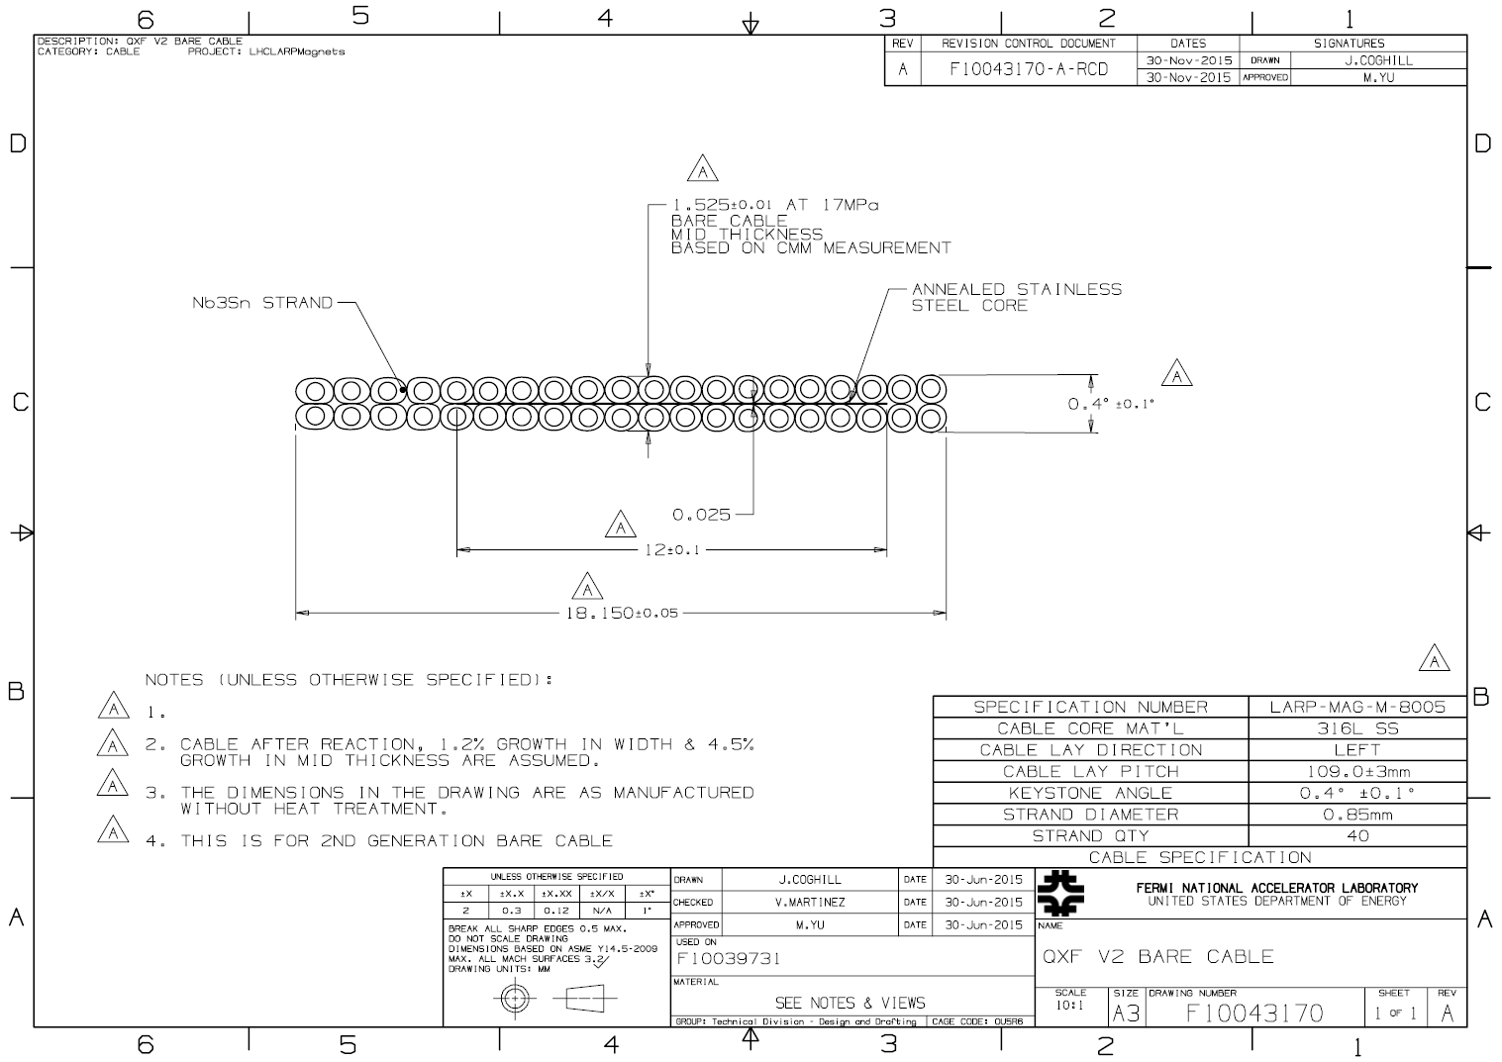

# References

[1] I. Pong, M. C. Jewell, B. Bordini, L. Oberli, S. Liu, F. Long, et al., "Worldwide Benchmarking of ITER Internal Tin Nb3Sn and NbTi Strands Test Facilities", IEEE Transactions on Applied Superconductivity, vol. 22, Article No. 4802606, June 2012.