**MQXFA15 Coil Acceptance Review**

Additional Committee Questions, Feb 27, 2023

*Arup Ghosh, Susana Izquierdo Bermudez, GianLuca Sabbi*

Coil 109:

* It was reported that NbTi leads are shorter in coil 109, since they were already cut according to its position in the original coil pack of magnet 3. In the coil ordering table, 109 appear in all quadrants except P3. Can you check for any positions that are not allowed because of the shorter leads and provide a revised table? It may also be useful to split the table in two sections: all combinations that have 109, and all combinations that do not have it.

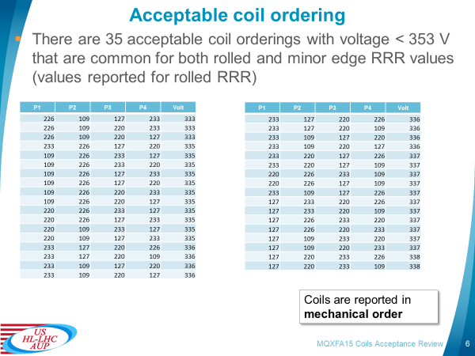

* If this coil is used, we will be mixing coils with solid and flexible end saddles. Can this have an impact on the axial mechanical behavior? Do we have examples in the past missing coils with and without slits in the end saddles in the same magnet assembly.
* From the “QXFA Coil Configuration” spreadsheet, it appears that the main differences to consider are b6 correction, end saddle design, and NbTi lead length issue. Other changes are minor and/or were implemented at later stages of the production. Can you confirm?

Coil 127:

* Validation of the reaction of Coil 127 by test results of witness samples: can you add this information or point us to where it was presented.

Documentation

* Coil 109[HCMQXFAC001-FL000009](https://edms5.cern.ch/pls/asbuilt/mtf_equip.eqp_main_top?cookie=68505240&p_rec_id=HCMQXFAC001-FL000009&p_rec_type=A)
* Formally rejected in MTF. One additional step shall be created in MTF documenting the repair. Also, the comment need to be updated, the available info now is: *“This coil was attached to magnet HCMQXFAS001-LB000001 but had electrical issues and was replaced.  
  NC in EDMS 2202415”*
* Coil 127 [HCMQXFAC001-FL000027](https://edms5.cern.ch/pls/asbuilt/mtf_equip.eqp_main_top?cookie=68505240&p_rec_id=HCMQXFAC001-FL000027&p_rec_type=A)
  + Very complete NCR on the quench heater to coil short, in circulation at CERN [EDMS 2470711](https://edms.cern.ch/document/2470711). The way the quench heater to coil non-conformity is documented and traced in coil 127 and 226 is very different: the project should have a uniform approach across labs to treat critical NCR.
  + Even if a big part of the documentation is available, there are less documents than in coil 109. In coil 127, when compared to coil 109, the following documentation is missing:
    - CMM
    - Electrical tests
    - Preparation Reaction
    - Preparation Impregnation
    - Reaction
* Coil 220 [HCMQXFAC001-BL000019](https://edms5.cern.ch/pls/asbuilt/mtf.build_obj_url?cookie=68505240&p_top_id=HCMQXFAC001-BL000019&p_top_type=A&p_open_id=HCMQXFAC001-BL000019&p_open_type=A)
  + The only documentation in MTF is the Coil Parts Kit Preparation and the cable manufacturing data. Even if all the steps are signed off, the documents are missing (manufacturing travels and DR).
* Coil 226 [HCMQXFAC001-BL000025](https://edms5.cern.ch/pls/asbuilt/mtf.build_obj_url?cookie=68505240&p_top_id=HCMQXFAC001-BL000025&p_top_type=A&p_open_id=HCMQXFAC001-BL000025&p_open_type=A)
  + The only documentation in MTF is the Coil Parts Kit Preparation. Even if all the steps are signed off, the documents are missing (manufacturing travels and DR).
* Coil 233 [HCMQXFAC001-BL000032](https://edms5.cern.ch/pls/asbuilt/mtf.build_obj_url?cookie=68505240&p_top_id=HCMQXFAC001-BL000032&p_top_type=A&p_open_id=HCMQXFAC001-BL000032&p_open_type=A)
  + The only documentation in MTF is the Coil Parts Kit Preparation. The steps are not signed, and all the documents are missing (manufacturing travels and DR).

**Answers:**

Coil 109:

* Lead lengths:

The length of coil 109 leads is 2 m (as shown in the QXFA coil Configuration spreadsheet). They weren’t cut during MQXFA03 assembly. In the middle of pre-series coil fabrication, the cold mass team requested to have longer leads on the inner layer and after a few iterations converged on: 3.045 m (IL) and 1.23 m (OL) (US-HiLumi-doc-1674). This length of the inner layer lead avoids a splice in the cold mass if that coil is in quadrant 3 (see picture below from doc-1674).

Therefore, coil 109 can be used in all quadrants except quadrant 3.

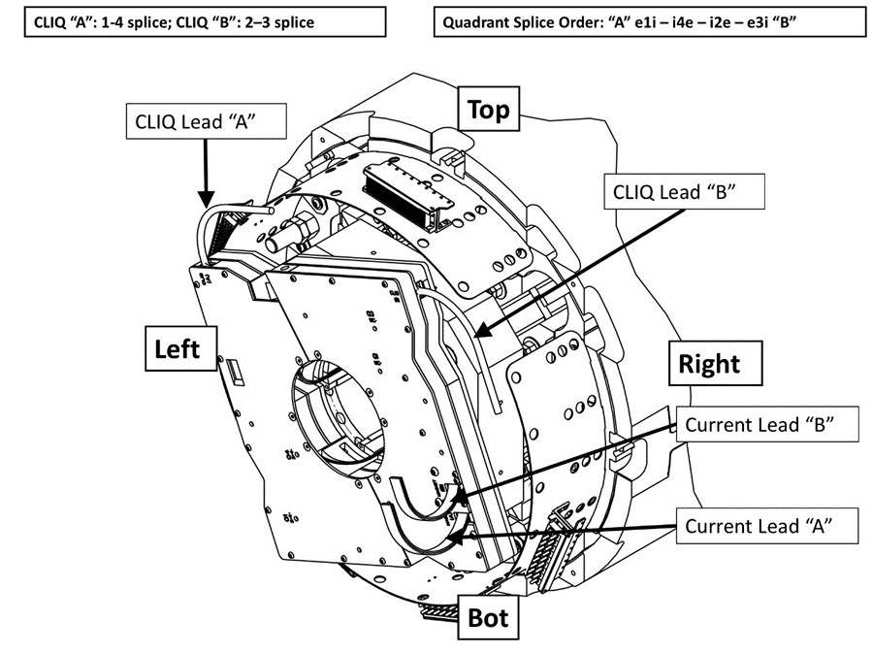

* Solid saddle:

Only two AUP coils had solid saddles: coils 108 and 109. Coil 108 was rejected. So, we did not use coils with solid saddles in AUP magnets.

The coils used in MQXFAP1 and MQXFAP2 were fabricated by LARP and used solid saddles. Coil P06 (replacement coil in MQXFAP1b) was fabricated by AUP and had a flexible saddle. Therefore, MQXFAP1b is the only long magnet where we used coils with solid saddles (3 coils) and flexible saddle (1 coil).

* Coil configuration:

We agree. All other configuration changes affecting coil 109 are minor changes.

* Coil orderings

All coil MQXFA15 orderings with 109 and without 109 are shown below in separate tables. The slides have been updated on Indico too.

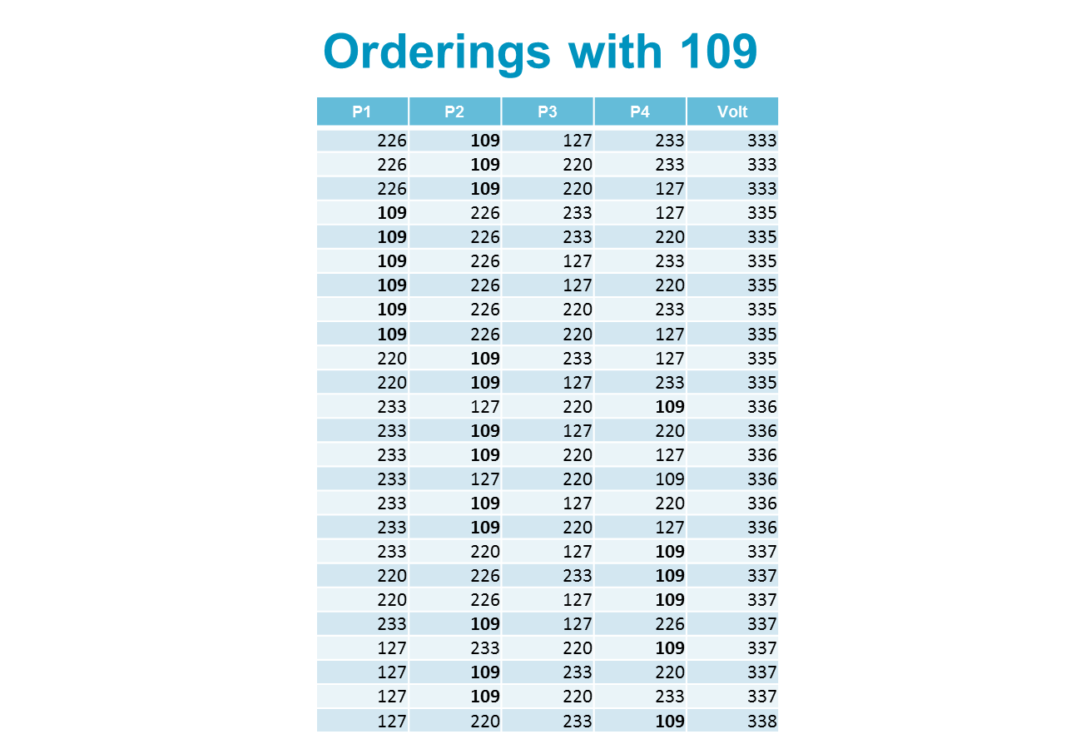

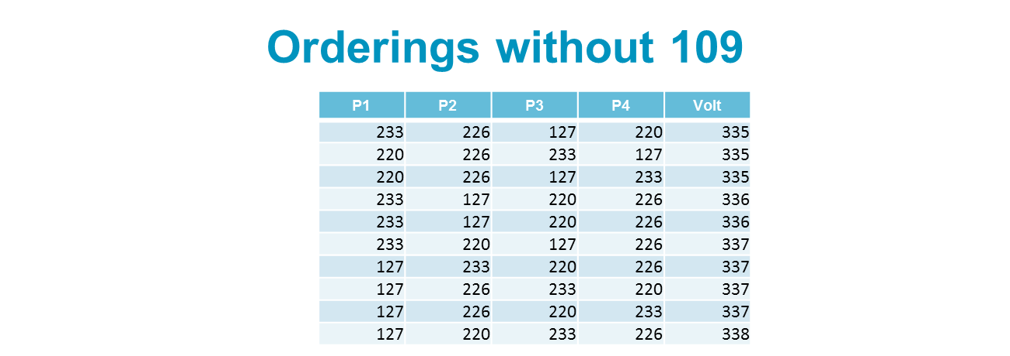

Coil 127:

The validation of coil 127 reaction is reported in the Coil Interface traveler.

Below you may see snapshots of the traveler and of the excel file with the raw data:

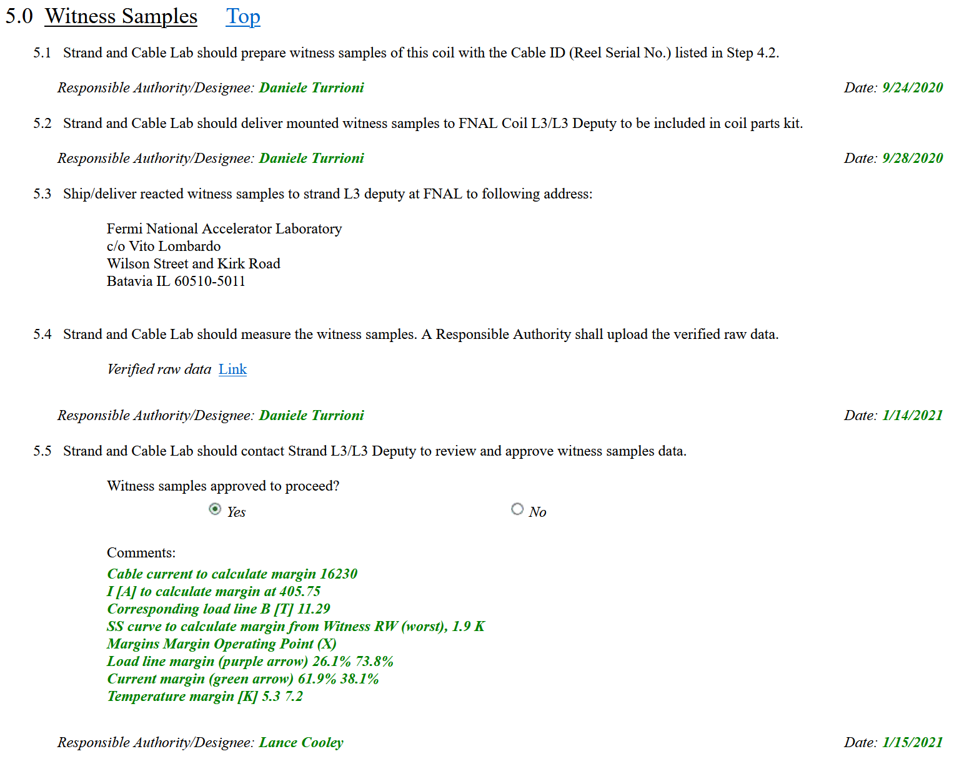



Documentation

* Regarding uploading travelers on MTF:

Travelers are uploaded on MTF after they are complete in Vector. For FNAL coils all travelers are filled electronically in Vector. For BNL coils all BNL travelers (on paper) are scanned and attached to the Coil Interface Traveler in Vector. The Coil Interface traveler includes the data collected at LBNL (mechanical and electrical inspection reports). Since coil storage space at LBNL is limited, coils are shipped to LBNL a few weeks before the Coil Acceptance Review of the magnet they are assigned to. Therefore, it is almost impossible to have their Coil Interface Traveler complete and uploaded on MTF by the time of the Coil Acceptance Review. AUP aims at having the coil travelers on MTF by the time we do the Structure and Shims Review. This goal is quite challenging because it takes time to complete the travelers, review them and upload them on MTF.

Requirement R-T-24 of the MQXFA Magnets Functional Requirements Specification, requires that “All travelers must be completed and delivered to CERN, and all NCR must be closed” without any time constrain. I understand it to mean that all travelers/NCRs of the magnets in each deliverable cryo-assembly must be completed/closed before the deliverable is delivered. So, we are doing what is possible and we are much ahead of the deliverables.

If any reviewer would like to look at the travelers not yet complete, we can arrange for a FNAL account allowing access to Vector.

* For coil 226 NCR:

Jamie has prepared the NCR for the heater-coil Hipot failure and uploaded it on EDMS.

* For coil 109 NCR:

We are going to add documentation about the repair. And after a decision is made will update it on MTF.