Identification of the Problem
The planned Rare Isotope Accelerator (RIA) will require special bending and focusing magnets as described in a recent report []. The magnetic system for beam transport requires a 180° bend of the beam channel, which is accomplished with a set of 4 bent dipole magnets. designated as B₂, B₃, B₆, and B₇ in Figure 1.

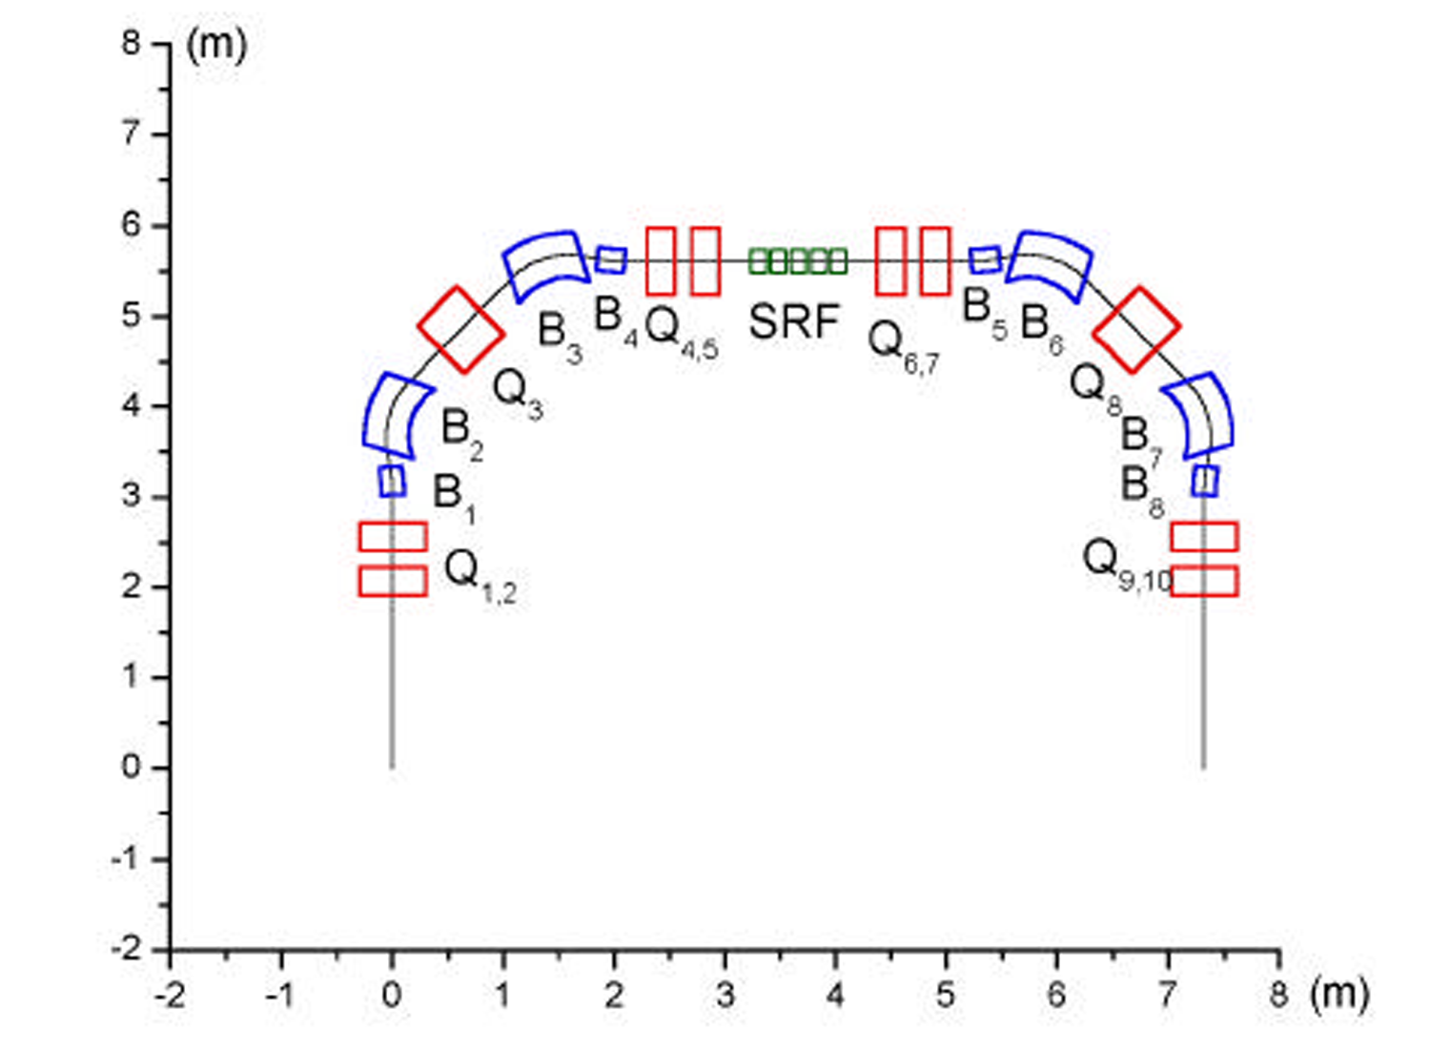
Figure 1. Section of RIA beam transport path showing the 55° bend dipole for this project. (Taken from [1].)
This project will develop the technology for producing curved dipole magnets for use in future accelerator applications such as RIA. The technology is also applicable to higher multipole magnets and to combined function magnets such as bent solenoids with superimposed dipole fields that are considered for a future muon collider.
The present effort will focus on the specialized dipole magnets shown in Figure 1. These have a bend radius of about 0.7 m traversing an arc of typically 55° with a dipole field of ~4.5 T. Magnets with these requirements can be based on the novel “Double-helix” coil configuration. This technology enables bent dipoles that are less complicated, and hence more reliable and lower cost, than traditional cosine theta dipole magnets. Furthermore, coil fabrication using this technology does not require expensive dedicated tooling, and thus prototype and small numbers of magnets can be produced at a significantly reduced cost.

[?] V.N. Aseev, J. Nolen, P.N. Ostroumov and M. Portillo, “Design of Magnetic Optical System for Transport and Matching of Multiple Charge State Heavy-Ion Beam”, Report of Physics Division, Argonne National Laboratory, 9700 S. Cass Av., Argonne, IL 60439

