Lab: Time of Flight- Secondary Ion Mass Spectrometry (ToF-SIMS)

Goals:
- Understand fundamental principle behind ToF-SIMS.
- Understand how to operate and align a ToF-SIMS instrument.
- Measure Nb₂O₅ as a function of depth in 3 samples with different metal capping layers.

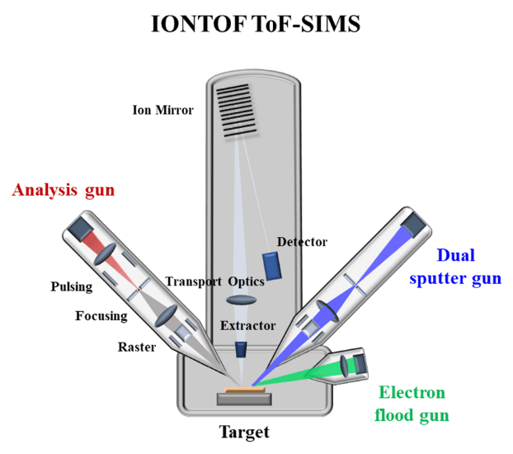
Background:
Time-of-Flight secondary ion mass spectrometry (TOF-SIMS) is a very sensitive surface analytical technique, well established for many industrial and research applications. The technique provides detailed elemental and molecular information about the sample's surface, thin layers, and interfaces and gives a full three-dimensional analysis.

For a TOF-SIMS analysis, a solid surface is bombarded by primary ions of some keV energy. The primary ion energy is transferred to target atoms via atomic collisions, and a so-called collision cascade is generated. Part of the energy is transported back to the surface, allowing surface atoms and molecular compounds to overcome the surface binding energy. The interaction of the collision cascade with surface molecules is soft enough to allow even large and non-volatile molecules with masses up to 12,000 daltons to escape without or with little fragmentation. SIMS is a surface-sensitive technique because the emitted particles originate from the uppermost one or two monolayers.

The subsequent time-of-flight mass analysis of the emitted ions provides detailed information on the elemental and molecular composition of the surface. TOF mass spectrometry is based on the fact that ions with the same energy but different masses travel at different velocities. An electrostatic field accelerates the generated ions to a common energy. The accelerated ions then travel over a drift path to the detector. The lighter ions fly with a higher velocity and arrive at the detector before the heavier ions. Measuring the flight time for each ion allows the determination of its mass.

Procedure:
- Activate ion beams and analyzer.
- Align ion beams.
- Move to Sample #1 and re-align.
- Take ~50nm depth profile from sample #1.
- Repeat Steps 3 and 4 with sample #2 and sample #3
- Perform mass calibration on each spectra.
- Identify which samples correspond to Nb film capped with Al, Nb film capped with Ta, and Nb film capped with TiN
- Compare Nb₂O₅⁻ signal in each measurement

