Lab: Electrical Resistance of niobium films

Goals:
- Understanding the origin of electrical resistance in metals as it relates to Ohm’s law and the Drude model.
- Explore variation of electrical resistance with temperature in metals.
- Understand difference between resistance and resistivity (geometric factor).
- Learn to probe parameters such as the mean free path, scattering time, τ, dimensionless scattering rate, Γ, and the residual resistivity ratio, RRR.
- Measure niobium films similar to those used in transmon qubits. Evaluate resistivity and RRR. Compare with other metals (tables will be provided.)
- Explore whether niobium is a good metal and how this aspect impacts its superconducting properties

Background:
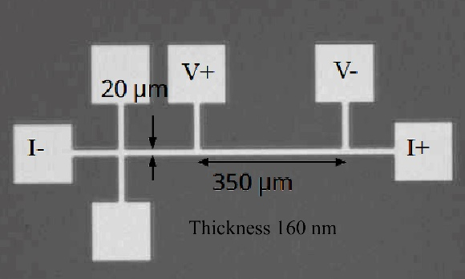
Electrical resistance is a fundamental property of materials. This property can range widely depending on the material and is known to span 30 orders of magnitude. All materials are grouped into classes according to the electrical resistance's values and temperature dependence. In metals, resistance decreases upon cooling, and they are good conductors.
You will learn how to use the Physical Property Measurement System (PPMS) from Quantum Design to accurately measure niobium films used in superconducting qubits. The films are made into structures called “transport bridges.” The basic idea is to apply known electric current from a terminal labeled (I+) to a terminal labeled (I-) and then read voltage V between (V+) and (V-) terminals, V=(V+)-(V-). The resistance is then obtained from Ohm’s law, R=V/I. This is only a basic principle, and you will learn different methods to measure electrical resistance, then evaluate the resistivity, ρ, using the dimensions shown in the image on this page. The PPMS does everything for you, and you obtain R and ρ if the instrument is properly initialized.

Procedure:
- Physically inspect the AC resistivity puck. This is similar to the Nb bridge samples that have been wired and loaded into the PPMS. This has been cooled down to 10 K, just above the Tc=9.3 K of niobium.
- Understand the MultiVue interface and how to set up a “sequence.”
- Measure resistivity from 10 K to 8 K and back to 10K. Do it quickly with a heating and cooling rate of 20 K/min.
- Repeat the measurement. This time slowly, 0.2 K/min. (Later, compare the results and comment).
- Apply a magnetic field of 5 kOe and repeat the measurement. Observe and record the shift in transition temperature at this field. This represents T_{c} (5 kOe).
- Reset the instrument by turning off the field and warming it up to 10 K.
- Cool down to T_{c} (5 kOe) in zero magnetic field. Measure resistance as a function of a magnetic field. Record the upper critical field. Is it different from 5 kOe? Why?

Homework after the lab and lecture:
- Convert experimental values of resistance to resistivity
- Calculate RRR – residual resistivity ratio

Advanced:
- Estimate the mean free path, ℓ.
- Calculate coherence length using the parameters provided in the lecture.
- Calculate the dimensionless scattering rate Γ.

