Lab: Scanning/Transmission Electron Microscopy (SEM/TEM)

Goals:
- Understand how to operate and align a scanning electron microscope.
- Understand the basics of sample preparation with focused ion beam.
- Gain experience processing TEM image and spectral data sets.

Background:
A scanning electron microscope (SEM) focuses and scans a beam of electrons over a sample surface to create an image. In this system, electrons are produced at the top of the column, accelerated down in the direction of the sample, and passed through a combination of lenses and apertures to produce a focused beam of electrons. As the electrons within the beam interact with the surface of the sample, a variety of signals are generated. By monitoring these signals, information regarding the surface’s topography and composition can be retrieved.
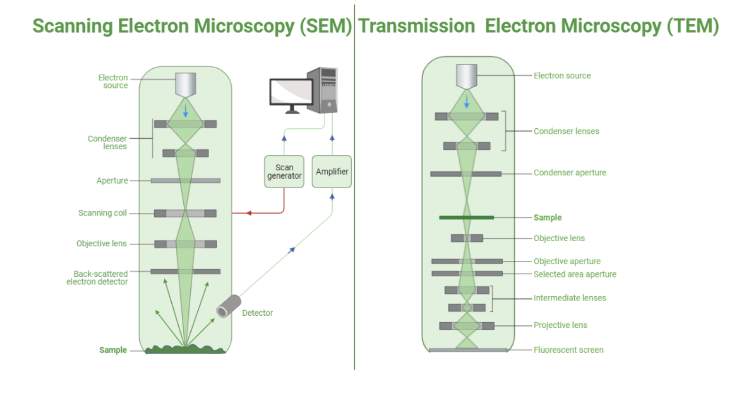
Source: https://microscopewiki.com/scanning-electron-microscope/

A focused ion beam (FIB) operates similarly to an SEM, except it involves finely focusing a beam of ions (typically gallium) instead of a beam of electrons. This instrument can be operated at low beam currents in the case of imaging samples or at higher beam currents in the case of site-specific sputtering or milling. FIB instruments are commonly used for preparing samples for transmission electron microscopy. In particular, the nm-scale spatial resolution available in FIB allows for the isolation and extraction of specific regions of interest. For example, such a tool makes it possible to prepare cross-sectional lamella from resonators, qubit pads, or Josephson junctions in the case of qubit materials characterization.

Transmission electron microscopy (TEM) involves the use of a beam of high energy electrons that are transmitted through a sample to form an image. In order for electrons to be reliably transmitted through the specimen, samples must typically be less than 100 nm thick. As the beam is transmitted through the specimen, the interaction between the electrons and the sample yields an image. This image is magnified and focused onto a detector and provides detailed information regarding the structure and morphology of the sample. Scanning transmission electron microscopy (STEM) is a special case of TEM where the electron beam is focused on a fine spot and is scanned over the sample. This technique offers a wide variety of imaging modalities as well as analytical techniques for chemical and structural analysis.

Procedure:
SEM Operation:
- Learn about components of the SEM
- Load sample and set working distance
- Adjust focus
- Align aperture
- Align stigmators - stigma X and stigma Y
- Correct astigmatism
- Image resonators in secondary electron (SE) mode
- Take energy dispersive spectroscopy (EDS) spectra of Nb pads.

FIB Sample Preparation:
- Deposit protective layer
- Mill out sample
- Attach omniprobe to sample
- Remove cross-section of interest from sample
- Attach cross-section to FIB grid
- Thin sample until electron transparent

TEM Data Processing Workstation:
- Measurements of structural features in Nb thin film
- Diffraction patterns/FFT of Nb and substrates
- EELS Analysis

