 |  |  |  | REVISIONS
 |  |  |  | LTR. | ECN | DESCRIPTION |  |  |  |  |  |  | DATE |  |  | APPROVED
 |  |  |  | - | NA | Original Document |  |  |  |  |  |  | 27 April 2021
 |  |  |  | - | NA | Updates of new Ref. Document titles |  |  |  |  |  |  | 25 FEB 2022
CONTROLLED COPY DIST. LIST
 |  |  |  |  | THE UNIVERSITY OF WISCONSIN
1 |  | 15 |  |  | Physical Sciences Laboratory
2 |  | 16 |  |  | MADISON, WISCONSIN
3 |  | 17 |  |  | TITLE
4 |  | 18
5 |  | 19 |  |  | Electrical Testing
6 |  | 20
7 |  | 21 |  |  | ORIGINATOR |  | DATE | ENGINEER |  |  | DATE |  |  | CHECKER 1 |  |  | DATE
8 |  | 22 |  |  | J. Laffin 27 April 2021 |  |  | Andrew Laundrie April 2017 |  |  |  |  |  | P. Marr-Laundrie 25 FEB 2022
9 |  | 23 |  |  | CHECKER 2 |  | DATE | QUALITY Assur. |  |  | DATE |  |  | PROJECT APPROVAL |  |  | DATE
10 |  | 24
11 |  | 25 |  |  | FILENAME  8760Doc012 Electrical Testing |  |  |  |  | PROJECT NO.
12 |  | 26
13 |  | 27 |  |  | DOCUMENT NO. |  |  |  | SCALE |  |  | SIZE |  |  | SHEET
14 |  | 28 |  |  | 8760Doc012 EDMS2616182 |  |  |  |  |  |  |  |  |  | 1 of 5

Purpose

Describes the process of wire layer electrical testing for electrical isolation, and leakage. Isolation and leakage tests are performed simultaneously to save time. Continuity is also checked for each individual wire on each wire layer. After successful completion of the tests, continue to 8760Doc043 V, U and G Layer Wire Comb Installation to install the wire combs for the subsequent wire layer.

Scope

Applies to Anode Plane Assemblies (APAs) made for ProtoDUNE II.

Reference Documents
Document # | Title of document
 | DUNE APA Process Traveler
8760doc043 | V, U and G Layer Wire Comb Installation
8760doc010 | Tension Testing
8760doc011 | Tape Solder Trim

Terms and Definitions
High slot beam – this is the side beam of the APA that has a long slot in the first full-length side board position back from its attachment to the head beam.
Low slot beam – this is the side beam of the APA that has a long slot in the second full-length side board position back from its attachment to the head beam.
Side A - the face of an APA on which the HSB (high slot beam) is on the right and the LSB (low slot beam) on the left, when viewed or envisioned with the head end on top.
Side B - the face of an APA on which the LSB (low slot beam) is on the right and the HSB (high slot beam) on the left, when viewed or envisioned with the head end on top.
Board 1 – when side B is up, the first head board is on the left-hand side, nearest the high slot beam. Board 10 is on the right-hand side, nearest the low slot beam.
Board 11- when side A is up, the 11th board is on the left-hand side of the frame nearest the low slot beam. Board 20 is on the right-hand side, nearest the high slot beam.
First wire – the first wire on any head board is on the left-hand side.

Responsibilities

5.1 Follow the most recent published procedure available for the assembly operations contained herein.
5.2 Use PPE (Personal Protective Equipment) wherever necessary, and specifically called out in documents.
5.3 As operations/processes are completed, record the necessary related information on the associated traveler for the S/N of the APA unit being assembled.

Materials / Equipment / Tools and Consumable Items Needed

  - For isolation and leakage testing

    - Keithley model 2410 SourceMeter

Configuration:
Constant voltage output: 1.0 kV
Default current limit: 1.05 micro-amps
Least significant digit displayed: 0.1 nA
Acquisition speed: normal
Noise Filter: on
Display Range: maximum
    - Red DVM test probe connected to the center conductor of RG-316 coaxial cable through a 10-Meg-Ohm series resistor. The resistor is embedded in the probe handle or located just outside the probe and covered with suitable insulation. The coaxial cable is about six meters in length. The shield covers the positive probe wire to within 1 cm of the resistor attached to the probe. The shield is grounded near the voltage source. The center conductor of the coaxial cable is connected to the positive side of the voltage source. See Figure 1.
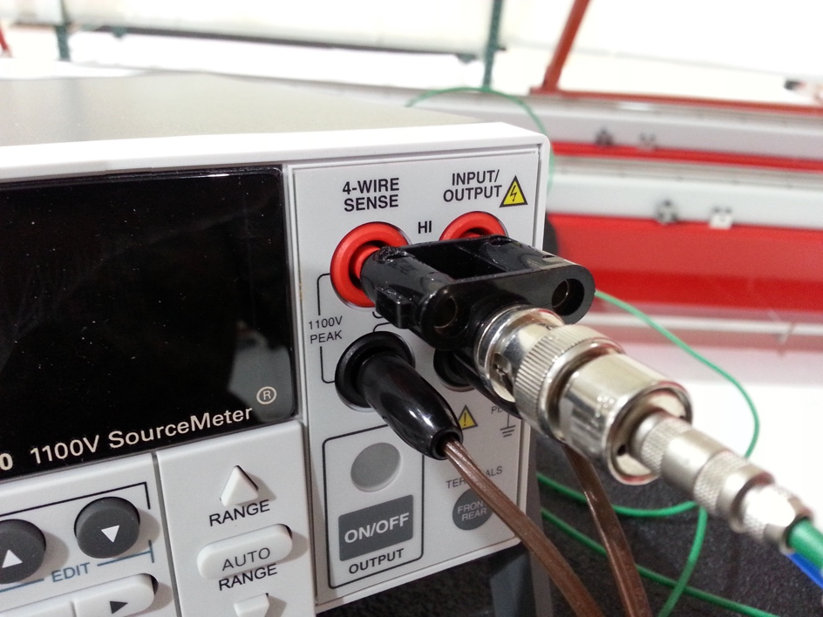
Figure 1 – connection of the test probe to the Keithley SourceMeter
    - Black test probe connected to about six meters of unshielded flexible wire. The other end of the wire is connected to a heavy-duty alligator clip that attaches to the APA frame.
    - Insulating gloves (nitrile)

  - For Continuity Testing –
    - Standard DVM (Digital Volt Meter), with extra long probes
    - Insulating gloves (nitrile)

Requirements / Additional Information

  - For all following processes, the person doing the testing (holding the red probe) MUST wear insulating gloves.
  - Make sure that the APA is properly grounded to Earth. Capacitance between an ungrounded APA and Earth Ground is enough to induce painful shocks when it is charged to 1kV.

Preparation / Setup
  - Review the APA process traveler to ensure all tension testing and soldering operations have been completed and recorded.
  - The negative side of the SourceMeter output is connected to the negative probe, and to the APA frame. The APA frame is also connected to Earth ground, to prevent electrical shocks to anyone touching the frame. The Earth ground also reduces electrical noise. The positive side of the SourceMeter is connected to the positive test probe.

Procedures
  - Isolation and Leakage testing

    - Assemble all materials in step 6.1. Ensure the APA frame is properly grounded to Earth. Begin with Side B up.
    - The probe operator wears insulating gloves, and applies the positive probe to the test pads provided on the head boards. While the positive probe is connected to the Nth test pad, the negative probe is connected to the adjacent test pad at location (N+1). This measures the combined current between adjacent wires (isolation), and between the wire under test and the rest of the APA assembly (leakage). A second person observes the reading on the source meter and records the results (Figure 2).
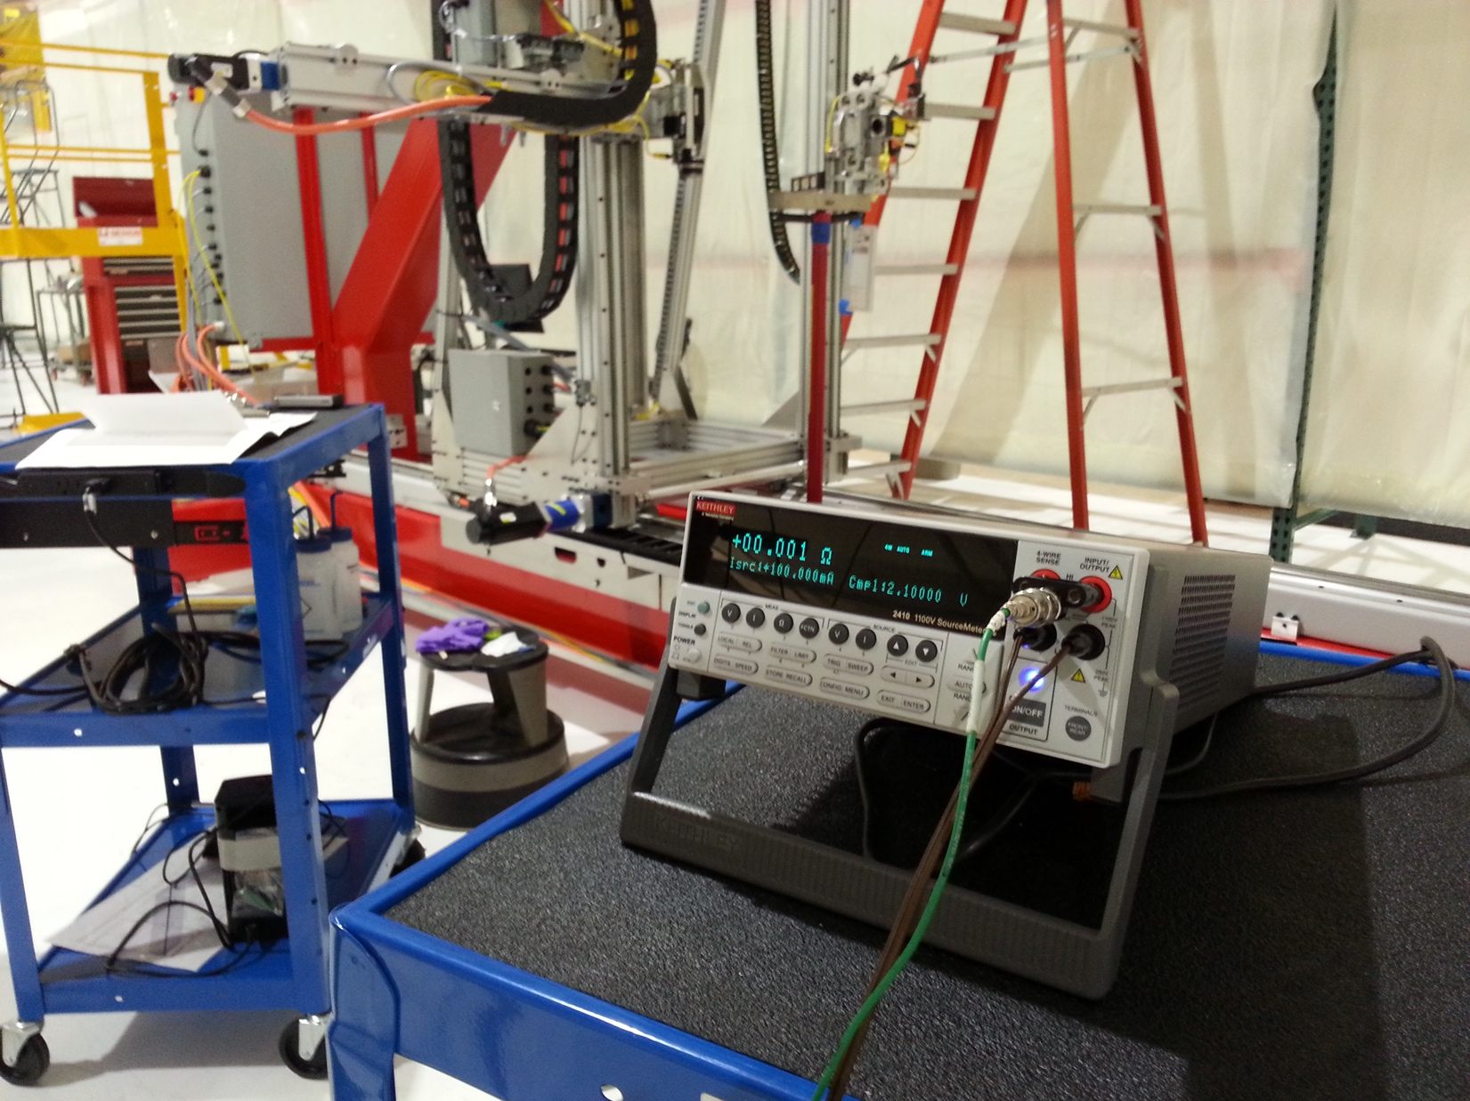
Figure 2 – Reading the sourcementer to record measurements.
    - If their combined current (L1) is within the maximum allowed for wire leakage (1 microamp), isolation (1 Giga-ohm) and leakage are both within acceptable limits. If not, L1 is used to compute the isolation resistance (1kV/L1). The wire under test is remeasured without the negative probe attached to an adjacent wire to yield on the leakage current (L2).
    - Repeat steps 9.1.2 and 9.1.3 for all boards and wires on Side B.
    - Rotate the APA so Side A is up.
    - Repeat steps 9.1.2 through 9.1.4.
    - When all wires have tested for each specific layer within acceptable limits, record in the traveler this portion of electrical testing has been completed.
  - Continuity Testing
    - Using a standard DVM and extra long probes, the continuity of each wire is tested from the Head to the Foot end. Two persons are required for this test; one at each end of the APA.
    - For X and G wire layers, the continuity test is simply from each pad of a Head Board pad to the corresponding pad at the Foot end. The DVM is set to “audible” mode, and the two persons move to the next adjacent wire as each audible “PASS” result is heard. Both Side A and Side B of the Head boards are tested to the corresponding connection side of each Foot board.
    - For V and U wire layers, the same method of testing is used, but the Head board pad to the corresponding pad at the Foot end must follow the wire mapping descriptions. Similarly, both Side A and Side B of the Head boards are tested to the corresponding connection side of each Foot board.
    - When all wires (on a specific layer) have tested within acceptable limits (have resulted in an audible “PASS”), record in the traveler this portion of electrical continuity testing has been completed for this wire layer.
    - If any portions of these tests result in an “open” (for continuity testing) or an unexpected value of isolation and leakage measurement, continue with troubleshooting and alleviate and correct the electrical issues.

