 |  |  |  | REVISIONS
 |  |  |  | LTR. | ECN | DESCRIPTION |  |  |  |  |  |  | DATE |  |  | APPROVED
 |  |  |  | -  A | NA  NA | Original Document  Revised Sction 9.3 with instructions to leave short head wires un-tensioned. |  |  |  |  |  |  | 29 May 2021  28 Feb 2022 |  |  | -  DLW
CONTROLLED COPY DIST. LIST
 |  |  |  |  | THE UNIVERSITY OF WISCONSIN
1 |  | 15 |  |  | Physical Sciences Laboratory
2 |  | 16 |  |  | MADISON, WISCONSIN
3 |  | 17 |  |  | TITLE
4 |  | 18
5 |  | 19
6 |  | 20
7 |  | 21 |  |  | ORIGINATOR |  | DATE | ENGINEER |  |  | DATE |  |  | CHECKER 1 |  |  | DATE
8 |  | 22 |  |  | J. Laffin 15 Feb. 2021 |  |  | J. Edwards 29 May 2021
9 |  | 23 |  |  | CHECKER 2 |  | DATE | QUALITY Assurance |  |  | DATE |  |  | PROJECT APPROVAL |  |  | DATE
10 |  | 24
11 |  | 25 |  |  | FILENAME  8760Doc011 Tape_Solder_Trim |  |  |  |  | PROJECT NO.
12 |  | 26
13 |  | 27 |  |  | DOCUMENT NO. |  |  |  | SCALE |  |  | SIZE |  |  | SHEET
14 |  | 28 |  |  | 8760Doc011 (EDMS2616182) |  |  |  |  |  |  |  |  |  | 1 of 8

Purpose
Describes the process of soldering the copper beryllium wires to the head, foot, and side circuit boards. The X and G layers are soldered similarly, and the V and U layers are soldered similarly. After wires are soldered and trimmed, proceed to 8760Doc012 Electrical Testing.

Scope
Applies to Anode Plane Assemblies made for ProtoDUNE2 (at CERN) or for the Far Detector in the Sandford Underground Research Facility (SURF) at Lead, South Dakota, USA.

Reference Documents

Document Number | Title
 | DUNE APA Process Traveler
8760Doc009 | Winding
8760Doc012 | Electrical Tests

Terms and Definitions
High slot beam (HSB): The side beam of the APA that has a long slot in the first full-length side board position back from its attachment to the head beam.
Low slot beam (LSB): The side beam of the APA that has a long slot in the first full-length board position from the foot beam.
Side A: The face of an APA on which the HSB is on the right and the LSB is on the left, when viewed with the head end on top.
Side B: The face of an APA on which the LSB is on the right and the HSB is on the left, when viewed with the head end on top.
Left or right end of the head board lineup: This is from the perspective of someone standing near the foot beam, facing the head beam.
Temporary Solder Boards (TSBs): These boards are attached to the head end of the APA frame. The wires soldered to this board to hold them in place.

Responsibilities

5.1 Follow the most recent published procedure for the assembly operations contained herein.
5.2 Use Personal Protective Equipment (PPE) whenever necessary, and specifically called out in documents.
5.3 As operations and processes are completed, record the necessary related information in the associated traveler for the serial number of the APA being assembled.

Consumables, Materials, and Tools

  - Lint-free, non-fiber gloves (e.g. latex, neoprene, nitrile, vinyl,). Must be worn for ALL assembly operations.
  - Masking tape, ½” wide
  - Head board wire-alignment tool
  - Solder, Kester 24-7150-0018, Sn/Pb/Ag = 62/36/2
  - Cart to hold soldering tools and materials near the operation site:
    - METCAL soldering equipment:
      - Power supply MX-PS5200
      - Workstand MX-W1AV
      - Handle MX-H1-AV
      - Tip STTC-120
    - Copper pad for cleaning soldering iron tip
    - Sponge for cleaning soldering iron tip
    - Distilled water for sponge
  - Exacto knife with a half-round blade
  - Jack stands (2 or more) and form foot attachments for side beam

Requirements / Additional Information

For all following processes lint free, non-fiber gloves (e.g. vinyl, nitrile, latex, or neoprene gloves) should be worn by all personnel to minimize any epoxy debris or hand oils being transferred to the APA assembly.

The rivnuts are sized to supply adequate hold to the side of the frame but are not designed to resist direct twisting torque. Do not tighten a single bolt directly to a rivnut. Most connections to the rivnuts are made with a M10 stud and an insert spacer. Failure to follow this instruction could cause the rivnut to loosen and result in scrapping the APA.

Preparation / Setup

Review the APA process traveler to ensure all preparation for soldering operations have been completed and recorded.

Procedures
  - Tape the Boards: Apply masking tape to the areas above and below the solder pads to protect the boards and wires from flux.
    - Tape the Foot Boards.
9.1.1.1 Position the APA in a vertical orientation.

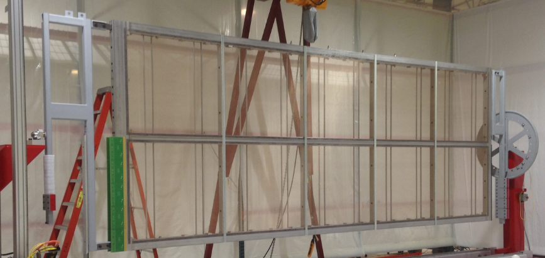
Figure 1. APA in vertical orientation.
9.1.1.2 Apply masking tape to the foot boards. Cover the boards and wires on each side of the solder pads along both edges of the boards. Use short pieces of tape, and overlap slightly at the ends. Ensure the wire lands in the center of each pad. Take care to keep the tape approximately 1mm away from the solder pads.

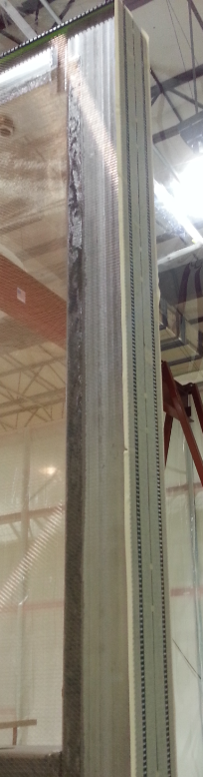 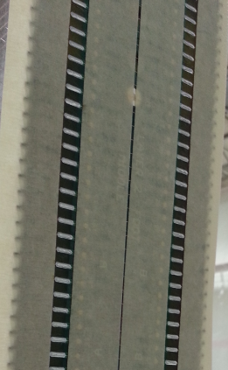Figure 2a. Foot boards with tape. Figure 2b. Close-up of tape on board.
    - Tape the head boards
      - Position the APA in a horizontal orientation with side A facing upwards.
      - Install two sets of M10 short studs and spacers into a pair of rivet nuts near the centers of both side beams and another two sets on the closest pair of rivet nuts to the head end of each side beam.
      - Mount aluminum “formed feet” over the studs with M10 washers and lock nuts.
      - Place jackstands under the four formed feet.
      - Raise the two jackstands near the centers of the side beams until the sag in the beam is removed, then alternate raising the head end pair of jackstands with the center pair until the head boards are lifted enough to just meet the wires.
      - Inspect each wire where it crosses the solder pad on the head board. Use a head board wire-alignment tool to gently position the wires on one board (48 of them) such that the wire crosses the center of the solder pad.

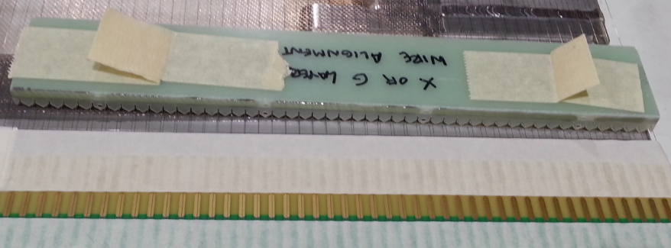
Figure 3. Wire-alignment tool for X and G layers.
      - Use masking tape to hold the wires in this position, then carefully remove the head board wire-alignment tool.
      - Repeat for each board until all wires on head side A are taped down.
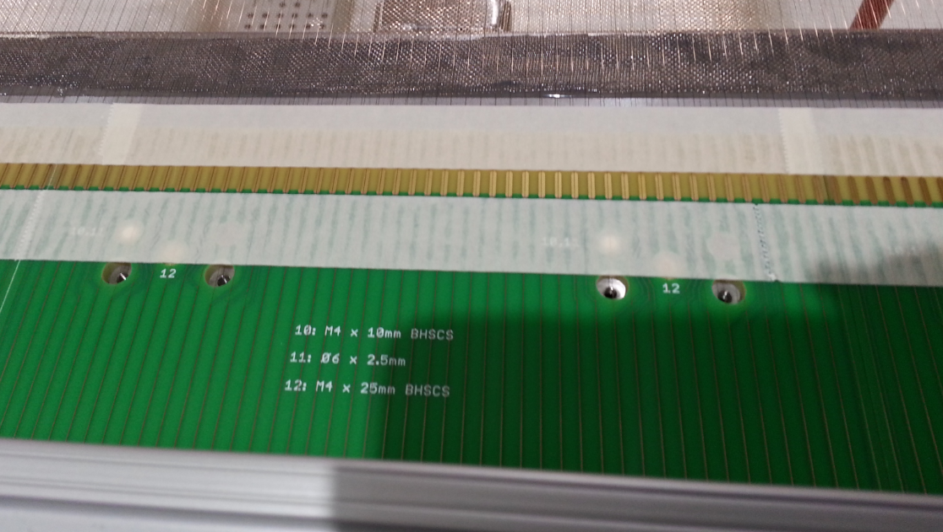 Figure 4. Head boards with tape.
  - Solder the wires to pads on boards.

Note: Position the APA frame in a vertical orientation to solder foot and side boards. The APA should be in a horizontal position to solder head boards. The X, V, U, and G wires are soldered in turn after winding of each layer.
    - Record the lot number of the solder and the serial number of the soldering station on the traveler.
    - Foot boards (X,V, U, and G)
      - Solder each wire to both solder pads it crosses over the foot board. It may be easier to solder the pads vertically down the left side first, then solder the pads down the right side.
      - Inspect all solder joints. The wires should be centered on the pad, and properly bonded. Check for even flow. There should be no peaks or valleys.
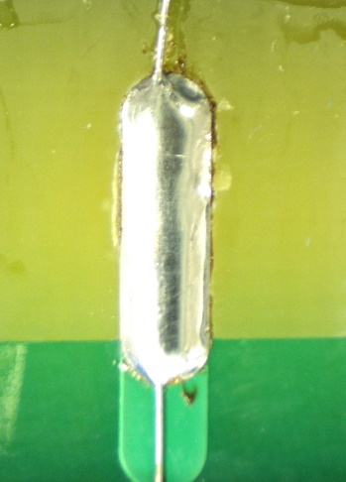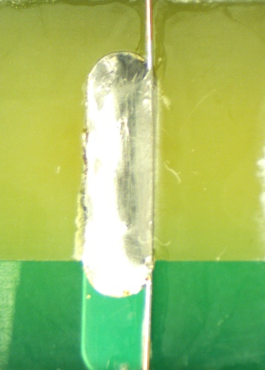
Figure 5a. Good solder joint. Figure 5b. Wire too far off pad.

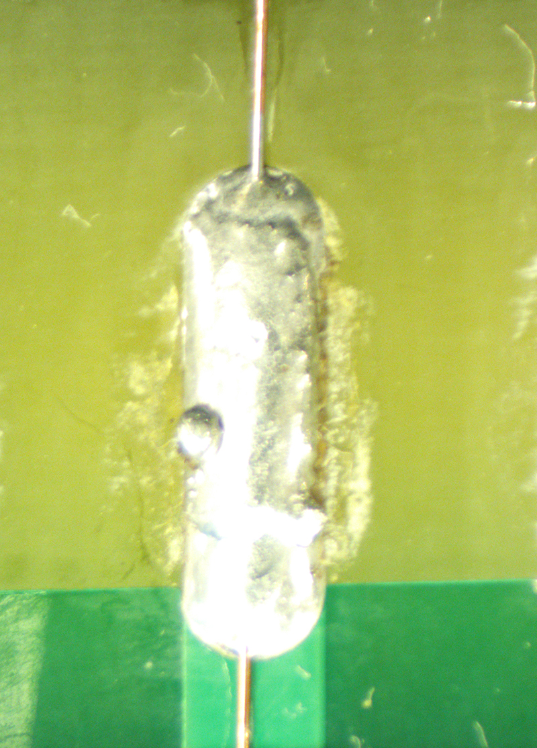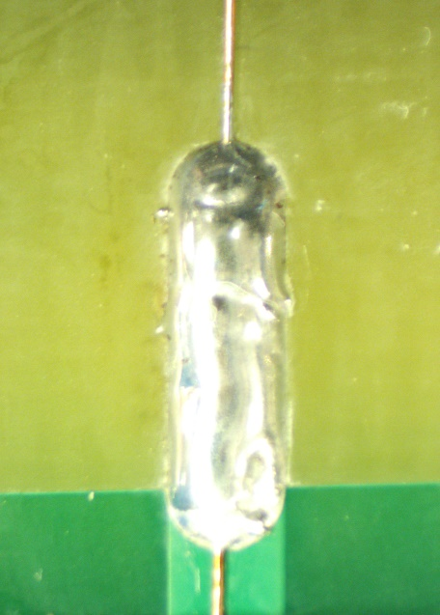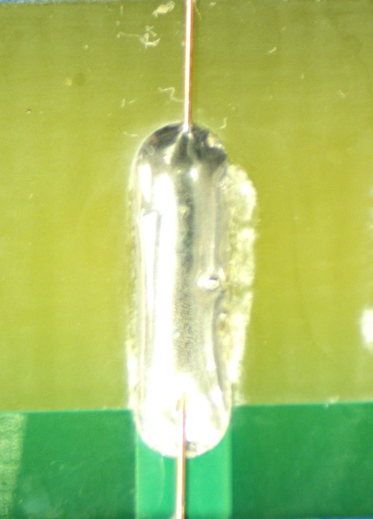
Figure 5c. Cold solder joint. Figure 5d. Disturbed solder joint. Figure 5e. Insufficient wetting

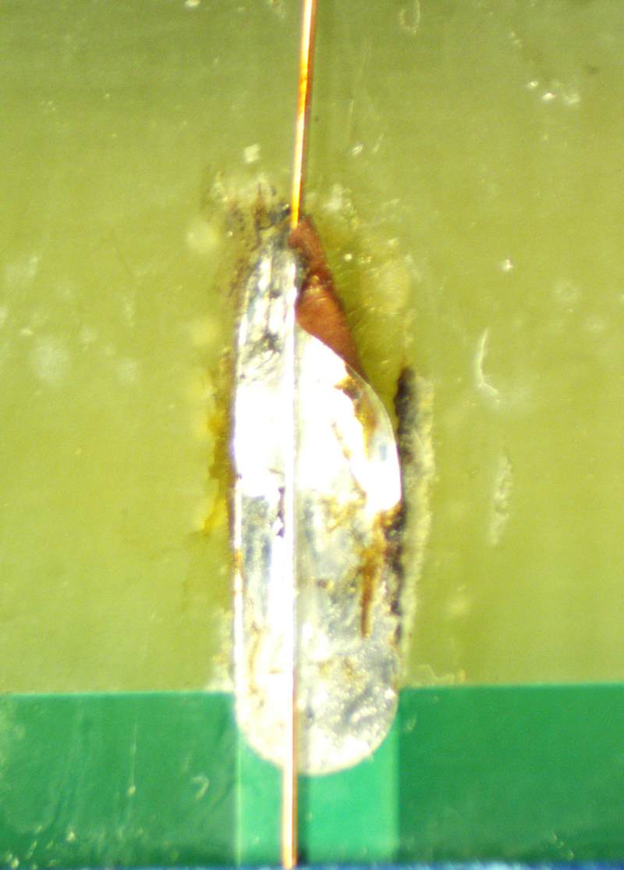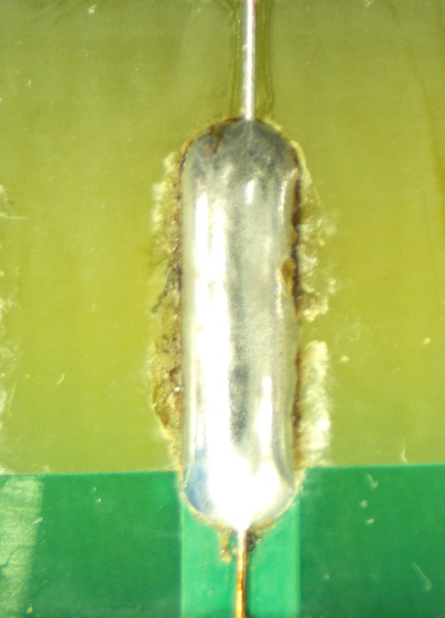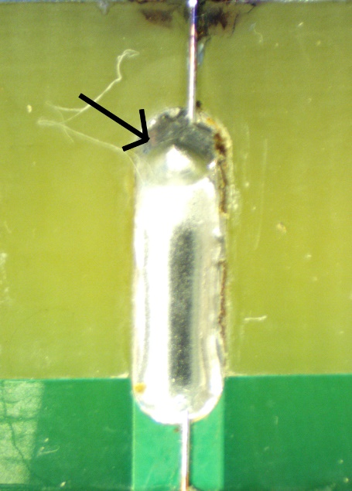
Figure 5f. Lifted pad. Figure 5g. Overheated pad. Figure 5h. Solder peak.

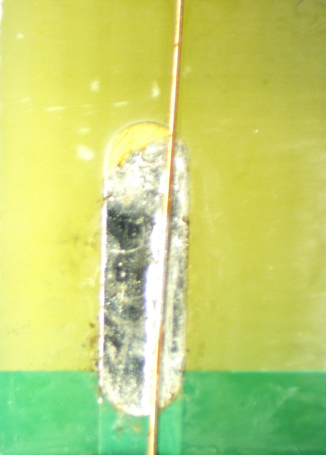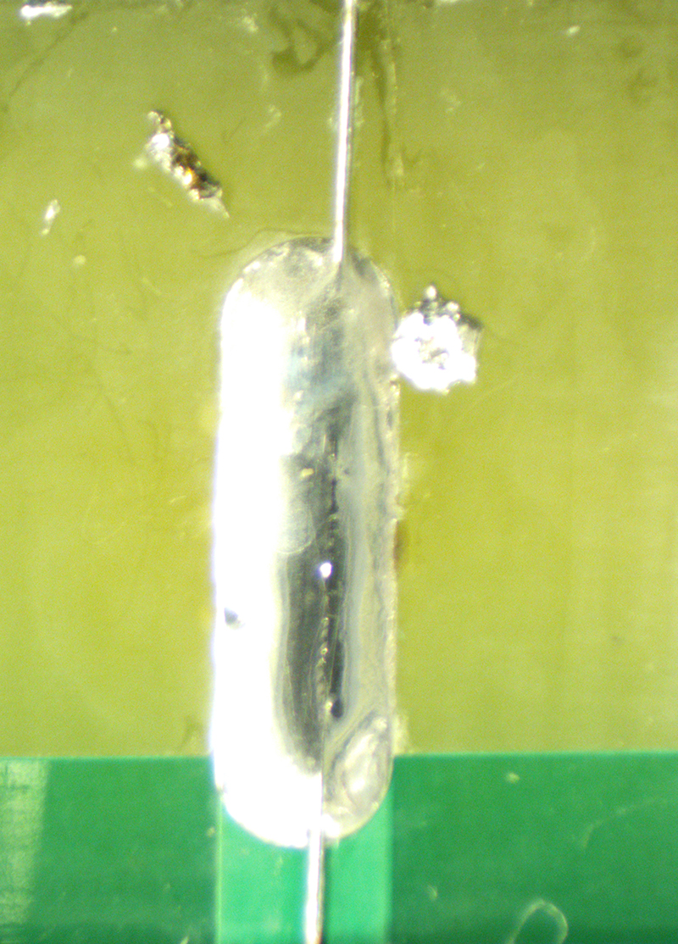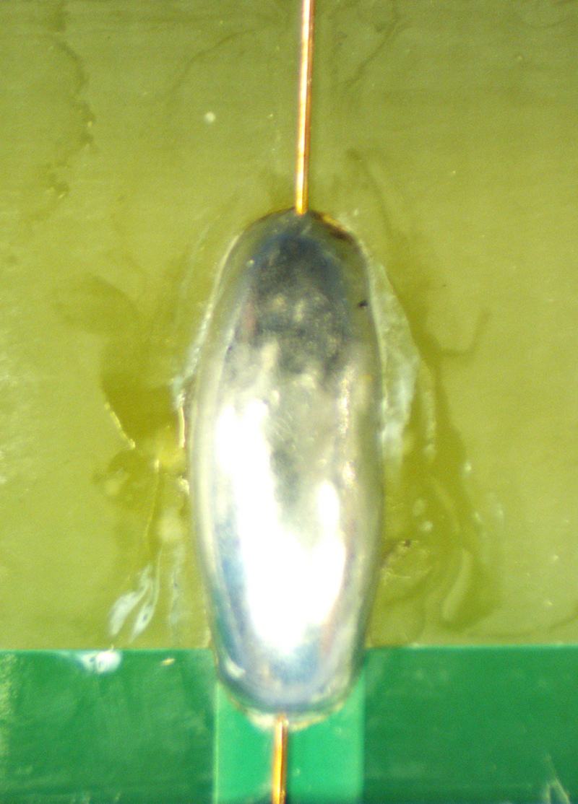
Figure 5i. Solder-starved joint. Figure 5j. Solder spatters. Figure 5k. Too much solder.
      - Rework any unsatisfactory solder joints.
      - Initial the box on the traveler “Soldered wires to foot board pads”.
    - Side Boards (V and U)
      - Solder each wire to both solder pads it crosses over the side board
      - Inspect all solder joints. The wires should be centered on the pad, and properly bonded. Check for even flow. There should be no peaks or valleys.
      - Rework any unsatisfactory solder joints.
      - Initial the box on the traveler “Soldered wires to side board pads”.
    - Head Boards (X and G)
      - Solder each wire to the pad as it crosses over the head board
      - Inspect all solder joints. The wires should be centered on the pad, and properly bonded. Check for even flow. There should be no peaks or valleys.
      - Rework any unsatisfactory solder joints.
      - Repeat steps 9.3.4.1 through 9.3.4.3 on the second side.
      - Initial the box on the traveler “Soldered wires to side board pads”.
    - Head Boards (V and U)
      - Cut the five short wires that route to the head board on the end that wraps onto the temporary winding board. See Figure 6.
      - Lift the tape to release any tension in the wire.
      - Re-tape these wires so they are straight, un-tensioned and pass over the center of the solder pad.
      - Solder each wire to the pad as it crosses over the head board.
      - Inspect all solder joints. The wires should be centered on the pad, and properly bonded. Check for even flow. There should be no peaks or valleys.
      - Rework any unsatisfactory solder joints.
      - Repeat steps 9.3.5.1 through 9.3.5.6 on the second side.
      - Initial the box on the traveler “Soldered wires to side board pads”.
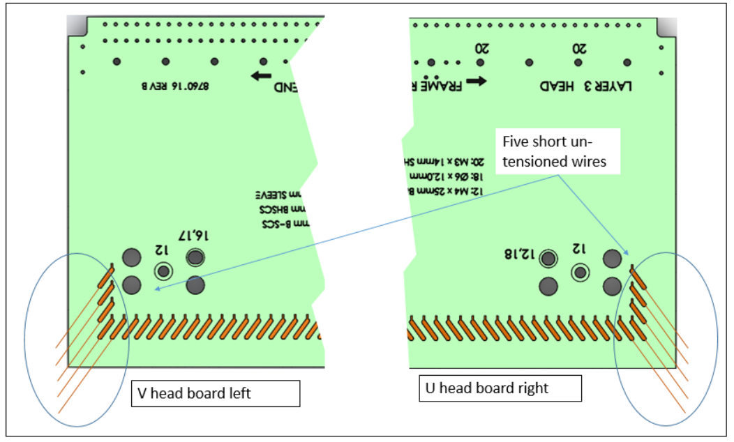
Figure 6. Short un-tensioned wires

  - Trim wires
    - Trim foot board wires
      - Do not remove the masking tape.
      - Start at the top end of the APA and use the tip of the Xacto blade to cut through the wire just inside each solder pad. This is the part of the wire that is located toward the center of the foot board.
      - Do not cut the trace on the circuit board.
      - Take care to not drag the knife between pads, as this may scratch the board.
      - The strips of masking tape will hold the cut pieces of wire, and keep them from falling into the APA.

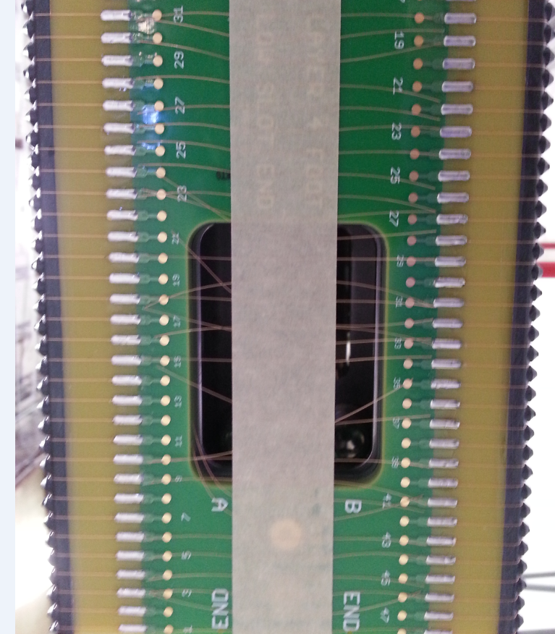
Figure 7. Trimmed wires.

      - Remove the masking tape, along with the attached pieces of cutoff wire.
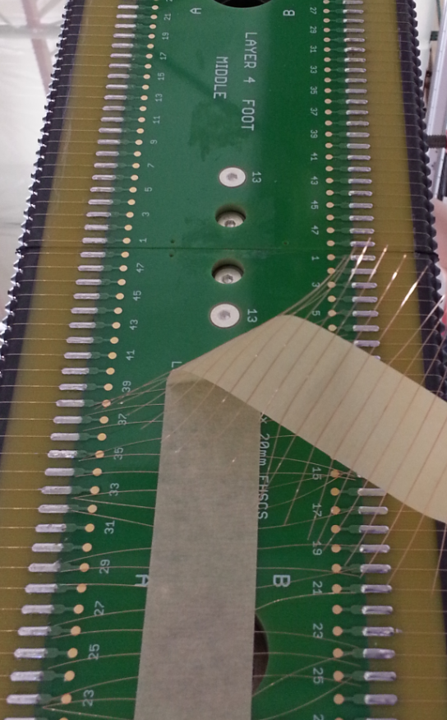
Figure 8. Remove tape with cut wire segments.
    - Trim head board wires.
      - Do not remove the masking tape.
      - Rotate the APA frame to a vertical (or angled) orientation so it is easier to see the wires where they are soldered to the pads.
      - Start at the top end of the APA and use the tip of an Xacto blade to cut through the wire just above each solder pad. This is the side closest to the head beam.
      - Do not cut the trace on the circuit board.
      - Take care to not drag the knife between pads, as this could scratch the board.
      - The strips of masking tape will hold the pieces of wire after they are cut.

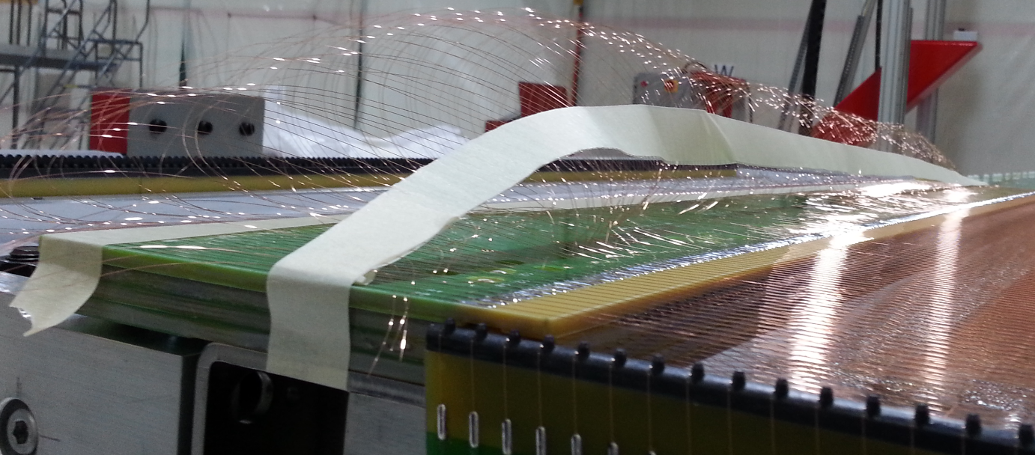
Figure 9. Head board wires during trimming operation.
      - Repeat the steps to trim the wires on the other side of the APA.
      - Remove the masking tape on both sides of the APA.
      - Remove the M4 flathead screws on the temporary solder boards so they can be detached from the winding fixture boards.

