Revisions
Version | Description | Date
01 | Original document | 10 Aug 2021
02 | Updated wire handling methodology to state that gloves must be worn whilst handling CuBe wire. | 24 Aug 2023

Wire Break Strength Testing
Document number: 8760Doc015 (EDMS2616170)

Originator | Jason Laffin | PSL Wisconsin | 10 August 2021
Modifier | Lewis Gannon | STFC Daresbury | 24 August 2023
Engineer/Physicist
Quality assur.
Checker 1
Checker 2
Checker 3

Purpose

This process is performed as a quality assurance check on the 0.15mm (0.006”) diameter, Alloy 25 copper beryllium wire used for winding the DUNE APAs.

Scope
Applies to Anode Plane Assemblies made for ProtoDUNE2 (at CERN) or for the Far Detector in tbe Sandford Underground Research Facility (SURF) at Lead, South Dakota, USA.

Reference Documents

Document # | Title of document
 | DUNE APA Process Traveler

Terms and Definitions

Responsibilities

Materials / Equipment / Tools and Consumable Items Needed

IMPORTANT – If you are testing wire from a new spool, vinyl or nitrile gloves must be worn to minimize any hand oils being transferred to the wire on the bobbin.

  - Tools used
    - Imada ZTA-44 digital force gauge
    - Imada MX2-110 motorized test stand
    - Imada WC-30 wire wrapping grip (2)
    - Diagonal wire cutter

Requirements / Additional Information
7.1 Gloves must be worn at all times when handling Berylium Copper wire.

Preparation / Setup
  - The force gauge should be mounted in the motorized test stand and equipped with the pair of wire wrapping grips as shown in photos below.
  - Turn on both the force gauge and the test stand. (Press and release the ON/OFF button on the force gauge, and click the test stand’s rocker switch on its left rear corner.)
  - Check to make sure that the upper wire wrapping grip is at its lower limit, ~5mm above the bottom grip. If you’re not sure that a mechanical stop has been set at this limit, be very careful about pressing and holding down the downward double-arrow button, which moves the test stand carriage downwards fairly quickly. Let up on the button when the upper wire grip is still a cm or two above the lower one, then tap it briefly until it comes down the remaining distance to a ~5mm clearance. Striking the upper grip against the lower one will damage the force gauge.
  - Select the -Peak display on the force gauge by pressing the Peak button twice; the display now will now show the maximum force exerted on the gauge shaft in a negative (pulling) direction since it was last powered on or reset.
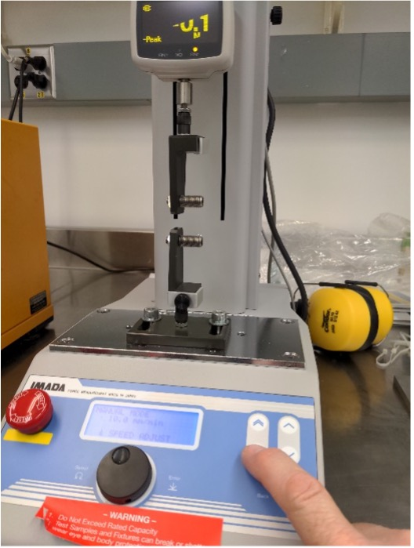

Procedure
  - If testing a new bobbin, record the bobbin information on the traveler: PO#, LFA#, and bobbin #.
  - If the bobbin to be tested is a new one, remove it from its protective packaging. So as not to deposit skin oils on the wire, make sure not to touch the wire on the bobbin with ungloved hands. While restraining the wire from unwinding from the bobbin, cut a piece 75 cm (~2.5 feet) length for break testing. Re-tape the end of the remaining wire on the bobbin and return the bobbin to its packaging.
  - Place one end of the length of wire under the lower wire grip’s wire retention plate and snug (turning clockwise) the knurled thumbscrew against the plate to secure the wire.
  - Grasp the wire a few inches from the retention plate and maintain a slight tension on it while sliding it through your fingers, moving it behind the lower wire grip’s threaded rod. Starting at a point just above where the wire is clamped to the retention plate, wrap the wire twice around the thread. Use fingers of either hand as necessary to maintain a bit of tension throughout each wrap so that the wrapped wire remains neatly settled into the bottom of the thread. While continuing to maintain slight tension on the wire, bring it behind the upper wire grip’s threaded rod. Starting at a point just above where the wire left the lower grip thread, wind the wire twice around the upper wire grip thread as you did with the lower grip.
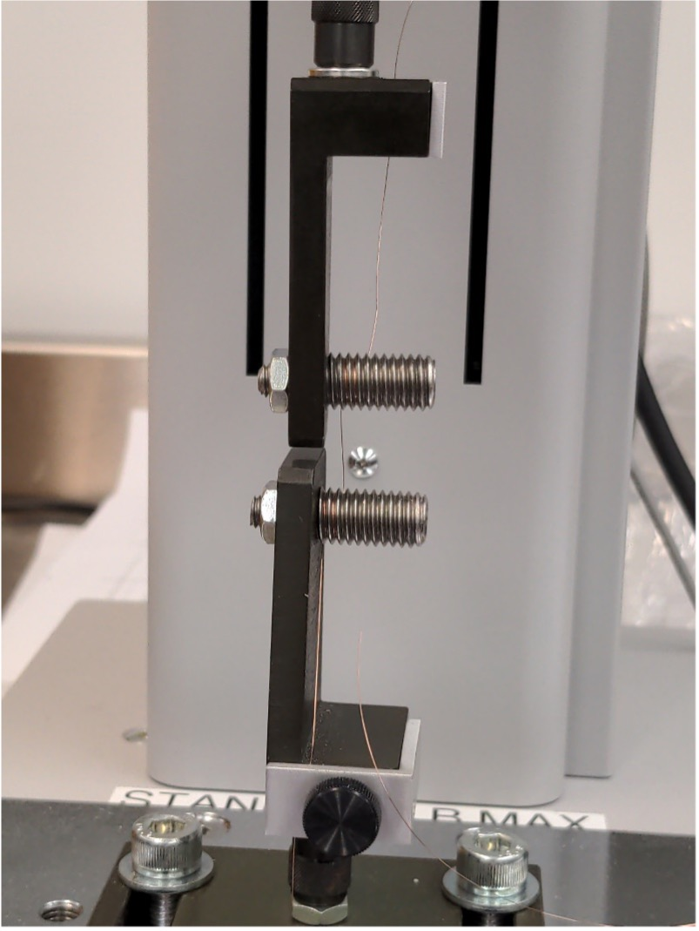

  - Still maintaining that slight tension to keep the wire settled into the two wire grips’ threads, bring the wire to the edge of the upper grip’s retention area (on the right), start the wire between the retention plate and the grip body, then move the wire back near the upper grip’s thumb screw. Tighten the thumb screw against the retention plate before letting go of the wire. The lower, restrained part of the wire should now run smoothly from the lower retention plate through the two loops on each grip to the upper retention plate, while excess wire extends from beyond the upper grip’s retention plate.
  - On the Imada force gauge, press the Zero button to reset the -Peak value; the display should now read 0.0
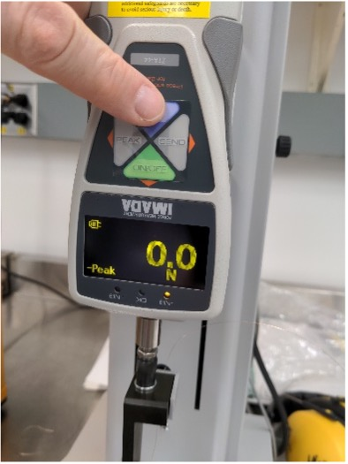
  - On the test stand control, press and hold the single upwards arrow button. Nothing may appear to be happening for several seconds as the test stand motor slowly raises the force gauge with the upper wire grip; then, the peak tension displayed on the gauge will begin to rise. Keep pressing the single upwards arrow key until the wire breaks, which is usually in the range between 25 and 28 Newtons. Release the single upwards arrow button when this occurs.
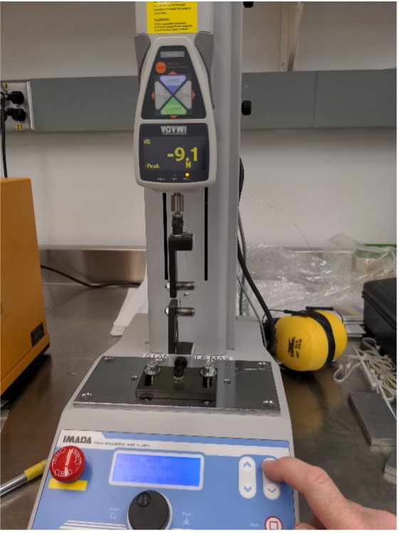
  - Briefly press the test stand’s double downwards arrow button to return the upper wire grip to its original position, noting the caveat in Setup step 8.3 above.
  - Record the displayed peak force value (without its minus sign) on the winding traveler.
  - Loosen (turn counterclockwise) the lower wire grip’s thumb screw and remove the short piece of wire scrap from the clamp; discard this piece or save it for recycling. Hold on to the longer piece of wire while loosening the upper grip’s thumbscrew.
  - Repeat twice steps 9.3-10 to make two more break test readings from the length of wire you sampled from the bobbin, separating the recorded force readings with slash marks on the winding traveler. Discard (or recycle) the remaining piece of sampled wire.

