SAD/ASE Revision Project
As you are all aware, it is of utmost importance and urgency for Fermilab to develop and implement safety requirements for our accelerator facilities and radiation generating devices (RGDs) that promote safe operations and ensure adequate protection of workers, the public, and the environment. To this end, Fermilab has been revising our Safety Analysis and Accelerator Safety Envelope Documents (SAD/ASEs) to enable safe operations and meet the requirements of DOE Order 420.2D, “Safety of Accelerators”.
In August, Fermilab completed an Accelerator Readiness Review (ARR) of our revised SAD/ASE documents, and although the review noted the Laboratory had made good progress, several notable opportunities for improvement were identified that need prompt resolution before Fermilab can resume operation of our main accelerator complex. I have therefore asked Marc Clay, the Deputy Chief Operations Officer, to lead an important short-term project to complete the revision of our SAD and ASEs. Marc is well suited for the role as he has experience in accelerator and nuclear facility operations at both Los Alamos and SLAC National Accelerator Laboratories (LANL and SLAC) and recently helped to update SLAC’s SAD/ASE documents to meet 420.2D requirements.
We will be engaging staff from both mission and mission-support organizations to actively participate on the project and will be using external subject matter expertise to aid in the revision of the documents and track our progress on meeting project milestones. The first step will be to develop a comprehensive project plan that includes milestones, the use of interim ARRs to track progress, and a final ARR leading to approval of the SAD/ASEs. A draft organizational structure is shown below and may be modified as Marc gets further along.
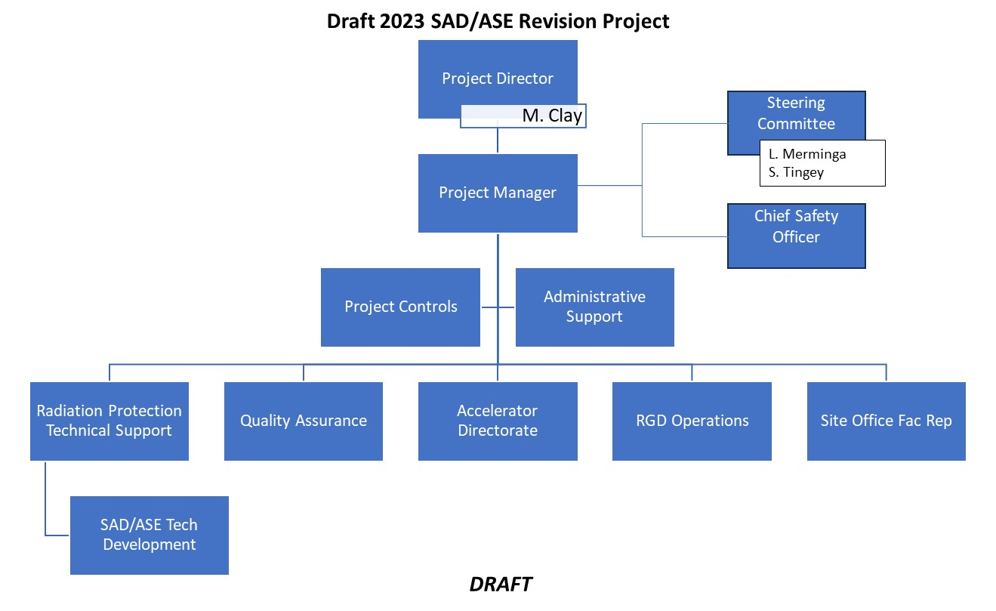
I would like to thank you all for the progress that has been made to date and for your dedicated effort going forward to complete the project and resume safe accelerator facility and RGD operations in a timely manner.
Scott

