|  |  |  |
| --- | --- | --- |
| **Revisions** | | |
| **Version** | **Description** | **Date** |
| **01** | **Original document** | **23 Mar 2021** |
| **02**  **03** | **Updates to procedure and modification from traveler to database.**  **Checked by Dan Salisbury, with minor modifications to ensure procedure reflects the process at Daresbury** | **27 June 2023**  **22 Sep 2023** |
|  |  |  |
|  |  |  |
|  |  |  |
|  |  |  |
|  |  |  |
|  |  |  |
|  |  |  |
|  |  |  |
|  |  |  |
|  |  |  |

**APA Foot Board Installation**

EDMS2616181

|  |  |  |  |
| --- | --- | --- | --- |
| Originator | Jason Laffin | PSL Wisconsin | 23 March 2021 |
| Modifier | Lewis Gannon | STFC Daresbury | 27 June 2023 |
| Engineer/Physicist | Dan Salisbury | STFC Daresbury | 22 Sep 2023 |
| Quality assur. |  |  |  |
| Checker 1 |  |  |  |
| Checker 2 |  |  |  |
| Checker 3 |  |  |  |

# 1.0 Purpose

Describes the process of installing the first (X), second (V), third (U), and fourth (G) layer foot board assemblies. The first (X) layer is attached with hardware, the subsequent layers (V, U, and G) are attached using hardware and epoxy. Clamp plates are installed over the V, U and G layer boards during epoxy curing, then removed. When installation of the foot board assemblies is complete, proceed to EDMS-26161§81 (8760Doc008) for V and U layer side board installation or to EDMS-2616182 (8760Doc009) for X and G layer winding.

# 2.0 Scope

Applies to Anode Plane Assemblies made for DUNE as used in the ProtoDUNE-2 detector at CERN and the Far Detector in the Sanford Underground Research Facility (SURF) in South Dakota, USA.

# 3.0 Reference Documents

|  |  |
| --- | --- |
| **Document #** | **Title of document** |
|  | DUNE APA Process Database |
| EDMS-2616181 | Head Board Installation |
| EDMS-2616201 | Epoxy Dispensing |
| EDMS-2616181 | Side Board Installation |
| Elog | Elog |
| EDMS 2716885 | Production non-conformance document – template |

# 4.0 Terms and Definitions

*High slot beam (HSB)* – this is the side beam of the APA that has a long slot in the first full-length side board position back from its attachment to the head beam.

*Low slot beam* *(LSB)* – this is the side beam of the APA that has a long slot in the first full-length board position from the foot beam.

*Side A* - the face of an APA on which the HSB (high slot beam) is on the right and the LSB (low slot beam) on the left, when viewed or envisioned with the head end on top.

*Side B* - the face of an APA on which the LSB (low slot beam) is on the right and the HSB (high slot beam) on the left, when viewed or envisioned with the head end on top.

*Left or right end of the head board line-up* – this is from the perspective of someone standing near the foot beam, facing the head beam.

# 5.0 Responsibilities

5.1 Follow the most recent published procedure available for the assembly operations contained herein.

5.2 Use Personal Protective Equipment (PPE) wherever necessary, and specifically called out in documents.

5.3 As operations/processes are completed, record the necessary related information on the associated Database for the serial number of the APA unit being assembled.

# 6.0 Materials / Equipment / Tools and Consumable Items Needed

## 6.1 For installation of X Foot boards and winding fixture boards

|  |  |  |
| --- | --- | --- |
| **Part Number** | **Description** | **QTY** |
|  | **Frame Assembly with Comb Base and Mesh** | **1** |
| **8760033** | **X middle foot board assembly** | **6** |
| **8760031** | **X end foot board assembly** | **2** |
| **8760110** | **X middle pos. 4 and 7 foot board assembly** | **2** |
| **8757042** | **Polyimide (Kapton) ring spacers** | **A / R** |

6.1.1 Lint free, non-fiber gloves (e.g. vinyl, nitrile, latex, or neoprene gloves) - ***Must be worn for ALL assembly operations.***

6.1.2 Small straight edge

6.1.3 Feeler gauges

6.1.4 M4-0.70 x 20 FHSCS Blue-dyed, Zinc-plated (20)

6.1.5 2.5mm hex ball driver

6.1.3 Torque limiting driver with 2.5mm hex bit**; Set to 2.0 Nm (18 lb-in.)**

6.1.4 0.003 inch (.076mm) shims (2)

## 6.2 For installing the V foot board assemblies

|  |  |  |
| --- | --- | --- |
| **Part Number** | **Description** | **QTY** |
| **8760029** | **V middle foot board assembly** | **6** |
| **8760035** | **V end foot board assembly** | **2** |
| **8760106** | **V middle pos. 4 and 7 foot board assembly** | **2** |
|  | **2216 Scotch-Weld Grey Epoxy *(Duopak cartridge)*** | **A / R** |

## 6.3 Tooling / Consumable Items for V, U, and G layer foot board installation

6.3.1 Lint free, non-fiber gloves (e.g. vinyl, nitrile, latex, or neoprene gloves) - ***Must be worn for ALL assembly operations.***

6.3.2 M4-0.70 x 20 FHSCS Blue-dyed, Zinc-plated (20)

6.3.3 2.5mm hex ball driver

6.3.4 Torque limiting driver with 2.5mm hex bit**; Set to 2.0 Nm (18 lb-in.)**

6.3.5 2.5mm hex bit (for torque limiting driver)

6.3.6 2.5mm L-shaped hex key

6.3.7 Duopak dispenser and mixing tip (for 2216G)

6.3.8 0.003 inch (.076mm) shims (2)

6.3.9 ½” inch acid brush with ½” inch bristles

6.3.10 small plastic cup

6.3.11 clamp plates

6.3.14 M4 x 25mm blue (for V and U layers), and M4 x 40mm (for G layer) fixture SHCS(20 per layer)

6.3.15 jack stands (2 or more) and formed foot (8752820) attachments to side beams

6.3.16 ethanol in dispenser bottle

6.3.17 lint-free KIMTEC wipes

## 6.4 For installing the U foot board assemblies

|  |  |  |
| --- | --- | --- |
| **Part Number** | **Description** | **QTY** |
| **8760056** | **U middle foot board assembly** | **6** |
| **8760043** | **U high slot end foot board assembly** | **1** |
| **8760058** | **U low slot end foot board assembly** | **1** |
| **8760112** | **U middle pos. 4 and 7 foot board assembly** | **2** |
|  | **2216 Scotch-Weld Grey Epoxy** ***(Duopak cartridge)*** | **A / R** |

## 6.5 For installing the G foot board assemblies

|  |  |  |
| --- | --- | --- |
| **Part Number** | **Description** | **QTY** |
| **8760053** | **G middle foot board assembly** | **6** |
| **8760061** | **G high slot end foot board assembly** | **1** |
| **8760049** | **G low slot end foot board assembly** | **1** |
| **8760114** | **G middle pos. 4 and 7 foot board assembly** | **2** |
|  | **2216 Scotch-Weld Grey Epoxy** ***(Duopak cartridge)*** | **A / R** |

# 7.0 Requirements / Additional Information

7.1 For all following processes where mesh or circuit boards are being handled, lint free, non-fiber (e.g.

vinyl, nitrile or neoprene) gloves must be worn by all personnel to minimize any epoxy debris or hand oils being transferred to the APA assembly.

7.2 The rivnuts are sized to supply adequate hold to the side of the frame but are not designed to resist direct twisting torque. **Do not tighten a single bolt directly to a rivnut.** Most connections to the rivnuts are made with a M10 stud and an insert spacer. **Failure to follow this instruction could cause the rivnut to loosen and result in scrapping the APA.**

7.3 **Caution: Do not overtighten the two M20 bolts which secure the centre support to the foot end of the APA. Overtightening will permanently deform and damage the foot tube of the APA**

# 8.0 Preparation / Setup

8.1 Review the APA process Database to ensure all head board installation operations have been completed and recorded.

8.2 Prior to installing the X layer foot boards, lay the straight edge perpendicularly across the mounting surface of the foot beam. Slide feeler gauges between the tube and the straight edge to determine the gap between the straight edge and the frame surface. Measure at three locations; at the end of each tube and in the centre.

8.3 Record the measurements in the Database, then average the three measurements.

8.4 Use *Table 1* to determine Polyimide ring thickness

|  |  |
| --- | --- |
| **If average thickness is:** | **Instructions** |
| Thickness < 0.006” (0.15mm) | No action required |
| 0.006”(0.15mm) < Thickness < 0.012”(0.30mm) | To underside of each board, install one polyimide ring shim beneath each hold-down screw hole |
| 0.012”(0.30mm) < Thickness < 0.018”(0.45mm) | To underside of each board, stack two polyimide ring shims beneath each hold-down screw hole |

***Table 1 – X-Layer Polyimide (Kapton) spacer application***

# 9.0 Procedures

|  |  |  |
| --- | --- | --- |
| **Part Number** | **Description** | **QTY** |
|  | **Frame Assembly with Comb Base and Mesh** | **1** |
| **8760033** | **X middle foot board assembly** | **6** |
| **8760031** | **X end foot board assembly** | **2** |
| **8760110** | **X middle pos. 4 and 7 foot board assembly** | **2** |
| **8757042** | **Polyimide (Kapton) ring spacers** | **A / R** |

## 9.1 Installation of X layer foot boards

9.1.1 Facing towards the head, ensure side B of the APA is up, with the low slot beam on the right and the high slot beam on the left. Then add the support stands to the middle and the foot end of the APA.

9.1.2 Use *Table 2* for X foot board positioning. The numbers provided are the last three digits of the respective assembly or part number (e.g. 8760031 [assembly part number] or 8760032 [board part number]). See image 1 for board number location.

|  |  |  |  |  |  |  |  |  |  |  |
| --- | --- | --- | --- | --- | --- | --- | --- | --- | --- | --- |
|  | HSB |  |  |  |  |  |  |  |  | LSB |
| 1 | 2 | 3 | 4 | 5 | 6 | 7 | 8 | 9 | 10 |
| Assembly # | 031 | 033 | 033 | 110 | 033 | 033 | 110 | 033 | 033 | 031 |
| Board # | 032 | 034 | 034 | 109 | 034 | 034 | 109 | 034 | 034 | 032 |

***Table 2 – X-Layer foot board layout.***

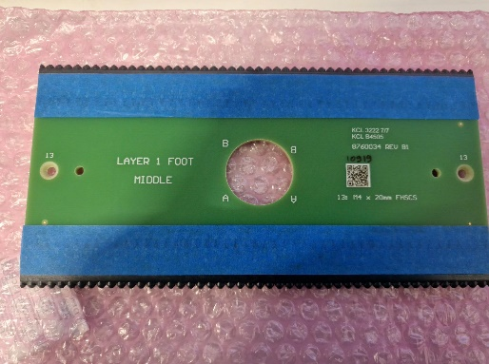

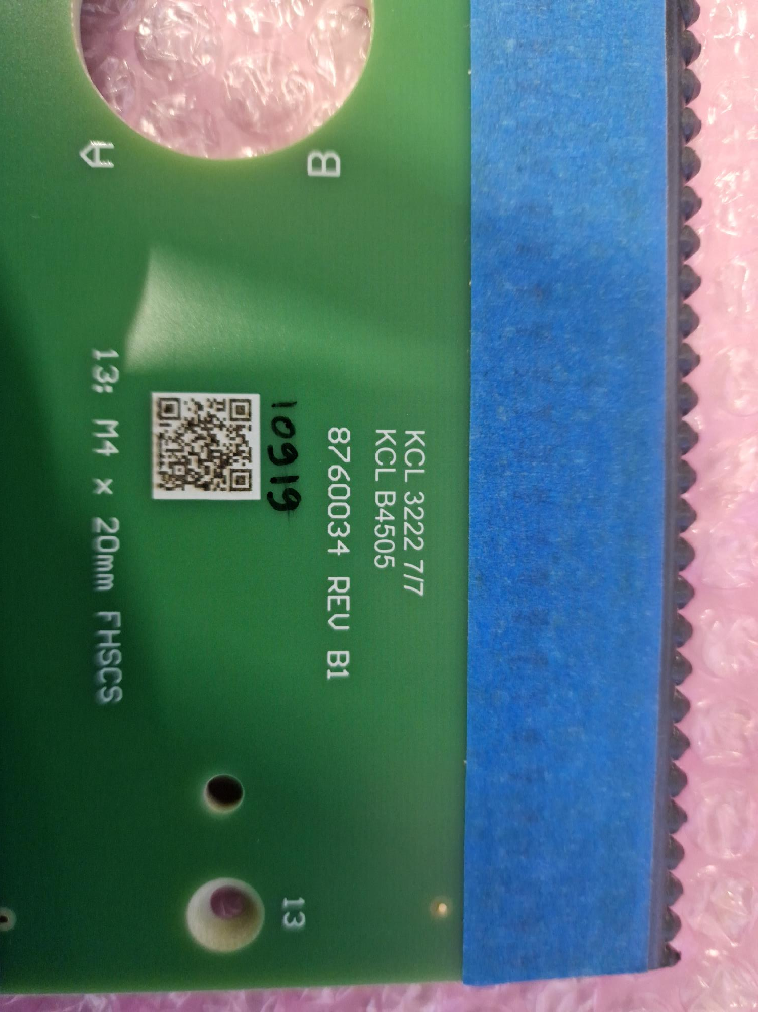

***Image 1 – Foot board number (underlined)***

9.1.3 On the HSB corner of the foot, position an X foot end board assembly against the foot beam and carefully start a ***M4 x 20mm blue-dyed FHSCS*** into both of its countersunk screw holes with a 2.5mm hex driver. Tighten screws until just snug.

9.1.4 Repeat the previous step with the boards as indicated in *Table 1*. Stack the two 0.003 inch (0.076mm) spacers to make a total thickness of 0.006 inches (0.15mm), then before you snug the screws in each board, slide the stacked shims between the boards to ensure proper spacing.

9.1.5 Use a 2.5mm hex bit in a torque driver set to 2.0 Nm (18 lb·in) to tighten both of the screws in turn on all ten boards, until the driver signals that the set torque is met. Note board position, by serial number, on the Database.

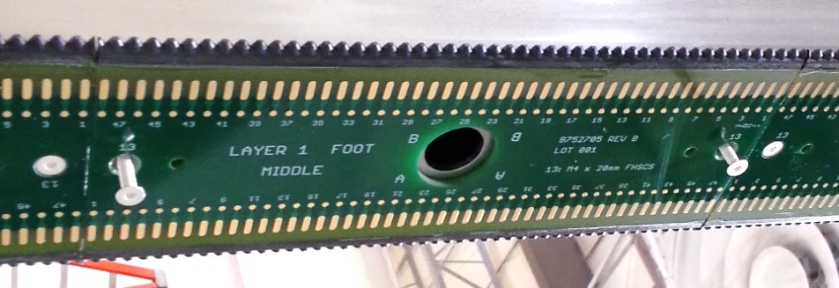

***Figure 1 - Middle X Foot Board Assembly attached w/ (2) M4 x 20mm FHSCS.***

9.1.6 A second person must verify all screws have been torqued properly. Repeat step 9.1.5. Note date and time of completion in the Database.

## 9.2 Installation of the V foot board assemblies

|  |  |  |
| --- | --- | --- |
| **Part Number** | **Description** | **QTY** |
| **8760029** | **V middle foot board assembly** | **6** |
| **8760035** | **V end foot board assembly** | **2** |
| **8760106** | **V middle pos. 4 and 7 foot board assembly** | **2** |
|  | **2216 Scotch-Weld Grey Epoxy *(Duopak cartridge)*** | **A / R** |

9.2.1 Read procedure 8760Doc007 Epoxy Dispensing

9.2.2 Facing towards the head, Ensure side B of the APA is up, with the low slot beam on the right and the high slot beam on the left. Then add the support stands to the middle and the foot end of the APA.

9.2.3 Prepare by assembling the items in Section 6.2 and Section 6.3 or above.

9.2.4 Use *Table 3* for V-layer foot board positioning. The numbers provided are the last three digits of the respective assembly or part number (e.g. 8760035 [assembly part number] or 8760036 [board part number]) see image 1 for board number location.

|  |  |  |  |  |  |  |  |  |  |  |
| --- | --- | --- | --- | --- | --- | --- | --- | --- | --- | --- |
|  | HSB |  |  |  |  |  |  |  |  | LSB |
| 1 | 2 | 3 | 4 | 5 | 6 | 7 | 8 | 9 | 10 |
| Assembly # | 035 | 029 | 029 | 106 | 029 | 029 | 106 | 029 | 029 | 035 |
| Board # | 036 | 030 | 030 | 107 | 030 | 030 | 107 | 030 | 030 | 036 |

### Table 3 – Board layout for the V-layer foot boards

9.2.5 Dispense a small amount of 2216 into the small plastic cup. Using the acid brush, apply a thin coat of epoxy to the five outer wires/solder pads on each X layer board (*see figure 2*). Take care to avoid getting epoxy into the gap between boards, and immediately remove the epoxy from between the gap if it occurs.

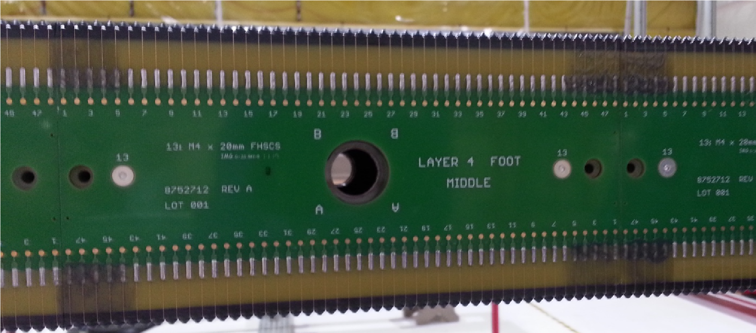

***Figure 2 – Epoxy painted on last five wires on each foot board.***

9.2.6 Use EDMS-2616201 8760Doc007_Epoxy_Dispensing for dispensing the proper pattern and volume of epoxy for each particular board type.

9.2.7 Pick up the epoxied foot end board assembly (designed with a passthrough hole for the end of the foot beam), epoxy side up and carry it over to the APA. When close to the foot beam corner, insert 2 M4x20 FHSCS into the countersunk holes of the board you are holding and align the board with the prior level foot end board assembly (and its passthrough hole) ensure that the letters on the board are in the same orientation to the APA and press it into place. Screw in the two screws slightly after placing board securing it in place.

9.2.8 Tighten both with the 2.5mm hex driver until they are just snug.

9.2.9 Use a 2.5mm hex bit in a torque driver set to 2.0 Nm (18 lb·in) to tighten both of the screws in turn on all ten foot board assemblies, until the driver signals that the set torque is met.

9.2.10 Use the 2.5mm L-shape hex key to remove, through the clearance holes in the foot board assemblies, the twenty M4 x 20 FHSCS that had held the previous layers’ assemblies in place. These screws can be set aside and re-used again later.

9.2.11 Insert two M4 x 25mm blue-dyed fixturing SHCSs through the clamp plate into the holes. Support the plate’s weight while tightening with the 2.5mm hex driver. Torque to 2.0 Nm (18 lb·in).

9.2.12 Note board position, by serial number, on the Database.

9.2.13 Repeat steps 9.2.5 through 9.2.12 with each of the nine remaining foot board assemblies in turn,

positioning each alongside its predecessor on the foot beam and screwing it into place. Before you snug the screws on each new board, slide the two stacked shims between the new board and the one previously mounted to ensure proper spacing.

9.2.14 A second person must verify all fixture screws have been torqued properly. Use the 2.5mm hex bit in a torque driver set to 2.0 Nm (18 lb·in) to tighten both of the screws in turn, on all ten foot board assemblies, until the driver signals that the set torque is met.

9.2.15 When all boards have been installed, note date and time of completion in the Database

9.2.16 Check all slots and cut-outs for epoxy leakage and remove with ethanol on a wipe as necessary. **This MUST be completed 30 min. – 1 hour after installing the clamp plates.**

9.2.17 Allow at least five hours for epoxy to cure then remove clamp plates and fixture screws using the 2.5mm L-shape hex key. Do not rotate the APA from its horizontal position during this 5 hour cure.

9.2.18 Once cured, removed the clamp-plates one at a time, replacing the M4x25 screws with the M4 x 20 screws you removed. Torque up using a 2.5mm hex bit torque driver set to 2.0 Nm (18 lb·in) until the driver signals that the torque is met and remove masking tape.

9.2.19 A second person must verify all screws have been torqued properly. Use the 2.5mm hex bit in a

torque driver set to 2.0 Nm (18 lb·in) to tighten both of the screws in turn on all ten foot board assemblies, until the driver signals that the set torque is met. Note date and time of completion in the Database.

9.2.20 After the V layer foot boards are installed, proceed to EDMS-2616181 8760Doc008_Side_Board_Installation.

# 9.3 Installation of the U and G foot board assemblies

**U layer board assemblies**

|  |  |  |
| --- | --- | --- |
| **Part Number** | **Description** | **QTY** |
| **8760056** | **U middle foot board assembly** | **6** |
| **8760043** | **U high slot end foot board assembly** | **1** |
| **8760058** | **U low slot end foot board assembly** | **1** |
| **8760112** | **U middle pos. 4 and 7 foot board assembly** | **2** |
|  | **2216 Scotch-Weld Grey Epoxy** ***(Duopak cartridge)*** | **A / R** |

**G layer board assemblies**

|  |  |  |
| --- | --- | --- |
| **Part Number** | **Description** | **QTY** |
| **8760053** | **G middle foot board assembly** | **6** |
| **8760061** | **G high slot end foot board assembly** | **1** |
| **8760049** | **G low slot end foot board assembly** | **1** |
| **8760114** | **G middle pos. 4 and 7 foot board assembly** | **2** |
|  | **2216 Scotch-Weld Grey Epoxy** ***(Duopak cartridge)*** | **A / R** |

9.3.1 While facing towards the head end of the APA, ensure side B of the APA is up, with the low slot beam on the right and the high slot beam on the left. Then add the support stands to the middle and the foot end of the APA.

9.3.2 Prepare by assembling the items in Section 6.3, and 6.4 (U layer) or 6.5 (G layer).

9.3.3 Use *Table 4* for U layer and *Table 5* for G layer foot board positioning. The numbers provided

are the last three digits of the respective assembly or part number (e.g. 8760058 [assembly part number] or 8760059 [board part number]). **Make sure all boards are installed in the proper order according to the proper table!** If side B is up, all lettering on the boards should be up and legible. See image 1 for location of board number.

|  |  |  |  |  |  |  |  |  |  |  |
| --- | --- | --- | --- | --- | --- | --- | --- | --- | --- | --- |
|  | HSB |  |  |  |  |  |  |  |  | LSB |
| 1 | 2 | 3 | 4 | 5 | 6 | 7 | 8 | 9 | 10 |
| Assembly # | 043 | 056 | 056 | 112 | 056 | 056 | 112 | 056 | 056 | 058 |
| Board # | 044 | 057 | 057 | 111 | 057 | 057 | 111 | 057 | 057 | 059 |

## *Table 4 – Board layout for the U-layer foot boards*

|  |  |  |  |  |  |  |  |  |  |  |
| --- | --- | --- | --- | --- | --- | --- | --- | --- | --- | --- |
|  | HSB |  |  |  |  |  |  |  |  | LSB |
| 1 | 2 | 3 | 4 | 5 | 6 | 7 | 8 | 9 | 10 |
| Assembly # | 061 | 053 | 053 | 114 | 053 | 053 | 114 | 053 | 053 | 049 |
| Board # | 062 | 054 | 054 | 113 | 054 | 054 | 113 | 054 | 054 | 051 |

## *Table 5 – Board layout for the G-layer foot boards*

9.3.4 Dispense a small amount of 2216 into the small plastic cup. Using the acid brush, apply a thin coat of epoxy to the five outer wires/solder pads on each prior layer board (*see figure 2*). **Note: do not apply epoxy to the four shortest wires from the V (lower left end and upper right end) and U (upper left end and lower right end) layers.** Take care to avoid getting epoxy into the gap between boards, and immediately remove the epoxy from between the gap if it occurs.

9.3.5 Repeat steps 9.2.5 – 9.2.19. With the exception:

9.3.5.1 Use M4 x 40mm BHSCS for G layer through the clamp plate into the holes from which you removed the previous layers’ mounting screws.

9.3.6 After the U layer foot boards are installed, proceed to EDMS-2616181

8760Doc008_Side_Board_Installation.

After the G layer foot boards are installed, proceed to EDMS-2616182 8760Doc009_Winding.