|  |  |  |
| --- | --- | --- |
| **Revisions** | | |
| **Version** | **Description** | **Date** |
| **01** | **Original document** | **23 Mar 2021** |
| **02**  **03** | **Updated procedure process and data base to replace traveler.**  **Checked by Dan Salisbury, with minor modifications to ensure procedures reflects the process at Daresbury** | **26 June 2023**  **22 Sep 2023** |
|  |  |  |
|  |  |  |
|  |  |  |
|  |  |  |
|  |  |  |
|  |  |  |
|  |  |  |
|  |  |  |
|  |  |  |

**APA Head Board Installation**

EDMS2616181

|  |  |  |  |
| --- | --- | --- | --- |
| Originator | Jason Laffin | PSL Wisconsin | 23 March 2021 |
| Modifier | Lewis Gannon | STFC Daresbury | 12 June 2023 |
| Engineer/Physicist | Dan Salisbury | STFC Daresbury | 22 Sep 2023 |
| Quality assur. |  |  |  |
| Checker 1 |  |  |  |
| Checker 2 |  |  |  |
| Checker 3 |  |  |  |

# 1.0 Purpose

Describes the process of installing head boards for all layers of the APA. The first (X) layer is attached with hardware, the subsequent layers (V, U, and G) are attached using hardware and epoxy. Use procedure EDMS-2616201 8760Doc007_Epoxy_Dispense for adding epoxy to the head boards. Once side A head boards are installed, during the curing of the epoxy, the foot boards can be applied. Please refer to the foot board process – EDMS-2616181 8760Doc006_Foot_Board_Installation. After the head boards are attached for each individual layer, continue to EDMS-2616181 8760Doc006_Foot_Board_Installation.

# 2.0 Scope

Applies to Anode Plane Assemblies made for DUNE as used in the ProtoDUNE-2 detector at CERN and the Far Detector in the Sanford Underground Research Facility (SURF) in South Dakota, USA.

# 3.0 Reference Documents

|  |  |
| --- | --- |
| **Document Number** | **Title of document** |
|  | DUNE APA Process Database |
| EDMS 2616168 | Mesh Panel Installation |
| EDMS 2616166 | Comb Base X layer wire comb Installation |
| EDMS 2616181 | Foot Board Installation |
| EDMS 2616182 | Epoxy Dispensing |

# 4.0 Terms and Definitions

*High slot beam* (HSB) – this is the side beam of the APA that has a long slot in the first full-length side board position back from its attachment to the head beam.

*Low slot beam* (LSB) – this is the side beam of the APA that has a long slot in the first full-length board position from the foot beam.

*Side A* - the face of an APA on which the HSB (high slot beam) is on the right and the LSB (low slot beam) on the left, when viewed or envisioned with the head end on top.

*Side B* - the face of an APA on which the LSB (low slot beam) is on the right and the HSB (high slot beam) on the left, when viewed or envisioned with the head end on top.

*Left or right end of the head board line-up* - is from the perspective of someone standing near the foot beam, facing the head beam.

# 

# 5.0 Responsibilities

5.1 Follow the most recent published procedure available for the assembly operations contained herein.

5.2 Use Personal Protective Equipment (PPE) wherever necessary, and specifically called out in documents.

5.3 As operations/processes are completed, record the necessary related information on the associated Database for the serial number of the APA unit being assembled.

# 6.0 Materials / Equipment / Tools and Consumable Items Needed

## 6.1 For installation of X Head boards and winding Fixture boards

|  |  |  |
| --- | --- | --- |
| **Part Number** | **Description** | **QTY** |
| **8760060/160** | **Frame Assembly with Comb Base and Mesh** | **1** |
| **8760104** | **X Head Board** | **20** |
| **8752747** | **APA Head Assembly Head Tube Screw Sleeve,**  **6.12mm OD x 2.5mm length** | **40** |
| **8757160** | **M4-0.70 x 10mm BHSCS A2 SS Silver plated** | **40** |
|  | **2216 Scotch-Weld Grey Epoxy** ***(Duopak cartridge)*** | **A / R** |

6.1.1 ***Tooling / Consumable Items***

6.1.1.1 Lint free, non-fiber gloves (e.g. vinyl, nitrile, latex, or neoprene gloves) - ***Must be worn for ALL assembly operations.***

6.1.1.2 M4-0.70 x 25 BHSCS blue-dyed, Zinc plated Alloy (40)

6.1.1.3 2.5mm hex ball driver

6.1.1.4 Torque limiting driver with 2.5mm hex bit**; Set to 2.0 Nm (18 lb-in.)**

6.1.1.5 0.003 inch (.0762mm) shims (2)

6.1.1.6 X Layer head board alignment tool, with locating pins

6.1.1.7 M4-0.70 x 12mm FHSCS blue-dyed, Zinc plated (40)

6.1.1.8 Duopak dispenser and mixing tip (for 2216G)

6.1.1.9 Ethanol in dispenser bottle

6.1.1.10 Lint-free KIMTEC wipes

6.1.1.11 5ml syringe with green tip (0.035" = 0.89mm orifice diameter)

6.1.1.12 Teflon epoxy tool

6.1.1.13 M4 screw epoxy application fixture

## 6.2 For installing the V layer head boards

|  |  |  |
| --- | --- | --- |
| **Part Number** | **Description** | **QTY** |
| **8760108** | **V Head Board Middle and Right End** | **18** |
| **8760116** | **V Board Head Left End** | **2** |
| **8752748** | **APA Head Assembly Head Tube Screw Sleeve,**  **6.12mm OD x 7.3mm length** | **40** |
| **8757162** | **M4-0.70 x 16mm BHSCS A2 SS Silver-Plated** | **40** |
|  | **2216 Scotch-Weld Grey Epoxy** ***(Duopak cartridge)*** | **A / R** |

## Tooling / Consumable Items for installing the V, U and G layer head boards

6.3.1 Lint free, non-fiber gloves (e.g. vinyl, nitrile, latex, or neoprene gloves) - ***Must be worn for ALL assembly operations.***

6.3.2 Interface frame piece for V-corner winding area at head end

6.3.3 2.5mm hex ball driver

6.3.4 Torque limiting driver with 2.5mm hex bit**; set to 2.0 Nm (18 lb-in.)**

6.3.5 2.5mm long arm, ball end hex key 2.5mm

6.3.6 0.003 inch (.076mm) shims (2)

6.3.7 ½” inch acid brush with bristles trimmed to ½” inch

6.3.8 Small plastic cup

6.3.9 Duopak dispenser and mixing tip (for 2216G)

6.3.10 Nylon screws

6.3.11 Ethanol in dispenser bottle

6.3.12 Lint-free KIMTEC wipes

6.3.13 Teflon epoxy tool

6.3.14 M4 screw epoxy application fixture

## 6.4 For installing the U layer head boards

|  |  |  |
| --- | --- | --- |
| **Part Number** | **Description** | **QTY** |
| **8760115** | **U Head Board Middle** | **16** |
| **8760123** | **U Board Head Right End** | **2** |
| **8760119** | **U Head Board Left End** | **2** |
| **8752749** | **APA Head Assembly Head Tube Screw Sleeve,**  **6.12mm OD x 12.0mm length** | **40** |
| **8757164** | **M4-0.70 x 25mm BHSCS A2 SS Silver-Plated** | **40** |
|  | **2216 Scotch-Weld Grey Epoxy** ***(Duopak cartridge)*** | **A / R** |

## 6.5 For installing the G layer head boards

|  |  |  |
| --- | --- | --- |
| **Part Number** | **Description** | **QTY** |
| **8760121** | **G Head Board Middle** | **16** |
| **8760122** | **G Head Board Left End** | **2** |
| **8760120** | **G Head Board Right End** | **2** |
| **8752750** | **APA Head Assembly Head Tube Screw Sleeve,**  **6.12mm OD x 16.8mm length** | **40** |
| **8757164** | **M4-0.70 x 25mm BHSCS A2 SS Silver-Plated** | **40** |
|  | **2216 Scotch-Weld Grey Epoxy *(Duopak cartridge)*** | **A / R** |

6.5.1 G winding fixture boards with sacrificial boards attached (see *figure 10*)

**7.0 Requirements / Additional Information**

7.1 All stainless steel M4 threaded fasteners (FHSCS & BHSCS) used in this procedure should be silver-plated to avoid galling in tapped frame holes.

7.2 For all following processes where mesh or circuit boards are being handled, lint free, non-fiber (e.g. vinyl, nitrile or neoprene) gloves must be worn by all personnel to minimize any epoxy debris or hand oils being transferred to the APA assembly.

7.3 The rivnuts are sized to supply adequate hold to the side of the frame but are not designed to resist direct twisting torque. **Do not tighten a single bolt directly to a rivnut.** Most connections to the rivnuts are made with an M10 stud and an insert spacer. **Failure to follow this instruction could cause the rivnut to loosen and result in scrapping the APA.**

# 8.0 Preparation / Setup

8.1 Review the APA process Database to ensure all Prep for Winding operations have been completed and recorded.

8.2 Read procedure EDMS-2616201 8760Doc007_Epoxy_Dispensing

# 9.0 Procedures

## 9.1 Installation of X Head boards & X-winding Fixture boards

|  |  |  |
| --- | --- | --- |
| **Part Number** | **Description** | **QTY** |
| **8760060/160** | **Frame Assembly with Comb Base and Mesh** | **1** |
| **8760104** | **X Head Board** | **20** |
| **8752747** | **APA Head Assembly Head Tube Screw Sleeve,**  **6.12mm OD x 2.5mm length** | **40** |
| **8757160** | **M4-0.70 x 10mm BHSCS A2 SS Silver plated** | **40** |
|  | **2216 Scotch-Weld Grey Epoxy** ***(Duopak cartridge)*** | **A / R** |

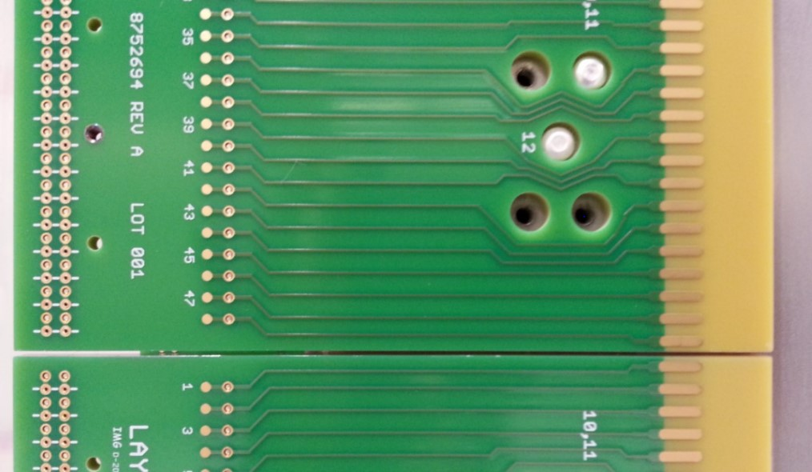

### Figure 1 - (2) X – Head Boards attached to the APA. Solder pads are facing the Foot End of the APA, and there is a small gap seen between the boards when positioned correctly on the APA. Each pattern of screw holes should have (2) screws attached for this level.

9.1.1 Prepare by assembling the items shown in Section 6.1 or above. Position the APA horizontally, so side A is facing upwards, toward the ceiling.

9.1.2 Place 2.5mm length screw sleeves (P/N 8752747) over twenty M4 x 10mm silver-plated BHSCS. Use the 2.5mm ball-end driver to thread the screws, with sleeves, into the screw epoxy application fixture by a turn or two. As needed, dispense 1-2 ml of 2216 epoxy into the syringe. Apply some epoxy to their threads behind the spacer from the 5ml syringe equipped with a green tip, giving each screw a single clockwise turn while applying the epoxy (*see figure 2).*

9.1.3 After applying the epoxy, place the Teflon epoxy tool against the epoxied part of a screw while giving the screw a single counter-clockwise turn with the 2.5mm driver to press the epoxy into the threads (*see figure 2)*.

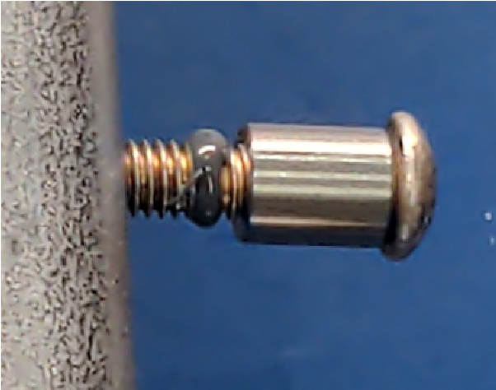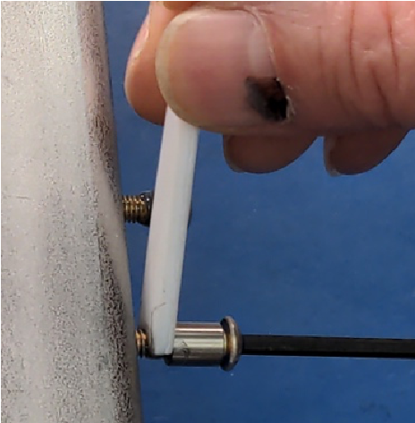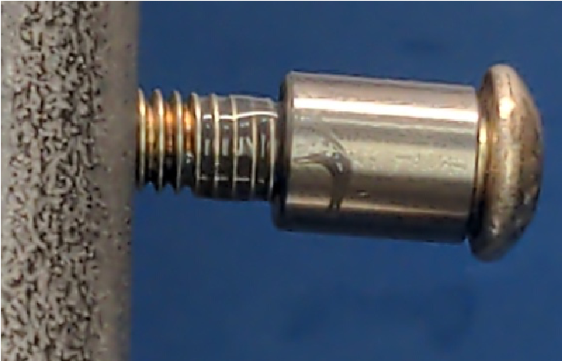

### Figure 2 – (left) epoxy just applied to M4 screw. (Centre) using tool to press epoxy into threads. (Right) epoxy in threads, ready for installation.

9.1.4 Place all X layer head boards (P/N 8760104) onto the APA head beam, lining up the screw holes. Rest the X board alignment jig (294-10931) on top of the boards, and align this with the outer holes of the board, see Fig 3. Once in place insert and screw in location pins 1 (2 x 294-10944) at either end of the jig, followed by location pins Type 3 (10 x 294-10946) in the holes marked on the alignment tool, and the remaining holes with location pins Type 2 (8 x 294-10945). See Fig 4 for order of the location pins.

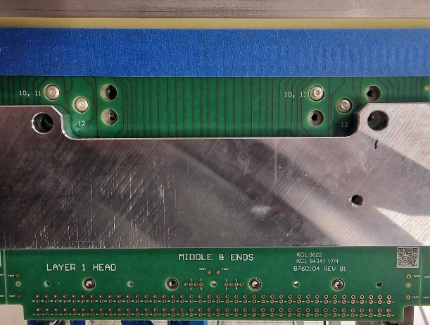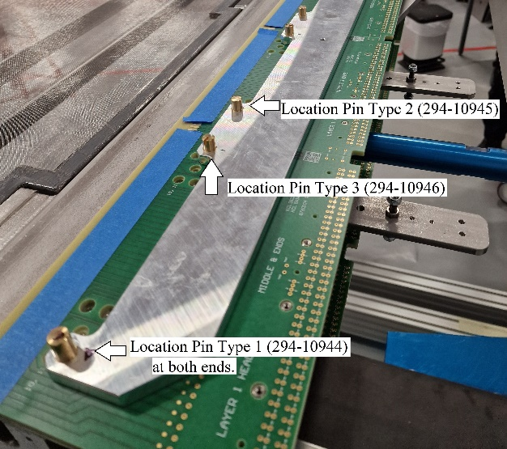

### Fig 3 Headboard Alignment tool with Location Pins

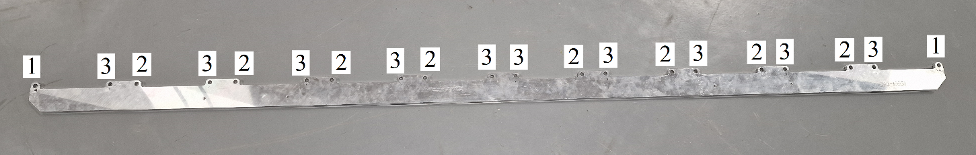

### Fig 4 Order of the Location Pins

9.1.5 Start an M4 x 25mm BHSCS blue-dyed, Zinc plated screw into the centre holes of the five hole pattern (*see Figure 5*). Tighten these screws with a 2.5mm hex driver until snug, then back them off slightly.

9.1.6 Remove two M4x10mm screws from the epoxy application fixture, then start the screws into the

board’s two location holes (*see Figure 5*) and tighten them until snug, with a 2.5mm hex driver. Note that these screw heads, when properly seated, will be below the surface of the board, but because the screw sleeves tend to seat prematurely against the board’s counter-bore, you will probably need to wiggle the board with one hand while turning the hex driver with the other until the screw sleeves slip into proper position. After the screw tightens against the properly positioned screw sleeve, loosen it a fraction of a turn.

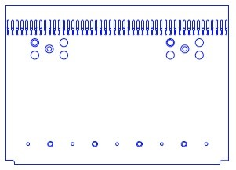

M4 x 25mm

M4 x 25mm

M4 x 10mm

and screw sleeve

M4 x 10mm

and screw sleeve

### Figure 5 – X Head board screw locations

9.1.7 Once all four screws are installed, wiggle the board to make sure that it is free to move in all directions, then **push it gently but firmly toward the foot end** of the APA, and hold it there while tightening, firstly, the two location screws (M4 x 10mm), then, the two hold-down screws at the centres of the five-hole patterns.

9.1.8 Use a 2.5mm hex bit in a torque driver set to 2.0 Nm (18 lb-in), first tighten the pair in the location holes with the screw sleeves M4 x 10mm, then the pair at the centre of the five-hole patterns M4 x 25mm, until the driver signals that the set torque is met.

9.1.9 Repeat steps 9.1.5 - 9.1.8 with the next X head board along the head beam, starting from one side of the frame going across.

9.1.10 A second person must verify all screws have been torqued properly. Note who installed the boards and checked the torque, plus the date and time of completion in the Database.

9.1.11 Once all of the screws have been torque-checked remove the locating pins from the alignment tool, then lift off the X Layer head board alignment tool, and place to one side.

9.1.12 Check that there is a sufficient gap between each of the boards by sliding two stacked 0.003 inch (0.076mm) shims between two neighbouring boards to ensure proper spacing.

9.1.13 Once all of the board gaps have been verified Record the board position, by serial number, on the Database.

9.1.14 Rotate the APA 180° so that side B faces upwards.

9.1.15 Repeat steps 9.1.2 - 9.1.13 to install X head boards onto side B. When all head boards have been installed on both sides, note date and time of completion in the Database.

9.1.16 Follow procedure EDMS-2616181 for the installation of X layer foot boards.

## 9.2 Installation of V layer head boards

|  |  |  |
| --- | --- | --- |
| **Part Number** | **Description** | **QTY** |
| **8760108** | **V Head Board Middle and Right End** | **18** |
| **8760116** | **V Board Head Left End** | **2** |
| **8752748** | **APA Head Assembly Head Tube Screw Sleeve,**  **6.12mm OD x 7.3mm length** | **40** |
| **8757162** | **M4-0.70 x 16mm BHSCS A2 SS Silver-Plated** | **40** |
|  | **2216 Scotch-Weld Grey Epoxy** ***(Duopak cartridge)*** | **A / R** |

9.2.1 Prepare by collecting the items shown in Sections 6.2 and 6.3 above. Position the APA horizontally, so side A is facing upwards, toward the ceiling.

9.2.2 Slide screw sleeves over 20 M4 x 16mm (or 20 **silver-plated** 25mm for U and G layer) BHSCS. Use the 2.5mm ball-end driver to thread the screws, with sleeves, into the screw epoxy application fixture by a turn or two. As needed, dispense 1-2 ml of 2216 epoxy into the syringe. Apply some epoxy to their threads behind the spacer.

9.2.3 After applying the epoxy, place the Teflon epoxy tool against the epoxied part of a screw while giving the screw a single turn with the 2.5mm driver to press the epoxy into the threads (*see figure 2)*. (Repeat this and previous step as needed while head boards remain to be installed.)

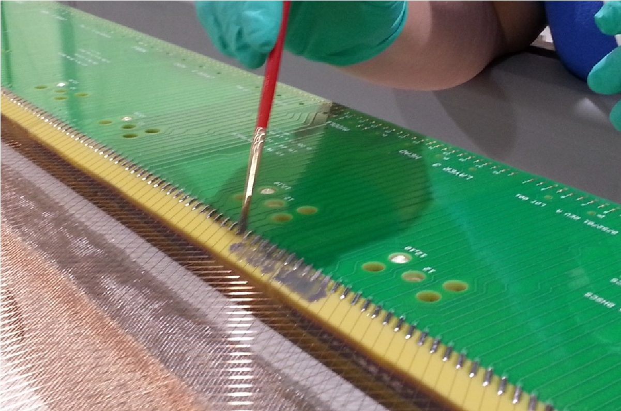

### Figure 6 – Applying epoxy to the end wires of each head board.

9.2.4 Using the 2.5mm L-shaped hex key, remove the M4x25mm blue-dyed BHSCS (which are in the *centres of the five-hole rectangular patterns)* previously installed X layer head boards, only remove these centre screws from the head boards and place them with the other hardware. **DO NOT remove any of the other BHSCS and screw sleeves in the five hole rectangular pattern!**

9.2.5 Dispense a small amount of 2216 epoxy into the small plastic cup. Using a brush, apply a coat of epoxy to the five outer wires and solder pads on the current board and the board ahead of the one that you are applying to (s*ee figure 6)*. Take care to avoid getting epoxy into the gap between boards, and immediately remove the epoxy from between the gap if it occurs.

9.2.6 Follow EDMS-2616201 8760Doc007_Epoxy_Dispensing for dispensing the proper pattern and volume of epoxy for each particular board type. Keep your boards in order as you apply the epoxy to minimise errors.

9.2.7 Starting from either the right hand side (RHS) or the left hand side (LHS) of the APA, pick up the head board which matches starting the position, epoxy side up, and carry over to the APA. Before applying the board, double check that the board is being placed in correct position (please remember that the **RHS and LHS is from the perspective of someone standing at the foot beam, facing the head beam**).

9.2.8 Carefully flip the board, and align the front end of the previous board with the current board, then slowly lay down the board down (front to back) lining the pins up last. If the pins are correctly aligned the board should drop into position with a few millimetre gap remaining. **Do not squeeze the boards together.**

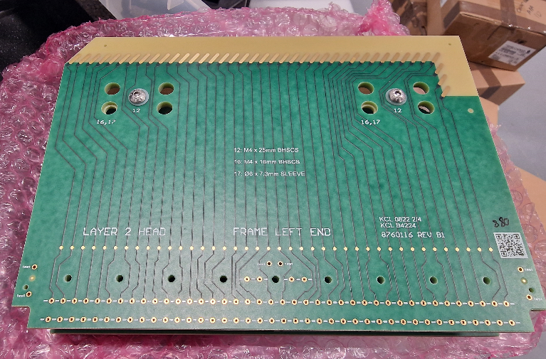

***Figure 7 – Head board indicating placement.***

9.2.9 Remove one of the M4x16mm screws from the epoxy application fixture, then insert the screws and sleeves into both of the holes indicated in *Figure 8* for V layer (*Figure 10* for U layer*, Figure 11* for G layer). Using a 2.5mm hex screwdriver, tighten them into place over the screw sleeves until snug.

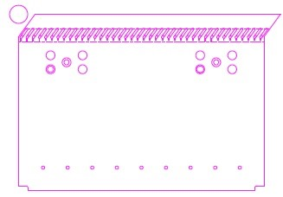

M4 x 25mm

M4 x 25mm

M4 x

16

mm

and

screw sleeve

M4 x

16

mm

and

screw sleeve

### Figure 8 – V head board screw locations

9.2.10 The two M4x25mm BHSCS removed in 9.2.4 will be placed back into the two hold-down screw holes at the centre of the five-hole patterns. Tighten these into place until they are just snug**.**

9.2.11 Insert a nylon screw into the holes along the near edge of the board as indicated in *Figure 9* (the nylon screws should align with treaded inserts in the X layer board). Tighten the screws until they are all snug against the board. Then starting from one edge tighten each screw in succession half a turn at a time, gradually closing the gap between the boards. If there is excessive resistance while tightening the nylon screws, stop, and check that all of the pins are aligned to their respective sockets.

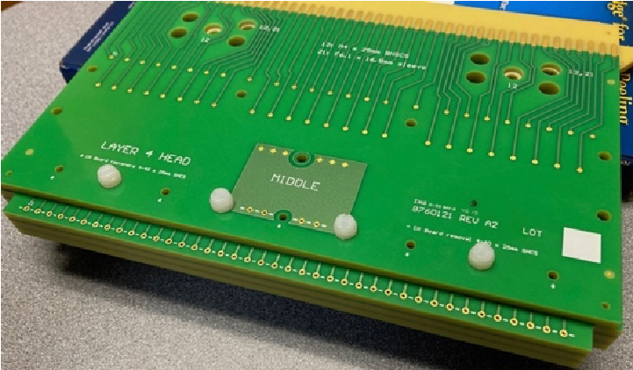

***Figure 9 – Nylon screw locations.***

9.2.12 Use a 2.5mm hex bit in a torque driver set to 2.0 Nm (18 lb·in) to tighten the two M4x16mm BHSCSs and the two M4x25mm BHSCSs, until the driver signals that the set torque is met.

9.2.13 Repeat steps 9.2.4 through 9.2.12 to install the next board. Slide the two**, stacked** 0.003 inch (0.076mm) shims between the boards to ensure proper spacing. While shims are inserted, snug the four screws: firstly the two installed in step 9.2.8, then the two M4x25 BHSCS. Remove the shims.

9.2.14 Repeat steps 9.2.4 through 9.2.13 to install the remaining eight boards on this side of the APA.

9.2.15 A second person must verify all of the M4 BHSCSs from step 9.2.9 and the two M4x25mm BHSCSsfrom step 9.2.10 have been torqued properly by repeating step 9.2.12. Record the board position, by serial number on the Database. Note who installed the boards, the date, and time of completion in the Database.

9.2.16 Using a Kimwipe, clean the screw epoxy application fixture ensuring all epoxy residue is gone.

9.2.17 Rotate the APA 180° so that side B faces upwards.

9.2.18 Repeat steps 9.2.2 through 9.2.15 to install ten head boards on side B.

9.2.19 When all head boards have been installed on both sides, note date and time of completion in the Database.

9.2.20 Follow procedure EDMS-2616181 8760Doc006 for the installation of V layer foot boards.

9.2.21 Remove the white Nylon screws after a minimum of five hours.

## 9.3 Installation of U layer head boards

|  |  |  |
| --- | --- | --- |
| **Part Number** | **Description** | **QTY** |
| **8760115** | **U Head Board Middle** | **16** |
| **8760123** | **U Board Head Right End** | **2** |
| **8760119** | **U Head Board Left End** | **2** |
| **8752749** | **APA Head Assembly Head Tube Screw Sleeve,**  **6.12mm OD x 12.0mm length** | **40** |
| **8757164** | **M4-0.70 x 25mm BHSCS A2 SS Silver-Plated** | **40** |
|  | **2216 Scotch-Weld Grey Epoxy** ***(Duopak cartridge)*** | **A / R** |

9.3.1 Prepare by collecting the items shown in Sections 6.3 and 6.4 or above. Position the APA horizontally, so side A is facing upwards, toward the ceiling.

9.3.2 Using the 2.5mm L-shaped hex key, remove the M4x25mm blue-dyed BHSCS (which are in the *centres of the five-hole rectangular patterns*, refer to figure 10) previously installed V layer head boards, only remove these centre screws from the head boards and place them with the other hardware. **DO NOT remove any of the other BHSCS and screw sleeves in the five hole rectangular pattern!**.

9.3.3 Dispense a small amount of 2216 into the small plastic cup. Using the acid brush, apply a coat of epoxy to the four outer wires / solder pads on each previous layer head board (*see figure 6).* **At the left side V layer head board (8760-116) apply epoxy ONLY to the last 5 pads of the shortest wires, and DO NOT APPLY EPOXY TO THE WIRES.** Take care to avoid getting epoxy into the gap between boards, and immediately remove the epoxy from between the gap if it occurs.

9.3.4 Repeat steps 9.2.2 - 9.2.19 to install all U head boards. See *Figure 10* for screw locations.

9.3.5 Follow procedure EDMS-2616181 8760Doc006 for the installation of U layer foot boards.

9.3.6 Remove the white Nylon screws after a minimum of five hours.

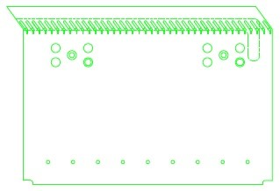

M4 x 25mm

M4 x

25

mm

and

screw sleeve

M4 x

25

mm

and

screw sleeve

M4 x 25mm

***Figure 10 - U head board screw locations***

## 9.4 Installation of G layer head boards

|  |  |  |
| --- | --- | --- |
| **Part Number** | **Description** | **QTY** |
| **8760121** | **G Head Board Middle** | **16** |
| **8760122** | **G Head Board Left End** | **2** |
| **8760120** | **G Head Board Right End** | **2** |
| **8752750** | **APA Head Assembly Head Tube Screw Sleeve,**  **6.12mm OD x 16.8mm length** | **40** |
| **8757164** | **M4-0.70 x 25mm BHSCS A2 SS Silver-Plated** | **40** |
|  | **2216 Scotch-Weld Grey Epoxy *(Duopak cartridge)*** | **A / R** |

## 

9.4.1 Prepare by collecting the items shown in Sections 6.3 and 6.5 or above. Position the APA horizontally, so side A is facing upwards, toward the ceiling.

9.4.2 Using the 2.5mm L-shaped hex key, remove the M4x25mm blue-dyed BHSCS (which are in the *centres of the five-hole rectangular patterns*, refer to figure 11) previously installed V layer head boards, only remove these centre screws from the head boards and place them with the other hardware. **DO NOT remove any of the other BHSCS and screw sleeves in the five hole rectangular pattern!**

9.4.3 Dispense a small amount of 2216 into the small plastic cup. Using the acid brush, apply a coat of epoxy to the four outer wires / solder pads on each previous layer head board (*see figure 6).* **At the right side U layer head board (8760-123) apply epoxy ONLY to the last 5 pads of the shortest wires, and DO NOT APPLY EPOXY TO THE WIRES.** Take care to avoid getting epoxy into the gap between boards, and immediately remove the epoxy from between the gap if it occurs.

9.4.4 Repeat steps 9.2.2 - 9.2.19 to install all G head boards. See *Figure 11* for screw locations.

9.4.5 Follow procedure EDMS-2616181 8760Doc006 for the installation of G layer foot boards.

9.4.6 Remove the white Nylon screws after a minimum of five hours.

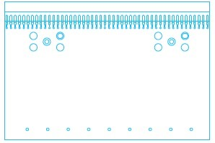

M4 x 25mm

M4 x 25mm

M4 x

25

mm

and

screw sleeve

M4 x

25

mm

and

screw sleeve

### Figure 11 – G head board screw locations