|  |  |  |  |
| --- | --- | --- | --- |
| **General** | | | |
| **This document is under the Change Management Control Policy.** | | | |
| Description | Service Catalog Document for Database Hosting  Describes the services offered under Database Hosting | | |
| Purpose | The purpose of this document is to publish agreed service level commitments between the service owner and the service customers. | | |
| Supersedes | *Service Level Agreement, Capacity Plan and Availability Plan for Database Hosting* | | |
| Document Owner | Mitch Renfer | **Owner Org** | *Core Computing Division* |
| **Effective Date** | 10-12-2015 | **Review Date** | *At minimum annually* |

| **Version History** | | | | |
| --- | --- | --- | --- | --- |
| Version | Date | Author(s) | Approved by  Change Number | Change Summary |
| 2.0 | 10-08-2015 | Mitchell Renfer | CHG000000010167 | Combined doc |
| 3.0 | 9/15/2017 | Mitchell Renfer | CHG000000012012 | 2016/2017-Annual review, combined and updated continuity |
| 4.0 | 10/1/2018 | Mitchell Renfer | CHG000000015126 | 2018 Annual Review. Updates based on usability project |
|  |  |  |  |  |

TABLE OF CONTENTS

EXECUTIVE SUMMARY 1

1 SERVICE AREA OVERVIEW 1

2 SERVICE OFFERINGS 1

2.1 Oracle - Standard 1

2.2 PostgreSQL - Standard 1

2.3 SQL Server - Standard 1

2.4 MySQL - Standard 1

2.5 MariaDB - Standard 1

2.6 Oracle - Gold 1

2.7 PostgreSQL - Gold 1

2.8 SQL Server - Gold 1

2.9 MySQL - Gold 1

2.10 MariaDB - Gold 1

3 SERVICE CAPACITY 1

3.1 Business Capacity Management 1

3.2 Service Capacity Management 1

3.3 Component Capacity Management 1

4 BUSINESS REQUIREMENTS, SERVICE ENTITLEMENTS AND COST 1

4.1 Business Requirements 1

4.2 Service Entitlements 1

4.3 Service Charging Policy 1

5 SERVICE REQUESTS 1

5.1 Standard Requests 1

6 SERVICE COMMITMENTS 1

6.1 Service Availability 1

6.2 Other Service Levels 1

7 SERVICE SUPPORT 1

7.1 Support Pre-requisites 1

7.1 Requesting Service Support 1

7.1.1 Special Support Coverage 1

7.2 Customer requests for Service Enhancements 1

8 SERVICE LIFECYCLE 1

9 RESPONSIBILITIES 1

9.1 General Responsibilities 1

9.2 Service Specific Responsibilities 1

9.2.1 CUSTOMER RESPONSIBILITIES 1

9.2.2 USER RESPONSIBILTIES 1

9.2.3 SERVICE OWNER 1

10 SERVICE CONTINUITY 1

10.1 Recovery Strategy 1

10.1.1 Initial recovery strategy 1

10.1.2 Overall recovery strategy 1

10.2 Recovery Scenarios 1

10.2.1 Building not accessible (Data Center Available) 1

10.2.2 Data Center Failure (Building Accessible) 1

10.2.3 Building not accessible and Data Center Failure 1

10.2.4 Critical recovery team not available 1

10.3 Return to Operations 1

11 SERVICE MEASURES AND REPORTING 1

11.1 Standard Service Measures and Reports 1

11.2 Service specific Measures and Reports 1

APPENDIX A: SUPPORTED HARDWARE AND SOFTWARE 1

APPENDIX B: SLA and OLA CROSS-REFERENCE 1

APPENDIX C: SERVICE DEPENDENCY CROSS-REFERENCE 1

APPENDIX D: UNDERPINNING CONTRACT (UC) CROSS-REFERENCE 1

APPENDIX E: TERMS AND CONDITIONS BY CUSTOMER 1

# EXECUTIVE SUMMARY

This document provides details and commitments of the Database Hosting Service Area and Service Offerings.

The descriptions of the Service Area and Service Offerings together with their service commitments and targets, owner, support organization and the type of Foundation Service Level Agreement that they conform to, are maintained and controlled in the CMDB under change control. This document contains the approved service parameters extracted from the CMDB at the time of approval of the document. Future versions of this document will contain url’s to reports from the CMDB (Service Now) rather than embedded tables of data extracted under change control.

In addition to those parameters, common to all Services, this document contains specific terms and conditions of the services for this Service area

This document, together with the applicable Foundation Service Level or Operational Level Agreement, forms the Service Level Agreement “SLA” or Operational Level Agreement “OLA” (for internal service offerings) for these services with the Fermilab community. Taken together they fully describe the responsibilities of the Service Owner, Customer(s) and Users, the Service Levels, Service Commitments, Service Support and Service breach procedures, computer security responsibilities, and specific terms and conditions for the services described below.

# 1 SERVICE AREA OVERVIEW

|  |  |
| --- | --- |
| **Service Area:** | **Database Hosting** |
| Service Area Owner: | Mitchell Renfer |
|  | The Database Hosting Service provides database services for Oracle, SQL Server, PostgreSQL and MySQL and MariaDB databases. |
|  | ISO20000 Certified |
|  | The Database Hosting Service (hereafter referred to as the "Service") is intended for customers wishing to provision new databases, maintain existing databases or migrate from existing databases to new database/server platforms. As with most resources, there is a cost associated with the Service. Customers provide annual funding for database and operating system software licenses and support/maintenance costs. These costs vary depending upon the database platform being used. Procurement and maintenance costs for operating system and servers may also be required. These costs also vary depending upon the OS platform and server platform (physical or virtual) being used.  **Standard Database Hosting Scope:**  • Database software installation services  • Database software patching (typically entails minor software updates)  • Database software upgrades (typically entails major software updates)  • Database design and implementation consultation  • Hardware infrastructure configuration and acquisition assistance  • Database troubleshooting assistance  • Database performance analysis and optimization  • Database space utilization monitoring  • Database backup and recovery operations  • Security procedures regarding passwords, access, etc  • Refresh non-production databases with production data as needed  • Optional database operation on general purpose servers (a lower cost option for some databases &ndash;size limitations, number of connections and data throughput restrictions may apply)  • Customer responsibility   o Provide primary and secondary customer contact   o Database licensing and annual maintenance costs (if applicable)   o OS licensing and annual maintenance costs (if applicable)   o Application software licensing and annual maintenance costs (if applicable)   o Server (physical or virtual) procurement costs   o Server (physical or virtual) annual maintenance costs   o Storage costs (local disk, network disk, tape)  **Enhanced Database Hosting Scope:**  Includes the Standard Database Hosting Scope plus the following…  • Database performance monitoring (customer may incur additional costs)  • 24 x 7 support availability which is negotiated on a case by case basis and identified in a service addendum for that specific customer. 24 x 7 support typically requires:   o A system infrastructure architected with high availability hardware and software   o 24x7 warranty support on all hardware and the operating system   o 24x7 availability of other dependent Service Providers (such as Network Services, Server Hosting Services, Storage Services and Application Services)   o 24x7 availability of customer contacts for system verification and testing   o 24x7 availability of 3 rd party vendor database support   o 24x7 monitoring and alerting (customer may incur additional costs for this support)   o Offered for production databases only  • Determine point in time database recovery requirements   o Recover with failover to secondary system option  • Automated failover  • Manual failover   o Recover from backup with minimal data loss option   o Recover to last full backup option   o Backup retention requirements  • Determine database replication requirements (subject to database platform availability)  • Special disaster recovery requirements and testing  • SQL statement tuning (performed in conjunction with Applications Team)  Any service component provided in addition to those listed in the Enhanced Offering section will be negotiated on a case by case basis and identified in a service addendum for that specific customer. |

|  |  |
| --- | --- |
| **Service Area:** | **Database Hosting** |
| Service Area Owner: | Mitchell Renfer |
|  | The Database Hosting Service provides database services for Oracle, SQL Server, PostgreSQL and MySQL and MariaDB databases. |
|  | ISO20K Certified |

|  |  |  |  |
| --- | --- | --- | --- |
| **Service Offering** | **Short Description** | **Offered** | **Owner** |
| Oracle - Standard | * Intended for customers wishing to provision new databases, maintain existing databases or migrate from existing databases to new database/server platforms. * Customers provide annual funding for database and operating system software licenses and support/maintenance costs. These costs vary depending upon the database platform. | Customer-facing | Mitchell Renfer |
| PostgreSQL - Standard | • Intended for customers wishing to provision new databases, maintain existing databases or migrate from existing databases to new database/server platforms.  • Customers provide annual funding for database and operating system software licenses and support/maintenance costs. These costs vary depending upon the database platform. | Customer-facing | Mitchell Renfer |
| SQL Server – Standard | • SQL Server is a database with vendor support suitable for mission-critical databases.  • Intended for customers wishing to provision new databases, maintain existing databases or migrate from existing databases to new database/server platforms.  • Customers provide annual funding for database and operating system software licenses and support/maintenance costs. These costs vary depending upon the database platform. | Customer-facing | Mitchell Renfer |
| MySQL – Standard | * MySQL is a database with limited vendor support for mission-critical databases. * Intended for customers wishing to provision new databases, maintain existing databases or migrate from existing databases to new database/server platforms. * Customers provide annual funding for database and operating system software licenses and support/maintenance costs. These costs vary depending upon the database platform. | Customer-facing | Mitchell Renfer |
| MariaDB - Standard | * MariaDB is a database with limited vendor support for mission-critical databases. * Intended for customers wishing to provision new databases, maintain existing databases or migrate from existing databases to new database/server platforms. * Customers provide annual funding for database and operating system software licenses and support/maintenance costs. These costs vary depending upon the database platform. | Customer-facing | Mitchell Renfer |
| Oracle – Gold | Anything not offered as part of the standard service will be negotiated on a case-by-case basis and identified in a service addendum for that specific customer. | Customer-facing | Mitchell Renfer |
| PostgreSQL - Gold | Anything not offered as part of the standard service will be negotiated on a case-by-case basis and identified in a service addendum for that specific customer. | Customer-facing | Mitchell Renfer |
| SQL Server - Gold | Anything not offered as part of the standard service will be negotiated on a case-by-case basis and identified in a service addendum for that specific customer. | Customer-facing | Mitchell Renfer |
| MySQL - Gold | Anything not offered as part of the standard service will be negotiated on a case-by-case basis and identified in a service addendum for that specific customer. | Customer-facing | Mitchell Renfer |
| MariaDB - Gold | Anything not offered as part of the standard service will be negotiated on a case-by-case basis and identified in a service addendum for that specific customer. | Customer-facing | Mitchell Renfer |

# SERVICE OFFERINGS

## Oracle - Standard

|  |  |
| --- | --- |
| **Oracle - Standard** |  |
| Other Information |  |
| Type of SLA | Based on Foundation Agreement |
| Service Criticality Tier 2 | Recovery in < 12 hours |
| Supported by | Database Services |
| Off hours support: 8to17by5 Critical Incidents allowed ISO20000 Certified | |

## PostgreSQL - Standard

|  |  |
| --- | --- |
| **PostgreSQL - Standard** |  |
| Other Information |  |
| Type of SLA | Based on Foundation Agreement |
| Service Criticality Tier 2 | Recovery in < 12 hours |
| Supported by | Database Services |
| Off hours support: 8to17by5 Critical Incidents none ISO20000 Certified | |

## SQL Server - Standard

|  |  |
| --- | --- |
| **SQL Server - Standard** |  |
| Other Information |  |
| Type of SLA | Based on Foundation Agreement |
| Service Criticality Tier 2 | Recovery in < 12 hours |
| Supported by | Database Services |
| Off hours support: 8to17by5 Critical Incidents none ISO20000 Certified | |

## MySQL - Standard

|  |  |
| --- | --- |
| **MySQL - Standard** |  |
| Other Information |  |
| Type of SLA | Based on Foundation Agreement |
| Service Criticality Tier 2 | Recovery in < 12 hours |
| Supported by | Database Services |
| Off hours support: 8to17by5 Critical Incidents allowed ISO20000 Certified | |

## MariaDB - Standard

|  |  |
| --- | --- |
| **MariaDB - Standard** |  |
| Other Information |  |
| Type of SLA | Based on Foundation Agreement |
| Service Criticality Tier 2 | Recovery in < 12 hours |
| Supported by | Database Services |
| Off hours support: 8to17by5 Critical Incidents allowed ISO20000 Certified | |

## Oracle - Gold

|  |  |
| --- | --- |
| **Enhanced Oracle (Enhanced)** |  |
| Other Information | Support availability is Negotiated |
| Type of SLA | Based on Foundation Agreement |
| Service Criticality Tier 2 | Recovery in < 12 hours |
| Supported by | Database Services |
| Off hours support: 24by7 Critical Incidents allowed ISO20000 Certified | |

## PostgreSQL - Gold

|  |  |
| --- | --- |
| **PostgreSQL - Gold** | |
| Other Information | Support availability is Negotiated |
| Type of SLA | Based on Foundation Agreement |
| Service Criticality Tier 2 | Recovery in < 12 hours |
| Supported by | Database Services |
| Off hours support: 24by7 Critical Incidents allowed ISO20000 Certified | |

## SQL Server - Gold

|  |  |
| --- | --- |
| **SQL Server - Gold** | |
| Other Information | Support availability is Negotiated |
| Type of SLA | Based on Foundation Agreement |
| Service Criticality Tier 2 | Recovery in < 12 hours |
| Supported by | Database Services |
| Off hours support: 24by7 Critical Incidents allowed ISO20000 Certified | |

## MySQL - Gold

|  |  |
| --- | --- |
| **MySQL - Gold** | |
| Other Information | Support availability is Negotiated |
| Type of SLA | Based on Foundation Agreement |
| Service Criticality Tier 2 | Recovery in < 12 hours |
| Supported by | Database Services |
| Off hours support: 24by7 Critical Incidents allowed ISO20000 Certified | |

## MariaDB - Gold

|  |  |
| --- | --- |
| **MariaDB - Gold** | |
| Other Information | Support availability is Negotiated |
| Type of SLA | Based on Foundation Agreement |
| Service Criticality Tier 2 | Recovery in < 12 hours |
| Supported by | Database Services |
| Off hours support: 24by7 Critical Incidents allowed ISO20000 Certified | |

# SERVICE CAPACITY

## 3.1 Business Capacity Management

The objective is to translate business needs and plans into capacity and performance requirements for Computing services and infrastructure, and to ensure that future capacity and performance needs can be fulfilled.

The Core IT Capacity Plan considers the overall business-driven capacity needs for Services and provides input for Service and Capacity targets for this service.

The Scientific Portfolio Management Team process collects requirements from all parts of the lab’s scientific program and reviews the requests and needs and prioritizes the resources to be provided in the coming one or two years in each area, based on Fermilab scientific strategies and priorities. The results of that process are captured in the annual Scientific Computing Capacity Plan and translated into Service and Component capacity targets for this service area.

The basic unit of Capacity is an “Instance of a Database Service”, based on one of the Service Offerings. An “Instance of Database Service” may actually consist of mutiple databases since it is typically necessary to have additional non-production databases (e.g. development or test databases) to fully support a production database.

## Service Capacity Management

The objective is to manage, control and predict the performance and capacity of operational services. This includes initiating proactive and reactive action to ensure that the performances and capacities of services meet their agreed targets.

Oracle, SQL Server, PostgreSQL, MySQL and MariaDB databases can be hosted on dedicated physical hardware servers, on dedicated virtual hardware servers or on preconfigured shared server environments (which help reduce costs and share resources). The server platform is determined based on database size, connection and throughput requirements.  The Service typically requires a minimum of two types (or categories) of databases for each discret “Instance of a Database Service”: a development instance and a production instance. In some cases, a replication server, for failover support, is added or an integration server is added for additional quality assurance testing prior to implementing changes to production databases. This configuration allows the production applications to be isolated from development and maintenance testing work.   There is no database license charge for the use of PostgreSQL, MySQL or MariaDB databases on any of the server environments. However, there may be license/maintenance costs associated with Oracle and MS SQL Server as well as Operating System and Server Hardware license/maintenance costs depending upon the server platform used.

## Component Capacity Management

The objective is to manage, control and predict the performance, utilization and capacity of IT resources and individual IT components.

Daily Operations-Related Database Metrics Monitored: Disk Space, CPU/Load, RAM, DB backups, DB Internal Metrics (DB platform dependent), DB replication status (DB platform dependent).

Personnel capacity planning is handled through load balancing staff through the use of vendor services such as Remote DBA Experts (RDX) personnel. RDX resource planning – monthly expenditure tracking and the addition of funding for service capacity as needed (reviewed annually at a minimum). RDX capacity planning document is available upon request.

Quarterly or Annually Assessed: Licenses, Customer Budget, New/additional servers, New/additional storage, additional CPU/RAM capacity, budgeting for RDX resources. Component capacity information is also being reported at SPPM.

Units of Capacity are Databases, Servers, Disk space, Licenses, Personnel – each with their own set of metrics.

For High Availability systems (used in certain enhanced support agreements), there are load balancing devices that balance user connection and system load as well as provide server failover capacity in the event of a single server failure.

Monitoring Operations Tools:

* Big Brother (BB) Monitoring: <https://monitor3.rdx.com/bb/FermiLab/bb.html> and via BB email alerts
* Oracle Enterprise Manager (OEM) Monitoring: <https://cd-omsora1.fnal.gov:7802/em> and via OEM email alerts
* Solar Winds Monitoring: <https://fnorion.fnal.gov/Orion/SummaryView.aspx?viewid=1> and via email alerts
* Ganglia Monitoring for ESO supported systems: <http://ussganglia.fnal.gov/ganglia/?m=load_one&r=hour&s=by%20name&hc=4&mc=2>
* Ganglia monitoring for FEF supported systems: <http://ganglia.fnal.gov/?r=hour&cs=&ce=&m=load_one&s=by+name&c=&tab=m&vn=&hide-hf=false>
* Department capacity reported through Quarterly Reports.

General capacity thresholds are monitored through the monitoring tools listed in the SLA. These thresholds are typically along the lines of receiving warning alerts at 80% of capacity and critical alerts at 90%. Of course there are exceptions to this for certain systems with special requirements but this 80/90 rule represents the general setup. We would typically start taking action at the first warning alert (80%) by adding capacity (e.g. disk space) or look at running processes if the load on the server was triggering warning alerts.

# BUSINESS REQUIREMENTS, SERVICE ENTITLEMENTS AND COST

## Business Requirements

Most applications that are used in the Operations of the lab (including all of the Financial, Procurement, ES&H, Facilities Services and other) as well as many applications that are used to support the scientific programs of the lab critically depend on an underlying database or databases for their functionality. This is an area where Computing has consolidated the support to one group that handles all permitted types of databases that underpin other Services.

In the annual budget process the business requirements are reviewed and aggregated so that the Database Hosting area owner may plan adequate technical resources to meet the business needs. Refer to:

* Tactical Plan and Budget process described in Financial Management Policy and Procedures (see docdb#4112)
* Capacity Plans (see docdb#4047)
* Business Impact Assessment (see docdb#4571)
* Continuity of Operations Plans (see docdb#5097,4969 and #4571)

## Service Entitlements

Service Entitlements are defined in the applicable Foundation Service Level Agreement. Exceptions to those entitlements (if any) are listed below.

## Service Charging Policy

The customer should work with the Service provider to develop a budget for the estimated costs of the databases, servers, storage and extra contract personnel required to provide the appropriate level of service. Once established, this budget will be input into the Computing Sector Budget entry system.

|  |  |
| --- | --- |
| **Oracle – Standard** | Customer pays Oracle database licensing and annual database maintenance costs plus may incur costs for operating system licensing and hardware maintenance costs depending on arrangements with the Server and Storage Services. |
| **PostgreSQL – Standard** | Customers utilizing PostgreSQL servers will not incur costs related to the database software, but may incur costs for operating system licensing and hardware maintenance costs depending on arrangements with the Server and Storage Services. |
| **SQL Server – Standard** | Customer pays SQL Server database licensing and annual database maintenance costs plus may incur costs for operating system licensing and hardware maintenance costs depending on arrangements with the Server and Storage Services. |
| **MySQL – Standard** | Customers utilizing MySQL servers will not incur costs related to the database software, but may incur costs for operating system licensing and hardware maintenance costs depending on arrangements with the Server and Storage Services. |
| **MariaDB – Standard** | Customers utilizing MariaDB servers will not incur costs related to the database software, but may incur costs for operating system licensing and hardware maintenance costs depending on arrangements with the Server and Storage Services. |
| **Oracle – Gold** | Negotiated |
| **PostgreSQL – Gold** | Negotiated |
| **SQL Server - Gold** | Negotiated |
| **MySQL – Gold** | Negotiated |
| **MariaDB - Gold** | Negotiated |

# SERVICE REQUESTS

## **Standard Requests**

|  |  |
| --- | --- |
| **Service Catalog Items** |  |
| **Service Offering** | **Catalog Item** |
| Oracle | General Request (Create a new database, add resources to a database, modify a database) |
| PostgreSQL | General Request (Create a new database, add resources to a database, modify a database) |
| SQL Server | General Request (Create a new database, add resources to a database, modify a database) |
| MySQL | General Request (Create a new database, add resources to a database, modify a database) |
| MariaDB | General Request (Create a new database, add resources to a database, modify a database) |

# SERVICE COMMITMENTS

Except as otherwise stated below the Availability commitments and targets and the Service Level commitments and targets for both response and resolution of Incident (something is broken) and Request tickets is as described in the applicable Foundation Service Level or Operational Level Agreement.

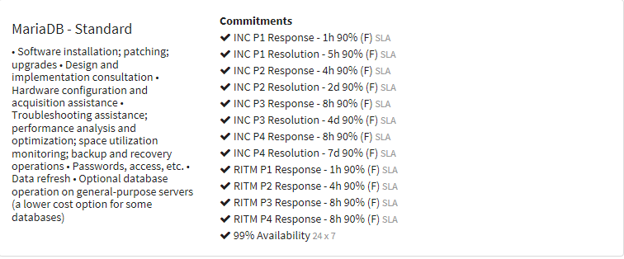

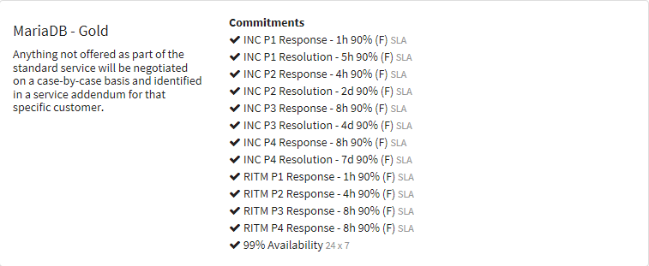

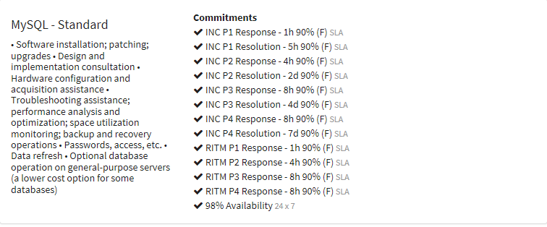

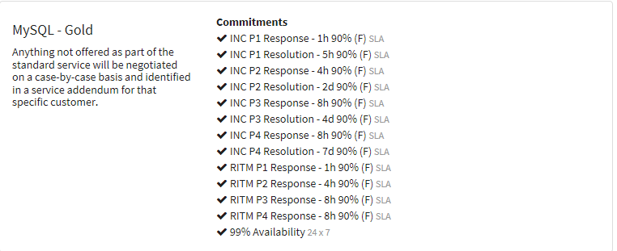

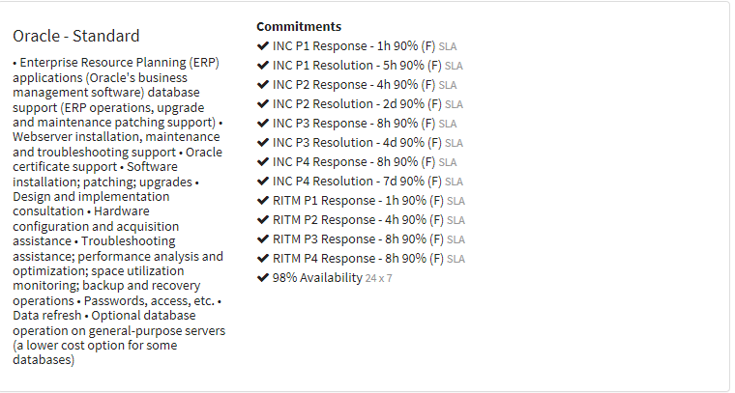

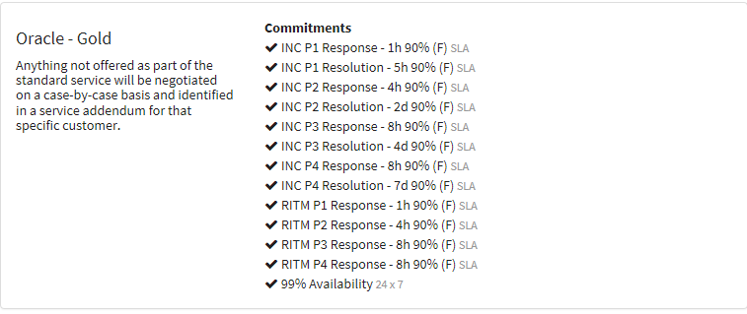

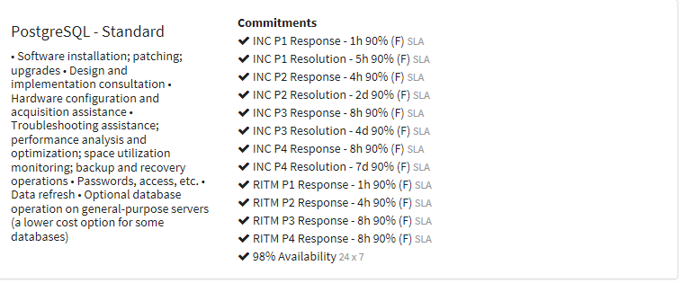

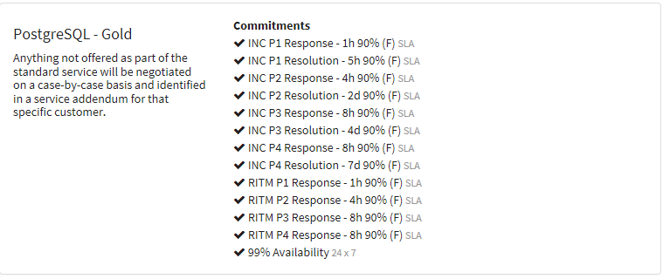

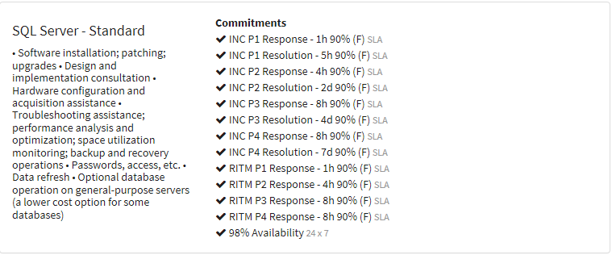

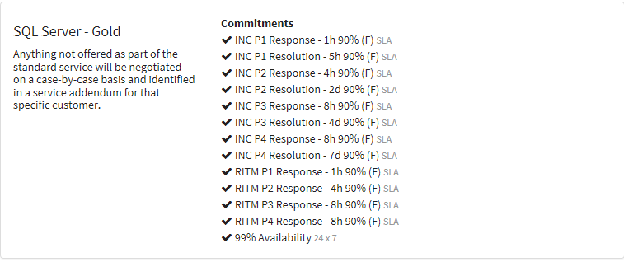

## **Service Availability**

Service availability is measured as an uptime percentage during the expected service availability window. An Outage implies service unavailability and negatively impacts availability measurements. An Outage during an ‘agreed to maintenance window’ does not impact the availability measurement.

* Maintenance Window – A monthly or quarterly maintenance window will be negotiated with the customer. Maintenance that occurs outside of the maintenance window will be agreed to and communicated. A document is kept that contains specific agreed to maintenance windows and can be provided upon request.
* Outage – all users are unable to access the database or use a critical database feature
* Degradation – 30% or more of users are unable to access the database or use a critical database feature. This could also mean a database performance issue affecting more than 30% of the users.

## **Other Service Levels**

For all Service Offerings, non-Production environments will not qualify for Critical or High response and resolution. At most, tickets entered for non-production environments will be set to medium priority.

# SERVICE SUPPORT

## 7.1 Support Pre-requisites

**Environments**

Typical systems supported by the Service require both a development and a production environment at a minimum. The development databases are used for testing patches and upgrades prior to production implementation. The exception to this support model would include:

* Systems that may require adding a third “integration” or QA environment for additional pre-production testing purposes.
* Non-critical databases hosted on Fermilab systems which act as a “mirror” database for offsite “primary” databases. In these cases, the offsite primary database support is responsible for patch and upgrade testing and continuity of database service prior to maintenance by the Database Hosting Service on the mirror database.

**Certified Platforms / In-Warranty Infrastructure**

In general, support is provided on certified operating system and database combinations running on in-warranty servers and storage hardware. Enhanced support for high availability (HA) systems is only available for Customers deployed on certified software/hardware platforms running on in-warranty hardware infrastructure. The Service will provide vendor based database certification lists (such as Oracle’s Matrix Certification List) for each database offering. All servers are expected to remain on certified and in-warranty configurations for the life of the support agreement. For non-compliant, out-of-support environments, the Service typically provides support based on a “best effort” basis. Exceptions may include:

* Some legacy, out of warranty systems are supported due to a specific application or lab related-related requirement.
* The rollout of Oracle databases on VMware.
* Systems that run locally and are isolated from the main Fermilab network. A variance from the Computer Security Team may be required to keep these systems running.

**Maintenance**

Customers agree to provide quarterly downtimes (at a minimum) for software and hardware maintenance on supported systems. Special accommodation for specific customer downtime requirements can be negotiated and documented in a service level agreement addendum. The Service will endeavor to keep databases patched to the penultimate level thus allowing the latest patches to be fully tested by the database platform community prior to implementation at Fermilab. Exceptions may include:

* Emergency fixes or security issues may require the latest patch versions.
* Special features required or desired in the latest patch versions.
* Special requirements of the customer to postpone regular maintenance schedules due to unusual circumstances when outages would be highly detrimental to the application, experiment or user community. If this becomes a reoccurring issue, a high availability system strategy may be needed.
* The lack of available user testing resources may postpone maintenance activities.
* The lack of available Service resources may postpone maintenance activities.
* Changing lab project priorities may require a change in database maintenance schedules. In such cases, the target will always be to ensure systems remain running on vendor supported, in-warranty versions.

**Communications**

* Customers agree to name a primary and secondary liaison to be used as the Customer communication contact between the end users and the Database Hosting Service. The Service will work with the Customer liaisons to determine the database and infrastructure requirements (e.g. performance, availability, maintenance schedules and backup requirements) and help coordinate communications with the appropriate Server and Storage Groups in the procurement process and support for the system.

## Requesting Service Support

Access to all Computing IT services should be requested through the Service Desk, via the [ServiceNow](https://fermi.service-now.com/fsc/) application, or by phone (630-840-2345). More information about requesting service can be found in the Self Service section of ServiceNow.

Unless otherwise noted Support Availability is 8:00AM to 5:00PM Monday to Friday excluding holidays

### Special Support Coverage

Requests for changes in support coverage should be made by opening a request with the Service Desk a minimum of 7 days before the coverage change is needed.

These requests must be negotiated and are subject to approval based on the staff available at the time and the nature of the additional support.

## Customer requests for Service Enhancements

Customers can request Service Enhancements by contacting their Computing Liaison. The Computing Liaison will work with the Service Owner and the Customer to prioritize and track progress.

# SERVICE LIFECYCLE

* Planning, analysis and design of initial hardware to work with this Service is a collaborative effort between the Database Hosting Service and the Server and Storage Services. Funding for dedicated servers and storage is typically provided by the Customer. Server procurement and configuration will be a coordinated effort between the Database Hosting Service and the Server and Storage Service teams.
* The Database Hosting Service typically supports two database categories: development and production. In some cases, additional categories of databases may be added such as an integration database (sometimes called a Quality Assurance or QA database) or a replication database (sometimes referred as a failover database). For some systems, changes to the production database application or database structure may be required to go through the existing change management process.
* A development database is to be used for database and application development, testing of database features and occasionally as a repository for software design tools. The Customer is responsible for the development phase.
* A development database is also used by the Service for database patching and database upgrade testing.
* An integration (or QA) database, if needed, is to be used for testing pre-production database applications by the Customer. If the Customer provides sufficient storage, the integration instance may be refreshed by the Service with production data on an as-needed basis during normal business hours. This refresh process is resource intensive so it will require negotiation between the Customer and the Service to minimize impact to production.
* A production database is to be used for fully operational database applications and will house only "real" or “live” data. Access to the production database will be based on a ‘minimal need’ requirement as defined by the Customer and implemented by the Service.
* In the Maintenance and Operations phases, the Service will patch, monitor and troubleshoot databases issues based on the current Service standard or enhanced offerings. Maintenance periods need to be defined to ensure adequate time for patching.
* Each year a “Taking Stock” or planning meeting” may be coordinated between the Customer, the associated Application Group, the Server Services group and the Database Services group to review and coordinate services and to review hardware and space requirements.
* Database software upgrades will be planned based on the offerings’ service life and Customer requirements.
* Typically this service is only offered on in-warranty servers and storage hardware. End-of-life hardware must be replaced in a timely manner by the Customer. The migration plan will be made and executed by the Database Hosting Service in conjunction with other related support services (such as Server and Storage Services). The excessing of old equipment will be handled by Server Services.
* Authority to support any database will be restricted to trained personnel in the Database Services Group or authorized contractors.

# RESPONSIBILITIES

## General Responsibilities

The applicable Foundation Service Level agreement defines the general responsibilities of the User, Customer and Service Owner including Computer Security responsibilities. It describes how to report incidents and the responsibilities with respect to service tickets.

## Service Specific Responsibilities

### CUSTOMER RESPONSIBILITIES

The Customer agrees to:

* Provide funding for the services acquired as per the costing guidelines.
* Convey pertinent information to the users about the content of this service agreement.
* Participate in SLA reviews.
* Provide representation for Continual Service Improvement (CSIP) activities. CSIP activities can be triggered in the event of an SLA breach or as part of normal Service Owner/Customer meetings. During this time, the customer and Service Owner can discuss what services are working well, which are not, and come up with suggestions as to what areas need improvements. During this time, the Service Owner may also discuss with the customer upcoming Service improvements/changes/additions and poll the Customer for an opinion regarding these topics.
* Coordinate standard maintenance downtimes requiring a service outage. Notification of a service outage will be provided to the customer via email and Operations meeting at least 2 weeks in advance of an outage.
* Name a primary and secondary Customer Database liaison to be used as the Customer communication contact between the end users and the Database Hosting Service.
* Identify Customer Database liaisons who are responsible for communicating downtimes to end user communities.
* Provide a single email (preferably a mailing list) which the Service owner may use to communicate any planned downtime or outages.
* Work with the Service owner to determine the database and infrastructure requirements (e.g. performance, availability, maintenance schedules and backup requirements) and help coordinate communications with the appropriate Server and Storage Groups in the procurement of the system.
* Be responsible for the database content (data).
* Follow On-Call Procedures per Foundation SLA.
* Make Customer contacts available 24x7 for system verification and testing if 24 x 7 support is requested.
* Notify the Service Owner of changes in user status or responsibilities.

### USER RESPONSIBILTIES

The users agree to:

* Be responsible for contacting the Customer Database liaison to obtain access to the database. The Customer Database liaison will contact the Service owner with authorization for access.
* Participate in system testing after database installation, upgrade, maintenance, and after incidents or outage resolution.
* Open a service desk ticket for technical assistance from the Service owner if necessary.
* When reporting an incident, the user must be available to work with the Service providers to troubleshoot and resolve the incident.
* Be accountable / responsible for all activity on their database and to notify the Service provider if these activities will cause a failure to perform the service.
* Be responsible for working with their Customer Database liaisonshould the Service provider notify the user that their activities on the server are detrimental to the Service.

### SERVICE OWNER

General responsibilities:

* Provide the services described in section 2.
* Review daily logs and metrics to ensure the environment is performing optimally.
* Provide adequate capacity to maintain the Service.
* Upgrade database and infrastructure as necessary as part of lifecycle management or in response to bug fixes.
* Recover/restore databases in line with Service offerings.
* Meet response times associated with the priority assigned to Customer requests as outlined in section 6.2.
* Maintain appropriately trained staff.
* Coordinate standard maintenance downtimes requiring a service outage. Notification of a service outage will be provided to the customer via email and Operations meeting at least 2 weeks in advance of an outage.

# SERVICE CONTINUITY

*Computing has created an overall IT Service Continuity Management Plan that covers the key areas that each individual service area would rely upon in a continuity situation such as command center information, vital records, personnel information.*

**Recovery Time Objective (RTO)**  is defined as the length of time processes could be unavailable before the downtime adversely impacts business operations.

**Recovery Point Objective (RPO)** is defined as the maximum interval of data loss since the last backup that can be tolerated and still resume the business process.

|  |  |  |
| --- | --- | --- |
| **Recovery Objectives\*** | **RTO** | **RPO** |
| Oracle – Standard | 12 hours | 24 hours |
| SQL Server – Standard | 12 hours | 24 hours |
| MySQL – Standard | 12 hours | 24 hours |
| PostgreSQL – Standard | 12 hours | 24 hours |
| MariaDB - Standard | 12 hours | 24 hours |
| PostgreSQL – Gold | 12 hours | 24 hours |
| Oracle – Gold | 12 hours | 24 hours |
| SQL Server – Gold | 12 hours | 24 hours |
| MySQL – Gold | 12 hours | 24 hours |
| MariaDB - Gold | 12 hours | 24 hours |

*The objectives above are typical. Large databases or unique circumstances/configurations may take longer to recover.

## Recovery Strategy

Database High-Level Recovery Strategy

1. Verify infrastructure is available. This includes facilities (power, cooling), SAN and NAS storage, networking (DNS, DHCP, firewalls, routers, switches), authentication services and servers.
2. Coordinate database recovery with customers.

### Initial recovery strategy

Assess infrastructure readiness for recovery and review situation with recovery team.

### Overall recovery strategy

High availability fail-over

* Triage lost databases,, then work to restore databases based on lab need.
* Some HA capabilities exist with certain database infrastructure implementations (OID, eBS load balanced webserver, Central Web, WordPress, DocDb, IFBeam and VOMS/GUMS).

Recover at another site or multiple sites

* Please see financials database hosting recovery plan.
* Some cool/warm DR site capability for financial databases. (Off-site host / storage / network / tape-restore capability is available at Argonne National Lab (ANL). Upgrades to infrastructure and plan in progress).

Build from scratch

* Depending on databases impacted, there are a couple of options that will be determined based on the scenario.
* Possible option is to convert existing QA or Integration server to the production database server.
* Some possible options are new VMs (if VM service is available), cloud VMs (if network is available), disaster recovery site (ANL), expedited procurement / rental of new equipment and/or data center.

## Recovery Scenarios

## **Building not accessible (Data Center Available)**

Document checklist/plan

* Verify VPN is available
* Remote fix where possible

.

## **Data Center Failure (Building Accessible)**

Document checklist/plan

* Data center floor separation allows for some recovery possibilities.
* Some remote-fix capability is possible depending on circumstances may recover to ANL.

## **Building not accessible and Data Center Failure**

Document checklist/plan

* No alternative datacenter recovery sites have been defined. If just one datacenter (FCC2 or FCC3) has failed, refer to the “Overall recovery strategy” section.
* A select number of business and financial systems have been identified as part of a disaster recovery plan hosted at Argonne data center (Building 221).

## **Critical recovery team not available**

Document checklist/plan

* Contact external DBA supports services vendor and/or use expedited procurement to employ contracted Database Administrators.

## Return to Operations

* Document checklist/plan
* Communicate and cooperate with Service Desk, Service Manager, higher level management
* Communicate and cooperate with OLA partners to get infrastructure ready for database recovery.
* Recover / restore database from backups.Verify database recovery.Release database to application service owners

# SERVICE MEASURES AND REPORTING

## Standard Service Measures and Reports

The Service Offering dashboard is available in the service desk application under the report section. The dashboard measures each offering for each service against the incident response and resolution times and request response times defined in section 6 of this document. The dashboard shows performance trending for the Service Offerings on a weekly/monthly/yearly basis.

The Service Offering dashboard is available to Service Owners and Providers, Business Analysts, Process Owners and Senior IT Management.

Service Level breaches are identified in the service offering dashboard and are monitored by the Service Owners, Incident Manager and Service Level Manager.

Customer Reports are available in ServiceNow in the Service Management Reports section.

## Service specific Measures and Reports

The Service Offering dashboard for Database Hosting is available in the service desk application under the report section. The dashboard measures each offering for this service against the incident response and resolution times and request response times defined in the Foundation SLA. The dashboard shows performance trending for the Service Offerings on a weekly/monthly/yearly basis.

The Service Offering dashboard is available to Service Owners and Providers, Business Analysts, Process Owners and Senior IT Management.

Service Level breaches are identified in the service offering dashboard and are monitored by the Service Owners, Incident Manager and Service Level Manager.

Weekly reports showing service metrics are shown during the CS operations meetings.

CCD Quarterly reports can be found in DocDB.

# APPENDIX A: SUPPORTED HARDWARE AND SOFTWARE

Supported hardware and software matrixes are a fluid set of requirements. The Database Services Group, Storage Group and System Support Group will consult with requester at time of request for latest supported configurations.

Databases run on Fermilab approved and supported Windows, Linux and Solaris X86 operating systems running on Fermilab supported server hardware (physical and vitual) utilizing Fermilab approved storage and backup systems.

# APPENDIX B: SLA and OLA CROSS-REFERENCE

The services in this Service Area depend on the following IT Services to operate within their respective SLAs / OLAs.

Critically depends on usually means that the Service Offering will be unavailable (or at minimum degraded) if the depends on Service Offering is unavailable.

Depends on means that there is a dependency for Availability and Continuity but the extent of the dependency can vary.

A Table of Service Dependencies is stored in a separate file (Database Hosting Service Dependencies) in the document database entry for this service area Docb#4664

# APPENDIX C: SERVICE DEPENDENCY CROSS-REFERENCE

A Table of Services that depend on Services in this service area is stored in a separate file in the document database entry for the Availability Process docdb#5614

# APPENDIX D: UNDERPINNING CONTRACT (UC) CROSS-REFERENCE

Vendor contracts directly supporting this service area, including contact information can be found in the [Vendor Contract list](https://fermipoint.fnal.gov/organization/cs/ocio/sm/sum/sumi/Lists/Contract%20List/Service%20Area.aspx) under this service area

Additional supporting contracts are via Services that this service depends on – see dependencies above.

# APPENDIX E: TERMS AND CONDITIONS BY CUSTOMER

Currently documented in DB spreadsheets for enhanced support (24/7 and high availability systems), special considerations/conditions are also noted there. This information is available upon request.

Additional customer specific information is detailed in experiment Technical Scope of Work Documents (TSW).