DUNE CCB Minutes
13 Feb 2024
DRAFT

Agenda: https://indico.fnal.gov/event/63159/

CCB Mail list: DUNE-CCB@FNAL.GOV

Present:
Country/Lab | Name | Present or apologies
Chair | P.Clarke | Present
BR | E.Kemp | Apologies
CA | L.Groer | Present
CH | M.Weber | Apologies
CZ | Petr Vokac | Present
ES | G.Merino | Present
FR | E.Pennacchio, Rachid Lemrani | Present
IN | N.Panyam | Present
IT | Marco Pallavicini | Not present
NL | J.Templon | Present
UK | A.McNab | Present
USA | S.Timm | Present
FNAL | K.Herner | Present
BNL | D.Benjamin | Present
CERN | Xavier Espinal | Present
Ex-officio | M.Kirby | Present
Ex-officio | H.Schellman | Present
Ex-officio | Aaron Higuera | Present

1. Introductions

P.Clarke opened the meeting and welcomed members.

2. DUNE usage and capacity requirements 2024

H.Schellman presented the DUNE usage (updated form the pre-meeting on 13 Dec 2023) and requests for 2024. See presentations and documents on agenda page. The summary request, taken from the document, is in the snapshot below.
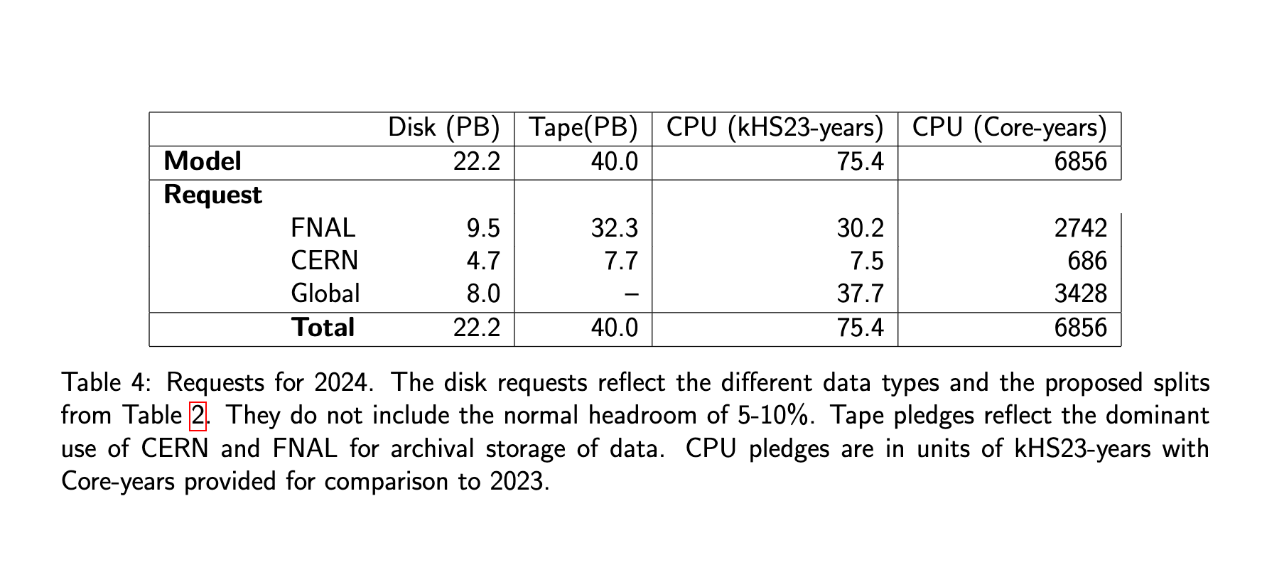
Discussion and questions:

- CPU is now requested in kHS23-years (== deployed kHS32). This is a change from last year where MWC (memory-weighted-cores) were used. For comparison a rough equivalence is 11 HS23==1 core with HT on (18 HS23 == 1 core with no HT)

- The CPU request this year is substantially less than it was last year. In approximate terms it has gone down from ~15000 cores to ~ 7000 cores. This led to some discussion as to whether countries should reduce their pledges w.r.t 2023. After discussion is clear several countries will do this, with the intent of increasing their pledge if DUNE uses its request fully and needs more. Several countries, as well as FNAL and CERN, can do this so there should be no problem.

- The message that it is BAD to underuse pledges as it gives various problems inside countries was repeated by many members. It is far better to request and pledge modestly, and then seek an increase if matters change. The meeting was remined that in 2023 the underuse was due to ProtoDUNE delays that were unknown at the time of pledging, and this is understood. The “trick” is to ensure this does not happen year-on-year.

- D. Benjamin ask if a GPU request will be developed. M.Kirby said that there are place holders in the model, but the production usage of GPU right now is limited to NERSC, and that allocation goes through a different request mechanism. K.Herner added that we need to tighten the screws on the estimates of GPU usage from the reco/sim groups because having estimates that are not accurate enough to include will not fly with the powers that be.

- S.Timm said that it is hoped to be able to pledge resources at US Universities in the future.

- M.Kirby said that DUNE should start to specify what we want (GB/core) and plan to have that as part of the request next year, and then start to iterate as the years go on in response to the resources that end up being delivered. Several countries already have at least 6 GB/core. . For 2024 the soft request is >= 4 GB/core, and more is better.

- J.Templon asked if in future iterations we could have a comparative table such as is used by LHCb at the CERN C-RSG. Example below.

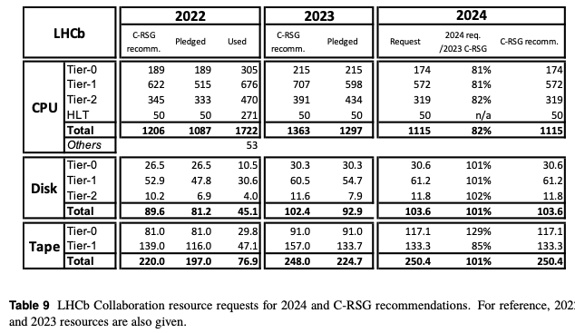

4. Pledges

The meeting then discussed the pledge spreadsheet. This is at the link below.

https://docs.google.com/spreadsheets/d/1-z73E7jaAQemlYBO2K4HFdRIzbqQe0vY/edit?rtpof=true

This has been pre filled in by P.Clarke with some known and some guessed numbers. All CCB members are asked to firm up and confirm their numbers in the spreadsheet and change the text colour to green.

5. CCB frequency
It is intended to have 4 CCB meetings per year with the following rough timeline and purpose:
Dec: preliminary request for resources for following year
Feb: finalized request and pledges
May: quarterly usage report to stakeholders [may be virtual]
Sep: quarterly usage report to stakeholders [may be virtual]
Note that the mid-year update would have been useful in 2023 as the ProtoDUNE delays could have been flagged and action taken w.r.t pledges.

6. AoB

There was no AoB at the meeting

7. Next meeting

No next meeting was set at the time.

