TCAD Simulation of Silicon Devices

EDIT 2024

The Silvaco package uses finite element code packages to simulate semiconductor devices: Athena performs structure initialization and manipulation, and provides basic deposition and etch facilities. Atlas performs the physical simulation based on finite element based-analysis of the semiconductor equations. Deckbuild is the framework to run the simulation scripts (.in files). Tonyplot is used to plot the associated structures (.str files) and characteristics (.log files).

The intent in EDIT is not to provide an in-depth tutorial, but to provide some examples of how TCAD can be used. The programs are described in more detail in the SIMDET2016 workshop website: <https://indico.in2p3.fr/event/12967/timetable/?view=standard> and in the very detailed manuals that can be accessed from deckbuild help. Students are free to extend the examples based on their curiosity.

1. Computer

We have a machine in Wilson Hall that has an active Silvaco license to which we will log in remotely. We will add each student’s kerberos ID to the EDIT user home directory on this machine, so that you can log in as the EDIT user:

>kinit USERNAME  
>ssh -X EDIT@fst-uic.fnal.gov

1. Software

> cd silvaco/diode  
 > emacs -nw params_edit.txt (or use any other available editor)

Here is where you can modify thickness or doping density, or fluence for irradiated devices, among many other device parameters. To start with we should run a diode with 290um thickness (same as the CMS diodes you are measuring in the other exercises) with negligible fluence (for example the CMS Outer Tracker expects ~10^15 1 MeV n_eq/cm^2/s. A negligible fluence would be many orders of magnitude below that. The smaller, the faster the simulation.

Filenames are built from the params_edit.txt file and the EDIT_tr analysis expects to read the files written by the EDIT_str generation program. **This only works if the filenames are not modified.**

1. Run deckbuild for initial structure generation and analysis  
   > deckbuild EDIT_str.in & (this takes about 5 minutes for a simple unirradiated diode, longer for more complex structures)

This opens a window that runs the program to build the simple diode structure. You run the program by clicking the green arrow button. Results will appear in output files like these:

EDIT_xx_yy_Diode_VF.str (structure under bias voltage)

EDIT_xx_yy_Diode_VF.log (structure under bias voltage, VI, CV and other data)

1. Now run deckbuild for the transient analysis, meaning what happens if a particle crosses through and a track forms:  
   > deckbuild EDIT_tr.in & (takes ~5 minutes for a simple diode)

This opens a window that runs the program to perform a transient analysis on the structure just built. It will generate simulations at full and half bias for the diode structure. The current version assumes a fast (delta function) impact of the track on the sensor. The output files look like this:

EDIT_xx_yy_Diode_tr_-200.str (State of the device at 1.1 ns after impact at 1 ns)  
EDIT_xx_yy_Diode-200.log (File with transient pulse shape)

The corresponding files with -100 in the name instead of -200 are for half the bias voltage.

1. Use Tonyplot to examine the structure and log files.

>tonyplot EDIT_xx_yy_Diode_VF.log & (initial VI and CV data)

>tonyplot EDIT_xx_yy_Diode_tr_-200.str & (structure file)

>tonyplot EDIT_xx_yy_Diode-200.log & (transient analysis)

Use the cutline tool to plot the field, potential, and doping profiles from the .str files. Further instructions down below.

Play with the parameters to see how they affect the pulse and structure. You can also add (simple) radiation exposure by modifying the fluence parameter.

Note that there is one simulation license and several Tonyplot licenses so people can work on plotting while others are generating simulations. Be sure to terminate the programs when you are done.

**EXTRA**

There is also a simulation for a n-on-p strip detector available. With this you can explore charge sharing and more complex pulse shapes. The files are: /home/EDIT/silvaco/strip

Similarly, there is a simple LGAD simulation.

Figure 1 Deckbuild interactive window. Just push the green arrow to execute the program.

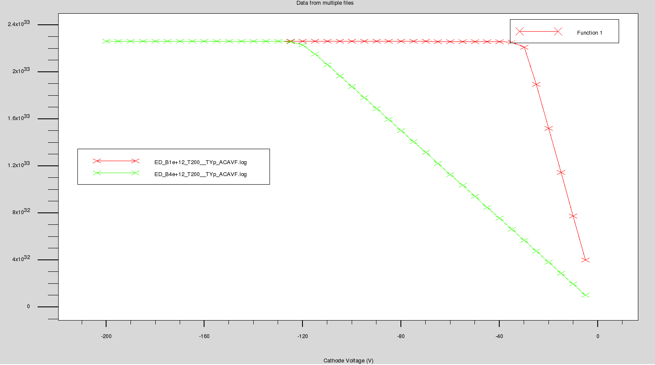

Figure 2 Tonyplot of 1/c^2 vs Cathode Voltage function for two different substrate resistivities.

Tonyplot of 1/C^2 vs Cathode Voltage function for two different substrate resistivities. To plot 1/C^2 you need to define a function:

🡪 Plot 🡪 Display 🡪 Functions

In the Functions window, define Graph Func 1: 1/(C Anode>Cathode)^2

Plot X Quantity: Cathode Voltage and Y Quantity: Function 1

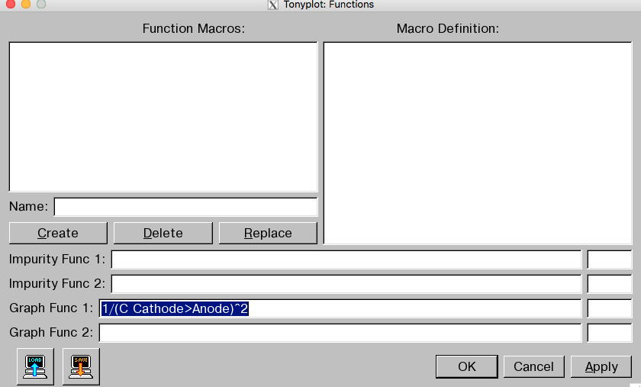

Figure 3 Defining functions in Tonyplot

Now we want to plot some other parameters using the simulated structure:

>tonyplot EDIT_xx_yy_Diode_tr_zz.str &

🡪 Plot 🡪 Display 🡪 select Contours button

🡪 Plot 🡪 Display 🡪 Define 🡪 Contours 🡪 Quantity: Potential (or any other parameter, e.g. current, etc.)

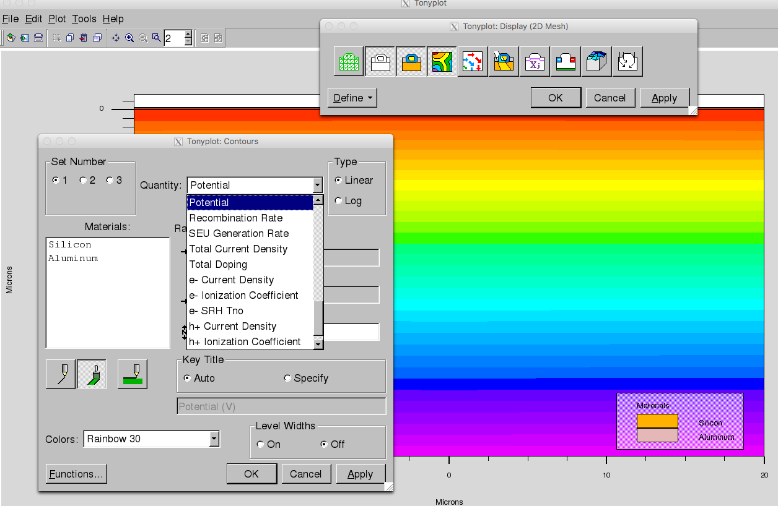

Figure Plotting contours, for example field potential lines in the substrate.

And using the log file we can look at actual pulse shapes:

>tonyplot EDIT_xx_yy_Diode-200.log &

🡪 Plot 🡪 Display

X Quantity: Transient Time and Y Quantity: Cathode (or Anode) Charge

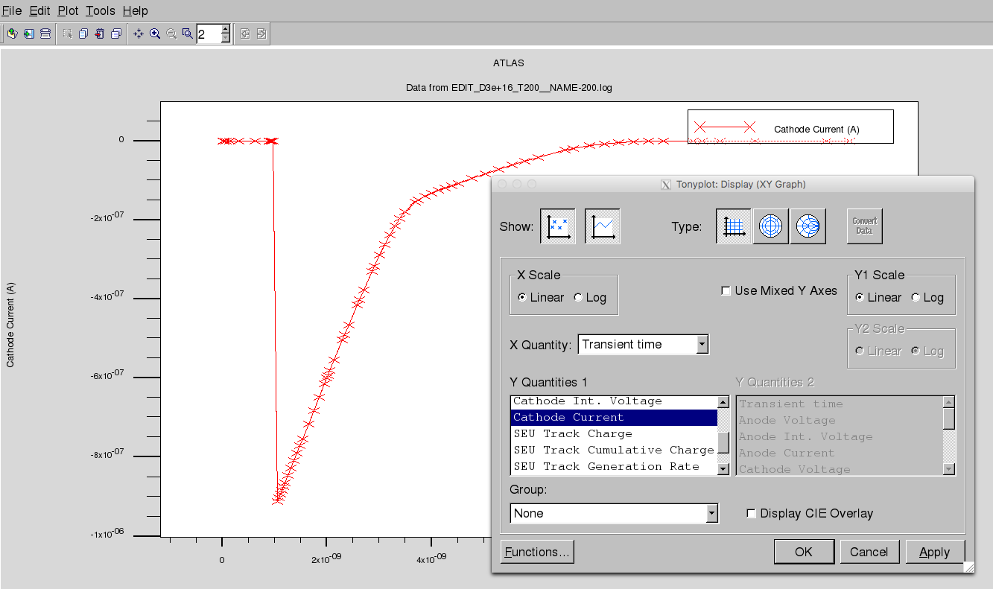

Figure Transient pulse shape