TMS Detector Mini-Review
10/18/2024

Reviewers:
Craig Group (U. Virginia), Brian Rebel (U. Wisconsin), Charlie Young (SLAC)

Speakers:
Andy Furmanski (U. MN), Andrew Sutton (FSU), Julianna Abel (U. MN), Mayly Sanchez (FSU)

Indico: (link) , Presentation is here.
Agenda:
- Overview of Detector Design - Andy Furmanski
- Physics performance of conceptual design - Andrew Sutton
- Mechanical Design – Julianna Abel
- Module Fabrication Process – Mayly Sanchez
- Summary and Opportunities – Andy Furmanski

******************************************************************************
Young (with followup email notes): Rectangular profiles tend to have small gaps between them, why not triangular strips to give you better single-plane efficiency?

When we put two pieces of scintillators side of side, any "waviness" on the faces that touch will lead to coverage cracks. This is in general larger, sometimes much larger, than the gaps we see by eye, because TiO2 coating thickness can be quite non-uniform.

This Fermilab Today https://www.fnal.gov/pub/today/archive/archive_2008/today08-12-10.html has picture of triangular profiles. Overall non-flatness is probably 0.5 mm or so. Corners are sharp as far as TiO2 is concerned but scintillator is pulled back quite a bit.

These slides https://ppd.fnal.gov/DivOffice/internal_rd/Copy%20of%20Reviews_files/Scintillator_RD/Scint-Rev.pdf have more profiles. If we put two of the bars from Page 20 next to one another, there can be a 1-mm gap - scintillator to scintillator - for most of the height of the bar.

Both of these are from a number of years ago, so things can be different now. It may be worth taking some recent samples, section it repeatedly, and see what the expectations are nowadays.

Group (email followup): Alan Bross is leading an LDRD at Fermilab to study polystyrene quality and consider coatings with more reflectivity than TiO2. TMS may benefit from these studies.

Group: On the few-meter scale, they bend a little bit, and the width does vary. We shimmed between some of the strips to make sure that they spread out within the module. You’ll need to deal with this somehow.

Young: On the y-resolution: 34 cm comes from overlap of one U and one V. Don’t we do better because there are many more than one of each? If there aren’t many layers, and the y-resolution is indeed bad, the range is short and the angle doesn’t matter... The 4.5% below seems large.

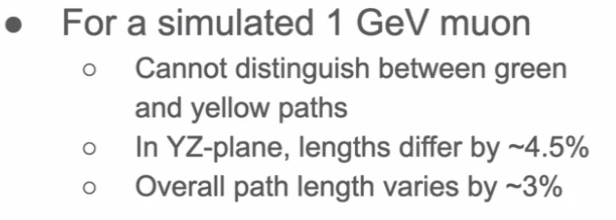

Young: Why are the mu-/mu+ ID fractions different. (A: anti-neutrino vs. neutrino kinematics). It would be interesting to see mu-/mu+ ID fractions as a function of muon entry angle.

Group: Have light yields been measured and prototype modules constructed. Didn’t see anything about a timescale? A big lesson learned is to build more prototypes than you think you need to. Surprises come up… you’ll need to address them, you’ll need time to tweak.

Young: Is the bend radius (28 mm) simply for mechanical purposes? (We believe it to be for transmission). Kurary web site recommends bend radius for long-term applications: See page 4 of https://www.kuraray.com/uploads/5a717515df6f5/PR0150_psf01.pdf. This is larger than what you propose. Light yield is the ultimate parameter of course. On the other hand, it just seems not best practice to ignore manufacturer recommendation because we don’t know for sure what ails us : - )
- Furmanski: Both NoVA and MINOS used the guidance that the bend radius be at least 20 times the fiber diameter.
- Heller: Yes, this worked fine for those applications, over decades. Manly: the real world detector it might be hard to distinguish some light yield loss due to bend vs light yield loss due to scintillator aging.

Group: My experience is the mill (aluminum, but steel is probably similar) is that they give you a huge tolerance, most of it is much flatter than that.

Group: In mu2e we used pogo pins to push the SiPM against the fiber. In original prototypes, we broke some SiPMs. Did you consider pogo pins? We did have problems, a mistake in the assembly, but this can be avoided.

Company set the force of the pick-n-place assembly improperly, some pins were bent, missing. Took them a while to admit they made a mistake. At the end, they replaced the ones that were visibly defective (still worry about the ones that are installed that weren’t visibly defective).

What’s worse, we prototyped it, but for the smaller batch for prototyping they used a different technique. The problem only appeared in their production run. Make sure that if you are testing items that they are produced with the final procedures.

This design seems perhaps more complicated than it needs to be.
- Kutter: We used pogo pins for a prototype, we’ve seen this work in other contexts. We think with this large number channels we think what we’ve proposed would be easier and more reliable. We wil continue to evalulate:
- Budd: FNAL 14th floor believes pogo pins can be made very reliably.

Young: What is the purpose of the Light injection system. Is there any thought of injection light at the far end as part of a full-length system check?
- Furmanski: Long-term monitoring will be with beam muons. LI confirms that optical and electrical connections are intact.
- Young: Isn’t this mildly circular since you need to find the muons first?

Group: Module stiffness - wouldn’t expect the aluminum to provide a lot of structural support.
- Abel: A lot is coming from the crimp. These increase the stiffness over the whole length.

Group: strongly recommend vacuum bonding. You can tune the force, its uniform.

Group: Flycutting - I think this works fine. For you, efficiency and high light-yield is not critical. A concern is that you have a whole module with 32 channels before you can do any QA. But if you don’t worry overly about light yield, you’re probably fine. On mu2e light yield was critical. On mu2e, we tested light from 2 strips, about 7% didn’t give enough light.

Detailed thesis on Mu2e CRV design and fabrication: https://libraetd.lib.virginia.edu/public_view/h415pb356

- Furmanski: We have thought about testing sub-components, but the challenges then are handling items without a lot of structural integrity.

Rebel: For the MINOS MUX (multiplexing) boxes, one thing we learnd: You might want to think about installing the fibers into the connectors first, then thread them through the scintillator. It might be easier to flycut that way.

Young: How will it be supported as it is being moved/handled?
- Oriunno: There will need to be a fixture that supplies the needed rigidity. This will also be important for storing the cassettes. They will be supported vertically, we don’t rely on the stiffness of the cassette alone.

Group: What was the rate they were able to build for MINOS? You’ll need to do QA too, which will also take time and space.
- Sanchez: Will need 3-6 tables, we need to put to time to each of the steps. Don’t have this level of detail yet.

Rebel: Is 24 hrs minimum cure time or total? APA epoxies need 7 days for a full cure. They go midway between those before moving on to the next step. 24 hrs. sounds like on the low side.
- Furmanski: 3 m² is a large area, it doesn’t necessarily need to be the strongest epoxy.

Rebel: If you’re going to move them around, APA production factories – development of these structures will take long than you think, engineering resources, construction time, bespoke shipping crates. Need to make sure you are planning for the behind-the-scenes work. You will probably under-estimate how long all of these stages can take.

Group: Agree – it’s a lot of work to design the crates, prototype those too!

Young: 2 unrelated questions about the adhesive:
- Is it complaint, or do we have to worry about differential expansion? (Andy, we do, but we haven’t yet done a final epoxy selection.) You don’t want it to put stress on the scintillator. Craig: We worried about that a lot for Mu2e (shipping from FL to FNAL in winter). In hindsight, we weren’t careful enough about that in mu2e. Avoided the hottest and coldest days.
- The cure time of 24 hrs, could that be accelerated
- Furmanski: We could, but this would be challenging given the size
- Young: electrical heater and home insulation on the top?

Group: Be mindful of ES&H considerations for using a large amount of epoxy. Need to work closely with ES&H at Universities and the lab. They required respirators.

Young: What is the drop-dead date by which decisions need to be made?
- Furmanski: It depends on what we’re talking about. There are some that can go almost to procurements.

Young: Would more planes be a problem, more electronics, power, etc?
- Furmanski: these would be 10% effects, we’d probably plan to build a few extra cassettes anyways.

Rebel: Not a lot of great places for storing APAs at FNAL. Wideband is great, big (but in demand). The top of ICARUS might be a suitable spot, there’s a crane there.
- Budd: We did look at that, depends on how much weight you can put on the blocks.

Rebel: How are the cassettes loaded into the detector?
- Furmanski: The cassette will have strip of low-friction tape, and a flat rail between the steel sheets, we’ll slide it out from the storage container. We’ll probably pull it through.
- Rebel: Definitely something you’ll want to prototype and try that out a few times.

Rebel: Endcap design (slide 34) – it looks like a lot of steps, could be quite labor intensive. (1) do we know how long this will take (2) can you streamline it? Looking at any part of your design where you can trim effort will be important leading through the FDR. Any time where you have several steps – it will inevitably take more time than you imagine.
- Abel: Good point, there are probably ways to streamline it, we’ll continue to think about that.

Group: Light sealing is harder than you expect – test as you go. Steel is hard to predict, just plan to buy some extra sheets and build some extra cassettes, the worst ones you wouldn’t have to use. Verifying the dimensions of everything (e.g. aluminum) took a great deal of time in mu2e.

Young: Showed a great deal of effort to prevent ambient light getting in. Is there protection bar to bar beyond the TiO2 coating?
- Furmanski: In the manifold they are optically separated sections, we’ll need to test to make sure there isn’t optical crosstalk through the diffuser and the LI system.

