Questions to PDS team
With responses

- Please provide data showing correlation (or lack thereof) between warm measurements of laser performance (from manufacturer) and cold measurements.

Correlation plots between warm measurements made by the vendor and cold ones made by DUNE of the threshold current and slope efficiency for a sample of 81 defocused laser diodes are shown below. While the correlation between warm and cold is negligible for the threshold current and minimal for the slope efficiency, 93% of devices to-date pass the VD PDS requirement for operation in liquid argon of 2.6 mA maximum threshold current and 0.03 mW/mA minimum slope efficiency. The procurement plan A) accounts for this loss, and B) is being modified to request an initial delivery of 10% of the units, which will be mounted and QC’d in cold prior to the vendor progressing with the remaining 90%. Funds will be available for purchase of additional laser diodes to account for unforeseen losses.

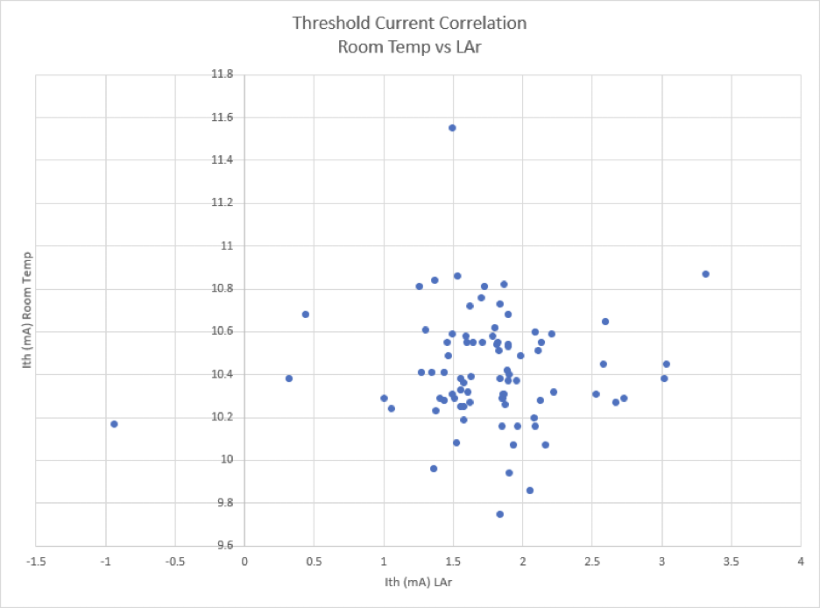

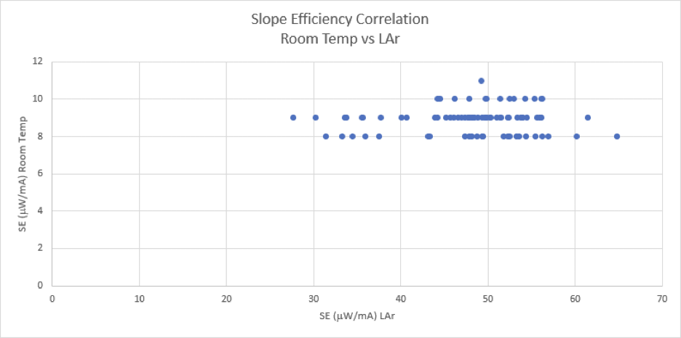
Forward voltage drop is highly correlated, however, as shown below in the ratio between cold and warm measurements of a sample of 4 laser diodes
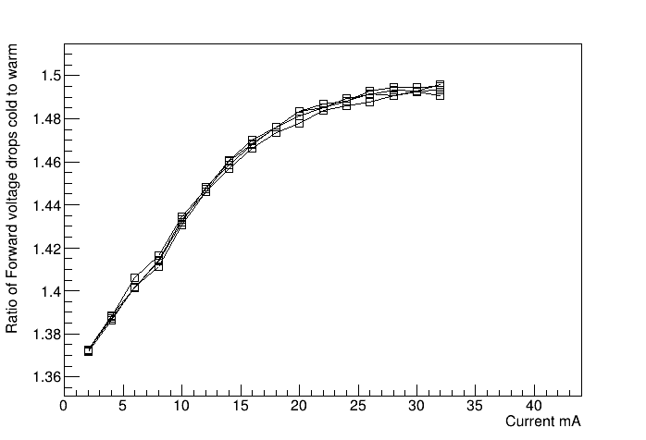

- If this procurement were to be delayed, at what point do the lasers drive the critical path?
The laser diode order could be delayed by up to approximately 5 months with respect to the schedule presented without impacting the critical path. A large increase in the number of channels of the initial 10% delivery failing QC could cost up to 2.5 months of that float.

- There are two versions of the DCEM.
What are the advantages/disadvantages of each and when will a choice be made?

While two versions of the SOF daughterboard were evaluated by the consortium during development (CMOS opamp and bipolar opamp with transistor), the consortium has settled on the bipolar opamp solution as it offers slightly better performance than the CMOS option and does not raise the possibility of a potential reduction in cold lifetime due to the hot carrier effect. The selection of this component (bipolar opamp and transistor) was based upon a series of successful bench tests at APC and FNAL, adopted in the SOF daughterboard with two successive steps of design optimization followed by exhaustive validation tests in ColdBox at CERN (three runs in 2024). The successful validation enabled instrumentation of 4 of the 8 cathode modules in ProtoDUNE-VD with bipolar amplifier front ends, and all 4 cathode modules in the upcoming cold box run (Nov-Dec) will be use the bipolar amplifier in the newly produced SOF daughterboard. This will be described in more detail in the cold electronics PRR, to be held in Q1 CY 2025.

- When will a complete longevity test report be released?

A complete report summarizing the longevity validation testing we have performed on the full cold electronics suite will be presented in the supporting data for the CE PRR, in Q1 CY 2025.

We summarized the testing performed specifically on the laser diodes in the presentation given at the review. If the committee is requesting a brief stand-alone document further summarizing the laser diode testing results we could likely produce it by the end of the year.

- When will the long-term system slice-test start?

We received the following recommendation from the VD PDS FDR:

“R17: To be completed before DOE IPR: FDC CD-2/3 September 2023. Plan for a long-term system slice-test, starting as soon as possible, beginning with final prototype components, with replacement to final production grade components when available. Leave these tests running until final installation of the detector at SURF to continue to gain experience.”

Our response to this recommendation was:

"Module-1 (ColdBox dedicated test at CERN) offers an opportunity for an approximately 1 month vertical slice-test operation in fall, which could possibly be extended if support exists and a specific justification is found. The consortium feels that dedicated long-tem component testing represents a better opportunity to conduct long-lifetime studies of the system components. ProtoDUNE-VD primary test stand for long term slice test. The plan is detailed in EDMS 2908414.”

We view the end-to-end test recommended as a cold electronics system test, more appropriate for the full CE PRR in Q1 CY2025. Development of the cold electronics chain has been under development pretty much continuously since the FDR. It is only recently (~April 2024) that we achieved sufficient stability to consider a long-term end-to-end test stand. At that point it was clear that we did not have the resources to launch an independent test stand and also bring ProtoDUNE 2 (our longest-term test stand) up to date, so we elected follow the path outlined in our original recommendation response: pursue bringing the entire ProtoDUNE 2 cathode electronics suite to the state of the art and rely on it for long-term performance data, while pursuing aggressive single component validations such as the laser diode tests at FNAL described in the presentation for this review. These dedicated tests allow us to stress the individual components being tested in a manner not possible with a “Vertical slice” type of validation testing (i.e. ~2 billion high-amplitude SOF pulses in the cold).

As we mentioned in our original response to the recommendation, we have gathered an additional data set of approximately 1.5 months of successful operation in the various NP02 cold box runs.

The protoDUNE installation is now complete, and we expect to begin taking data in the very near future, with sufficient time for us to collect results before the cold electronics PRR.

  - What is the plan for analysis?
In early January 2025 we will begin initial testing with the LED calibration system, establishing a baseline of X-ARAPUCA performance (dark count rate, S/N, detector stability for known calibration flashes) which will be periodically monitored throughout the ProtoDUNE running. When the detector is fully filled, we will begin additional studies of the system performance with cosmic rays and eventually beam events, but that is beyond the scope of this review.

  - What results will be available in time for the cold electronics system PRR?
We expect filling of ProtoDUNE 2 VD to begin in December 2024, and that the cathode will be sufficiently covered with LAr to allow us to begin meaningful continuing operations of the lower membrane and cathode modules by the beginning of January 2025 when CERN re-opens. As such we expect approximately 2.5 months of continuous operation before the CE PRR.

  - Will this longevity test run for the entire duration of ProtoDUNE-VD?
Yes. Normal operation and data taking will provide continuous monitoring of the overall detector performance, including of the laser diodes, throughout the duration of ProtoDUNE-VD running. However, dedicated stress tests, including extended high rate/high intensity pulser runs, are not currently planned. Such planning will take part as part of broader discussions of the ProtoDUNE-VD run plan.

- Is a potential light leakage from the laser diode into the cryostat a concern? If it is, what mitigation actions do you have and what QC actions will be taken to ensure that the light does not leak?

We are not concerned about potential light leakage from the SOF. The power of the SOF lasers is very low (2mW) and the SOF lasers are enclosed in a sheet metal enclosure greatly reducing the possibility of light leakage. (Note that the 1000 mW delivered per module by the power-over-fiber system drives the light-tightness considerations of the enclosure design.) No problems have been observed with SOF light leakage influencing X-ARAPUCA operations in any of our many test runs.

