NOvA Ash River Laboratory
1 May 2013

Introduction: Experimental long baseline neutrino physics analyses in the next decade will likely focus on data from detectors in existing beam lines in the United States, Japan and Europe. The longest and most intense of these three beams is NuMI, which extends from Fermilab 735 km to the Soudan Underground Laboratory and 811 km to the off-axis NOvA Ash River Laboratory, both in northeastern Minnesota. The 14 kT NOvA Far Detector is currently being installed at the Ash River Laboratory.

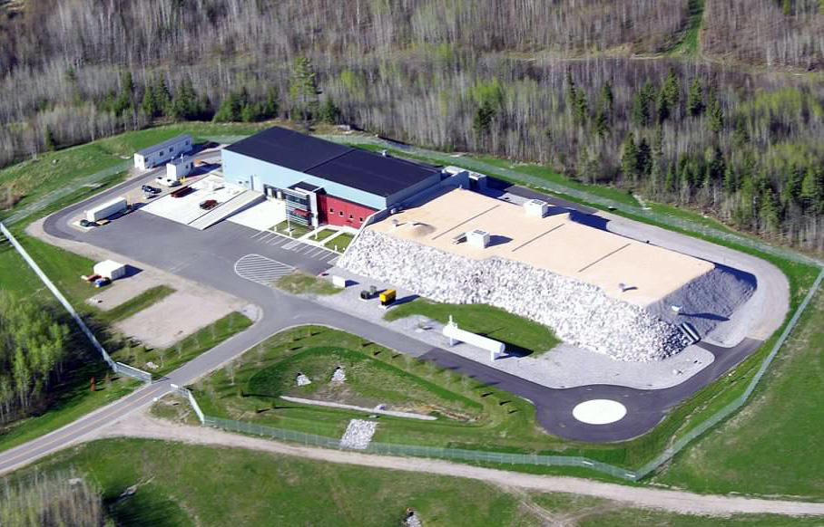
Fig. 1: Aerial view of the NOvA Ash River Laboratory. The shielded Detector Enclosure is the right section. The Service Building is to the left.
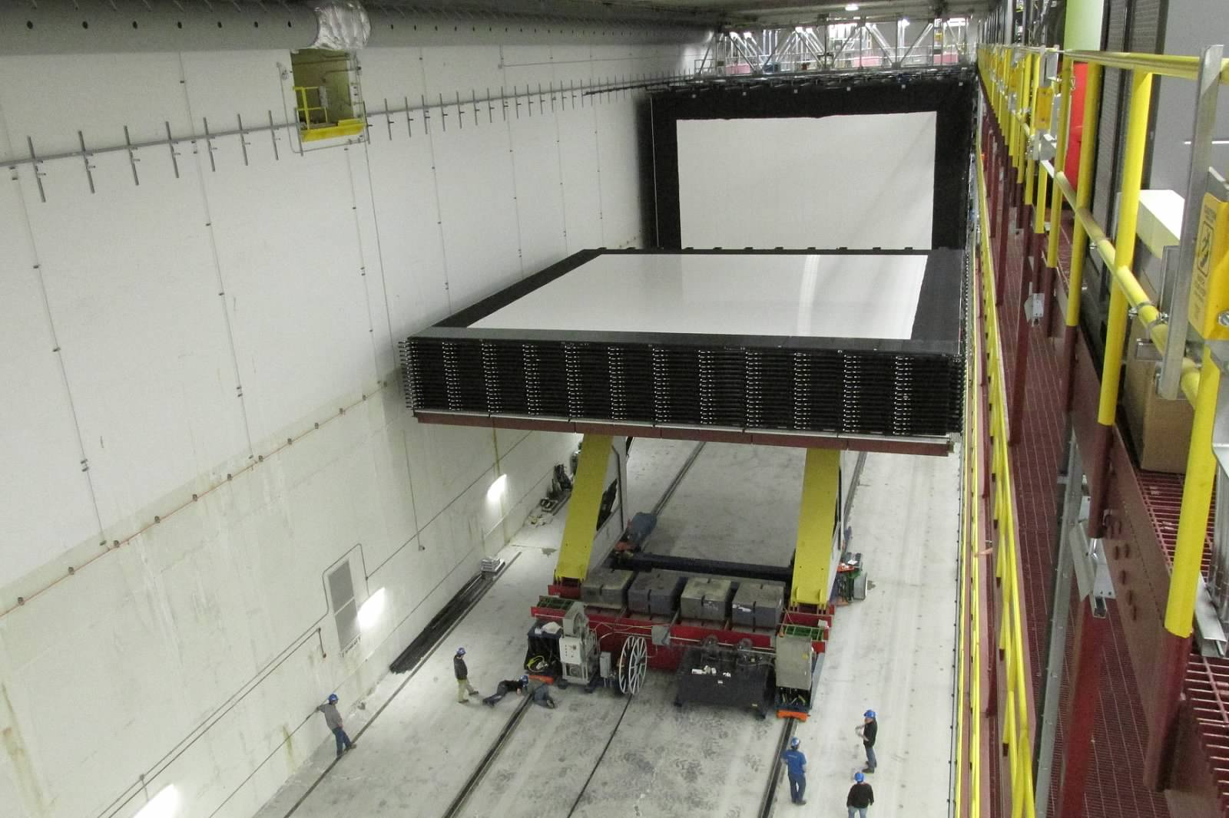
Fig. 2: An assembled block of the NOvA Detector moving into place on the Block Pivoter. Note people at the bottom for scale.

Facilities: The NOvA Ash River Laboratory is owned by the University of Minnesota and operated by the University in cooperation with the NOvA Collaboration and Fermilab. The NOvA Detector is owned by the U.S. Department of Energy (USDOE) and operated by NOvA Collaboration members and University of Minnesota and Fermilab staff members. Financial support for Laboratory and Detector operation is provided to the University of Minnesota through a Cooperative Agreement with USDOE. Detector installation is supported by USDOE through Fermilab.
The NOvA Detector Laboratory consists of a Detector Enclosure and an attached Service Building, as shown in Fig. 1. The Detector Enclosure is 108 m long by 19.2 m wide by 20.7 m high. The north 22.2 m of the Detector Enclosure is a NOvA Assembly area, which beginning in 2014, along with any unused NOvA Detector volume could provide space for an additional neutrino detector, for example, ~5 kT of Liquid Argon. The Detector Enclosure is shielded on the east, south and west sides by ~5 to 10 m of crushed rock. The top is shielded by ~1.3 m of pre-stressed concrete beams topped by ~15 cm of barite. This shielding and the rock sides of the Detector Enclosure substantially reduce the “soft” cosmic ray component and attenuate cosmic ray muons by a factor of ~4.
The Service Building is 29.2 m long by 19.2 m wide by 9.1 m high. The floor of the Service Building is 16.7 m above the floor of the Detector Enclosure. The Service Building is equipped with loading docks, a semitrailer bay and two bridge cranes, which can travel into the Detector Enclosure. The entire NOvA Ash River Laboratory is equipped with electrical power with backup, HVAC, telecom, internet, potable water and sewer utilities, a fire detection system and a sophisticated, high pressure, water misting fire suppression system with a diesel pump and indoor water storage tanks. Ancillary facilities surrounding the Detector Enclosure and the Service Building include a tanker unloading area, a hazardous waste storage area, a water retention pond, a helicopter landing pad, vehicle parking areas and a “lunch room” trailer. The NOvA Ash River Laboratory is accessed via a 5.6 km University-owned road through marshlands and boreal forest, branching off the public highway.

Future Plans: Following full NOvA Far Detector installation in 2014, space for an additional detector will be available in the Ash River Detector Enclosure. The University of Minnesota owns 22.3 hectares of land at the Ash River site, which is sufficient space to house an additional detector building of at least NOvA size.

