Mesabi Range Mine Pit Water Cerenkov Detector Facility
1 May 2013

Introduction: The goals of current and planned long baseline neutrino experiments are determinations of mass hierarchy and first measurements of δ_{CP}. For example, the Long Baseline Neutrino Experiment plans to use a ~2 MW beam and a ~10-35 kT Liquid Argon Detector either on the surface or underground to make these measurements for 6 to 10 years beginning in ~2025 for a cost of just under $1 billion. It is possible that this combination of beam power and detector mass is insufficient to make precision measurements of δ_{CP}. While it is unlikely that beam power can be increased in the foreseeable future, it is possible to envision a megaton mass Water Cerenkov Detector (WCD), if such a device can be operated on the surface in an existing reservoir. The GRANDE Detector, proposed in late 1990 for a barite mine near Little Rock AR with a beam from the SSC, was an example of such a device. The CHIPs Detector, currently in a planning stage, is a future example of a surface-located WCD. In addition to developing designs for future detectors, it is also possible that near term R&D on a surface WCD may even produce interesting results on mass hierarchy and δ_{CP}, to complement expected data from NOvA and T2K in the next decade before LBNE.

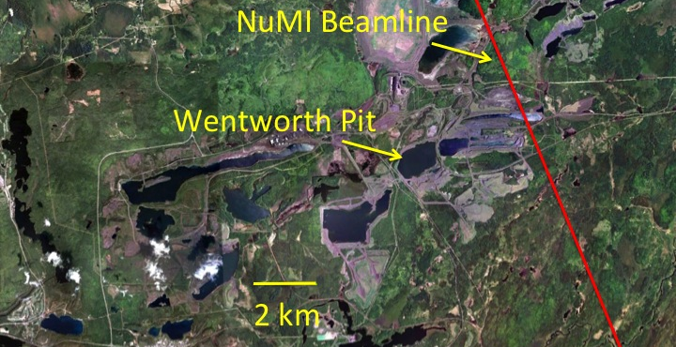
Fig. 1: Aerial photo of Mesabi Range Mine Pits, showing the NuMI Beam centerline, the range of pits and a distance scale.

Facilities: The NuMI Beam from Fermilab to northern Minnesota is the longest and most intense of three neutrino beams existing in the world. The beam extends from Fermilab 735 km to the Soudan Underground Laboratory and 811 km to the NOvA Ash River Laboratory. About 710 km from Fermilab, the NuMI Beam crosses the Mesabi Range, the largest natural iron ore deposit in North America. The Mesabi Range is a narrow formation, more than 100 km in length but only a few kilometers in width, running roughly southwest to northeast, perpendicular to the NuMI Beam. The Mesabi Range has been extensively mined, leaving a variety of water-filled mine pits, as shown in Fig. 1. For example, the Wentworth Pit, marked in Fig. 1 and the current of CHIPs discussions, is about ~1300 m by ~800 m by ~60 m deep and is located ~5 km from the centerline of the NuMI Beam. The variety of pits shown in Fig. 1 provide multiple off-axis locations that have been targeted by Fermilab neutrinos since the NuMI Beam began operation in 2005 and require only water purification and photomultiplier tubes (PMTs) to become active neutrino detectors and prototypes for a megaton surface WCD.

Detectors: A Detector in the Mesabi Range WCD Facility would likely include an array of floating platforms suspending a fabric liner to isolate a volume of purified water from the remaining water in the pit. Water would be taken initially from the non-detector volume of the pit, purified by filtering and perhaps reverse osmosis and then added to the detector volume. Once the fabric liner volume is filled, the same water system would be used to constantly recirculate and purify detector water. The cover of the detector volume would include accessible hatches, so that strings of self-contained PMT assemblies (similar to ICECUBE, could be introduced, perhaps in phases, into the detector. The instrumented region would begin, perhaps 30 m below the water surface, to provide some reduction is cosmic ray background.

Ownership: The Mesabi Range Pits are owned by several public and private entities. Most have no current use either for mining or recreation and are naturally water-filled.

