**Underground Facilities in Antarctica**

Albrecht Karle,

Wisconsin IceCube Particle Astrophysics Center (WIPAC) and Department of Physics, University of Wisconsin–Madison

Over the past decade, the Amundsen-Scott South Pole Station has emerged as a site of world-class astronomy, particle astrophysics and neutrinos physics. Recent overviews of neutrino, cosmic ray and astronomy programs at the South Pole were presented at a workshop in 2011 in Washington [1] and at the Symposium 288, Astrophysics from Antarctica, at the International Astronomical Union General Assembly [2].

IceCube.pdfSince 2011, IceCube has been in full operation, with 5160 optical sensors distributed on 86 strings (cables), transforming one gigaton of extremely clear ice into a giant Cherenkov detector. IceCube detects muons at a rate of 3kHz and atmospheric neutrinos at rate of more than 50,000 events per year at energies from 500 GeV to 100 TeV. It is the most sensitive detector for astrophysical neutrinos from energies of 100 GeV to 109 GeV. An additional surface detector, IceTop, consisting of 162 detector tanks, acts as a veto against high-energy air showers. A denser subarray for energies above 10 GeV, IceCube’s DeepCore is located in the lower part of the detector’s center.

The IceCube detector can be used to veto incoming muons in order to greatly lower the background rates in the deep detector to levels comparable to the deepest mines, such as Sudbury, or deeper. The more than 100,000-year-old ice is not only clear but also extremely pure. Radioactive contaminants in the deep ice are in the range of 0.1-1 ppt for uranium and thorium and 0.1-1 ppb for potassium.

Two smaller subdetectors that emerged from IceCube, IceTop and DeepCore, are now integral parts of the detector. Other projects that are in the prototype phase include:

* DM-Ice, a NaI-based direct dark matter detector that would be sensitive to a DAMA like signal in the few keV range [4]
* The ARA (Askaryan Radio Array) neutrino array, a detector that uses the IceCube lab as a base [5]

Still other projects are in the planning stages for full-scale implementation, such as the full-scale DM-Ice and PINGU (Precision IceCube Next Generation Upgrade) [3]. PINGU is envisioned as a denser array in the center of IceCube, with the primary goal of measuring the neutrino mass hierarchy [6]. Also under consideration is an even denser detector yet—a 5-megaton, superdense, supernova neutrino detector (MICA)—also planned for tackling proton decay. A PINGU-like detector has also been suggested for use as a long baseline far detector for a neutrino beam from the Northern Hemisphere, see for example ref. [7]. Envisioned scheduled for these proposed projects are illustrated in the figure below.

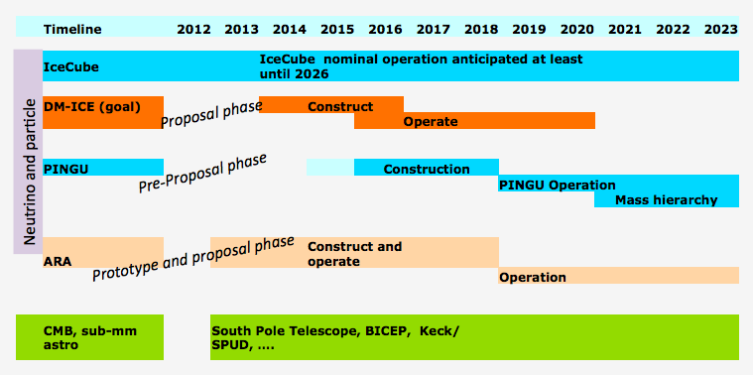

There is no elevator shaft to this underground “laboratory.” Deployment of new instruments requires drilling holes in the ice for which IceCube designed and developed a special drill—the Enhanced Hot Water Drill (EWHD). Drilling a single 60-cm diameter hole to a depth of 2500 m takes 30 hours. The costs are relatively small compared to excavation costs of a large volume detector in a mine.

The IceCube Neutrino Observatory is operated by the University of Wisconsin–Madison. The South Pole station as a whole is operated by NSF’s Office of Polar Programs. The NSF grant proposal mechanism is the process for gaining access to the South Pole and the IceCube facility.

**References:**

1. Astrophysics from the South Pole: Status and Future Prospects. Report from a workshop held in Washington, April 2012, <http://find.spa.umn.edu/~pryke/southpolemeeting/sp_ws_wp.pdf>
2. International Astronomical Union Symposium 288: Astronomy and Astrophysics from Antarctica, Proceedings, <http://www.phys.unsw.edu.au/IAUS288/>
3. Neutrino Astronomy – A Review of Future Experiments, Neutrino 2012, Kyoto, arXiv:1210.2058
4. Cherwinka et al., A Search for the Dark Matter Annual Modulation in South Pole Ice, Astroparticle Physics 35 (2012) 749-754, [arXiv:1106.1156](http://arxiv.org/abs/1106.1156)
5. P. Allison et al. (ARA collaboration), Design and Initial Performance of the Askaryan Radio Array Prototype EeV Neutrino Detector at the South Pole, arXiv:1105.2854, Astropart. Phys. 35 (2012) 457-477
6. PINGU one-page white paper for Snowmass 2013
7. W. Winter, Requirements for a New Detector at the South Pole Receiving an Accelerator Neutrino Beam, arXiv:1110.5908