Soudan Underground Laboratory
1 May 2013

Introduction: The mission of the Soudan Underground Laboratory is ongoing support of significant physics experiments and technological innovations that require low background environments. The first proton decay detector was installed at Soudan in 1980. Since that time, at least 33 “top-cited” papers have resulted from experiments performed at Soudan on proton decay, cosmic ray muons, neutrino oscillations and dark matter searches. The Soudan Laboratory is also unique in its location as a target in the Fermilab-to-Minnesota NuMI Long Baseline Neutrino Beam, currently the longest and most intense of the three long baseline neutrino beams in the world.
Facilities: The Soudan Underground Laboratory is located in Soudan Underground Mine State Park, Soudan, Breitung Township, St. Louis County, Minnesota, ~360 km north of Minneapolis-St. Paul. The Laboratory is ~710 m underground and has shielding equivalent to ~2.1 km of water. The University of Minnesota operates the Laboratory under a lease agreement with the Minnesota Department of Natural Resources. The U.S. Department of Energy provides primary financial support for Laboratory operations through a Statement of Work (SOW) between Fermilab and the University. The National Science Foundation provides some support for the Cryogenic Dark Matter Search (CDMS) Experiment and for the Laboratory outreach program.
The physical facilities at Soudan include two large experimental halls. The Low Background Counting Facility (LBCF) Hall is 71.6 m long, 13.9 m wide and 10.7 m high. The MINOS Hall is 82.3 m long by 15.8 m wide by 13.7 m high. Both Halls are equipped with bridge cranes. The entire Soudan Laboratory is equipped with electrical power with backup, HVAC, telecom, internet, cryogenics facilities and fire detection and suppression systems. Access is through a three-compartment shaft, with two hoisting compartments operated by State Parks staff. A Refuge Facility is located ~1 km west of the Laboratory and is accessible via a horizontal drift.

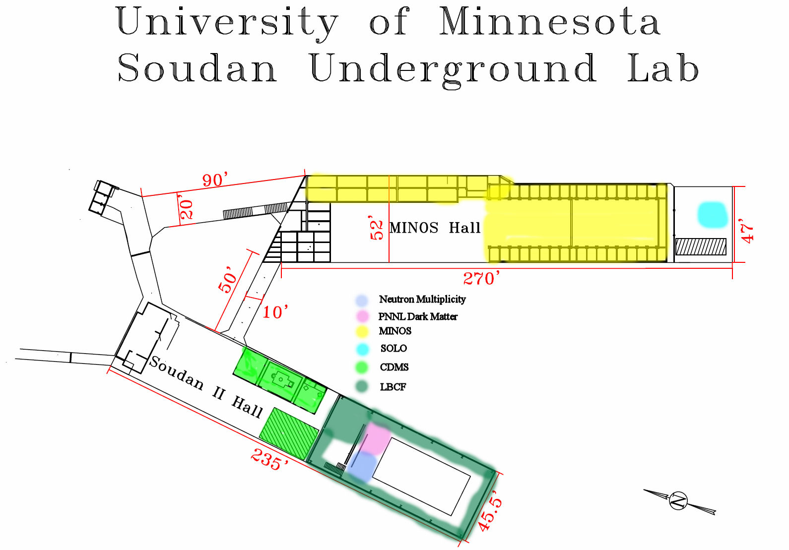
Fig. 1. A plan view with dimensions of the Soudan Underground Laboratory. Locations of several experiments are shown in the diagram.
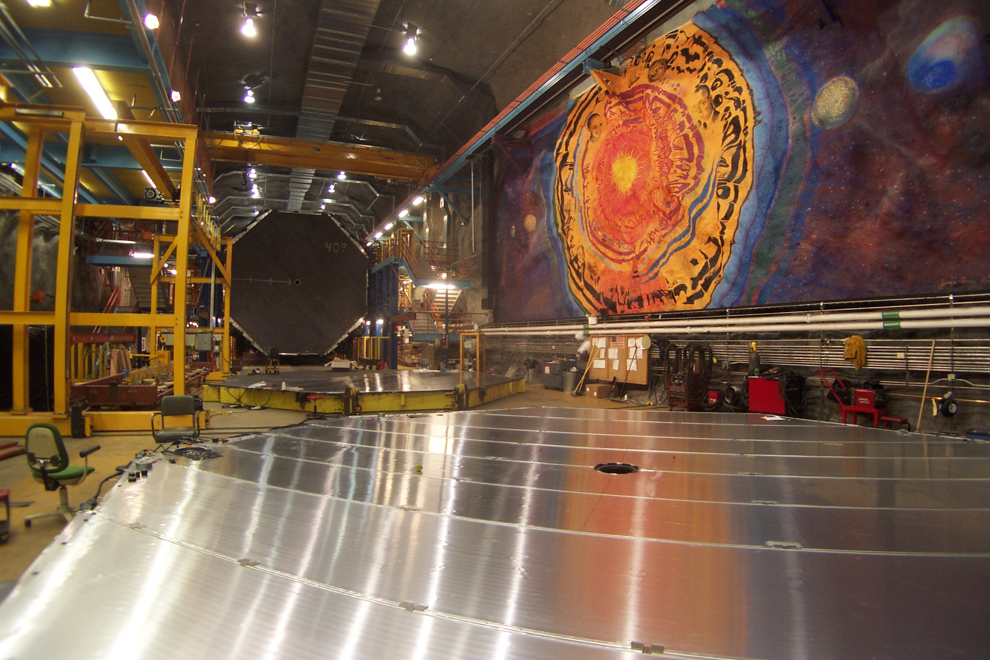

Fig.2. The 5.5 kT Steel-Scintillator MINOS Far Detector, now in use for the MINOS+ Experiment. The MINOS Mural is on the wall at right.

Current Experiments: The following experiments are currently operating at the Soudan Underground Laboratory:
• MINOS+: Improved measurements of 2-3 neutrino oscillation parameters, searches for non-standard interactions and sterile neutrinos. MINOS+ utilizes the Medium Energy NuMI Beam.
• CDMS2/Super CDMS: Dark matter search using very low temperature silicon and germanium detectors.
• Neutron Multiplicity: Background measurements of underground neutron fluxes.
• CoGeNt: Dark matter search using cooled, low background germanium detectors.
• SOLO: HPGe Detector used as a materials screening facility for Majorana, CDMS, XENON and LUX.
• Gopher: An HPGe Detector used to screen samples for radioisotope contamination using gamma spectroscopy.
• USD Neutron Detector: A large liquid scintillator neutron detector operated by the University of South Dakota to establish baseline measurements for ultra-low background experiments.
• Time of Flight: A continuing initiative for precision measurement of neutrino velocity between Fermilab and Soudan.
• Low Background Counting Facility (LBCF): An actively shielded, general purpose facility with support provided for users with low background testing and calibration requirements.
• Spansion Memory: A commercial study of the effects of radiation on errors in semiconductor memory devices.

Outreach and Education: The Soudan Laboratory operates an extensive education and outreach program with ~5,000 visitors to the underground experimental halls each year. High School Teachers and Undergraduate Students works as tour guides and interpreters, in cooperation with State Parks staff members. K-12 school and other group tours are scheduled year round. Open access public tours are offered daily during the Summer and on Fall Weekends. The Soudan Outreach Coordinator also responds to requests for K-12 school and community group visits.

Future Plans: The Soudan Laboratory is focused on supporting current and future active and funded physics experiments, tests and calibrations over the near to intermediate term. Soudan is a user facility and experimenters and their funding agencies drive the Laboratory’s future plans. The Soudan Laboratory will continue to utilize and exploit its assets of two fully equipped laboratory caverns and the existing NuMI Beam, as well as work to expand its capabilities, to facilitate outstanding physics for as long as the current high level of community interest continues.

