The Waste Isolation Pilot Plant as an Underground Research Laboratory
May 1, 2013

The Waste Isolation Pilot Plant (WIPP) is a deep geologic repository for the permanent isolation of radioactive waste. It is owned and operated by the US Department of Energy Office of Environmental Management (DOE-EM) near Carlsbad, New Mexico. It also hosts several basic science experiments that take advantage of low natural background radioactivity in the host rock (halite), and cosmic ray muon attenuation from 667 meters of overburden.

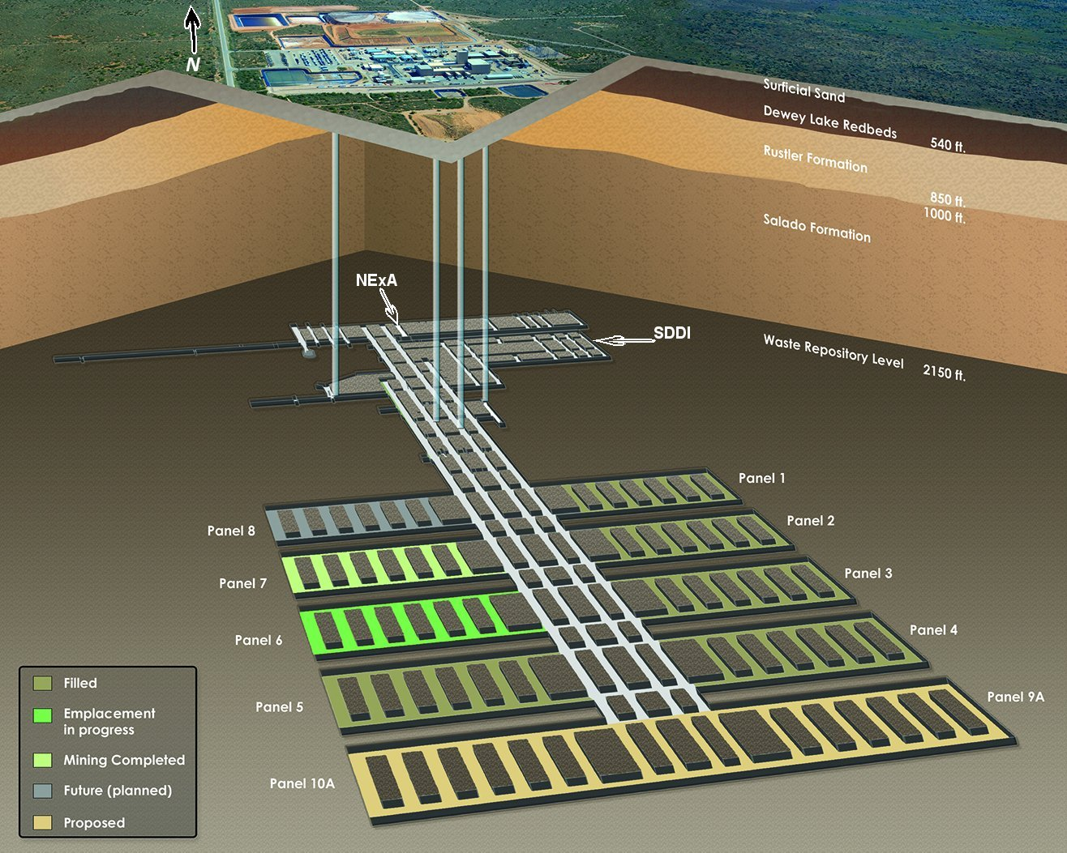
Fig. 1 WIPP cutaway showing disposal panels to the south of main access shafts and experimental areas to the north.

WIPP’s prime mission of waste disposal takes priority over use of the facility for underground experiments. However, infrastructure and access are available to the science community and have been successfully shared for more than a decade. WIPP is a hazard category 2 nuclear facility, and operates within a strict nuclear safety envelope. While the experimental regimen at WIPP does not employ radioactive materials, research must still be carried out under this same stringent safety umbrella. To help researchers interface and operate within these requirements, WIPP maintains staff (primarily supported through Los Alamos National Laboratory, from its Carlsbad office) in a Test Coordination Office (TCO). The TCO essentially serves as a liaison between the research organization and the Management and Operating (M&O) Contractor for the facility, and is provided at no cost to the science community.

There are 4 vertical shafts to the underground, with two primarily used for personnel and equipment. Waste emplacement is south of the central access shafts, while the area to the north is used for infrastructure and experiments. Electrical power (480 VAC) to the North Experimental Area (called NExA – see Fig. 1) is provided via two separate circuits and power centers to minimize outages, although a few short site-wide outages per year can be expected. The underground is nominally accessible from about 0530-1530, six days a week. When second shift operations occur, the access window is nominally 0530-2330. Access 24/7 can be provided if experimental funding is made available. NExA is home to EXO-200, a dark matter detector development effort (DMTPC) led by MIT, and a biology experiment operated by NMSU. At approximately 1200 m², it is 100% subscribed. A new experimental area (about 10K m²) labeled SDDI in Fig. 1 is being mined (completion date August 2013), and some of this space could be offered for future experiments.

WIPP does not fund the research itself, but does provide in-kind services as available from the waste disposal mission (e.g., training, ground control, power, lighting, ventilation, heavy equipment movement, and of course, access and hoisting to/from the underground). DOE-EM and the DOE Office of Science (both Nuclear Physics and High Energy Physics) can coordinate funding transfer should additional services from the M&O contractor be needed (e.g., shift differential labor, new mining, new telecommunication equipment, etc.). WIPP’s annual operating budget for the waste disposal mission is approximately $200 million per year. The facility is in its 14th year of disposal operations, and plans are to maintain and operate it until about 2050.

Conditions in the underground are completely dry, and with a nominal rock temperature of 28ºC, NExA is consistently warm. The WIPP underground contains significantly less (3-5%) natural radioactivity than the rocks exposed in other mines, with U~40 ppb, Th~70 ppb and K-40~0.5 ppm. Underground Radon concentrations are driven by those at the surface entering with ventilation air. More information about the facility can be found at: http://www.wipp.energy.gov/science/UG_Lab/UG_LabNew.htm.

