The Kimballton Underground Research Facility (KURF) provides large, low-cost, low-risk, shallow to mid-depth, existing and future laboratory space for underground physics research and detector development, with drive-in access and close proximity to Virginia Tech (a 30,000 student major research university). The Lhoist Group owns and operates the host limestone mine, providing water pumping and unlimited researcher access 6am-11pm five days a week (7am-3pm on Saturdays) with very little interference. Virginia Tech and Lhoist have a 30 year agreement in place for KURF, with the basic cost for space and operations at KURF currently at $10k/yr for an experimental module.
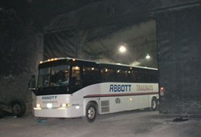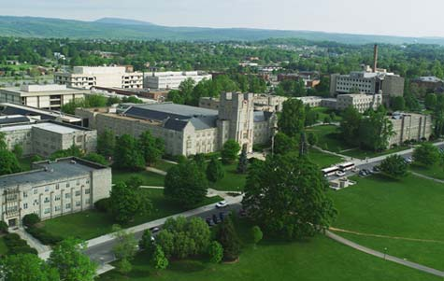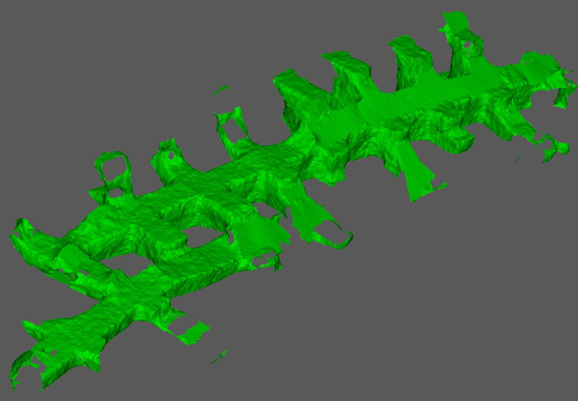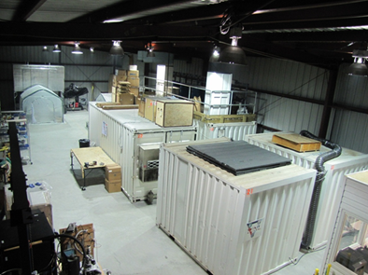
KURF is a 30 minute drive from Virginia Tech, and diesel trucks can be driven underground via a spiral ramp to deliver even large equipment.
Tour buses and
roll-back trucks have
visited KURF. The 50 miles of drifts
are 40 ft wide and 24-100 ft high.
KURF is on the 14th E#1 level in
window 4 (1450 mwe overburden), but the
whole drift mapped above (1000’x40’x60-100’) is
available for future research, as well as other levels.
Currently over sixty researchers are trained to use KURF (there are only 30 miners). Groups (and their funding source) making use of KURF include:
- mini-LENS (Low Energy Neutrino Spectroscopy) (NSF: Virginia Tech, Louisiana State University, BNL, UNC, NCCU, HBNI)
- Neutron Spectrometer (NSF: University of Maryland, NIST)
- ββ Decay to Excited States (DOE: Duke University)
- HPGe Low-Bkgd Screening (NSF: North Carolina State University, University of North Carolina, Virginia Tech)
- MALBEK (Majorana 0νββ) (DOE: University of North Carolina)
- ³⁹Ar Depleted Argon (NSF: Princeton University)
- Watchman (Watchboy) (DOE: LLNL – located on the second level)

As a consequence of the limestone rock setting, the natural background levels at KURF are very low: Th (2.6MeV) at 0.5 cm⁻²min⁻¹; K(1.4MeV) at 3.8 cm⁻²min⁻¹; U(0.6MeV) at 1.9 cm⁻²min⁻¹; ²²²Rn < 14.8 Bq m⁻³ The muon flux at the 1450 mwe KURF depth is 1 muon m⁻² min⁻¹. [P. Finnerty, et al., Nucl.Instrum.Meth.A642:65-69,2011. [arXiv:1007.0015]; J. Xu, et al. [arxiv:1204.6011]].
The future research program at KURF includes ongoing programs as well as new users who have requested space: from UC Berkeley (Bolometry - Kolomensky); from FNAL (CENNS - Yoo); from Columbia University (Geotraces – Kenna). In addition, major research efforts not requiring depths found at Gran Sasso, SNOLab or SURF will find KURF a potentially ideal home.
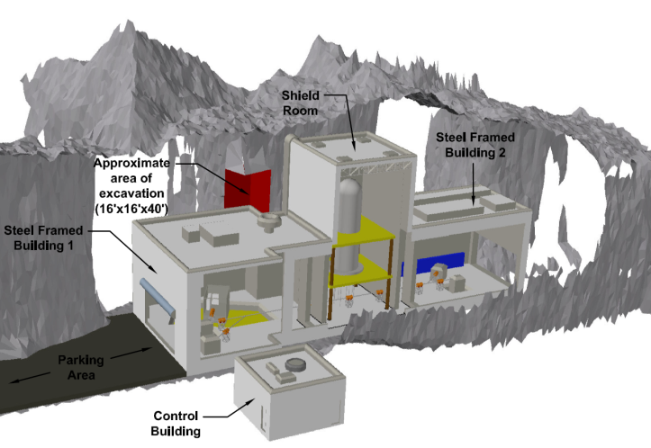
KURF is being actively considered as a host location for the Dual Ion Accelerators for Nuclear Astrophysics (DIANA) NSF program. KURF provides sufficient depth, multiple possible locations in existing space, drive-in access, low risk, and low infrastructure and operating costs (the latter being consistent with NSF’s historic funding capabilities for similar scale projects, in contrast to the high overall costs already encountered elsewhere should they need to be borne by the NSF alone). The corner-cut indicated in the diagram at right is estimated to cost only $10k. The complete infrastructure to host and house DIANA at KURF, per their specifications, is estimated at $6M plus contingency. Beneficial occupancy for DIANA could be achieved well within two years after funding.
DIANA can be placed in any number of locations within the 14th level.

Another direction for KURF is the LENS experiment, following successful completion of the mini-LENS proto-type. LENS could be housed at several locations, but probably with lowest cost at KURF, since the triple-coincidence experiment does not need extreme depths, and space already exists. Further information regarding KURF can be found at: www.kimballton.org.

Bruce Vogelaar (vogelaar@vt.edu); Derek Rountree (rountree@vt.edu); March 2013.

