Target Magnet “20to2T5m120cm4pDL”

Robert J. Weggel Particle Beam Lasers, Inc. May 9, 2014

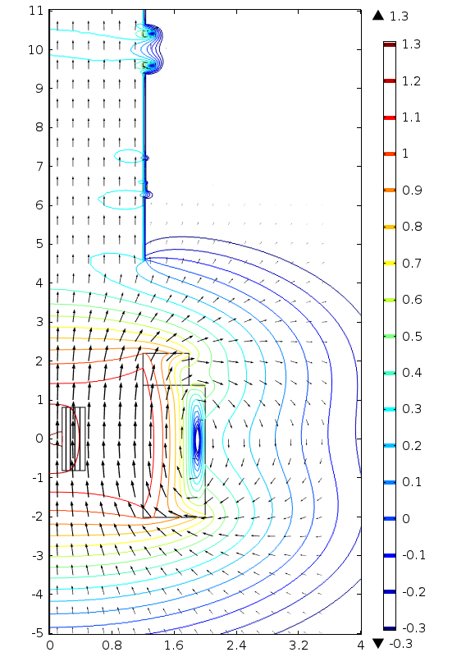

Fig. 1a Field direction (arrows) & log10|B| (contours) of Target Magnet “20to2T5m120cm4pDL”; consecutive contours are [~0.5 (navy), 0.63, 0.8, 1, 1.26, 1.6, 2.0, 2.5, 3.2, 4, 5, 6.3, 8, 10, 12.6, 16, 20 (maroon)] T.



