Abstract.

This paper describes design of the LCLS-II 1.3 GHz cryomodules, using a risk-based methodology for optimizing long-term reliability and maintainability of the CW systems, based on developments of the XFEL cryomodule design. Major differences in RF power coupler, BPM, and quadrupole/correction magnet, as well as cryomodule segmentation options and solutions for heat removal are described, which are essential for CW operation and LCLS-II beam parameters.

Introduction.

An XFEL-style cryomodule (very similar to a TESLA/ILC style 3+) with minimal changes for CW operation has been selected as a baseline concept for LCLS-II in order to provide efficient and low-risk cryomodule design and production, consistent with space constraints in the existing SLAC tunnel. The cryogenic linac will then consist of long, un-segmented strings of as many as 10 cryomodules with insulating vacuum and internal piping connected from one cryomodule to the next.

Requirements.

A Physics Requirements Document (LCLSII-4.1-PR-0146), and a Functional Requirements Specification Document (LCLSII-2.5-FR-0053) describe requirements for the 1.3 GHz superconducting RF cryomodules. In summary, these cryomodules contain the superconducting RF cavities and magnets as required for proper performance in the linac: aligned, at low temperature, magnetically shielded, with RF power input and necessary controls systems and instrumentation.

Design.

Like the TESLA, ILC and XFEL designs, RF cavities will be welded into titanium helium vessels, which contain the 2 K saturated liquid helium surrounding the RF cavities. Also like XFEL, each cryomodule will include eight RF cavities, one superferric (cold) combined quadrupole and corrector magnet package, and a cold beam position monitor. The length of an LCLS-II cryomodule is approximately 12.2 meters. Each dressed cavity will incorporate a cold electro-mechanical, end-lever tuner, similar to that in XFEL, and an adjustable coaxial RF power coupler. Like the TESLA/ILC dressed cavities, the maximum allowable working pressures will be 2 bar warm, 4 bar cold for the helium vessels and associated piping, and 20 bar for other piping.

Cryomodule insulating vacuum and most internal piping will be connected end-to-end as in the TESLA design concept, eliminating the need for an external transfer line. Space constraints in the SLAC tunnel would make the design and implementation of a system with external transfer line extremely difficult. The TESLA/XFEL-style cryomodule, which contains all cryogenic piping within the cryomodule, provides the best existing design solution for elimination of the external transfer line.

Some differences from the XFEL (or Type 3+) design are necessary. Heat loads greater than 10 W per cavity at 2 K, with eight cavities per cryomodule, as opposed to 1 to 2 Watts per cavity for XFEL, result in some thermal and helium flow considerations which force changes from the XFEL design. Changes include some increased pipe sizes to allow conduction of the heat from the cavities through the superfluid helium; limitation of the length of the 2 K 2-phase bath; omitting the 5 K radiation shield; and using modified input and HOM couplers and coupler cooling. LCLS-II will require two-phase pipe size changes to accommodate the large vapor flow rate. Both the relatively large heat load of over 90 W at 2 K and the 0.5% tunnel slope make the division of 2 K liquid units desirable at the one-per-cryomodule level in order to adequately control helium mass flow rate and helium inventory in each cryomodule.

CW operation imposes tight constraints on cavity frequency in order to minimize RF power source requirements. Thus microphonics and cavity frequency variation with pressure need to be minimized, and active control of cavity resonant frequency will be accomplished using cavity tuners. A double-layer magnetic shielding configuration will protect the high Q0 performance of the cavities, and cooldown rate will be controlled both in speed and uniformity to minimize trapped flux.

A few related instrumentation differences from the XFEL-type of cryomodule result from modifications for CW operation. Those differences include liquid level sensors at each end of each cryomodule, in the ends of the closed 2-phase pipe.  The liquid level control valve operates on one of those liquid levels as a control set point.  Another difference is a larger heater (capacity ~150 W total) in the 2 Kelvin system in each cryomodule.   This heater is used to "pre-set" cryogenic flow and conditions prior to RF turn-on, then heaters are turned down as RF comes on.  But at a low level of a few watts, these heaters may also provide some fine control of 2 K flow.

Experience with existing SRF cryomodules points to certain risks for which mitigation options will be considered and developed. Potential problems include excessive cavity microphonics, cavity tuner mechanical failure, input coupler overheating, HOM coupler overheating or multipactoring, and cavity performance degradation in the cryomodule relative to initial vertical test results.

Mitigation measures under consideration include some separation of injector and lower energy cryomodules such that they can more readily accommodate specialized cavities with a HOM coupler design to minimize perturbation of the low-energy beam, and allow to be warmed independently; access ports for tuners on all 1.3 GHz cryomodules.

Recent tests of high-Q, nitrogen-doped RF cavities indicate that rapid cooling through the superconductor transition temperature may help prevent flux trapping and result in a better cavity Q. Capillary tubes provide cool-down flow to each helium vessel from a much larger diameter cool-down/warm-up line.  (See Figure 1.) The capillary tubes, having by far the dominant resistance to flow in the flow path, provide essentially a uniform parallel cool-down of all helium vessels simultaneously.  The control of flow into the cool-down/warm-up line is provided back at the distribution box.  So, for example in the longest string of cryomodules, L3, we have 20 cryomodules cooled in parallel.  This means 160 helium vessels cooled in parallel, not optimal for quick cool-down.  Features for rapid cool-down could be added to the system of cryomodules with a few possible modifications of the distribution system and cryomodule system as described below.

It may be possible to provide a rapid switch from 80 K to 5 K at the entrances to the capillary tubes by means of a valve in the end box at the far end of the string. The end box valve could allow a large flow to move through the cool-down pipe (returning via the 300 mm pipe) and pre-establish a low temperature in the cool-down pipe before much significant cooling of helium vessels occurs.

A second concept, which should provide even faster cooling of the RF cavities, involves the addition of a second valve in each cryomodule supplying a local cool-down/warm-up pipe from the 5 K thermal shield supply pipe.  This permits, for example, precooling everything to 80 K, then closing the valve to the cool-down line, precooling the 5 K line, then opening one cool-down valve at a time, cooling one cryomodule at time from 80 K to 5 K, and doing so with a sharp 5 K helium wave.  Only 8 cavities cool in parallel rather that 160, which means a much higher helium flow rate is possible.

The addition of the second valve in a cryomodule is expensive and introduces new operational risks (e.g., a valve leak sends 5 K helium into the 2 K region).  But this can provide much more speed and control of cool-down.  Cryomodule and distribution system designers are collaborating on various helium flow design issues; we will plan to add some cool-down simulations to this work.

A split quadrupole/corrector magnet package developed for ILC allows installation of the magnet around the beam pipe after removal from the clean room. Although this differs from the XFEL magnet scheme, it benefits from simplification of the string assembly in the clean room. Tests have shown that this magnet design meets our specifications for alignment and magnetic center stability.

In summary, we start with the TESLA Type 3+, and XFEL, designs and make the following changes:

* High heat loads result in
  + Larger chimney pipe from helium vessel to 2-phase pipe
  + Larger 2-phase pipe (~100 mm OD)
* Both high heat load and the 0.5% slope of the SLAC tunnel require
  + Closed-ended 2-phase pipe providing separate 2 K liquid levels in each cryomodule
  + 2 K JT valve on each cryomodule
* Two layers of cold magnetic shielding to preserve high Q0
* Minimal df/dP results in our selection of end lever tuner and associated helium vessel design
* Addition of access ports for maintenance of tuners
* Uniform cool-down of bimetal joints at each end of the cavity by means of two cool-down ports in each helium vessel
* No 5 K thermal shield, a simplification due to large dynamic heat at 2 K making such a thermal shield of marginal value
  + But retain 5 K intercepts on input coupler
* Input coupler design for 7 kW CW plus some margin, a modification of an existing pulsed coupler design involving better heat transfer from and cooling of the inner conductor
* Enhanced cooling of HOM couplers

A flow schematic illustrating the separation of 2-phase pipes and addition of a valve for liquid level control in each cryomodule is shown below.

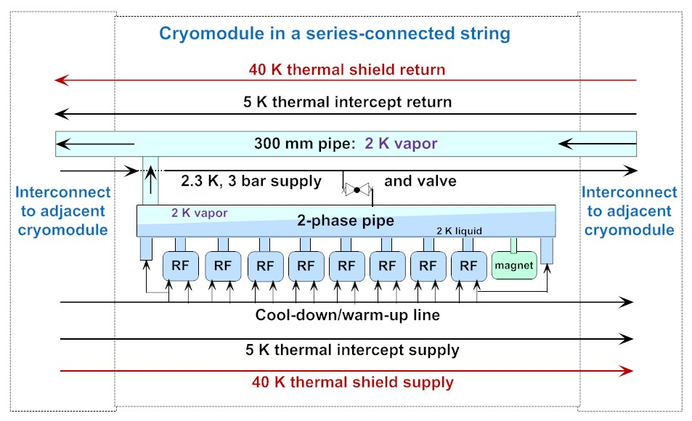

Figure 1. LCLS-II cryomodule helium flow scheme illustrating slope, liquid supply valve, and through pipes.

Images from the CAD model of a dressed cavity with end lever tuner and cold part of the input coupler are shown below. Support lugs on the titanium helium vessel are shown, as is the helium port which connects to the 2-phase pipe.

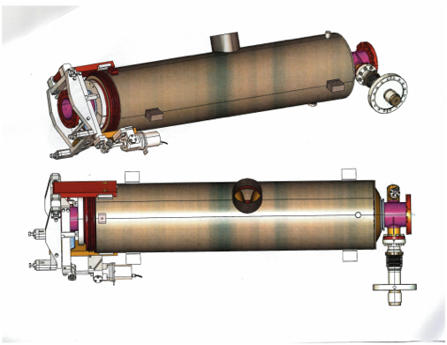

Figure 2. CAD images of a dressed cavity, showing (left to right) end-lever tuner surrounding HOM couplers, helium vessel, chimney near center, and high-power coaxial RF coupler.

Images from the CAD model of the modified cryomodule are shown below.

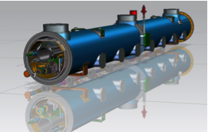

Figure 3. CAD image of the cryomodule assembly within its vacuum vessel.

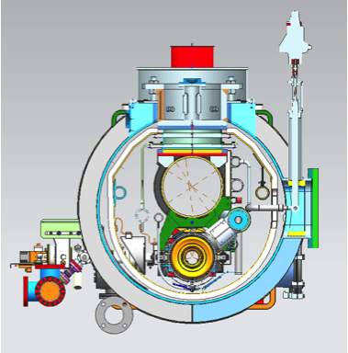

Figure 4. Cross-sectional image of the cryomodule assembly at the liquid fill valve

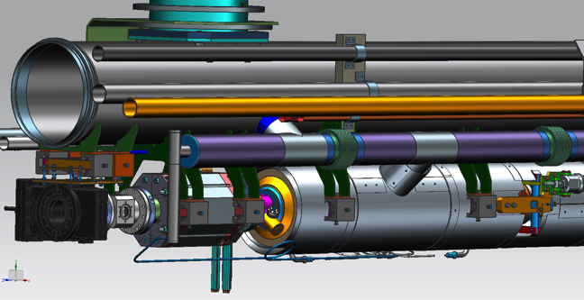

Figure 5. CAD image of the BPM, magnet package, cavity string (under magnetic shielding), and cryogenic piping within the cryomodule assembly. Outer vacuum jacket, thermal shield, and multi-layer insulation are not shown.

Conclusion.

The 1.3 GHz cryomodule for LCLS-II will be a modified XFEL/Type 3+ cryomodule. Significant experience with this cryomodule design in various laboratories including Fermilab, and limited space in the SLAC tunnel, drive this choice. Most major features exist and are proven in operation. Changes from previous similar designs involve slight modifications of the Ti helium vessels and piping for the high heat loads associated with CW operation. The most significant such change involves the addition of a liquid level control valve for each cryomodule. Other modifications include simplified thermal shielding, enhanced magnetic shielding, ports for access to piezos and tuners on the vacuum vessel, modified input couplers, and other details. These are all incremental modifications of existing designs. In general, considerations for structural stiffness and thermal design for CW heat loads will be emphasized in the design and assembly process. Finally, cryomodules will all be tested before shipment to SLAC.

References

Functional Requirements Specification Document for the 1.3 GHz Superconducting RF Cryomodule (Document Number: LCLSII-2.5-FR-0053-R0)

Physics Requirements Document for the LCLS-II SCRF 1.3 GHz Cryomodule (Document Number: LCLSII-4.1-PR-0146)