Cryomodule Comparison, Including LCLS-II Design and Options
Tom Peterson, 19 May 2014

Introduction.
This document summarizes major differences among TESLA-ILC-style cryomodules starting with Type 3+ in the FLASH linac. These then also include Type IV (ILC), XFEL, and LCLS-II.

Overview of cryomodule differences.
Tabulated below are comparisons of TESLA Test Facility (TTF/FLASH), XFEL, ILC Type 4, and LCLS-II cryomodules.

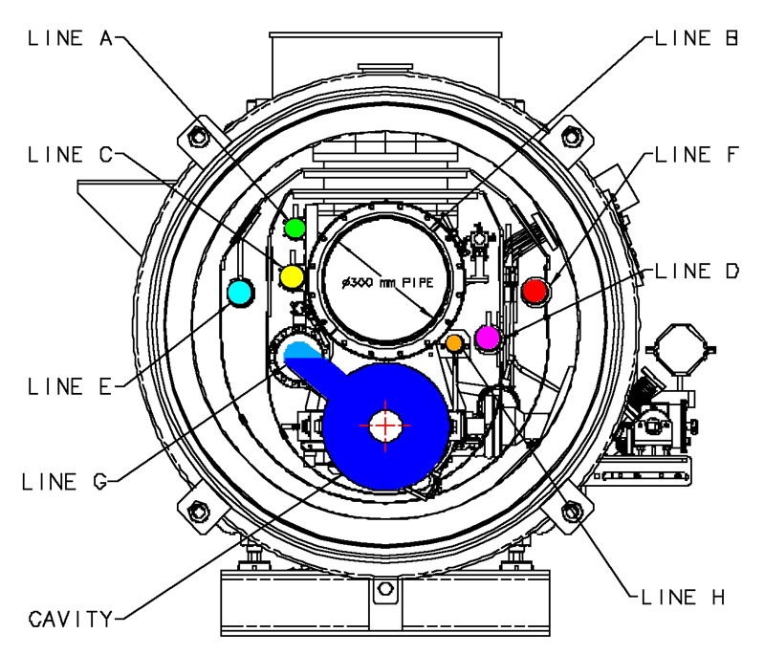
Figure 1. Cryomodule line definitions for reference with Table 1.

Table 1. Cryomodule pipe diameters

Pipe function | BCD  name | TTF inner diameter (mm) | XFEL inner diameter  (mm) | Type IV (ILC) inner dia  (mm) | LCLS-II inner diameter (mm)
2.2 K subcooled supply | A | 45.2 | 45.2 | 60.2 | 45.0
Gas helium return header, structural support | B | 300 | 300 | 300 | 300
5 K shield and intercept supply | C | 54 | 54 | 56.1 | 55.1
8 K shield and intercept return | D | 50 | 65 | 69.9 | 55.1
High temperature shield and intercept supply | E | 54 | 65 | 72.0 | 55.1
High temperature shield and intercept return | F | 50 | 65 | 79.4 | 52.5
2-phase pipe | G | 72.1 | >72.1 | 69.0 | 95.5
Helium vessel to 2-phase pipe nozzle (“chimney”) |  | 54.9 | 54.9 | 54.9
Warm-up/cool-down line | H |  |  | 38.9 | 38.9

Table 2. Some major cryomodule features compared.

Feature | TTF (type 3+) | XFEL | Type IV (ILC) | LCLS-II
Cavity cold slot length (mm) | 1383.7 | 1383.7 | 1326.9 | 1383.7
Cryomodule slot length (mm) | 12450 | 12220 | 12652 | 12220
Magnet style | Bath cooled at 4.5 K | Bath cooled at 2 K | Conductively cooled to 2 K | Conductively cooled to 2 K
Magnet location | End | End | Middle | End
Current leads | Vapor cooled from 4.5 K | Conductively cooled | Conductively cooled | Conductively cooled
BPM style

5 K thermal shield | YES | YES | YES | NO, but retain intercepts
Input coupler | TTF3 design | TTF3 modified for better thermal intercepts |  | Modified TTF3 for CW cooling

LCLS-II prototype versus production design.

Table 3. Comparison of LCLS-II prototype cryomodule and production cryomodule designs.

Feature | LCLS-II prototype cryomodule | LCLS-II production cryomodule | Comments and options
Bare cavity | ILC-style with equal length short beam tube ends | XFEL-style with unequal long-short beam tube ends | Slot lengths will be identical. Option: continue production with short-short beam tubes (only compatible with Fermilab tuner)
Dressed cavity | Bellows on vessel shell diameter at end | Same as prototype | Options:  (1) smaller bellows for lower df/dP or, another option,  (2) replicate XFEL helium vessel
Tuner | Fermilab end lever tuner | Fermilab end lever tuner | Option: XFEL / Saclay tuner
Access ports for tuner | YES | YES | Ports not useful for XFEL tuner. Option: use Fermilab tuner but leave ports off.
Instrumentation |  | Same as prototype except less thermometry

For the options listed above, tabulated below are decision considerations.

Table 4. Considerations for LCLS-II production cryomodule design

Feature | Advantages or disadvantages of choices | Decision process
Short-short ILC-style) versus long-short (XFEL-style) cavities | Both have been procured in large numbers. No major advantages of either except for tuner compatibility. | XFEL tuner only fits on long-short. Fermilab tuner fits on both. Could stay with short-short if Fermilab tuner. No disadvantages of long-short, and long-short keeps tuner options open ➔ go with long-short in production.
Helium vessel bellows, df/dP | Prototype design with large bellows is clean modification of ILC design which preserves weld designs and assembly procedure (essentially a helium vessel shell extension). Smaller bellows can provide df/dP closer to zero. European vendor comfort with XFEL design may provide some price/production advantage. | Clarify df/dP requirement. (Suggestion: cavity bandwidth = 30 Hz. Allow 10 Hz for pressure. Assume 0.2 mbar fluctuation ➔ need <50 Hz/mbar.) What design matches df/dP requirements. One motivation for change could be df/dP. Stay with prototype design unless change is required.
Tuner style | Fermilab tuner fits short-short cavity ends, improves piezo integration over XFEL tuner, and is accessible via ports. | Stay with prototype design unless change is required. (This was a review recommendation.) Input from tuner tests outside of HTS – life testing, cold testing, etc.
Tuner access ports | Allow access to motor, mechanism, and piezos without pulling string out of cryostat. | Definitely include in prototypes. Include in production based on cost / risk analysis following initial tuner tests in HTS. Assemble a mechanical mock-up including thermal shield and MLI to check access port utility.

