|  |  |
| --- | --- |
| **Document Approval:** | **Date Approved** |
| Originator: Jerry Makara, Title? |  |
| Approver: Marc Ross, Cryogenic System Manager |  |
| Approver: Jose Chan, Accelerator System Manager |  |
| Approver: Bob Law, Infrastructure System Manager |  |
| Approver: Richard Stanek, FNAL LCLS-II Senior Team Lead |  |
| Approver: George Neil, JLAB LCLS-II Senior Team Lead |  |
| Approver: David Schultz, Project Technical Director |  |

Revision History

|  |  |  |
| --- | --- | --- |
| Revision | Date Released | Description of Change |
| R0 | Month Day, Year | Original Release. |

**Table of Contents**

1 Introduction 3

2 Definitions 4

3 Cryogenic Plant Interface (JLab, FNAL) 4

4 Cryomodule Interface (FNAL) 8

5 Process Controls (PC) Interface (SLAC, JLab, FNAL) 8

6 Utilities Interface (SLAC, FNAL) 9

7 Accelerator Systems Interface (SLAC, FNAL) 10

8 Integration Interface (SLAC, FNAL) 10

9 References 11

# Introduction

LCLS-II is an upgrade to the original LCLS which will keep the United States at the forefront of X-ray science. LCLS-II uses highly focused beams that allow researchers to take crisp pictures of atomic motion and changes in chemical bonds, shedding light on the fundamental processes of chemistry, technology and life itself. It allows scientists to do important research including work in drug development, energy science and advanced materials.

The LCLS-II accelerator (Linac) design is based on Superconducting Radio Frequency (SRF) technology. In order to meet LCLS-II requirements, the Linac employs the TESLA cryomodule design, with minimal modifications to accommodate continuous wave operation (CW). The Linac is comprised of cryomodules in contiguous sections which utilize the Cryogenic Distribution System (CDS).

The CDS consists of the equipment needed to feed and return the cryogens, via vacuum insulated pipelines, to the Linac components needing these services throughout the entire Linac. This includes distribution boxes, cryogenic transfer lines, feed caps, end caps and cryogenic bypasses. A simplified schematic of the Linac is shown in Figure 1. This is based on a configuration outlined in the CDR[1].

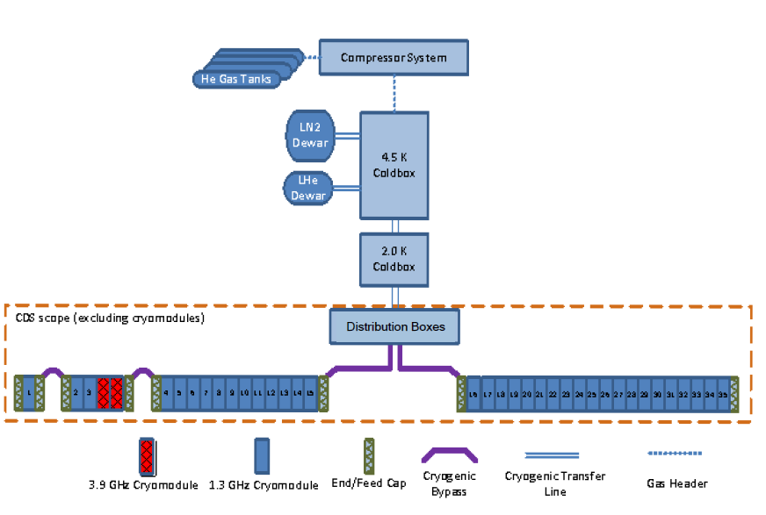

Figure LCLS II Cryogenic system schematic

# Definitions

|  |  |
| --- | --- |
| **Abbreviation** | **Definition** |
| CDS | Cryogenic Distribution System is set of cryogenic components to feed and return the cryogens via vacuum insulated pipelines throughout the Linac to distributed components requiring cryogenic refrigeration |
| CM | Cryomodule is a device containing superconducting RF cavities used to accelerate a beam of particles |
| CP | Cryogenic Plant is a helium refrigerator that contains all necessary cryogenic devices and machinery necessary to produce refrigeration at liquid helium temperatures |
| DB | Distribution Box is a cryogenic component used to distribute cryogens from the cryogenic plant to the Linac |
| EC | End Cap is a cryogenic component at the end of each Linac string which interfaces with a cryomodule and returns excess cryogens to the distribution box |
| FC | Feed Cap is a cryogenic component that connects a supply transfer line to a cryomodule through a modified cryomodule-style interconnect |
| He | Helium gas |
| LHe | Liquid helium |
| LN2 | Liquid nitrogen |
| ODH | Oxygen deficiency hazard |
| LT | Low temperature |
| HT | High temperature |
| CD | Cool down |
| ESD | Engineering Specification Document |

# Cryogenic Plant Interface (D.Arenius/JLab, J.Makara/FNAL)

### 3.1 The interface between the CDS and the Cryoplant (CP) is the Interface box (part of the CP) and the Distribution Box (BD) (part of the CDS). Per Cryogenic Distribution System Functional Requirement Specification (CDS FRS)[4], the DB connection to the Interface box shall be accomplished by using two sets of removable vacuum insulated bayonets (U-tubes), one set per each Linac cryogenic string (see Figure 2 below). The following cryogenic services must be provided for:

#### Low pressure (Sub-atmospheric) helium gas return

#### Low temperature (LT) helium supply (Low Temperature Intercept & 2K Supply)

#### Low temperature thermal intercept (LTTI) helium return

#### High temperature thermal shield (HTTS) helium supply

#### High temperature thermal shield (HTTS) helium return

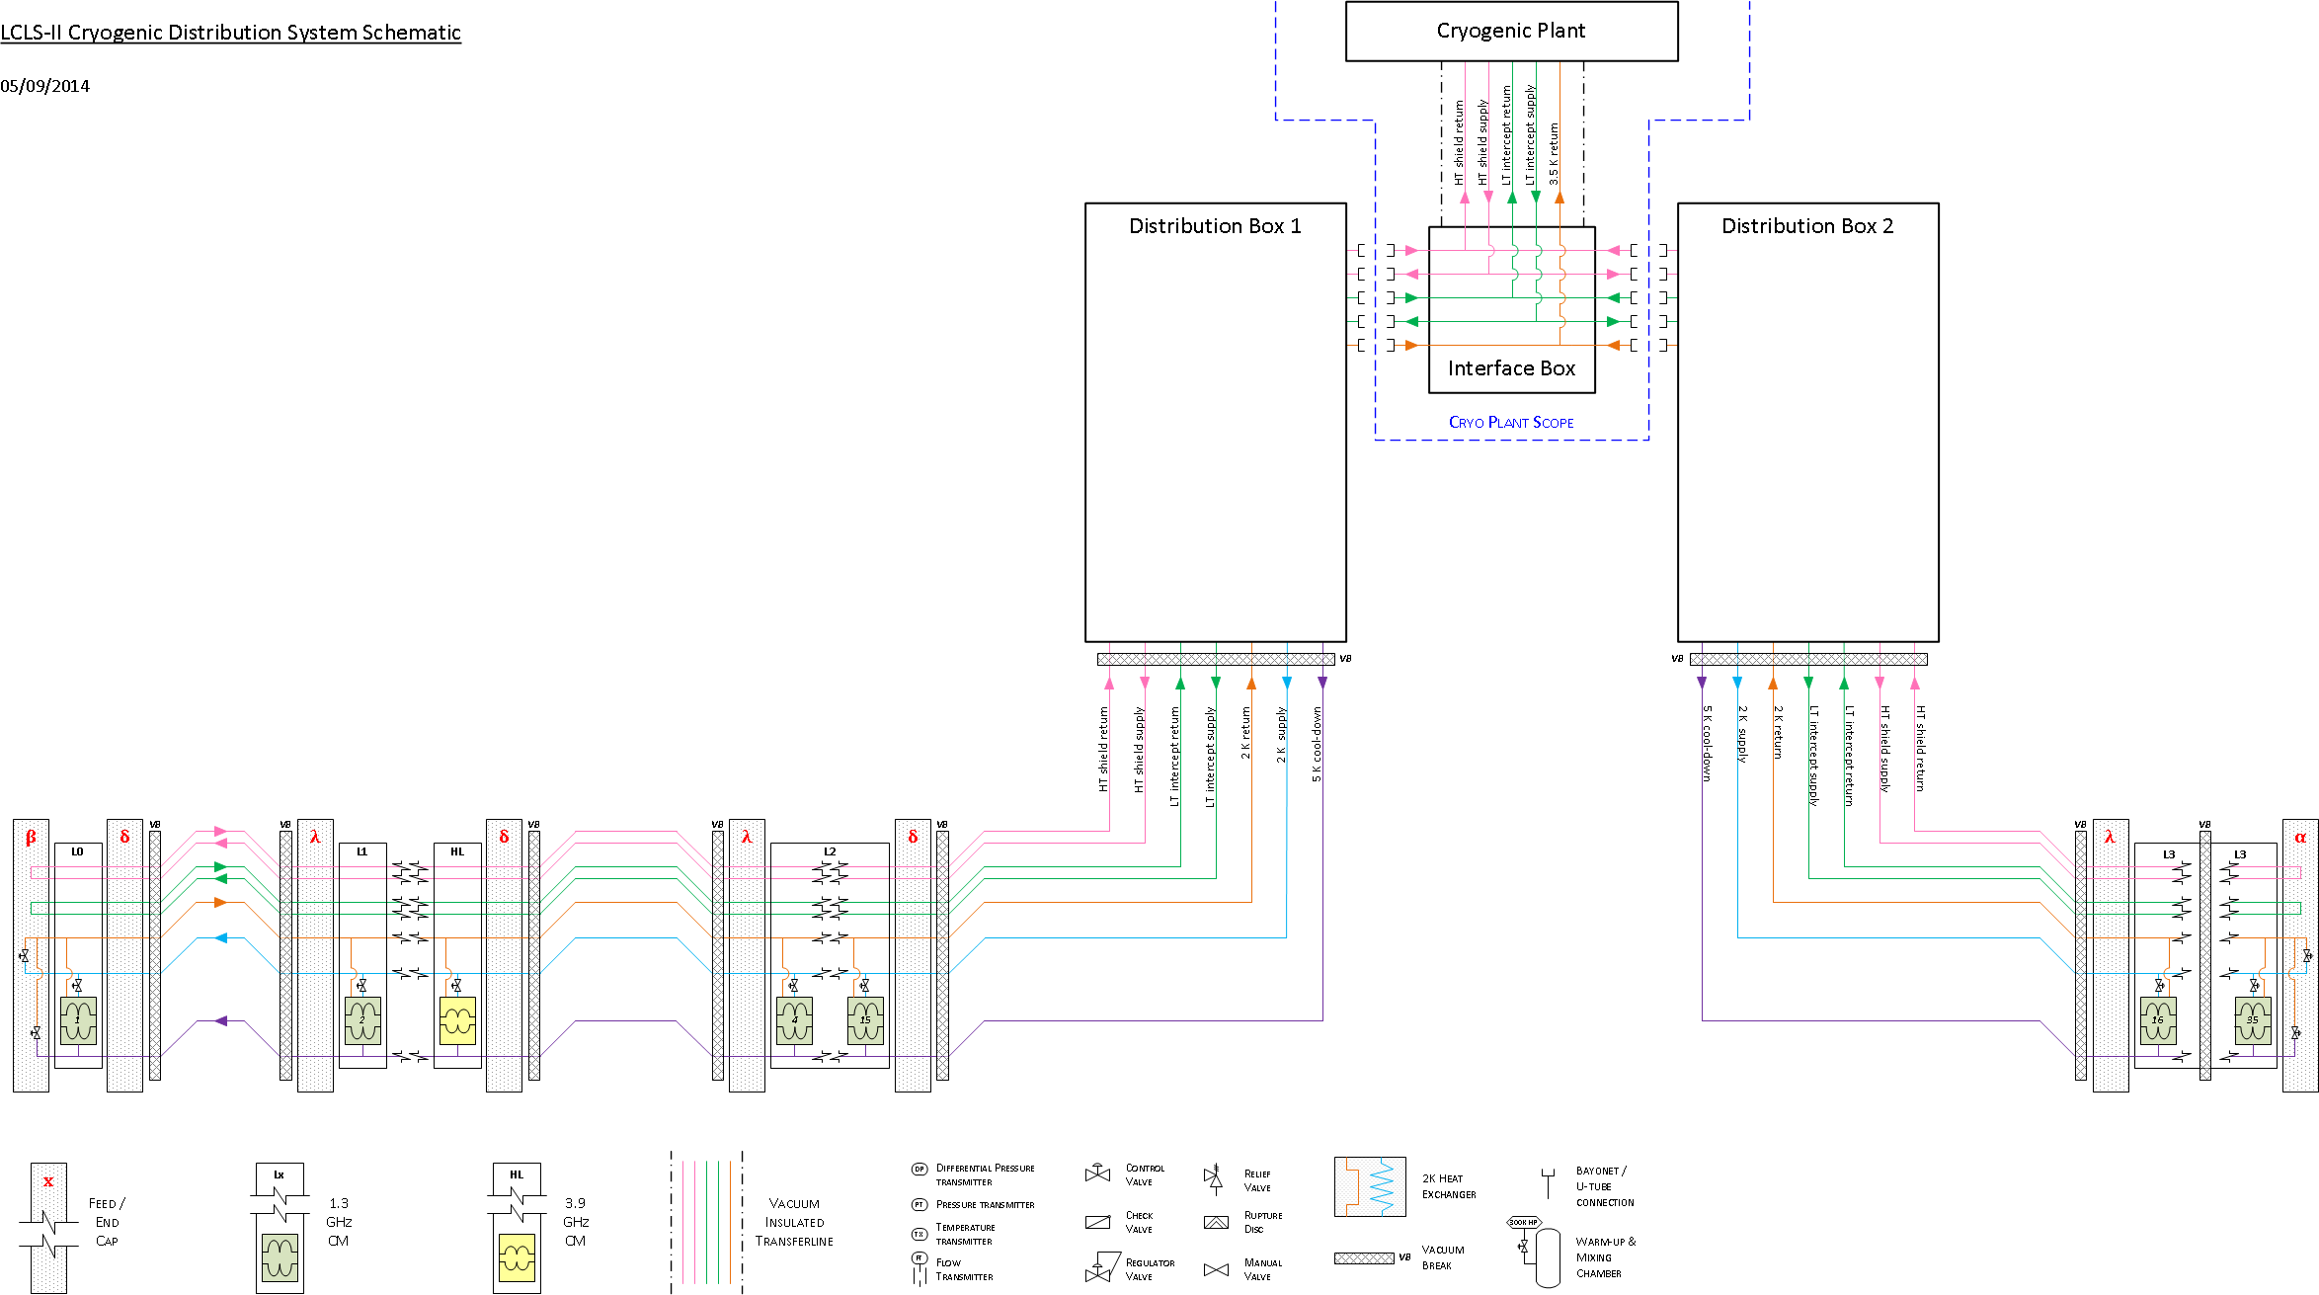

Figure 2 LCLS II Cryogenic Distribution System schematic

### The DB-side (female) bayonet design of each cryogenic service above shall be agreed upon between JLab and FNAL in terms of inside diameter, overall length (upper seal to lower seal), and upper and lower seals details (to allow proper mating of bayonets on U-tubes). This will be defined in the CDS Engineering Specification Document (ESD).

### The bayonet upper seal elevation must be agreed upon such that the DB and CP are at same level for ease of operations during maintenance isolation.

3.1.3 Plan view arrangement of bayonet connections between the DBs and Interface Box must be agreed upon between FNAL and JLab. Location of DBs in the Klystron gallery is determined by final tunnel penetration location as determined by PRD.

3.1.4 The CP shall provide the U-tubes on agreement of specific lengths for final installation at SLAC.

3.2 Per CDS FRS, the CP shall provide the following warm helium gas services. The interfaces shall be flanged connections.

#### 300K high pressure (HP) helium supply from CP main compressor discharge

b. 300K high pressure (MP) helium supply from CP purification compressor system

#### c. 300K low pressure (LP) helium return to CP main compressor suction

d. 300K low pressure helium return to CP purification compressor system

e. Sub-atmospheric seal guard supply (vacuum and helium)

3.3 Operating and design pressures and temperatures are specified in the CDS FRS.

3.4 The CP supply/return cryogenic service parameters to/from CDS are defined in CDS FRS [4]. The heat loads of the LCLS-II CM and CDS are officially defined in Engineering Note “LCLS-II Cryogenic Heat Load” [6].

3.5 The CP supply/return 300K helium services nominal flows to/from CDS have the following requirements noted in Table 1. These services are used for initial purification and cool down rate control, with maximum flow noted for full Linac cool down.

Table 1. CDS Operating 300K Flows

|  |  |  |  |
| --- | --- | --- | --- |
| Circuit | Pin (bar) | Tin (K) | CD max Flow (g/s) |
| 300K HP helium supply from CP Main Compr System | 10-18 | 300 | 200 |
| 300K HP helium supply from CP Purification Compr System | 3-10 | 300 | 40 |
| 300K LP helium return to CP Main Compr System | 1.6 | 300 | 200 |
| 300K LP helium return to CP Purification Compr System | 1.2 | 300 | 40 |

3.6 The CP shall be able to recover helium gas in the 300K LP helium return header that comes from various cryogenic circuit reliefs and cool down valves. This will be defined in the CDS Engineering Specification Document [y].

3.7 The CP shall provide 300K HP helium gas with minimum purity of 99.998%, grade A.

3.8 Sub-atmospheric seal guard is to be determined using either vacuum or low pressure helium gas supply.

# Cryomodule Interface (A.Dalesandro,T.Peterson/FNAL)

## The CDS interface connections to cryomodules, specifically through FCs and ECs, are defined in CM Engineering Specification Document [x] for the following:

1. Cryogenic piping connection size (diameter, wall thickness, out of roundness (ovality, eccentricity), material, interface location (x, y, z, and angle) with allowable tolerances, and end prep (e.g. weld)
2. Thermal shield (intercept) size, material, and location (x,y,z, and angle) with allowable tolerances
3. Beam tube connection size (diameter and wall thickness), material, interface location (x, y, z, and angle) with allowable tolerances, and end prep (e.g. flange)
4. Insulating vacuum closure mating design, size, material, and location (x,y,z, and angle) with allowable tolerances

## Pressure/vacuum thrust loading of all interfaces (cryogenic circuit lines, beam tube, and insulating vacuum) must be accounted for in the FC and EC as defined in CM ESD.

## The CDS shall accommodate CM relief venting requirements, in addition to its own, per CM Engineering Specification Document.

# Process Controls (PC) Interface (M.Boyes/SLAC, D.Arenius/JLab, J.Makara/FNAL)

## The CDS will provide process monitoring instrumentation, detailed in ESD, for the following:

1. Circuit pressure
2. Insulating vacuum pressure
3. Differential pressure
4. Temperature (warm); both primary and secondary
5. Temperature (cold); both primary and secondary sensors in one connector on warm feedthrough; potentially multiple circuit sensors will use one larger connector.
6. Flow

5.2 Instrumentation connections shall be clearly permanently labeled for identification, including any unique number associated with its calibration curve. Details will be listed in the CDS ESD.

## CDS valve actuators will be of pneumatic type, defined in ESD, with following as example:

1. Supply air of minimum 3.0 barg and maximum of 6.0 barg required
2. Air supply piping connection minimum of 6mm (1/4 inch) diameter compression fitting
3. Electro-pneumatic (i-p) positioner being 2-wire system with power supply by signal. PRD will define radiation environment.

## Process control requirements will be defined in an ESD including such items as follows:

1. Control loop algorithms for various modes of CDS operations
2. Interlock logic, if necessary, for various modes of CDS operations
3. Operational limits of process parameters resulting in alarms, automatic process change, or equipment shutdown

# Utilities Interface (R.Law/SLAC, J.Makara/FNAL)

## Civil

### CDS FC/EC end plate vacuum and weight loading will be transferred to the tunnel concrete floor, per ESD and with minimum anchor type (e.g. Hilti) requirements plus any additional requirements due to local seismic codes. Concrete strength should be confirmed per ASTM C39/C39M-14.

### Support concrete pads/floors for equipment placement with floor bearing capacity at least 10 kN/m^2 (209 lbf/ft^2), with minimum anchor type (e.g. Hilti) requirements, and any additional requirements due to local seismic codes. Concrete strength should be confirmed per ASTM C39/C39M-14.

### CDS transfer line will be supported from the tunnel ceiling. The ceiling concrete must support the weight of the cryogenic transfer lines and anchor as required per ESD, as well as minimum anchor type (e.g. Hilti) requirements plus any additional requirements due to local seismic codes. Concrete strength should be confirmed per ASTM C39/C39M-14.

### CDS to tunnel vertical penetrations for transfer lines and piping shall be sized per ESD. Two new penetrations will be provided for the transfer lines entering the tunnel per Attachment-1. Existing penetrations will be used for other needs, including cable trays and relief vent headers.

### Crane and rigging will be required for equipment installation. Subsequent requirements for localized crane may be required for cryogenic U-Tube insertion/removal between CDS and CP.

### CDS will provide working platforms atop large units (e.g. DB). Access stair locations require coordination with building management for proper egress as per OSHA standards.

6.1.7 Tunnel or facility water leakage onto CDS components must be mitigated in reasonable time during normal operations (especially onto exposed bellows) but immediately during installation process whereas cryogenic piping is not protected by insulating vacuum piping.

## Mechanical (Pneumatics, Vacuum)

### CDS requires an air supply system for controls valves with minimum of 6.0 barg and maximum of 10.0 barg.

### The supply air quality must be as follows:

### Particulates – not allowed

### Dewpoint (water) <= (-30) degC

### oil content < 0.01 mg/m^3

### The supply air requirements shall be defined in appropriate ESD based on pneumatic actuators chosen. Appropriate secondary backup for continuous supply is required allowing maintenance to be performed on primary unit.

### Vacuum pumping systems for insulating vacuum across CDS components will be required as necessary, for initial evacuations and subsequent maintenance requirements. FNAL will not provide such. Ultimate vacuum of 1E-5 Torr must be attainable.

## Electrical

### CDS requires sufficient 120VAC, 208VAC, and 480VAC during installation and commissioning phases, to be specified for specific locations of components.

### CDS requires sufficient lighting during installation and commissioning phases, to be specified for specific locations of components.

# Accelerator Systems Interface (J.Chan/SLAC, A.Martinez/FNAL)

## CDS usage of tunnel space is allocated per PRD. This includes beamline allocation as well as nominal beamline elevation and required horizontal/vertical alignment motion. Cryogenic bypass transfer lines, feed transfer lines, feedcaps, and endcaps also require tunnel space for initial component installation work, supports, and potential relief systems; Attachment-1 provides such preliminary space allocation requirements.

7.2 Surface location of DBs is dependent on tunnel penetration location as defined per PRD. Area around DBs must be clear for operations and maintenance access to valves and ports. ESD will provide such space requirements.

7.3 Radiation resistance requirements for tunnel components are defined by PRD (e.g. 5 MGy over 20 years).

7.4 All CDS components in tunnel will have piping insulated as necessary to limit temperature differential maximum of 10 degC to ambient, thus reducing condensation or icing inside the tunnel.

# Integration Interface (L.Plummer/SLAC, A.Klebaner/FNAL)

8.1 Delivery of CDS components will address completion of all tests and documentations, shipping requirements for component protection from elements and transport forces, and all applicable DOT regulations.

8.2 Delivery of CDS components will be coordinated with available facility structures and equipment (e.g. crane).

8.3 CDS installation will require use of ironworkers (crane, rigging), pipefitters, welders, technicians, authorized inspectors, etc. thus necessitating accesses and associated safety requirements.

8.4 CDS installation process may require use of x-ray of welds and pressure tests of systems at various stages, ranging between evacuations for mass spectrometry and pressurizing to appropriate Code requirements. This necessitates accesses and associated safety requirements.

8.5 Installation and testing schedule will be agreed upon in advance.

8.6 Testing of control systems must be completed prior to CDS commissioning phase.

8.7 Cryogenic testing of CDS components with at least one Linac string upon receipt of operational readiness clearance.

# References

|  |  |
| --- | --- |
| **#** | **Document Title** |
| 1 | LCLS-II Conceptual Design Report, SLAC National Accelerator Laboratory,  LCLSII-1.1-DR-0001-R0 |
| 2 | 1.3 GHz Superconducting RF Cryomodule Functional Requirement Specification, LCLSII-4.5-FR-0053-R0. |
| 3 | Cryoplant Functional Requirement Specification,  LCLSII-WBS-FR-00XX-R0. |
| 4 | LCLS-II Cryogenic Distribution System Functional Requirement Specification,  LCLSII-4.9-FR-0057-R0 |
| 5 | Seismic Design Specification for Buildings, Structures, Equipment, and Systems: 2014, SLAC-I-720-0A24E-001-R004 |
| 6 | Cryogenic Heat Load,  LCLS-II-4.5-EN-0179 |

ATTACHMENT-1. LCLS-II Cryo Distribution Tunnel Space

