Development of the Geant 4 Validation Web Interface for End Users
Author: K. Nicole Barnett

PDS Team: Krzysztof Genser
Tomasz Golan
Adam Para
Gabriel Perdue
Hanz-Joachim Wenzel
Julia Yarba

Submitted to: US DoE
Fermilab

Supervisor: Hanz-Joachim Wenzel

Issued date: Aug 4, 2014

Abstract

Geant4 stands for Geometry and Tracking and is the standard tool kit for particle interaction simulations in the physics industry. Due to its critical position, it must constantly improved upon. The most recent improvement is the development of the Geant4 Validation web application which is geared to make the Geant4 Validation library data accessible to anyone.

To develop this web application, I made use of various software suites and programming languages to create a method to pull the data dynamically at the user’s request and display it in a way that is easy to understand. The overall interface is user friendly to open the data in the validation library to the target audience, everybody.

Table of Contents

Abstract ii
1. Introduction 1
2. Software Tools and theeir Use in Development 1
3. Results 3
3.1 Database Statistics 3
3.2 Test Selection 3
3.3 Criteria Refinement 4
3.4 Data Delivery 4
4. Discussion 5
5. Conclusion 4
6. References 6
7. Appendix 7

Introduction
Geant4 (Geometry and Tracking) is an ever evolving toolkit which models the interactions of particles with matter. The applications of Geant4 are far reaching and of critical importance; as such, its accuracy must be continuously tested and improved upon. Historically, graphical comparisons have been created by the Geant4 team and made available in the form of static images. In order to better facilitate end user versatility and usability, I have been programming a web application which creates dynamic plots from user selected criteria.
While Geant4 is an excellent tool for classroom investigation into physical interactions, it also has implications in medicine, space and radiation, and high energy physics (HEP). For cancer patients whose tumors are located such that surgery would be difficult or impossible, the ability to successfully gauge the appropriate energy level range to achieve a proton beam bragg peak with minimum radiation impact on healthy tissue is paramount. In the space community, engineers must be able to accurately predict the impact radiation will have on their equipment and in some cases, human passengers. High energy physics experiments, as a result of the high cost of equipment and operation, need a tool by which to assess the correct scale to which their experiment must be parameterized. Geant4 can do and has done all of this.
The critically important nature of all of the above scenarios dictates that Geant4 be constantly improved upon which is done by way of a validation library. The validation library is a database which houses experimental data as well as simulation data for several different physics models. Historically, the simulations have been manually compared to experimental data and made available via static images which can be sought out on the Geant4 Validation web page through search or drill down methods. As new experimental data is added to the validation library, this method is becoming both obsolete and cumbersome as end users must have a working knowledge of how the website is structured in order to efficiently utilize it. Further, while collaborators continue to add experimental data to the library, alteration to existing images or addition of new images becomes time prohibitive. Instead, it benefits both end users and collaborators that data be stored in one location and made available via dynamic request.

Software Tools and their Use in Development
I created the web application using an assortment of software suites and programming protocols working in seamless congruity. The software tools includ NetBeans 8.0 Integrated Development Environment (IDE) to edit, compile, and debug the code, Java as the primary coding language, XHTML and JavaScript to code the web pages, JSF (JavaServer Faces) 2.0 as the server side specification, PrimeFaces 4.0 component library from which to draw upon for ease of user interface component configuration, JFreeChart as the Java based chart display program, and HighCharts as the JavaScript chart display program. The complete communication process can be thought of as an iced layer cake where the first layer is the XHTML page which uses HighCharts and JavaScript, the second layer is the Managed Bean which is written in Java and uses JFreeCharts, the third layer is the Java coded object class, the final layer is the actual database, and the icing in which it is all presented is the cloud. Here, NetBeans is the mixing bowl. All of these programming utilities operate as a framework through which to represent Geant4 simulation data stored in a PostgreSQL database. As the current implementation of Geant4 needs to remain operational, a small sample of the data from the validation library had been copied to a production project database and a development phase web application prior to my involvement.
Cloud
PostgreSQL
Database
XHTML/JavaScript
Managed Bean (Java)
Object Class (Java)
Request

Response

The user interfaces through the cloud with the XHTML web page which also makes use of JavaScript and HighCharts protocol. This portion of the web application primarily acts as an interface to the server. It translates the user’s request into Java and also sends a request to HighCharts for the framework in which to present the data. When it receives the both responses, it puts the Java data into the HighCharts framework and displays it to the user. The user may also select to display the raw data in a data table.
At the next layer, the managed bean forwards the request to the object class layer. When it receives a response, it parses the object data into arrays and then translates those arrays into a format the charting programs can use, namely strings and floats, as the data coming from the object class is not immediately readable. It then draws upon JFreeCharts, which is directly integrated into Java, to display a Java servlet based chart using the same information that it passes to the XHTML page.
The object class receives the request from the managed bean and puts the requested criteria into a prepared SQL statement which it sends to the database. The response it receives from the database is in database object format which it forwards to the managed bean for parsing.
The PostgreSQL database houses all the data and allows searchability by way of its schema. Where a type of metadata is available for both simulation and experimental data tables, we limit simulation table searches to those which have the same data type. For example, “workgroup” is a metadata category indicating the type of experiment and is indirectly associated with both test and experimental data. A user may not compare an electromagnetic test to a hadronic experiment.

Results
Each of the completed production pages, components, and methods perform as expected; however, the end distribution application is not yet complete. The end user may navigate from the front page to view statistics about the tests in the database. The remaining element to set in place is the ability to overlay the corresponding simulation histograms on top of the displayed experimental data. The overall design of the application user interface is visually appealing, professional, and easy to navigate and understand.
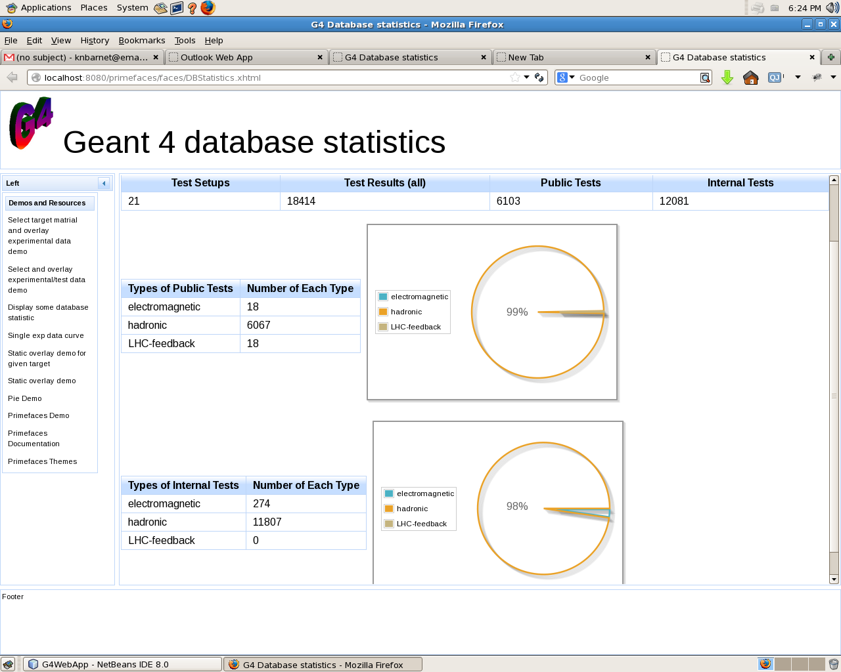
Database Statistics
All components for the Geant4 Database Statistics page are implemented successfully. This portion of the web application simply allows users to see the total number of available tests and results available from those tests as well as a breakdown into public and internal categories and further subdivision into test type subcategories. The data is displayed in both raw form via tables and visually via pie charts.
Test Selection
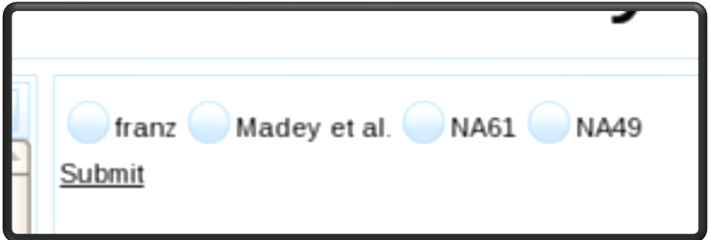
The experiment selection page allows a user to select an experiment to which he or she would like to compare a simulation. Available experiments are pulled dynamically from the database, so as the database is expanded, no changes need be made to any code. The managed java bean successfully pulls the available experiments through the object java class from the database and returns them to the web page which presents them to the end user by way of a selectOneRadio. When the user submits his or her option, the bean receives the request and passes it on to the next XHTML page and associate Java bean for further refinement.
Criteria Refinement
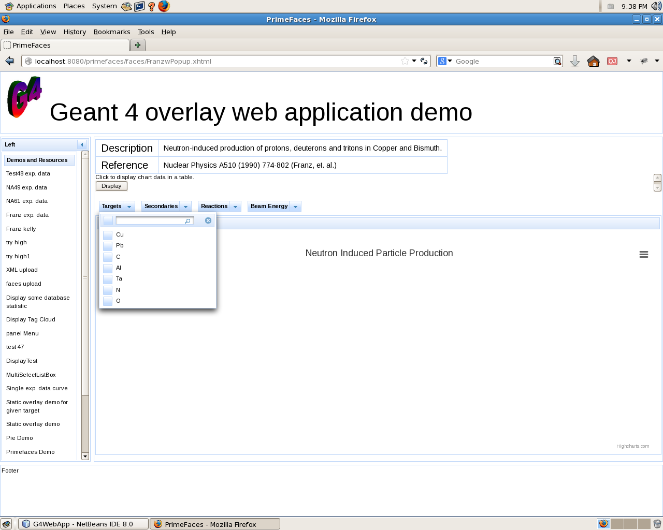
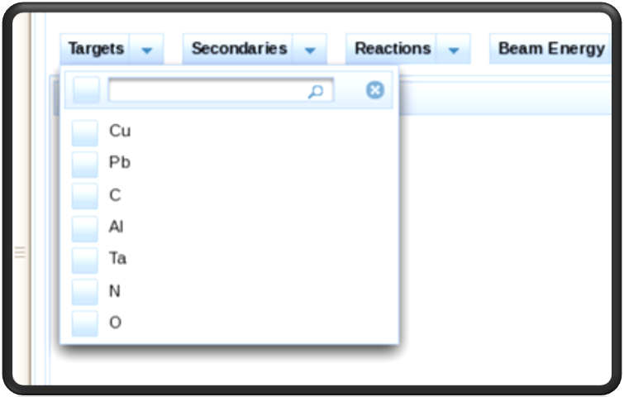
The next step in the process involves a webpage which allows the user to further refine search criteria for the selected experiment. The available categories by which the user may narrow their search are beam type, target material, reaction measured, secondary particles produced, and beam energies or beam momentums as applicable. The XHTML passes the request through the java classes as in the first case and parses the returned data into an appropriate chart via both a servlet and JavaScript based HighCharts. A similar method exists to display simulation test data through a Java servlet, but as of right now is not in place to overlay on HighCarts.
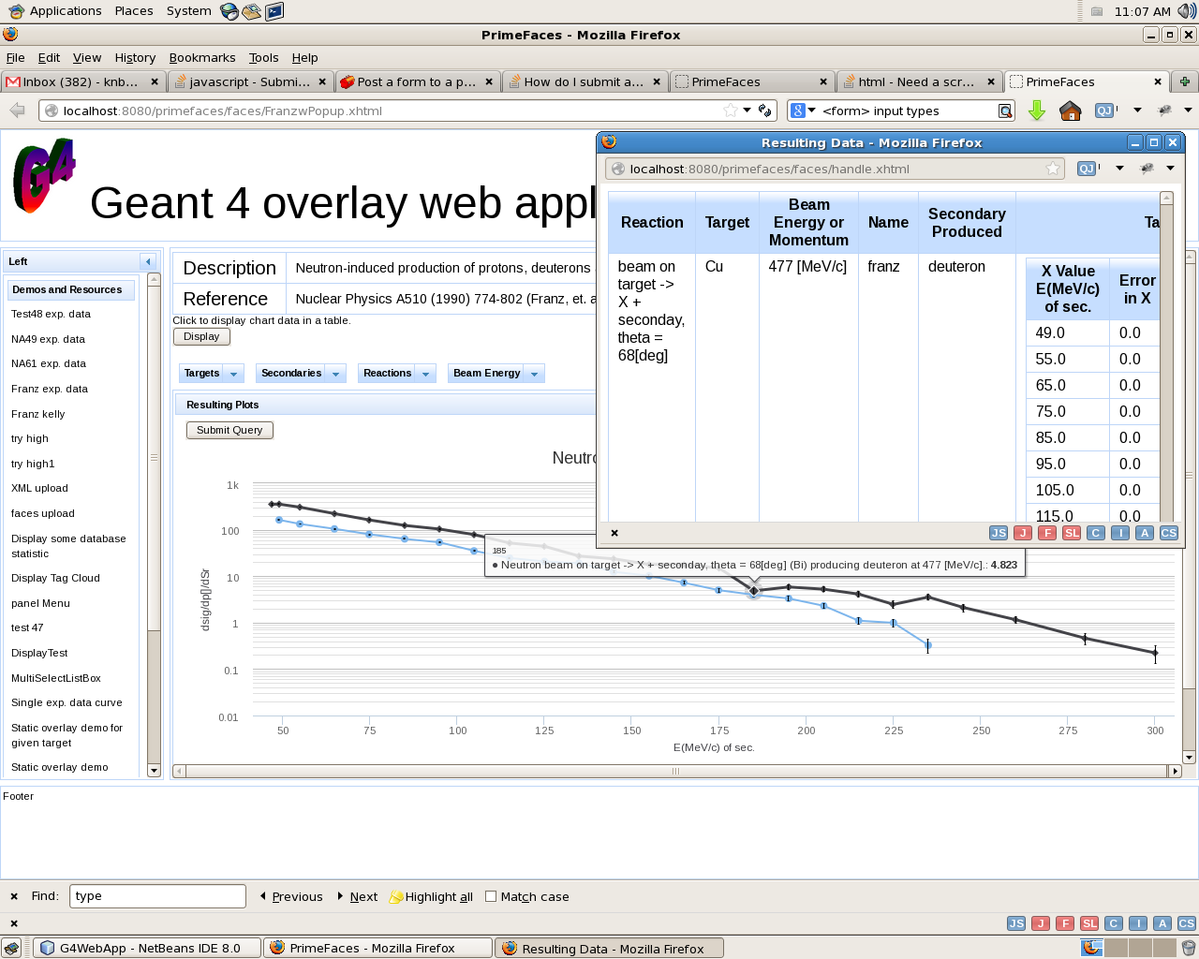
Data Delivery
Upon successful parsing of the returned data from the database, the resulting plot is displayed beneath the selection drop down menus from the criteria refinement step. A user who is interested in seeing the raw data, may select to do so by clicking a “Display” commandButton which will display a table that echoes the search criteria back to the user as well as the x, y, and corresponding error values within a popup window.
While the project is very near completion with all methods functioning correctly, it is not, as yet, completely assembled into one coherent web application. The next step is to add simulation data overlay, which will most likely be completed by September of 2014, and then move it from production to distribution.

Discussion

In its current state, the Geant4 Validation Library is not easy to access or navigate. It is tailored to users who are highly knowledgeable in the area of High Energy Physics. As Geant4 is the industry standard particle simulation tool kit, user access expansion is critical. The release of the Geant4 Validation web application will open the critical data held in its library to a broader user base including students, medical personnel, and the scientifically curious members of society.
However, its limited user base has led to a small data sample, twenty one total experiments, with which to compare simulations. Expansion of the Geant4 Validation Library database is crucial to continued growth and increased distribution.

Conclusion
Geant4 is well established in the physics community, but an effort to expand the user base has led to the development of the Geant4 Validation web application to replace the outdated Geant4 Validation library web page. I used a variety of compatible software tools to achieve the end state which is very near completion. Completion should be achieved no later than the end of September of 2014 when it can be placed into production. As this opens up the validation library to a broader variety of users, expansion is crucial.
References
[1] C. Civici, “PrimeFaces Useer’s Guid 4.0,” [Online]. Available: http://www.primefaces.org.
Appendix
DatabaseStatistics.xhtml
<!--
<!DOCTYPE HTML PUBLIC "-//W3C//DTD HTML 4.01 Transitional//EN" "http://www.w3.org/TR/html4/loose.dtd">
<html xmlns="http://www.w3.org/1999/xhtml"
xmlns:h="http://java.sun.com/jsf/html"
xmlns:f="http://java.sun.com/jsf/core"
xmlns:ui="http://java.sun.com/jsf/facelets"
xmlns:p="http://primefaces.org/ui"
template="templates/ui.xhtml">
-->

<ui:composition xmlns="http://www.w3.org/1999/xhtml"
xmlns:ui="http://java.sun.com/jsf/facelets"
xmlns:h="http://java.sun.com/jsf/html"
xmlns:f="http://java.sun.com/jsf/core"
xmlns:p="http://primefaces.org/ui"
xmlns:c="http://java.sun.com/jsp/jstl/core">
<!-- template="templates/ui.xhtml">
-->

<script type="text/javascript" language="javascript" src="plugins/jqplot.logAxisRenderer.js"></script>

<f:view contentType="text/html">
<h:head>
<link type="text/css" rel="stylesheet" href="themes/bluesky/skin.css" />
<f:facet name="first">
<meta content='text/html; charset=UTF-8' http-equiv="Content-Type"/>
<title>G4 Database statistics </title>
</f:facet>

</h:head>

<h:body>

<p:layout fullPage="true">

<p:layoutUnit position="north" size="120" resizable="true" closable="true" collapsible="true">
<img id="respic" src="G4.gif" height="90" width="90" />
<font size="8">Geant 4 database statistics</font>
</p:layoutUnit>

<p:layoutUnit position="south" size="100" closable="true" collapsible="true">
Footer

</p:layoutUnit>
<p:layoutUnit position="west" size="175" header="Left" collapsible="true">
<p:growl id="growl"/>
<h:form>
<p:menu>
<p:submenu label="Demos and Resources">
<p:menuitem value="Select target matrial and overlay experimental data demo" url="faces/DataOverlay.xhtml" />
<p:menuitem value="Select and overlay experimental/test data demo" url="faces/HistoOverlay.xhtml" />
<p:menuitem value="Display some database statistic" url="faces/DBStatistics.xhtml" />
<p:menuitem value="Single exp data curve" url="ServletDemo4" />
<p:menuitem value="Static overlay demo for given target" url="ServletDemo5" />
<p:menuitem value="Static overlay demo" url="ServletDemolib" />
<p:menuitem value="Pie Demo" url="testpie.jsp" />
<p:menuitem value="Primefaces Demo" url="http://www.primefaces.org/showcase-labs/ui/home.jsf" />
<p:menuitem value="Primefaces Documentation" url="http://www.primefaces.org/documentation.html" />
<p:menuitem value="Primefaces Themes" url="http://www.primefaces.org/themes.html" />
</p:submenu>

</p:menu>
</h:form>
</p:layoutUnit>

<p:layoutUnit position="center">

<br />
<br />

<h2>Geant 4 Validation database table statistics</h2>

<br />
<br />

<h:form>
<p:dataTable var="g4stat" value="#{databaseStatisticsBean}">
<p:column headerText="Test Setups">
<h:outputText value="#{g4stat.noTestDes}" />
</p:column>

<p:column headerText="Test Results (all)">
<h:outputText value="#{g4stat.noTests}" />
</p:column>
<p:column headerText="Public Tests">
<h:outputText value="#{g4stat.noPubTest}" />
</p:column>
<p:column headerText="Internal Tests">
<h:outputText value="#{g4stat.noIntTest}" />
</p:column>
</p:dataTable>
</h:form>

<h:panelGrid border="0" columns="2" cellpadding="0" cellspacing="0">
<h:column>
<p:dataTable resizableColumns="" value="#{databaseStatisticsBean.pairs}" var="pairEntry">

<p:column headerText="Types of Public Tests" resizable="true">
<h:outputText value="#{pairEntry.key}" />
</p:column>
<p:column headerText="Number of Each Type">
<h:outputText value="#{pairEntry.value}" />
</p:column>
</p:dataTable>
</h:column>
<h:column>
<p:pieChart id="chart1" value="#{chartView.pieModel1}" legendPosition="w" showDataLabels="true" fill="false"
style="width:400px;height:300px"/>
</h:column>
</h:panelGrid>

<h:panelGrid border="0" columns="2" cellpadding="0" cellspacing="0">
<h:column>
<p:dataTable resizableColumns="" value="#{databaseStatisticsBean.getIntPairs()}" var="intpairEntry">

<p:column headerText="Types of Internal Tests" resizable="true">
<h:outputText value="#{intpairEntry.key}" />
</p:column>
<p:column headerText="Number of Each Type">
<h:outputText value="#{intpairEntry.value}" />
</p:column>
</p:dataTable>
</h:column>
<h:column>
<p:pieChart id="chart2" value="#{chartView.pieModel2}" legendPosition="w" showDataLabels="true" fill="false"
style="width:400px;height:300px"/>
</h:column>
</h:panelGrid>

</p:layoutUnit>

</p:layout>

</h:body>

</f:view>
</ui:composition>
testselect.xhtml
<ui:composition xmlns="http://www.w3.org/1999/xhtml"
xmlns:ui="http://java.sun.com/jsf/facelets"
xmlns:h="http://java.sun.com/jsf/html"
xmlns:f="http://java.sun.com/jsf/core"
xmlns:p="http://primefaces.org/ui"
xmlns:c="http://java.sun.com/jsp/jstl/core">

<f:view contentType="text/html">

<h:head>
<script src="http://code.highcharts.com/highcharts.js"></script>
<script src="http://code.highcharts.com/highcharts-more.js"></script>
<script src="http://code.highcharts.com/modules/exporting.js"></script>

<f:facet name="first">
<meta content='text/html; charset=UTF-8' http-equiv="Content-Type"/>
<title>PrimeFaces</title>
</f:facet>

</h:head>

<h:body id="testSelect">

<p:layout fullPage="true">

<p:layoutUnit position="north" size="120" resizable="true" closable="true" collapsible="true" >
<img id="respic" src="G4.gif" height="90" width="90" />
<font size="8">Geant 4 overlay web application demo</font>
</p:layoutUnit>

<p:layoutUnit position="south" size="100" closable="true" collapsible="true">
Footer
</p:layoutUnit>

<p:layoutUnit position="west" size="175" header="Left" collapsible="true">
<ui:include src="LeftSideMenu.xhtml" />
</p:layoutUnit>

<p:layoutUnit position="center">
<h:form>
<p:selectOneRadio id="Test" value="#{testSelectBean.selectedNameOfExperiments}" >
<f:selectItems id="selectedNameOfExperiments" value="#{testSelectBean.nameofexperiments}" var="entry" itemValue="#{entry.key}" itemLabel="#{entry.value}" />
</p:selectOneRadio>

<p:commandLink id="nonAjax" action="open" actionListener="#{testSelectBean.getParameters}" style="margin-right:20px;" ajax="false">
<h:outputText value="Submit" />
</p:commandLink>

</h:form>
</p:layoutUnit>

</p:layout>

</h:body>

</f:view>
</ui:composition>

testselectbean.java

package DataDemo;

import G4ValidationLib.XYexpdataServiceAdapter;
import G4ValidationLib.XYexpdataServiceAdapterImpl;
import java.io.Serializable;
import java.sql.SQLException;
import java.util.HashMap;
import java.util.List;
import java.util.Map;
import javax.faces.application.FacesMessage;
import javax.faces.bean.ManagedBean;
import javax.faces.bean.SessionScoped;
import javax.faces.context.FacesContext;
import javax.inject.Named;

@ManagedBean(name = "testSelectBean", eager = true)
@SessionScoped

public class TestSelectBean implements Serializable {

private static final long serialVersionUID = 1L;
protected String selectedNameOfExperiments;
private final Map<String, String> nameofexperiments;

public TestSelectBean() throws SQLException {

nameofexperiments = new HashMap<String, String>();
XYexpdataServiceAdapter xydata = new XYexpdataServiceAdapterImpl();
List<String> dbnameofexperiments = xydata.getNameofexperiments();
for (String ta : dbnameofexperiments) {
nameofexperiments.put(ta, ta);
}
}

public String getSelectedNameOfExperiments() {
return selectedNameOfExperiments;
}

public void setSelectedNameOfExperiments(String selectedNameOfExperiments1) {
this.selectedNameOfExperiments = selectedNameOfExperiments1;
}

public Map<String, String> getNameofexperiments() {
return nameofexperiments;
}

public void getParameters() {
FacesContext.getCurrentInstance().addMessage(null, new FacesMessage("You've selected Experiment:" + selectedNameOfExperiments));
System.out.println("You've selected Experiment:" + selectedNameOfExperiments);
}
}
FranzwPopup.xhtml

<ui:composition xmlns="http://www.w3.org/1999/xhtml"
xmlns:ui="http://java.sun.com/jsf/facelets"
xmlns:h="http://java.sun.com/jsf/html"
xmlns:f="http://java.sun.com/jsf/core"
xmlns:p="http://primefaces.org/ui"
xmlns:c="http://java.sun.com/jsp/jstl/core">
<!-- template="templates/ui.xhtml">
-->
<ui:define name="head">
<style>.ui-growl{ #{growlerMessageBean.getMessage()}: 20px; }</style>
</ui:define>

<f:view contentType="text/html">

<h:head>
<script src="http://code.highcharts.com/highcharts.js"></script>
<script src="http://code.highcharts.com/highcharts-more.js"></script>
<script src="http://code.highcharts.com/modules/exporting.js"></script>
<script>
process = function()
{
window.open('about:blank', 'popup', 'width=320,height=400,resizeable=yes, scrollbars=yes');
document.login.setAttribute('target', 'popup');
document.login.setAttribute('onsubmit', '');
document.login.submit();
};
</script>
<f:facet name="first">
<meta content='text/html; charset=UTF-8' http-equiv="Content-Type"/>
<title>PrimeFaces</title>
</f:facet>
</h:head>

<h:body id="showdataForm">

<p:layout fullPage="true">

<p:layoutUnit position="north" size="120" resizable="true" closable="true" collapsible="true" >
<img id="respic" src="G4.gif" height="90" width="90" />
<font size="8">Geant 4 overlay web application demo</font>
</p:layoutUnit>

<p:layoutUnit position="south" size="100" closable="true" collapsible="true">
Footer
</p:layoutUnit>

<p:layoutUnit position="west" size="175" header="Left" collapsible="true">
<ui:include src="LeftSideMenu.xhtml" />
</p:layoutUnit>

<p:layoutUnit position="center">

<p:panelGrid columns="2" style=" font-size: 14">
<h:outputLabel value="Description" style="font-size: 20"/>
<h:outputText value="Neutron-induced production of protons, deuterons and tritons in Copper and Bismuth."/>

<h:outputLabel value="Reference" style="font-size: 20"/>
<h:outputText value="Nuclear Physics A510 (1990) 774-802 (Franz, et. al.)"/>
</p:panelGrid>

<form action="http://localhost:8080/primefaces/faces/handle.xhtml" method="get" name="login" onsubmit="process();
return false;" style="overflow-y: scroll">
Click to display chart data in a table.<br />
<input type="submit" value="Display"/>
</form>

<h:form>

<h:panelGrid columns="6" cellpadding="5">
<p:selectCheckboxMenu id="menu1" value="#{targetBeanFranz.selectedTargets}" label="Targets" filter="true" filterMatchMode="startsWith"
panelStyle="width:220px">
<f:selectItems value="#{targetBeanFranz.targets}" />
</p:selectCheckboxMenu>
<p:selectCheckboxMenu id="menu2" value="#{targetBeanFranz.selectedBeams}" label="Beams" filter="true" filterMatchMode="startsWith"
panelStyle="width:220px">
<f:selectItems value="#{targetBeanFranz.beams}" />
</p:selectCheckboxMenu>
<p:selectCheckboxMenu id="menu3" value="#{targetBeanFranz.selectedSecondaries}" label="Secondaries" filter="true" filterMatchMode="startsWith"
panelStyle="width:220px">
<f:selectItems value="#{targetBeanFranz.secondaries}" />
</p:selectCheckboxMenu>
<p:selectCheckboxMenu id="menu4" value="#{targetBeanFranz.selectedReactions}" label="Reactions" filter="true" filterMatchMode="startsWith"
panelStyle="width:220px">
<f:selectItems value="#{targetBeanFranz.reactions}" />
</p:selectCheckboxMenu>
<p:selectCheckboxMenu id="menu5" value="#{targetBeanFranz.selectedBeamEnergies}" label="Beam Energy" filter="true" filterMatchMode="startsWith"
panelStyle="width:220px">
<f:selectItems value="#{targetBeanFranz.beamenergies}" />
</p:selectCheckboxMenu>
<p:selectCheckboxMenu id="menu6" value="#{targetBeanFranz.selectedBeamMomentums}" label="Beam Momentum" filter="true" filterMatchMode="startsWith"
panelStyle="width:220px">
<f:selectItems value="#{targetBeanFranz.beamMomentums}" />
</p:selectCheckboxMenu>

</h:panelGrid>

<p:panel header="Resulting Plots">

<p:commandLink id="nonAjax" actionListener="#{targetBeanFranz.getParameters}" style="margin-right:20px;" ajax="false">
<button id="change">Submit Query</button>
</p:commandLink>

<div id="container" style="min-width: 310px; margin: 0 auto"></div>
</p:panel>
</h:form>

</p:layoutUnit>

</p:layout>

</h:body>

</f:view>

<script>
var chart;
$(function() {

xyArray = new Array();
xyArray = #{targetBeanFranz.seriesDataArArray};
errorbarArray = new Array();
errorbarArray = #{targetBeanFranz.seriesErrorArArray};
nameArray = new Array();
nameArray = #{targetBeanFranz.seriesNameArray};
yAxis = new String;
yAxis = #{targetBeanFranz.ydes1};
xAxis = new String;
xAxis = #{targetBeanFranz.xdes1};

len = new Number;
len = xyArray.length;

series = new Array();
for (i = 0; i &lt; len; i++) {
series.push({
name: nameArray[i],
data: xyArray[i]
}, {name: nameArray[i] + 'error',
type: 'errorbar',
data: errorbarArray[i]
}
);
}

$('#container').highcharts({
chart: {
zoomType: 'xy'
},
title: {
text: 'Neutron Induced Particle Production'
},
xAxis: [{
title: {
text: xAxis,
style: {
color: Highcharts.getOptions().colors[1]
}
}
}],
yAxis: [{
minimum: 0.1,
maximum: 1000,
type: 'logarithmic',
minorTickInterval: 0.1,
title: {
text: yAxis,
style: {
color: Highcharts.getOptions().colors[1]
}
}
}],
tooltip: {
shared: false
},
series: series

});
});

</script>
</ui:composition>
TargetBeanFranz.java

package DataDemo;

import G4ValidationLib.TestDes;
import G4ValidationLib.TestDesServiceAdapter;
import G4ValidationLib.TestDesServiceAdapterImpl;
import G4ValidationLib.XYexpdata;
import G4ValidationLib.XYexpdataServiceAdapter;
import G4ValidationLib.XYexpdataServiceAdapterImpl;
import java.io.Serializable;
import java.sql.Array;
import java.sql.SQLException;
import java.util.ArrayList;
import java.util.HashMap;
import java.util.List;
import java.util.Map;
import javax.faces.bean.ManagedBean;
import javax.faces.bean.ManagedProperty;
import javax.faces.bean.SessionScoped;
import javax.inject.Inject;
import org.primefaces.event.SelectEvent;

@ManagedBean(name = "targetBeanFranz", eager = true)
@SessionScoped

public class TargetBeanFranz implements Serializable {

@ManagedProperty(value = "#{testSelectBean.selectedNameOfExperiments}")
private String selectedNameOfExperiments;

private static final long serialVersionUID = 1L;

private ArrayList<String> seriesDataArray;
private ArrayList<ArrayList<String>> seriesDataArArray;
private ArrayList<ArrayList<String>> seriesErrorArArray;
private ArrayList<String> seriesNameArray;
private ArrayList<String> seriesToolTipArray;
private ArrayList<String> seriesErrorArray;
public List<String> selectedTargets;
private Map<String, String> targets;
public List<String> selectedSecondaries;
private Map<String, String> secondaries;
public List<String> selectedReactions;
private Map<String, String> reactions;
public List<String> selectedBeamEnergies;
private Map<String, String> beamenergies;
public List<String> selectedBeamMomentums;
private Map<String, String> beammomentums;
public List<String> selectedBeams;
private Map<String, String> beams;

private transient List<XYexpdata> allselected;

private final String xdes = "X Axis";
private final String ydes = "Y Axis";
private final String xdes1 = "X Axis";
private final String ydes1 = "Y Axis";

public TargetBeanFranz() throws SQLException {

targets = new HashMap<String, String>();
selectedTargets = new ArrayList<String>();
beams = new HashMap<String, String>();
selectedBeams = new ArrayList<String>();
secondaries = new HashMap<String, String>();
selectedSecondaries = new ArrayList<String>();
reactions = new HashMap<String, String>();
selectedReactions = new ArrayList<String>();
beamenergies = new HashMap<String, String>();
selectedBeamEnergies = new ArrayList<String>();
beammomentums = new HashMap<String, String>();
selectedBeamMomentums = new ArrayList<String>();
seriesDataArray = new ArrayList<String>();
seriesDataArArray = new ArrayList<ArrayList<String>>();
seriesNameArray = new ArrayList<String>();
seriesToolTipArray = new ArrayList<String>();
seriesErrorArray = new ArrayList<String>();
seriesErrorArArray = new ArrayList<ArrayList<String>>();
allselected = new ArrayList<XYexpdata>();

}

//This setter is for the managed property - may be replaced later
//****************************************************************
public void setSelectedNameOfExperiments(String selectedNameOfExperiments) {
this.selectedNameOfExperiments = selectedNameOfExperiments;
}

//This method pulls the tdid which is uniqu for each experiment name
//********************************************************************
public Integer getTest(String selectedNameOfExperiments) {
XYexpdataServiceAdapter xydata = new XYexpdataServiceAdapterImpl();
HashMap<String, Integer> map = xydata.getMapofNamestoIDs();
Integer id = map.get(selectedNameOfExperiments);
System.out.println("Here is the tdid fron the getTest() method in Franz: " + id);
return id;
}

//
//These methods are the getters which populate the dropdown menus on the FranzwPopup.XHTML page
//All methods return hashmaps
//**********************************************************************************
public Map<String, String> getBeams() {
if (beams != null) {
beams.clear();
}
XYexpdataServiceAdapter xydata = new XYexpdataServiceAdapterImpl();
List<String> dbbeams = xydata.getBeams(selectedNameOfExperiments);
for (String b : dbbeams) {
b = b.trim();
beams.put(b, b);
}
return beams;
}

public Map<String, String> getTargets() {
if (targets != null) {
targets.clear();
}
XYexpdataServiceAdapter xydata = new XYexpdataServiceAdapterImpl();
List<String> dbtargets = xydata.getTargetNamesbyExperiment(selectedNameOfExperiments);
for (String ta : dbtargets) {
ta = ta.trim();
targets.put(ta, ta);
}
return targets;
}

public Map<String, String> getReactions() {
if (reactions != null) {
reactions.clear();
}
XYexpdataServiceAdapter xydata = new XYexpdataServiceAdapterImpl();
List<String> dbreactions = xydata.getReactionNamesbyExperiment(selectedNameOfExperiments);
for (String re : dbreactions) {
re = re.trim();
reactions.put(re, re);
}
return reactions;
}

public Map<String, String> getSecondaries() {
if (secondaries != null) {
secondaries.clear();
}
XYexpdataServiceAdapter xydata = new XYexpdataServiceAdapterImpl();
List<String> dbsecondaries = xydata.getSecondaryNamesbyExperiment(selectedNameOfExperiments);
for (String se : dbsecondaries) {
se = se.trim();
secondaries.put(se, se);

}
return secondaries;
}

public Map<String, String> getBeamenergies() {
if (beamenergies != null) {
beamenergies.clear();
}
XYexpdataServiceAdapter xydata = new XYexpdataServiceAdapterImpl();
List<String> dbbeamenergies = xydata.getBeamEnergybyExperiment(selectedNameOfExperiments);
for (String be : dbbeamenergies) {
be = be.trim();
beamenergies.put(be, be);
}
return beamenergies;
}

public Map<String, String> getBeamMomentums() {
if (beammomentums != null) {
beammomentums.clear();
}
XYexpdataServiceAdapter xydata = new XYexpdataServiceAdapterImpl();
List<String> dbbeamenergies = xydata.getBeamMomentumbyExperiment(selectedNameOfExperiments);
for (String bm : dbbeamenergies) {
if (bm != null) {
bm = bm.trim();
beammomentums.put(bm, bm);
}
}
return beammomentums;
}

//
//These methods get and set the user selected input from the FranzwPopup.XHTML page
//They correspond to the filling getters above.
//All methods return lists, and have been checked by debugging statements for accuracy
//*****************************************************************************
public void setSelectedBeams(List<String> selectedBeams) {
this.selectedBeams = selectedBeams;
}

public List<String> getSelectedBeams() {

return selectedBeams;
}

public void setSelectedTargets(List<String> selectedTargets) {
this.selectedTargets = selectedTargets;
}

public List<String> getSelectedTargets() {

return selectedTargets;
}

public List<String> getSelectedReactions() {

return selectedReactions;
}

public void setSelectedReactions(List<String> selectedReactions) {
this.selectedReactions = selectedReactions;
}

public List<String> getSelectedSecondaries() {

return selectedSecondaries;
}

public void setSelectedSecondaries(List<String> selectedSecondaries) {
this.selectedSecondaries = selectedSecondaries;
}

public List<String> getSelectedBeamEnergies() {

return selectedBeamEnergies;
}

public void setSelectedBeamEnergies(List<String> selectedBeamEnergies) {
this.selectedBeamEnergies = selectedBeamEnergies;
}

public List<String> getSelectedBeamMomentums() {

return selectedBeamMomentums;
}

public void setSelectedBeamMomentums(List<String> selectedBeamMomentums) {
this.selectedBeamMomentums = selectedBeamMomentums;
}

/*
**************************************************************************************
*************************************************************************************
These were used to populate the x and y axis of the charts on jfreechart and highcharts
however, pulling and utilization will have to be further thought out as it is possible
to pull multiple x and y descriptions assuming limited values passed to getbyMetadata()
which would result in confusion to the chart methods which set the axis labels. The
Franz page will not display without them, though, so they remain.
***************************************************************************
*/
public String getYdes() {
return ydes; //JFreeChart
}

public String getXdes() {
return xdes; //JFreeChart
}

public String getYdes1() {
return ydes1; //HighCharts (JS)
}

public String getXdes1() {
return xdes1; //HighCharts (JS)
}

//
//This method is to iterate over data returned by the database and put it into
//one parsable list.
//Impliments the new getbyMetadata() method.
//Not currently producing list appropriately
//***********************************************************************
public List<XYexpdata> getParameters() {
if (allselected != null) {
allselected.clear();
}
Integer test = getTest(selectedNameOfExperiments);
XYexpdataServiceAdapter xydata = new XYexpdataServiceAdapterImpl();
List<XYexpdata> OneTarget;
allselected = new ArrayList<XYexpdata>();
for (String value : selectedTargets) {
//System.out.println("The target for this OneTarget is: " + value);
for (String reac : selectedReactions) {
// System.out.println("The reaction for this OneTarget is: " + reac);
for (String b : selectedBeams) {
// System.out.println("The beam for this OneTarget is: " + b);
for (String sec : selectedSecondaries) {
//System.out.println("The secondary for this OneTarget is: " + sec);
//System.out.println("This line is to tell us if beam momentum is null. The beam momentum is: "+selectedBeamMomentums);
if (selectedBeamMomentums.isEmpty() || selectedBeamMomentums == null) {
for (String be : selectedBeamEnergies) {
System.out.println("The beam energy for this OneTarget is: " + be);
OneTarget = xydata.getbyMetadata(test, selectedNameOfExperiments, value, reac, b, null, be, sec);
if (OneTarget != null) {
System.out.println("This is the one target which is being added to allselected: " + OneTarget);
for (XYexpdata targ : OneTarget) {
allselected.add(targ);
//System.out.println("This is each step of the all selected addition: " + allselected);

}
}
}
} else {
for (String bm : selectedBeamMomentums) {
System.out.println("The beam momentum for this OneTarget is:" + bm);
OneTarget = xydata.getbyMetadata(test, selectedNameOfExperiments, value, reac, b, bm, null, sec);
if (OneTarget != null) {
System.out.println("This is the one target which is being added to allselected is: " + OneTarget);
for (XYexpdata targ : OneTarget) {
allselected.add(targ);
//System.out.println("This is each step of the all selected addition: " + allselected);
}
}

}
}
}

}
}
}
// System.out.println("This is the final all selected print out: " + allselected);
return allselected;
}

//
//These methods create the the array of float arrays cast as strings to be passed
//into JS on the XHTML page for further parsing into datacharts on HighCharts
//Their data reperesents the primary data line around which error arrays are set
//**************************************************************************
public ArrayList<ArrayList<String>> getSeriesDataArArray() throws SQLException {
createSeriesDataArArray();
return seriesDataArArray;
}

private void createSeriesDataArArray() throws SQLException {
getParameters();
seriesDataArArray.clear();
for (XYexpdata targ : allselected) {
ArrayList<String> seriesDataArraytmp = new ArrayList<String>();
Array arx = targ.getX();
Object objX = arx.getArray();
Float[] floatArrayX = (Float[]) objX;
Array ary = targ.getY();
Object objY = ary.getArray();
Float[] floatArrayY = (Float[]) objY;
String elementX;
String elementY;

for (int i = 0; i < floatArrayX.length; i++) {
elementX = floatArrayX[i].toString();
elementY = floatArrayY[i].toString();
seriesDataArraytmp.add("[" + elementX + ", " + elementY + "]");
}
seriesDataArArray.add(seriesDataArraytmp);
}
}

//
//These methods creat the array of float arrays cast as strings to be passed
//into JS on the XHTML page for further parsing onto HighCharts.
//Their data represents the errors around the main data points
public ArrayList<ArrayList<String>> getSeriesErrorArArray() throws SQLException {
createSeriesErrorArArray();
return seriesErrorArArray;
}

private void createSeriesErrorArArray() throws SQLException {
getParameters();
seriesErrorArArray.clear();
for (XYexpdata targ : allselected) {
ArrayList<String> seriesErrorArraytmp = new ArrayList<String>();
Array ary = targ.getY();
Object objY = ary.getArray();
Float[] floatArrayY = (Float[]) objY;
Array arx = targ.getX();
Object objX = arx.getArray();
Float[] floatArrayX = (Float[]) objX;
Array arerror = targ.getErrY();
Object objErrY = arerror.getArray();
Float[] floatArrayError = (Float[]) objErrY;
String elementErr;
for (int j = 0; j < floatArrayError.length; j++) {
Float errorlow = floatArrayY[j] - ((floatArrayError[j]) / 2);
Float errorhigh = floatArrayY[j] + ((floatArrayError[j]) / 2);
String lowerror = errorlow.toString();
String higherror = errorhigh.toString();
elementErr = "[" + floatArrayX[j] + ", " + lowerror + ", " + higherror + "]";
seriesErrorArraytmp.add(elementErr);
}
seriesErrorArArray.add(seriesErrorArraytmp);
}
}

//
//These methods create string arrays which are passed to JS (HighCharts)
//That give the labels to each data series
//*******************************************************************
public ArrayList<String> getSeriesNameArray() throws SQLException {
createSeriesNameArray();
return seriesNameArray;
}

private void createSeriesNameArray() throws SQLException {
getParameters();
seriesNameArray.clear();
for (XYexpdata targ : allselected) {
String Reaction;
String Target;
String Secondary;
for (int i = 1; i < allselected.size(); i = i + 3) {
Reaction = targ.getReaction();
Target = targ.getTarget();
Secondary = targ.getSecondary();
seriesNameArray.add("'" + Reaction + " (" + Target + ") producing " + Secondary + "'");
}
}
}

//
//These methods were intended to be used to create unique tooltips
//in JS (HighCharts). They are currently not used; HighCharts seems to be
//adapting just fine and creating appropriate tool tips. Consider
//removing all together.
//**********************************************************************8
public ArrayList<String> getSeriesToolTipArray() throws SQLException {
return seriesToolTipArray;
}

private void createSeriesToolTipArray() throws SQLException {
getParameters();
for (XYexpdata targ : allselected) {
String BeamEnergy;
String BeamMomentum;
for (int i = 1; i < allselected.size(); i = i * 3) {
BeamEnergy = targ.getBeamEnergy();
BeamMomentum = targ.getBeamMomentum();
if (BeamEnergy.isEmpty()) {
seriesToolTipArray.add('"' + BeamMomentum + '"');
} else {
seriesToolTipArray.add('"' + BeamEnergy + '"');
}
}
}
}
}
handle.xhtml

<ui:composition xmlns="http://www.w3.org/1999/xhtml"
xmlns:ui="http://java.sun.com/jsf/facelets"
xmlns:h="http://java.sun.com/jsf/html"
xmlns:f="http://java.sun.com/jsf/core"
xmlns:p="http://primefaces.org/ui"
xmlns:c="http://java.sun.com/jsp/jstl/core">

<f:view contentType="text/html">

<h:head>
<f:facet name="first">
<meta content='text/html; charset=UTF-8' http-equiv="Content-Type"/>
<title>Resulting Data</title>
</f:facet>
</h:head>

<h:body>
<div style="overflow-y: auto">
<h:form>

<p:dataTable resizableColumns="" value="#{targetBeantFranz.parameters}" var="bean" style=" vertical-align: top">
<p:columnGroup type="header">
<p:row>
<p:column rowspan="1" headerText="Reaction" />
<p:column rowspan="1" headerText="Target" />
<p:column rowspan="1" headerText="Beam Energy or Momentum" />
<p:column rowspan="1" headerText="Name" />
<p:column rowspan="1" headerText="Secondary Produced" />
<p:column colspan="1" headerText="Table Data" />
</p:row>
</p:columnGroup>

<p:column style=" vertical-align: top" >
#{bean.reaction}
</p:column>
<p:column style=" vertical-align: top">
#{bean.target}
</p:column>
<p:column style=" vertical-align: top">
#{bean.beamEnergy} #{bean.beamMomentum}
</p:column>
<p:column style=" vertical-align: top">
#{bean.name}
</p:column>
<p:column style=" vertical-align: top">
#{bean.secondary}
</p:column>

<p:column colspan="4">
<p:dataTable var="content" value="#{bean.DPList}">
<p:column headerText=" X Value #{bean.xdes}">
<h:outputText value="#{content.x}" />
</p:column>
<p:column headerText="Error in X">
<h:outputText value="#{content.errX}" />
</p:column>
<p:column headerText="Y Value #{bean.ydes}">
<h:outputText value="#{content.y}" />
</p:column>
<p:column headerText="Error in Y">
<h:outputText value="#{content.errY}" />
</p:column>
</p:dataTable>
</p:column>

</p:dataTable>

</h:form>
</div>

</h:body>

</f:view>

</ui:composition>
errorpage.xhtml

<ui:composition xmlns="http://www.w3.org/1999/xhtml"
xmlns:ui="http://java.sun.com/jsf/facelets"
xmlns:h="http://java.sun.com/jsf/html"
xmlns:f="http://java.sun.com/jsf/core"
xmlns:p="http://primefaces.org/ui"
xmlns:c="http://java.sun.com/jsp/jstl/core">

<f:view contentType="text/html">

<h:head>
<f:facet name="first">
<meta content='text/html; charset=UTF-8' http-equiv="Content-Type"/>
<title>Resulting Data</title>
</f:facet>
</h:head>

<h:body>
<div style="overflow-y: auto">
<h:form>

Sorry, you must select at least one option from each search criteria. You may select all.

</h:form>
</div>

</h:body>

</f:view>

</ui:composition>
XYexpdataServiceAdapterImpl.java

package G4ValidationLib;

import java.io.IOException;
import java.net.MalformedURLException;
import java.net.URL;
import java.net.URLConnection;
import java.sql.*;
import java.util.ArrayList;
import java.util.HashMap;
import java.util.List;
import java.util.logging.Level;
import java.util.logging.Logger;

/**
* * Handler class for all interactions with the xyexpdata table
* <code>xyexpdatas</code> of the database.
*
* @author wenzel
*/
public class XYexpdataServiceAdapterImpl extends ServiceAdapter implements XYexpdataServiceAdapter {

//
//This method calls the distinct experiments which the user may choose from.
//It is utilized by TestSelectBean.
//It's results are displayed on Testselect.XHTML
//***************************************************************************
@Override
public List<String> getNameofexperiments() {
List<String> list = new ArrayList<String>();

String sql = "select distinct nameofexperiment from public.xyexpdata";

try {
PreparedStatement ps = prepareStatement(sql);
result = ps.executeQuery();
//System.out.println("This is the XYexpdata class sql result for getNameofexperiments(): " + result);
//This debugger was commented out as this method was shown to be functioning correctly

while (result.next()) {
list.add(result.getString(1));
}
} catch (SQLException ex) {
Logger.getLogger(XYexpdataServiceAdapterImpl.class.getName()).log(Level.SEVERE, null, ex);
} finally {
closeConnection();
}
return list;
}

//
//This method creates a hashmap of the tdids to the name of the experiment
//It is used in TargetBeanFranz to get the "test" variable" for getParameters()
//which is then passed back here into getbyMetadata()
//****************************************************************************
@Override
public HashMap<String, Integer> getMapofNamestoIDs() {
HashMap<String, Integer> map = new HashMap<String, Integer>();
String sql = "select distinct tdid,nameofexperiment from public.xyexpdata;";
try {
PreparedStatement ps = prepareStatement(sql);
result = ps.executeQuery();
while (result.next()) {
System.out.println("This is an XYexpdata class sql result for getMapofNamestoIDs(): " + result.getString(2) + ":" + result.getInt(1));
map.put(result.getString(2), result.getInt(1));
}
} catch (SQLException ex) {
Logger.getLogger(XYexpdataServiceAdapterImpl.class.getName()).log(Level.SEVERE, null, ex);
} finally {
closeConnection();
}
return map;
}

//
//These methods correspond to methods on the targetBeanFranz Java file
//that are used to fill the drop down menus.
//***************************************************************************
@Override
public List<String> getBeams(String selectedNameOfExperiments) {
List<String> list = new ArrayList<String>();

String sql = "select distinct beam from public.xyexpdata where nameofexperiment='" + selectedNameOfExperiments + "';";

try {
PreparedStatement ps = prepareStatement(sql);
result = ps.executeQuery();
while (result.next()) {
//System.out.println("This is the XYexpdata class sql result for getBeams(): " + result.getString(1));
//This debugger was commented out as this method was shown to be functioning correctly
list.add(result.getString(1));
}
} catch (SQLException ex) {
Logger.getLogger(XYexpdataServiceAdapterImpl.class.getName()).log(Level.SEVERE, null, ex);
} finally {
closeConnection();
}
return list;
}

@Override
public List<String> getTargetNamesbyExperiment(String selectedNameOfExperiments) {
List<String> list = new ArrayList<String>();

String sql = "select distinct target from public.xyexpdata where nameofexperiment='" + selectedNameOfExperiments + "';";

try {
PreparedStatement ps = prepareStatement(sql);
result = ps.executeQuery();
while (result.next()) {
//System.out.println("This is the XYexpdata class sql result for getTargetNamesbyExperiment(): " + result.getString(1));
//This debugger was commented out as this method was shown to be functioning correctly

list.add(result.getString(1));
}
} catch (SQLException ex) {
Logger.getLogger(XYexpdataServiceAdapterImpl.class.getName()).log(Level.SEVERE, null, ex);
} finally {
closeConnection();
}
return list;
}

@Override
public List<String> getReactionNamesbyExperiment(String selectedNameOfExperiments) {
List<String> list = new ArrayList<String>();

String sql = "select distinct reaction from public.xyexpdata where nameofexperiment='" + selectedNameOfExperiments + "';";

try {
PreparedStatement ps = prepareStatement(sql);
result = ps.executeQuery();
while (result.next()) {
//System.out.println("This is the XYexpdata class sql result for getReactionNamesbyExperiment(): " + result.getString(1));
//This debugger was commented out as this method was shown to be functioning correctly

list.add(result.getString(1));
}
} catch (SQLException ex) {
Logger.getLogger(XYexpdataServiceAdapterImpl.class.getName()).log(Level.SEVERE, null, ex);
} finally {
closeConnection();
}
return list;
}

@Override
public List<String> getSecondaryNamesbyExperiment(String selectedNameOfExperiments) {
List<String> list = new ArrayList<String>();

String sql = "select distinct secondary from public.xyexpdata where nameofexperiment='" + selectedNameOfExperiments + "';";

try {
PreparedStatement ps = prepareStatement(sql);
result = ps.executeQuery();
while (result.next()) {
//System.out.println("This is the XYexpdata class sql result for getSecondaryNamesbyExperiment(): " + result.getString(1));
//This debugger was commented out as this method was shown to be functioning correctly

list.add(result.getString(1));
}
} catch (SQLException ex) {
Logger.getLogger(XYexpdataServiceAdapterImpl.class.getName()).log(Level.SEVERE, null, ex);
} finally {
closeConnection();
}
return list;
}

@Override
public List<String> getBeamEnergybyExperiment(String selectedNameOfExperiments
) {
List<String> list = new ArrayList<String>();

String sql = "select distinct beamenergy from public.xyexpdata where nameofexperiment='" + selectedNameOfExperiments + "';";

try {
PreparedStatement ps = prepareStatement(sql);
result = ps.executeQuery();
while (result.next()) {
//System.out.println("This is the XYexpdata class sql result for getBeamEnergybyExperiment(): " + result.getString(1));
//This debugger was commented out as this method was shown to be functioning correctly

list.add(result.getString(1));
}
} catch (SQLException ex) {
Logger.getLogger(XYexpdataServiceAdapterImpl.class.getName()).log(Level.SEVERE, null, ex);
} finally {
closeConnection();
}
return list;
}

@Override
public List<String> getBeamMomentumbyExperiment(String selectedNameOfExperiments) {
List<String> list = new ArrayList<String>();

String sql = "select distinct beammomentum from public.xyexpdata where nameofexperiment='" + selectedNameOfExperiments + "';";

try {
PreparedStatement ps = prepareStatement(sql);
result = ps.executeQuery();
while (result.next()) {
// System.out.println("This is the XYexpdata class sql result for getBeams(): " + result.getString(1));
//This debugger was commented out as this method was shown to be functioning correctly

list.add(result.getString(1));
}
} catch (SQLException ex) {
Logger.getLogger(XYexpdataServiceAdapterImpl.class.getName()).log(Level.SEVERE, null, ex);
} finally {
closeConnection();
}
return list;
}

//
//This is the method which is supposed to return slected data to the getParameters() method in TargetBeanFranz.
//It is currently under developement and seems to require further refinement.
//*********************************************************************************
/**
*
* @param tdid. Can be null
* @param Name. Can be null
* @param Target. Can be null
* @param Reaction. Can be null
* @param Beam. Can be null
* @param BeamMomentum. Can be null
* @param BeamEnergy. Can be null
* @param Secondary. Can be null
* @return
*/
@Override

public List<XYexpdata> getbyMetadata(Integer tdid,
String Name,
String Target,
String Reaction,
String Beam,
String BeamMomentum,
String BeamEnergy,
String Secondary) {

List<XYexpdata> list = new ArrayList<XYexpdata>();
String sql = "select id,tdid,name,target,reaction,xdes,ydes,y,errx,erry,beam,nameofexperiment,beamenergy,beammomentum,secondary from public.xyexpdata where";
/* if (tdid == null && Name == null && Target == null && Reaction == null && Beam == null && (BeamMomentum == null && BeamEnergy == null) && Secondary == null) {
try {
URL errorpage = new URL("http://localhost:8080/primefaces/faces/errorpage.xhtml");
URLConnection errorpageconnection = errorpage.openConnection();
errorpageconnection.connect();

} catch (MalformedURLException e) {
Logger.getLogger(XYexpdataServiceAdapterImpl.class
.getName()).log(Level.SEVERE, null, e);

} catch (IOException e) {
Logger.getLogger(XYexpdataServiceAdapterImpl.class
.getName()).log(Level.SEVERE, null, e);

}
} else {
*/
if (tdid != null) {
sql = sql + " tdid=" + tdid;
}
if (Name != null) {
sql = sql + " and name='" + Name + "'";
}
if (Target != null) {
sql = sql + " and target='" + Target + "'";
}
if (Reaction != null) {
sql = sql + " and reaction='" + Reaction + "'";
}
if (Beam != null) {
sql = sql + " and beam='" + Beam + "'";
}
if (BeamMomentum != null) {
sql = sql + " and beammomentum='" + BeamMomentum + "'";
}
if (BeamEnergy != null) {
sql = sql + " and beamenergy='" + BeamEnergy + "'";
}
if (Secondary != null) {
sql = sql + " and secondary='" + Secondary + "'";
}
sql = sql + ";";
System.out.println("****************************************************");
System.out.println(sql);
System.out.println("****************************************************");
try {
getConnection();

} catch (SQLException exc) {
Logger.getLogger(XYexpdataServiceAdapterImpl.class
.getName()).log(Level.SEVERE, null, exc);
}
try {
PreparedStatement ps = prepareStatement(sql);
result = ps.executeQuery();
System.out.println("This is the XYexpdata class sql result: " + result.toString());

} catch (SQLException ex) {
Logger.getLogger(XYexpdataServiceAdapterImpl.class
.getName()).log(Level.SEVERE, null, ex);
}

try {
while (result.next()) {
XYexpdata histo = new XYexpdata();
histo.setId(result.getInt(1));
histo.setTdid(result.getInt(2));
histo.setName(result.getString(3));
histo.setTarget(result.getString(4));
histo.setReaction(result.getString(5));
histo.setXdes(result.getString(6));
histo.setYdes(result.getString(7));
histo.setX(result.getArray(8));
histo.setY(result.getArray(9));
histo.setErrX(result.getArray(10));
histo.setErrY(result.getArray(11));
histo.setBeam(result.getString(12));
histo.setNameofExperiment(result.getString(13));
histo.setBeamEnergy(result.getString(14));
histo.setBeamMomentum(result.getString(15));
histo.setSecondary(result.getString(16));

list.add(histo);

}
} catch (SQLException ex) {
Logger.getLogger(HistogramServiceAdapterImpl.class
.getName()).log(Level.SEVERE, null, ex);
}
// }
System.out.println("This is the list being returned to TargetBeanFranz which is given the name OneTarget: " + list);
return list;
}

//*************************************************************************
//*************************************************************************
//
//
//I'm fairly certain the rest of this is a jumbled up mess of obsoleteness.
//
//
//*************************************************************************
//************************************************************************
/**
*
* @param id
* @return
*/
@Override
public XYexpdata getById(Integer id) {
String sql = "select tdid,name,target,reaction,xdes,ydes,x,y,errx,erry,beam,nameofexperiment,beamenergy,beammomentum,secondary from public.xyexpdata where id="
+ id + ";";
try {
getConnection();
} catch (SQLException ex) {
Logger.getLogger(XYexpdataServiceAdapterImpl.class.getName()).log(Level.SEVERE, null, ex);
}
XYexpdata xydata = null;
try {
Statement stmt = connection.createStatement(
ResultSet.TYPE_SCROLL_SENSITIVE,
ResultSet.CONCUR_READ_ONLY);
ResultSet rs = stmt.executeQuery(sql);
while (rs.next()) {
xydata = new XYexpdata();
xydata.setId(id);
xydata.setTdid(rs.getInt(1));
xydata.setName(rs.getString(2));
xydata.setTarget(rs.getString(3));
xydata.setReaction(rs.getString(4));
xydata.setXdes(rs.getString(5));
xydata.setYdes(rs.getString(6));
xydata.setX(rs.getArray(7));
xydata.setY(rs.getArray(8));
xydata.setErrX(rs.getArray(9));
xydata.setErrY(rs.getArray(10));
xydata.setBeam(rs.getString(11));
xydata.setNameofExperiment(rs.getString(12));
xydata.setBeamEnergy(rs.getString(13));
xydata.setBeamMomentum(rs.getString(14));
xydata.setSecondary(rs.getString(15));

}
} catch (SQLException ex) {
Logger.getLogger(XYexpdataServiceAdapterImpl.class.getName()).log(Level.SEVERE, null, ex);
} finally {
closeConnection();
}
return xydata;
}

/**
*
* @param tdid
* @return
*/
@Override
public List<XYexpdata> getByTdid(Integer tdid) {
String sql = "select id,name,target,reaction,xdes,ydes,x,y,errx,erry,beam,nameofexperiment,beamenergy,beammomentum,secondary from public.xyexpdata where tdid=" + tdid + ";";
try {
getConnection();

} catch (SQLException exc) {
Logger.getLogger(XYexpdataServiceAdapterImpl.class
.getName()).log(Level.SEVERE, null, exc);
}
List<XYexpdata> list = new ArrayList<XYexpdata>();
Statement stmt = null;
try {
stmt = connection.createStatement(
ResultSet.TYPE_SCROLL_SENSITIVE,
ResultSet.CONCUR_READ_ONLY);

} catch (SQLException ex) {
Logger.getLogger(XYexpdataServiceAdapterImpl.class
.getName()).log(Level.SEVERE, null, ex);
}
ResultSet result = null;
try {
result = stmt.executeQuery(sql);

} catch (SQLException ex) {
Logger.getLogger(XYexpdataServiceAdapterImpl.class
.getName()).log(Level.SEVERE, null, ex);
}
try {
while (result.next()) {
XYexpdata xydata = new XYexpdata();
xydata.setTdid(tdid);
xydata.setId(result.getInt(1));
xydata.setName(result.getString(2));
xydata.setTarget(result.getString(3));
xydata.setReaction(result.getString(4));
xydata.setXdes(result.getString(5));
xydata.setYdes(result.getString(6));
xydata.setX(result.getArray(7));
xydata.setY(result.getArray(8));
xydata.setErrX(result.getArray(9));
xydata.setErrY(result.getArray(10));
xydata.setBeam(result.getString(11));
xydata.setNameofExperiment(result.getString(12));
xydata.setBeamEnergy(result.getString(13));
xydata.setBeamMomentum(result.getString(14));
xydata.setSecondary(result.getString(15));
list.add(xydata);

}
} catch (SQLException ex) {
Logger.getLogger(XYexpdataServiceAdapterImpl.class
.getName()).log(Level.SEVERE, null, ex);

} finally {
closeConnection();
}
return list;
}

@Override
public List<XYexpdata> getByTarget(String Target) {

String sql = "select id,tdid,name,target,reaction,xdes,ydes,x,y,errx,erry,beam,nameofexperiment,beamenergy,beammomentum,secondary from public.xyexpdata where target='" + Target + "';";
try {
getConnection();

} catch (SQLException exc) {
Logger.getLogger(XYexpdataServiceAdapterImpl.class
.getName()).log(Level.SEVERE, null, exc);
}
List<XYexpdata> list = new ArrayList<XYexpdata>();
Statement stmt = null;
try {
stmt = connection.createStatement(
ResultSet.TYPE_SCROLL_SENSITIVE,
ResultSet.CONCUR_READ_ONLY);

} catch (SQLException ex) {
Logger.getLogger(XYexpdataServiceAdapterImpl.class
.getName()).log(Level.SEVERE, null, ex);
}
ResultSet result = null;
try {
result = stmt.executeQuery(sql);

} catch (SQLException ex) {
Logger.getLogger(XYexpdataServiceAdapterImpl.class
.getName()).log(Level.SEVERE, null, ex);
}
try {
while (result.next()) {
XYexpdata xydata = new XYexpdata();
xydata.setId(result.getInt(1));
xydata.setTdid(result.getInt(2));
xydata.setName(result.getString(3));
xydata.setTarget(result.getString(4));
xydata.setReaction(result.getString(5));
xydata.setXdes(result.getString(6));
xydata.setYdes(result.getString(7));
xydata.setX(result.getArray(8));
xydata.setY(result.getArray(9));
xydata.setErrX(result.getArray(10));
xydata.setErrY(result.getArray(11));
xydata.setBeam(result.getString(12));
xydata.setNameofExperiment(result.getString(13));
xydata.setBeamEnergy(result.getString(14));
xydata.setBeamMomentum(result.getString(15));
xydata.setSecondary(result.getString(16));

list.add(xydata);

}
} catch (SQLException ex) {
Logger.getLogger(XYexpdataServiceAdapterImpl.class
.getName()).log(Level.SEVERE, null, ex);
} finally {
closeConnection();
}

return list;
}

@Override
public List<XYexpdata> getByTestandTarget(Integer Test, String Target) {

String sql = "select id,tdid,name,target,reaction,xdes,ydes,x,y,errx,erry,beam,nameofexperiment,beamenergy,beammomentum,secondary from public.xyexpdata where target='"
+ Target
+ "' and tdid="
+ Test + ";";
try {
getConnection();

} catch (SQLException exc) {
Logger.getLogger(XYexpdataServiceAdapterImpl.class
.getName()).log(Level.SEVERE, null, exc);
}
List<XYexpdata> list = new ArrayList<XYexpdata>();
Statement stmt = null;
try {
stmt = connection.createStatement(
ResultSet.TYPE_SCROLL_SENSITIVE,
ResultSet.CONCUR_READ_ONLY);

} catch (SQLException ex) {
Logger.getLogger(XYexpdataServiceAdapterImpl.class
.getName()).log(Level.SEVERE, null, ex);
}
ResultSet result = null;
try {
result = stmt.executeQuery(sql);

} catch (SQLException ex) {
Logger.getLogger(XYexpdataServiceAdapterImpl.class
.getName()).log(Level.SEVERE, null, ex);
}
try {
while (result.next()) {
XYexpdata xydata = new XYexpdata();
xydata.setId(result.getInt(1));
xydata.setTdid(result.getInt(2));
xydata.setName(result.getString(3));
xydata.setTarget(result.getString(4));
xydata.setReaction(result.getString(5));
xydata.setXdes(result.getString(6));
xydata.setYdes(result.getString(7));
xydata.setX(result.getArray(8));
xydata.setY(result.getArray(9));
xydata.setErrX(result.getArray(10));
xydata.setErrY(result.getArray(11));
xydata.setBeam(result.getString(12));
xydata.setNameofExperiment(result.getString(13));
xydata.setBeamEnergy(result.getString(14));
xydata.setBeamMomentum(result.getString(15));
xydata.setSecondary(result.getString(16));
list.add(xydata);

}
} catch (SQLException ex) {
Logger.getLogger(XYexpdataServiceAdapterImpl.class
.getName()).log(Level.SEVERE, null, ex);
} finally {
closeConnection();
}

return list;
}

/*
public Test getById(Integer id) {
String sql = "select tdid,g4version,observable,reaction,status,beam,beamenergy,target,secondary,beammomentum from public.tests where id=?;";

Test test = null;

try {
PreparedStatement ps = prepareStatement(sql);
ps.setInt(1, id);
result = ps.executeQuery();

while (result.next()) {
test = new Test();
test.setId(id);
test.setTid(result.getInt(1));
test.setVersion(result.getString(2));
test.setObservable(result.getString(3));
test.setReaction(result.getString(4));
test.setStatus(result.getString(5));
test.setBeam(result.getString(6));
test.setBeamEnergy(result.getString(7));
test.setTarget(result.getString(8));
test.setSecondary(result.getString(9));
test.setBeamMomentum(result.getString(10));
}
} catch (SQLException ex) {
Logger.getLogger(TestServiceAdapterImpl.class.getName()).log(Level.SEVERE, null, ex);
} finally {
closeConnection();
}
return test;
}
*/
/**
*
* OneTarget = xydata.getSelected(value, reac, xdes, ydes, val,
* selectedNameOfExperiments, be);
*
* @param Target
* @param Reaction
* @param xdes
* @param BeamEnergy
* @param ydes
* @param secondary
* @param experiment
* @return
*/
@Override
public List<XYexpdata> getSelected(String Target, String Reaction, String xdes, String ydes, String secondary, String experiment, String BeamEnergy
) {

String sql = "select id,tdid,name,target,reaction,xdes,ydes,x,y,errx,erry,beam,nameofexperiment,beamenergy,beammomentum,secondary from public.xyexpdata where target=? and reaction=? and xdes=? and ydes=? and secondary=? and nameofexperiment=? and beamenergy=?;";

try {
getConnection();

} catch (SQLException exc) {
Logger.getLogger(XYexpdataServiceAdapterImpl.class
.getName()).log(Level.SEVERE, null, exc);
}

XYexpdata xydata;
List<XYexpdata> list = new ArrayList<XYexpdata>();

try {
PreparedStatement ps = prepareStatement(sql);
ps.setString(1, Target);
ps.setString(2, Reaction);
ps.setString(3, xdes);
ps.setString(4, ydes);
ps.setString(5, secondary);
ps.setString(6, experiment);
ps.setString(7, BeamEnergy);
result = ps.executeQuery();
System.out.println("This is the XYexpdata class sql result: " + result);

} catch (SQLException ex) {
Logger.getLogger(XYexpdataServiceAdapterImpl.class
.getName()).log(Level.SEVERE, null, ex);
}
try {
while (result.next()) {
xydata = new XYexpdata();
xydata.setId(result.getInt(1));
xydata.setTdid(result.getInt(2));
xydata.setName(result.getString(3));
xydata.setTarget(result.getString(4));
xydata.setReaction(result.getString(5));
xydata.setXdes(result.getString(6));
xydata.setYdes(result.getString(7));
xydata.setX(result.getArray(8));
xydata.setY(result.getArray(9));
xydata.setErrX(result.getArray(10));
xydata.setErrY(result.getArray(11));
xydata.setBeam(result.getString(12));
xydata.setNameofExperiment(result.getString(13));
xydata.setBeamEnergy(result.getString(14));
xydata.setBeamMomentum(result.getString(15));
xydata.setSecondary(result.getString(16));
list.add(xydata);

}
} catch (SQLException ex) {
Logger.getLogger(TestServiceAdapterImpl.class
.getName()).log(Level.SEVERE, null, ex);
} finally {
closeConnection();
}
System.out.println(list);
return list;
}

// List<XYexpdata> OneTarget = xydata.getSelected(Test, value, reac, xdes, ydes, val, Experiment, be);
@Override
public List<XYexpdata> getSelected(Integer tdid, String Target, String Reaction, String xdes, String ydes, String secondary, String experiment, String BeamEnergy) {

String sql = "select id,tdid,name,target,reaction,xdes,ydes,x,y,errx,erry,beam,nameofexperiment,beamenergy,beammomentum,secondary from public.xyexpdata where target='"
+ Target
+ "' and reaction='" + Reaction
+ "' and xdes='" + xdes
+ "' and ydes='" + ydes
+ "' and secondary='" + secondary
+ "' and nameofexperiment='" + experiment
+ "' and beamenergy='" + BeamEnergy
+ "';";
try {
getConnection();
} catch (SQLException exc) {
Logger.getLogger(XYexpdataServiceAdapterImpl.class.getName()).log(Level.SEVERE, null, exc);
}
List<XYexpdata> list = new ArrayList<XYexpdata>();
Statement stmt = null;
try {
stmt = connection.createStatement(
ResultSet.TYPE_SCROLL_SENSITIVE,
ResultSet.CONCUR_READ_ONLY);
} catch (SQLException ex) {
Logger.getLogger(XYexpdataServiceAdapterImpl.class.getName()).log(Level.SEVERE, null, ex);
}
ResultSet result = null;
try {
result = stmt.executeQuery(sql);
} catch (SQLException ex) {
Logger.getLogger(XYexpdataServiceAdapterImpl.class.getName()).log(Level.SEVERE, null, ex);
}
try {
while (result.next()) {
XYexpdata xydata = new XYexpdata();
xydata.setId(result.getInt(1));
xydata.setTdid(result.getInt(2));
xydata.setName(result.getString(3));
xydata.setTarget(result.getString(4));
xydata.setReaction(result.getString(5));
xydata.setXdes(result.getString(6));
xydata.setYdes(result.getString(7));
xydata.setX(result.getArray(8));
xydata.setY(result.getArray(9));
xydata.setErrX(result.getArray(10));
xydata.setErrY(result.getArray(11));
xydata.setBeam(result.getString(12));
xydata.setNameofExperiment(result.getString(13));
xydata.setBeamEnergy(result.getString(14));
xydata.setBeamMomentum(result.getString(15));
xydata.setSecondary(result.getString(16));
list.add(xydata);
}
} catch (SQLException ex) {
Logger.getLogger(XYexpdataServiceAdapterImpl.class.getName()).log(Level.SEVERE, null, ex);
} finally {
closeConnection();
}

return list;
}

/**
*
* @param @return
*
*/
@Override
public List<XYexpdata> getSelected(String Target, String Reaction, String xdes, String ydes, String secondary, String experiment) {

String sql = "select id,tdid,name,target,reaction,xdes,ydes,x,y,errx,erry,beam,nameofexperiment,beamenergy,beammomentum,secondary from public.xyexpdata where target='"
+ Target
+ "' and reaction='" + Reaction
+ "' and xdes='" + xdes
+ "' and ydes='" + ydes
+ "' and secondary='" + secondary
+ "' and nameofexperiment='" + experiment
+ "';";
// System.out.println(sql);
try {
getConnection();

} catch (SQLException exc) {
Logger.getLogger(XYexpdataServiceAdapterImpl.class
.getName()).log(Level.SEVERE, null, exc);
}
List<XYexpdata> list = new ArrayList<XYexpdata>();
Statement stmt = null;
try {
stmt = connection.createStatement(
ResultSet.TYPE_SCROLL_SENSITIVE,
ResultSet.CONCUR_READ_ONLY);

} catch (SQLException ex) {
Logger.getLogger(XYexpdataServiceAdapterImpl.class
.getName()).log(Level.SEVERE, null, ex);
}
ResultSet result = null;
try {
result = stmt.executeQuery(sql);

} catch (SQLException ex) {
Logger.getLogger(XYexpdataServiceAdapterImpl.class
.getName()).log(Level.SEVERE, null, ex);
}
try {
while (result.next()) {
XYexpdata xydata = new XYexpdata();
xydata.setId(result.getInt(1));
xydata.setTdid(result.getInt(2));
xydata.setName(result.getString(3));
xydata.setTarget(result.getString(4));
xydata.setReaction(result.getString(5));
xydata.setXdes(result.getString(6));
xydata.setYdes(result.getString(7));
xydata.setX(result.getArray(8));
xydata.setY(result.getArray(9));
xydata.setErrX(result.getArray(10));
xydata.setErrY(result.getArray(11));
xydata.setBeam(result.getString(12));
xydata.setNameofExperiment(result.getString(13));
xydata.setBeamEnergy(result.getString(14));
xydata.setBeamMomentum(result.getString(15));
xydata.setSecondary(result.getString(16));
list.add(xydata);

}
} catch (SQLException ex) {
Logger.getLogger(XYexpdataServiceAdapterImpl.class
.getName()).log(Level.SEVERE, null, ex);
} finally {
closeConnection();
}
System.out.println(list.toString());
return list;
}

/**
*
* @param @return
*/
@Override
public List<String> getTargetNames() {
List<String> list = new ArrayList<String>();
try {
String sql = "select distinct target from public.xyexpdata";
result = executeQuery(sql);
while (result.next()) {
list.add(result.getString(1));

}
} catch (SQLException ex) {
Logger.getLogger(TagsServiceAdapterImpl.class
.getName()).log(Level.SEVERE, null, ex);
} finally {
closeConnection();
}
return list;
}

@Override
public List<String> getTargetNamesbyTest(Integer Test
) {
List<String> list = new ArrayList<String>();
try {
String sql = "select distinct target from public.xyexpdata where tdid=" + Test + ";";
result = executeQuery(sql);
while (result.next()) {
list.add(result.getString(1));

}
} catch (SQLException ex) {
Logger.getLogger(TagsServiceAdapterImpl.class
.getName()).log(Level.SEVERE, null, ex);
} finally {
closeConnection();
}
return list;
}

@Override
public List<String> getTargetNamesbyTestxdesydes(Integer Test, String xdes, String ydes
) {
List<String> list = new ArrayList<String>();
try {
String sql = "select distinct target from public.xyexpdata where tdid="
+ Test
+ "' and xdes='" + xdes
+ "' and ydes='" + ydes
+ "';";
result = executeQuery(sql);
while (result.next()) {
list.add(result.getString(1));

}
} catch (SQLException ex) {
Logger.getLogger(TagsServiceAdapterImpl.class
.getName()).log(Level.SEVERE, null, ex);
} finally {
closeConnection();
}
return list;
}

/**
*
* @param @return
*/
@Override
public List<String> getSecondaryNames() {
List<String> list = new ArrayList<String>();
try {
String sql = "select distinct secondary from public.xyexpdata";
result = executeQuery(sql);
while (result.next()) {
list.add(result.getString(1));

}
} catch (SQLException ex) {
Logger.getLogger(TagsServiceAdapterImpl.class
.getName()).log(Level.SEVERE, null, ex);
} finally {
closeConnection();
}
return list;
}

@Override
public List<String> getSecondaryNamesbyTest(Integer Test
) {
String sql = "select distinct secondary from public.xyexpdata where tdid=" + Test + ";";
List<String> list = new ArrayList<String>();
try {
PreparedStatement ps = prepareStatement(sql);
result = ps.executeQuery();
while (result.next()) {
list.add(result.getString(1));

}
} catch (SQLException ex) {
Logger.getLogger(TagsServiceAdapterImpl.class
.getName()).log(Level.SEVERE, null, ex);
} finally {
closeConnection();
}
return list;
}

@Override
public List<String> getSecondaryNamesbyTestxdesydes(Integer Test, String xdes, String ydes
) {
List<String> list = new ArrayList<String>();
try {
String sql = "select distinct secondary from public.xyexpdata where tdid="
+ Test
+ "' and xdes='" + xdes
+ "' and ydes='" + ydes + ";";
result = executeQuery(sql);
while (result.next()) {
list.add(result.getString(1));

}
} catch (SQLException ex) {
Logger.getLogger(TagsServiceAdapterImpl.class
.getName()).log(Level.SEVERE, null, ex);
} finally {
closeConnection();
}
return list;
}

/*

public List<String> getCompatibleWG(String selectedNameOfExperiment) {
String sql = "select distinct wgroup from public.testdes join xyexpdata on testdes.id=xyexpdata.tdid where xyexpdata.nameofexperiment=?;";
List<String> list = new ArrayList<String>();
try {
PreparedStatement ps = prepareStatement(sql);
ps.setString(1, selectedNameOfExperiment);
result = ps.executeQuery();
while (result.next()) {
list.add(result.getString(1));
}
} catch (SQLException ex) {
Logger.getLogger(TestServiceAdapterImpl.class.getName()).log(Level.SEVERE, null, ex);
} finally {
closeConnection();
}
return list;
}

*/
/**
*
* @return
*/
@Override
public Integer getNumberOfXYexpdata() {
String sql = "select count(*) from public.xyexpdata;";
Integer nr = 0;
try {
result = executeQuery(sql);

result.next();
nr = result.getInt(1);

} catch (SQLException ex) {
Logger.getLogger(XYexpdataServiceAdapterImpl.class
.getName()).log(Level.SEVERE, null, ex);
} finally {
closeConnection();
}
return nr;
}

/**
*
* @param XYexpdata
* @return
*/
@Override
public Integer insertXYexpdata(XYexpdata xydata
) {
String sql = "insert into xyexpdata (tdid,name,target,reaction,xdes,ydes,x,y,errx,erry) values(?,?,?,?,?,?,?,?,?,?) returning id;";
Integer id = 0;
try {
PreparedStatement ps = prepareWriteStatement(sql);
ps.setInt(1, xydata.getTdid());
ps.setString(2, xydata.getName());
ps.setString(3, xydata.getTarget());
ps.setString(4, xydata.getReaction());
ps.setString(5, xydata.getXdes());
ps.setString(6, xydata.getYdes());
ps.setArray(7, xydata.getX());
ps.setArray(8, xydata.getY());
ps.setArray(9, xydata.getErrX());
ps.setArray(10, xydata.getErrY());
result = ps.executeQuery();
while (result.next()) {
id = result.getInt(1);

}

} catch (SQLException ex) {
Logger.getLogger(XYexpdataServiceAdapterImpl.class
.getName()).log(Level.SEVERE, null, ex);
} finally {
closeConnection();
}
return id;
}

@Override
public void updateXYexpdata(XYexpdata xydata
) {

String sql = "update xyexpdata set tdid=?,name=?,target=?,reaction=?,xdes=?,ydes=?,x=?,y=?,errx=?,erry=?"
+ "where id=?;";
try {
PreparedStatement ps = prepareWriteStatement(sql);
ps.setInt(1, xydata.getTdid());
ps.setString(2, xydata.getName());
ps.setString(3, xydata.getTarget());
ps.setString(4, xydata.getReaction());
ps.setString(5, xydata.getXdes());
ps.setString(6, xydata.getYdes());
ps.setArray(7, xydata.getX());
ps.setArray(8, xydata.getY());
ps.setArray(9, xydata.getErrX());
ps.setArray(10, xydata.getErrY());
ps.executeUpdate();

} catch (SQLException ex) {
Logger.getLogger(XYexpdataServiceAdapterImpl.class
.getName()).log(Level.SEVERE, null, ex);
} finally {
closeConnection();
}
}

@Override
public void deleteXYexpdata(XYexpdata xydata
) {
String sql = "delete from xydatas where id=?";
try {
// System.out.println("SQL:" + sql);
PreparedStatement ps = prepareWriteStatement(sql);
ps.setInt(1, xydata.getId());
ps.executeUpdate();

} catch (SQLException ex) {
Logger.getLogger(XYexpdataServiceAdapterImpl.class
.getName()).log(Level.SEVERE, null, ex);
} finally {
closeConnection();
}
}
}
XYexpdataServiceAdapter.java

/*
* $Id: TestServiceAdapter.java 252 2011-02-13 21:21:34Z schaelic $
*/
package G4ValidationLib;

import java.util.HashMap;
import java.util.List;

/**
* Abstract handler class for all interactions with the XYexpdata table
* <code>XYexpdata</code> of the database.
*
* @author wenzel
*/
public interface XYexpdataServiceAdapter {

/**
*
* @param id
* @return
*/
public XYexpdata getById(Integer id);

public List<String> getBeams(String selectedNameOfExperiments);

public List<String> getBeamMomentumbyExperiment(String selectedNameOfExperiments);

/**
*
* @param tdid
* @return
*/
public List<XYexpdata> getByTdid(Integer tdid);

public HashMap<String, Integer> getMapofNamestoIDs();

public List<XYexpdata> getByTarget(String Target);

public List<XYexpdata> getByTestandTarget(Integer test, String Target);

public List<XYexpdata> getSelected(String Target, String Reaction, String xdes, String ydes, String secondary, String experiment);

public List<XYexpdata> getSelected(Integer tdid, String Target, String Reaction, String xdes, String ydes, String secondary, String experiment, String BeamEnergy);

public List<XYexpdata> getSelected(String Target, String Reaction, String xdes, String ydes, String secondary, String experiment, String BeamEnergy);

public List<String> getTargetNames();

public List<String> getNameofexperiments();

public List<String> getSecondaryNames();

public List<String> getTargetNamesbyTest(Integer test);

public List<String> getSecondaryNamesbyTest(Integer test);

public List<String> getTargetNamesbyTestxdesydes(Integer test, String xdes, String ydes);

public List<String> getSecondaryNamesbyTestxdesydes(Integer test, String xdes, String ydes);

public List<String> getReactionNamesbyExperiment(String exp);

public List<String> getTargetNamesbyExperiment(String exp);

public List<String> getSecondaryNamesbyExperiment(String exp);

public List<String> getBeamEnergybyExperiment(String exp);

public List<XYexpdata> getbyMetadata(Integer tdid,
String Name,
String Target,
String Reaction,
String Beam,
String BeamMomentum,
String BeamEnergy,
String Secondary);

/**
*
* @return
*/
public Integer getNumberOfXYexpdata();

/**
*
* @param XYexpdata
* @return
*/
public Integer insertXYexpdata(XYexpdata xydata);

public void updateXYexpdata(XYexpdata xydata);

public void deleteXYexpdata(XYexpdata xydata);
}
XYexpdata.java

package G4ValidationLib;

import java.io.Serializable;
import java.sql.Array;
import java.sql.SQLException;
import java.util.ArrayList;
import java.util.List;
import javax.faces.bean.ManagedBean;
import javax.faces.bean.SessionScoped;

/**
* This class defines the domain model of the XYexpdata table in the
* g4validation database.
*
* @author wenzel
*/
@ManagedBean(name = "xYexpdata", eager = true)
@SessionScoped
public class XYexpdata implements Serializable {

private static final long serialVersionUID = 1L;
private Integer id;
private Integer tdid;
private String Name;
private String Target;
private String Reaction;
private String Xdes;
private String Ydes;
private Array X;
private Array Y;
private Array ErrX;
private Array ErrY;
private String beam;
private String nameofexperiment;
private String beamenergy;
private String beammomentum;
private String secondary;
private List<DataPoint> DPList;

/**
*
* @return
*/
public List<DataPoint> getDPList() throws SQLException {
DPList = new ArrayList<DataPoint>();
Float[] xvalue = (Float[]) X.getArray();
Float[] yvalue = (Float[]) Y.getArray();
Float[] xerrvalue = (Float[]) ErrX.getArray();
Float[] yerrvalue = (Float[]) ErrY.getArray();
for (int i = 0; i < xvalue.length; i++) {
DataPoint dp = new DataPoint(xvalue[i], yvalue[i], xerrvalue[i], yerrvalue[i]);
DPList.add(dp);
}
return DPList;
}

/**
*
* @return
*/
public Integer getId() {
return id;
}

/**
*
* @param id
*/
public void setId(Integer id) {
this.id = id;
}

/**
*
* @return
*/
public Integer getTdid() {
return tdid;
}

/**
*
* @param tdid
*/
public void setTdid(Integer tdid) {
this.tdid = tdid;
}

/**
*
* @return
*/
public String getName() {
return Name;
}

/**
*
* @param Name
*/
public void setName(String nam) {
this.Name = nam;
}

/**
*
* @return
*/
public String getTarget() {
return Target;
}

/**
*
* @param Target
*/
public void setTarget(String targ) {
this.Target = targ;
}

/**
*
* @return
*/
public String getReaction() {
return Reaction;
}

/**
*
* @param Reaction
*/
public void setReaction(String reac) {
this.Reaction = reac;
}

/**
*
* @return
*/
public String getXdes() {
return Xdes;
}

/**
*
* @param Xdes
*/
public void setXdes(String des) {
this.Xdes = des;
}

/**
*
* @return
*/
public String getYdes() {
return Ydes;
}

/**
*
* @param Ydes
*/
public void setYdes(String des) {
this.Ydes = des;
}

/**
*
* @return
*/
public String getBeam() {
return beam;
}

/**
*
* @param
*/
public void setBeam(String be) {
this.beam = be;
}

/**
*
* @return
*/
public String getNameofExperiment() {
return nameofexperiment;
}

/**
*
* @param
*/
public void setNameofExperiment(String nexp) {
this.nameofexperiment = nexp;
}

/**
*
* @return
*/
public String getBeamEnergy() {
return beamenergy;
}

/**
*
* @param
*/
public void setBeamEnergy(String be) {
this.beamenergy = be;
}

/**
*
* @return
*/
public String getBeamMomentum() {
return beammomentum;
}

/**
*
* @param
*/
public void setBeamMomentum(String bm) {
this.beammomentum = bm;
}

/**
*
* @return
*/
public String getSecondary() {
return secondary;
}

/**
*
* @param
*/
public void setSecondary(String sec) {
this.secondary = sec;
}

/**
*
* @return
*/
public Array getX() {
return X;
}

/**
*
* @param X
*/
public void setX(Array xarray) {
this.X = xarray;
}

/**
*
* @return
*/
public Array getY() {
return Y;
}

/**
*
* @param Y
*/
public void setY(Array yarray) {
this.Y = yarray;
}

/**
*
* @return
*/
public Array getErrX() {
return ErrX;
}

/**
*
* @param ErrX
*/
public void setErrX(Array errxarray) {
this.ErrX = errxarray;
}

/**
*
* @return
*/
public Array getErrY() {
return ErrY;
}

/**
*
* @param ErrY
*/
public void setErrY(Array erryarray) {
this.ErrY = erryarray;
}

@Override
public String toString() {
return "XYexpdata{"
+ "id=" + id
+ "tdid=" + tdid
+ "Name=" + Name
+ "Target=" + Target
+ "Reaction=" + Reaction
+ "Xdes=" + Xdes
+ "Ydes=" + Ydes
+ "X=" + X
+ "Y=" + Y
+ "ErrX=" + ErrX
+ "ErrY=" + ErrY
+ "beam=" + beam
+ "nameofexperiment=" + nameofexperiment
+ "beamenergy=" + beamenergy
+ "beammomentum=" + beammomentum
+ "secondary=" + secondary
+ '}';
}
}

