

**U.S. HiLumi Project**

**MQXFA MAGNETS**

**FUNCTIONAL REQUIREMENTS SPECIFICATION**

|  |  |  |
| --- | --- | --- |
| **Prepared by:**  Date:  Ruben Carcagno, US-HiLumi Project Engineer | **Organization**  FNAL | **Contact**  [ruben@fnal.gov](mailto:ruben@fnal.gov)  (630) 840-3915 |
| **Reviewed by:**  **Date:**  Giorgio Ambrosio, US-HiLumi MQXFA L2 Manager | **Organization**  FNAL | **Contact**  [giorgioa@fnal.gov](mailto:giorgioa@fnal.gov)  (630) 840-2297 |
| **Reviewed by:**  **Date:**  Ezio Todesco, HL-LHC (IR Magnets) Manager | **Organization**  CERN | **Contact**  [Ezio.Todesco@cern.ch](mailto:Ezio.Todesco@cern.ch) |
| **Approved by:**  Date:  Giorgio Apollinari, US-HiLumi Project Manager | **Organization**  FNAL | **Contact**  [apollina@fnal.gov](mailto:apollina@fnal.gov)  (630) 840-4641 |
| **Approved by:**  Date:  Lucio Rossi, CERN HL-LHC Project Coordinator | **Organization**  CERN | **Contact**  [Lucio.Rossi@cern.ch](mailto:Lucio.Rossi@cern.ch) |

**Revision History**

|  |  |  |  |
| --- | --- | --- | --- |
| **Revision** | **Date** | **Section No.** | **Revision Description** |
| 1.0 | TBD | All | Initial Release |
| Draft | 5/7/15 |  | Incorporated comments from Lucio Rossi |
|  |  |  |  |
|  |  |  |  |
|  |  |  |  |
|  |  |  |  |
|  |  |  |  |
|  |  |  |  |
|  |  |  |  |
|  |  |  |  |
|  |  |  |  |
|  |  |  |  |

**TABLE OF CONTENTS**

1. Purpose 5

2. Introduction 5

3. Functional Requirements Overview 8

4. Physical Requirements 8

4.1. Coil Aperture Requirement 8

4.2. Physical Envelope Requirements 8

4.3. Twist and Straightness Requirements 8

5. Magnetic Field Requirements 9

5.1. Operating Gradient 9

5.2. Magnetic Length 9

5.3. Field Quality 9

5.4. Fringe Field 10

6. Cryogenic Requirements 10

6.1. Operating Temperature 10

6.2. Heat Loads 10

6.2.1. Coil Peak Power 10

6.2.2. Total Heat Load 10

6.3. Cooling Requirements 11

6.3.1. Provisions for installation of Heat Exchangers Tubes 11

6.3.2. Provisions for radial heat extraction 12

6.4. Peak Pressure 12

6.5. Cooldown and Warmup 12

7. Electrical Requirements 12

7.1. Maximum Operating Current 13

7.2. Maximum Operating Current Ramp Rate 13

7.3. Maximum Operating Voltage 13

7.4. Electrical Busses 13

7.5. Instrumentation 14

7.6. Voltage Limits 14

8. Quench Requirements 14

8.1. Temperature Margin 14

8.2. Maximum MIITs after a quench 14

8.3. Maximum coil voltage to ground after a quench 14

8.4. Quench Training Requirements 15

8.5. Quench while ramping up or down 15

8.6. Quench Protection 15

9. Radiation Hardness Requirements 15

10. Reliability Requirements 16

10.1. Lifetime 16

10.2. Number of Thermal Cycles 16

10.3. Number of Powering Cycles 16

10.4. Number of Quenches 16

11. Interface Requirements 16

12. Safety Requirements 17

13. CERN Provided Parts 17

14. Requirements Summary Table 18

15. References 20

1. Purpose

This document specifies the functional requirement for the High Luminosity LHC (HL-LHC, or HiLumi LHC) MQXFA Magnets. Twenty (20) of these magnets are expected to be fabricated and delivered to CERN by the U.S. HiLumi project as part to the U.S. contributions to the LHC High Luminosity Upgrade. These magnets are the quadrupole magnetic components of the HL-LHC Q1 and Q3 inner triplet optical elements in front of the interactions points 1(ATLAS) and 5 (CMS). Two MQXFA magnets are installed in each Q1 or Q3. Since these magnets are identical whether installed in Q1 or Q3, the functional requirements are identical for all MQXFA magnets.

If all the functional requirements specified in this document are verified, then the U.S. HiLumi MQXFA magnet deliverables should be fit for the intended use and satisfy CERN’s needs for the HL-LHC upgrade. The quality of the U.S. HiLumi MQXFA deliverables will be measured by the degree to which its characteristics fulfill the requirements specified in this document.

1. Introduction

The Inner Triplet (IT) quadrupoles are the magnetic system used to squeeze the beta functions around the Interaction Point (IP). The triplet is made of three optical elements: Q1, Q2, and Q3. The change of the Inner Triplets in the high luminosity insertions is the cornerstone of the LHC upgrade. The decision for HL-LHC heavily relies on the success of the advanced Nb3Sn technology that provides access to magnetic fields well beyond 9 T, allowing the maximization of the aperture of the IT quadrupoles. A 15-year-long study led by the DOE in the US under the auspices of the U.S. LARP program, and lately by other EU programs, has shown the feasibility of Nb3Sn accelerator magnets. The HL-LHC is expected to be the first application of accelerator-quality Nb3Sn magnet technology in an operating particle accelerator.

For HL-LHC, some 24 IT Nb3Sn quadrupoles are needed: they all feature 150 mm aperture and operating gradient of 132.6 T/m, which entails more than 12 T peak field on the coils. In addition, HL-LHC will use the same Nb3Sn technology to provide collimation in the Dispersion Suppression (DS) region, which will be achieved by replacing a number of selected main dipoles with two shorter 11 T Nb3Sn dipoles (MBH). For more details see [1].

Figure 1 shows a conceptual layout of the HL-LHC interaction region, and Figure 2 shows the CERN nomenclature of the IT system.

The MQXFA magnet is the quadrupole magnetic element of Q1 and Q3, including the coils and mechanical support pieces to a perimeter defined by the outer shell of the magnets and the end plates of each magnet. A pair of ~ 5m MQXFA magnet structures is installed in a 1.9K stainless steel helium vessel, including the end domes, to make the Q1 Cold Mass (LMQXFA) or the Q3 Cold Mass (LMQXFB). Q2a and Q2b each consist of a single unit MQXFB ~ 7m long.

The LMQXFA or LMQXFB, when surrounded by the QQXFA or QQXFC cryostat shields, piping, and vacuum vessel, is then the LQXFA cryo-assembly for Q1 and the LQXFB cryo-assembly for Q3, as installed in the tunnel of LHC.



Figure 1: Conceptual layout of the IR region of HL-LHC– thick boxes are magnets, thin boxes are cryostats

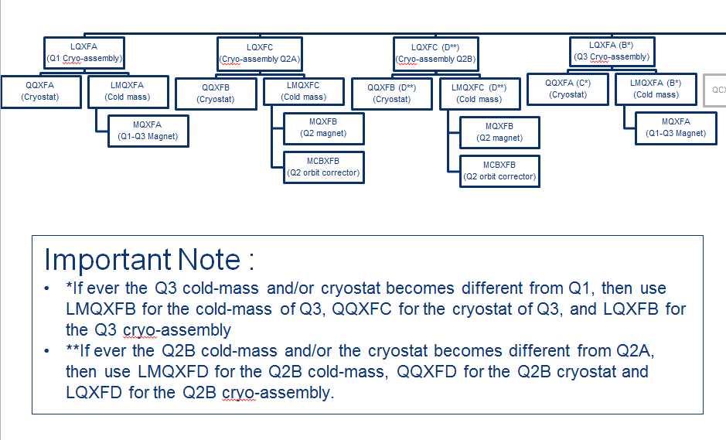

Figure 2: CERN Naming Conventions for HL-LHC Inner Triplets (C. Parente (TQO) and S. Chemli (Configuration), updated October 6, 2014)

The MQXFA magnet production is expected to be the responsibility of the U.S. HiLumi Project. The LMQXFA and LMQXFB Cold Mass assembly production responsibility is TBD [RC Note: the cold mass assembly is part of the US-HiLumi tentative baseline, pending CERN/DOE approved collaboration agreement]. CERN is responsible for the design and assembly of the QQXFA and QQXFC cryostat assemblies and for the production of all other HL-LHC Nb3Sn magnets (Q2a, Q2b, and DS Dipoles). Table 1 shows a list of anticipated institutional responsibilities and quantities (including spares) for HL-LHC Inner Triplet Nb3Sn magnets.

Table 1: Anticipated institutional responsibilities for HL-LHC Inner Triplet Nb3Sn Magnets

|  |  |  |  |  |
| --- | --- | --- | --- | --- |
|  |  | **Qty** | **U.S.** | **CERN** |
| **LQXFA** | **Q1 Cryo-assembly** | 5 |  | X |
| QQXFA | Cryostat | 5 |  | X |
| LMQXFA | Cold Mass | 5 | TBD | TBD |
|  | Beam Screen |  |  | X |
| MQXFA | Magnets | 10 | X |  |
| **LQXFA (B*)** | **Q3 Cryo-assembly** | 5 |  | X |
| QQXFA (C*) | Cryostat | 5 |  | X |
| LMQXFA (B*) | Cold Mass | 5 | TBD | TBD |
|  | Beam Screen |  |  | X |
| MQXFA | Magnets | 10 | X |  |
| **Q2A** |  |  |  |  |
| QQXFB | Cryostat | 5 |  | X |
| LMQXFC | Cold Mass | 5 |  | X |
| MQXFB | Magnet | 5 |  | X |
| MCBXFB | Corrector | 5 |  | X |
| **Q2B** |  |  |  |  |
| QQXFB (D*) | Cryostat | 5 |  | X |
| LMQXFC (D*) | Cold Mass | 5 |  | X |
| MQXFB | Magnet | 5 |  | X |
| MCBXFB | Corrector | 5 |  | X |

This functional requirements specification is for MQXFA only, however most of the requirements are the same for MQXFB (the length is the main exception). There will be mutual benefit, for CERN and USHiLumi, in keeping the MQXFA and MQXFB designs as close to each other as possible. A separate functional requirements specification will be written for cold mass assembly, LMQXFA and LMQXFB.

The MQXFA preliminary design (Figures 3 and 4) consists of four 2-layer Nb3Sn coils. The quadrupole makes use of an Aluminum-shell based structure developed within the LARP collaboration. Coils are mainly prestressed by the Al shell during the cool-down, acting as the structure to contain the Lorentz forces during powering. The level of stress is fine-tuned during the loading of the coil, which is done at room temperature using water-pressurized bladders and interference key [1].

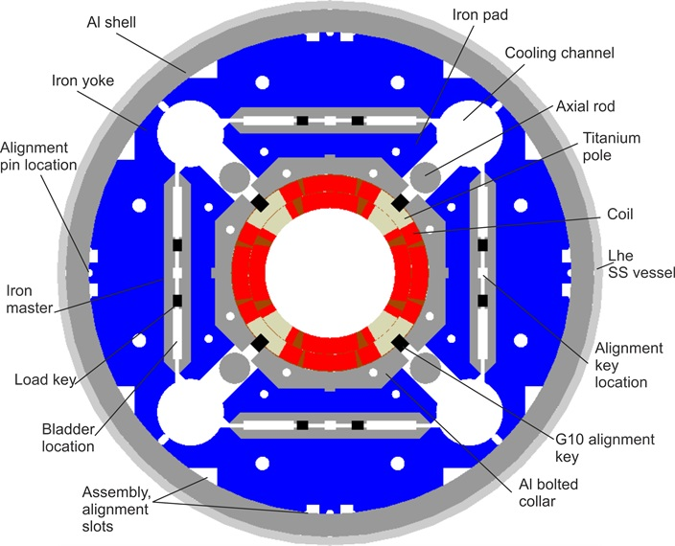

Figure 3: MQXFA cross-section

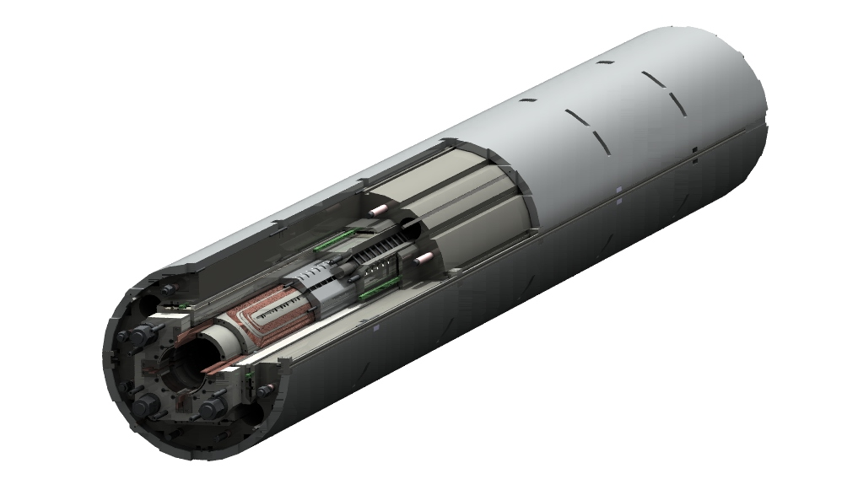

Figure 4: MQXFA 3-D conceptual cutaway view

1. Functional Requirements Overview

The MQXFA functional requirements are the main technical requirements for the MQXFA magnet structure. These requirements are driven by the optics functions that the Q1 and Q3 elements need to satisfy plus physical, operational, environmental, and risk tolerance constraints.

Each requirement should be **verifiable** by a Quality Control (QC) process. If all the functional requirements specified in this document are verified, then the U.S. HiLumi MQXFA magnet deliverables shall be fit for the intended use and satisfy CERN’s needs for the HL-LHC upgrade. The quality of the U.S. HiLumi MQXFA deliverables will be measured by the degree to which its characteristics fulfill the requirements specified in this document.

This document provides some background information for each requirement, and throughout this document requirements are identified by a requirement ID of the format “**R-XX**”, where XX is the requirement number.

At the end of the document Table 4 summarizes all MQXFA functional requirements.

1. Physical Requirements
   1. Coil Aperture Requirement

**R-01: The MQXFA coil aperture requirement is 150mm. This aperture is the coil inner diameter at room temperature, excluding ground insulation, cold bore and beam screens.**

This aperture represents an increase of 80mm over the present LHC inner triplet coil aperture of 70mm. The larger aperture is a key MQXFA requirement for HL-LHC, because it allows a smaller * and higher luminosity. Advances in Nb3Sn technology for superconducting magnets allow this increase in aperture while keeping the magnet length at acceptable values.

* 1. Physical Envelope Requirements

**R-02: The MQXFA physical length must not exceed 5.0 m, and the physical outer diameter must not exceed 614 mm**.

The MQXFA magnet structure must fit within the available physical space envelope in the tunnel provided by CERN. The diameter limitation is driven by the maximum cold mass diameter of 630 mm, leaving sufficient space for an 8 mm thick wall stainless steel helium vessel capable of sustaining the peak pressure requirement of 20 bar [RC Note: an FNAL ASME and PED code expert have stated that the 8 mm shell thickness can only be met with 100% radiography testing]

* 2. Twist and Straightness Requirements

**R-03: The allowable twist of the MQXFA magnet is 1 mrad / 5m, and the required straightness is 100 um / 5m**

[RC Note: these requirements are taken from the present MQXB cold mass requirements for the field axis. I expect this to be the same for MQXFA, but please verify. These are for the cold mass, so I am not sure if they also translate to MQXFA. We should discuss, and also how to measure this to verify compliance].

1. Magnetic Field Requirements
   1. Operating Gradient

**R-04: The MQXFA magnet must be capable of reaching a nominal operating gradient of 132.6 T/m, and an ultimate gradient of 140 T/m, in superfluid helium at 1.9 K. These values are for the magnetic length specified in R-05.**

The inner triplets Q1 and Q3 ramp with the energy of the LHC, with a nominal gradient of 9 T/m at 450 GeV, and of 132.6 T/m at 7 TeV. During squeeze, its gradient is constant or decreases by no more than 10% [1].

* 1. Magnetic Length

**R-05: The MQXFA magnetic length requirement is 4.2 meters at 1.9K.**

The required magnetic length of Q1 or Q3 is 8.4 meters. Q1 or Q3 are made up of two MQXFA magnets, therefore its magnetic length is 4.2 meters.

* 2. Field Quality

**R-06: The MQXFA field harmonics must be optimized at high field. Table 2 (needs to be updated) provides specific target values for field harmonics at a reference radius of 50 mm. CERN will provide b14 correctors if the target b14 value cannot be met.**

Table 2: Expected systematic harmonics (left) and random components (right) in the triplet

 

[Note: This table needs to be updated]

Contributions of the coil ends have to be taken into account and optimized and/or compensated through the straight part [1].

Random components are estimated for a 25 µm random error in the block positioning for non-allowed, and 100 µm for the allowed (see Table 2); most critical components are low order harmonics (b3, a3, b4, a4). Magnetic shimming is allowed for correcting these components [1**].**

* 1. Fringe Field

**R-07: The fringe field on the Q1 or Q3 outer cryostat surface must be below 50 mT**

1. Cryogenic Requirements
   1. Operating Temperature

**R-08: MQXFA magnets must be capable of operation in pressurized static superfluid helium (HeII) bath at 1.3 bar and at a temperature of about 1.9K-2.1K**

**R-09: At least 40% of the coil inner surface must be free of polyamide.**

This measureable requirement is to keep the peak operating coil within its temperature margin.

* 1. Heat Loads

The primary heat load in MQXFA magnets is collision debris from the interaction point. Although the HL-LHC has a nominal luminosity 5 times larger than the nominal design goal of the LHC, CERN is planning to install a newly designed absorber, using thick tungsten (W) shielding attached to the outer surface of the beam screen to reduce the effect of collision debris on both MQXFA radiation damage and heat load (Figure 7). This new absorber is assumed to be installed and working as expected for the following requirements.

* + 1. Coil Peak Power

The coil peak power in MQXFA magnets installed in Q1 is expected to be 1.1 mW/cm3, and the coil peak power in MQXFA magnets installed in Q3 is expected to be 2.5 mW/cm3 [1]. Therefore:

**R-10: MQXFA magnets must be capable of operating under a coil peak power of 2.5 mW/cm3.**

For reference, the present Nb-Ti LHC inner triplet has a target of 4 mW/cm3 coil peak power; however, as a result of the tungsten screen previously mentioned, the coil peak power expected for MQXFA coils are always below the present target of 4 mW/cm3.

* + 1. Total Heat Load

The static heat load on the MQXFA magnets is mainly due to collision debris. In Q1 the collision debris is expected to generate a heat load of 110 W, and in Q2 the collision debris is expected to generate a heat load of 160 W [1]. Therefore:

**R-11: MQXFA magnets must be capable of operating under a maximum heat load per unit length due to collision debris of 20 W/m.**

[RC Note: please verify the 20 W/m value. How much for other sources of static heat load? What about dynamic heat loads during ramping, etc?]

* 1. Cooling Requirements

Cooling is ensured via two 68-mm-inner-diameter heat exchangers in which saturated HeII circulates. In these heat exchangers the heat is extracted by vaporization of the superfluid helium which travels as a low pressure two-phase flow through them. The low vapor pressure inside the heat exchanger is maintained by a CERN supplied cold compressor system, with a suction pressure of 15 mbar corresponding to a saturation temperature of 1.776K. Figure 5 shows a schematic architecture of the cooling using superfluid helium [2]. The bayonet heat exchangers are installed in-line through all the Inner Triplet magnets (Q1, Q2a, Q2b, Q3) and interconnects, with a possible phase separator at the Q2a-Q2b interconnect.



Figure 5: Schematic architecture of the cooling using superfluid helium

* + 1. Provisions for installation of Heat Exchangers Tubes

The heat exchanger tubes are required to carry a total inner triple heat load of 800W at a luminosity of 7.5x1034 cm2 s-1. This requirement resulted in the following CERN choices and parameters relevant to MQXFA [2]:

1. A total of two parallel heat exchanger tubes must be accommodated in the MQXFA yoke cooling channels (see Figure 3)
2. The heat exchanger tubes will be made of high thermal conductivity copper to assure proper heat conduction across the walls
3. The inner diameter of the heat exchanger tubes is 68mm, and a wall thickness of about 3 mm is required to sustain the external design pressure of 20 bar. The outer diameter is therefore 74mm.
4. An annular space of 1.5 mm is required between the heat exchanger tube and the yoke to allow contact area of the pressurized superfluid on the magnet structure side.

**R-12: The MQXFA cooling channels must be capable of accommodating two (2) 74 mm O.D. copper heat exchanger tubes running along the length of the magnet in the yoke cooling channels. The minimum diameter of the MQXFA yoke cooling channels that will provide an adequate gap around the heat exchanger tubes is 77 mm**

* + 1. Provisions for radial heat extraction

The heat loads from the coils and the beam-pipe area can only evacuate to the two heat exchangers mentioned above by means of the static pressurized HeII. To this end the MQXFA cold mass design shall incorporate the necessary helium passages specified in [1] and [2], resulting in:

**R-13: The MQXFA must have provisions for the following cooling passages: (1) an annular space between the cold bore and the inner coil block of 1.5 mm; (2) Free passage through the coil pole and subsequent G-10 alignment key equivalent of 8mm diameter holes repeated every 50 mm; and (3) free helium paths interconnecting the yoke cooling channels holes**

* 1. Peak Pressure

The maximum internal pressure in the MQXFA magnet structure is 20 bar, set by the cold mass helium vessel Maximum Allowable Working Pressure (MAWP). Peak pressures might be experienced by the MQXFA magnet after a full energy magnet system quench, and will be kept below the MAWP by the CERN supplied relief system. Therefore:

**R-14: The MQXFA magnet structure must be capable of sustaining a sudden rise of pressure from atmospheric up to 20 bar without damage and without degradation of subsequent performance.**

* 1. Cooldown and Warmup

**R-15: The MQXFA magnet structure must be capable of surviving a maximum rate of temperature change of +/-TBD K/hr without degradation in its performance**

The maximum rate of temperature change is determined by CERN cryogenic systems.

1. Electrical Requirements

The HL-LHC quadrupole Triplets (Q1, Q2 and Q3) are powered via two main circuits, each equipped with one trim power converter. The two Q2 units are powered in series with a 200 A trim converter on Q2b. Q1 and Q3 are powered in series with a 2 kA trim converter on Q3 (Figure 6). The trim is needed for special beam measurements requiring a different powering between Q1 and Q3.

The stability of the HL-LHC power converters is expected to be at the level of 1 ppm (10-6 of nominal current) with an uncertainty of ±1 ppm. Additional details and considerations for this powering scheme can be found in [1].

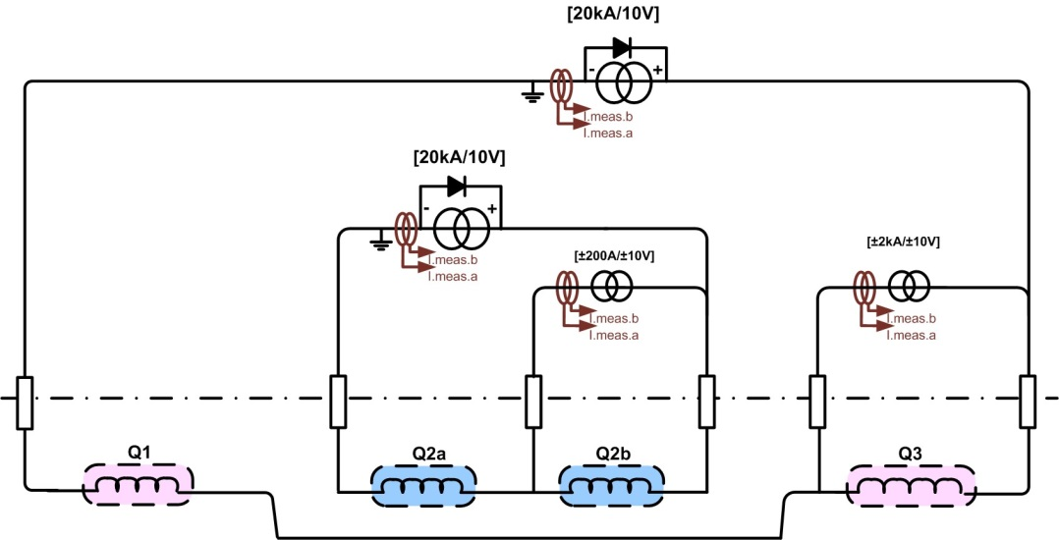

Figure 6: Powering layout of the High-Luminosity Inner Triplets

* 1. Maximum Operating Current

**R-16: The feeding current of the MQXFA coils must not exceed 20 kA**

The planned capacity of HL-LHC electrical circuits is 20 kA. The nominal MQXFA operating current is expected to be 17.46 kA [1].

* 1. Maximum Operating Current Ramp Rate

**R-17: The MQXFA magnets must be capable of operating at the standard HL-LHC current ramp rate of 10 A/s**

[RC Note: Please verify this number. What is the required ramp rate for production testing?)

* 1. Maximum Operating Voltage

**R-18: The voltage on the MQXFA coils must not exceed 2 Volts (please verify) during the standard HL-LHC current ramping**. **A derived requirement is that the maximum magnet inductance must not exceed 200 mH (please verify) to satisfy this requirement**

This is determined by the available voltage capacity of the existing LHC electrical circuits at the Q1 and Q3 current leads connection point (10 volts?), taking into account that Q1 and Q3 will be powered in series plus ~ 2V (please verify) of resistive losses in current leads, busses, etc. (see Figure 6).The expected MQXFA inductance is 33 mH [1].

* 1. Electrical Busses

**R-19: MQXFA magnets must be delivered with a (+) Nb-Ti superconducting lead and a (-) Nb-Ti superconducting lead rated for 20 kA and adequately stabilized for connection to the Cold Mass LMQXFA or LMQXFAB electrical bus**

These leads must be adequately spliced to the Nb3Sn coil cable. Both leads must come out at the same end of MQXFA magnet.

**R-20: The joint resistance for internal (Nb3Sn-NbTi) and external (NbTi-NbTi) joints must be less than TBD µΩ** [RC Note: how do we verify this? Will voltage taps for joints be a requirement?]

**R-21: The MQXFA cross section must have provisions for routing the LMQXFA or LMQXFB superconducting busses**. This is anticipated to be done by using available yoke cooling channels without heat exchanger tubes. (RC Note: any more details about expected bus cross section, etc?)

* 1. Instrumentation

**R-22: The MQXFA magnet shall be delivered with three (3) quench detection voltage taps for interfacing with the CERN supplied Quench Detection system. These taps are located on each magnet lead and at the electrical midpoint of the magnet circuit**

**R-23: The MQXFA magnet shall be delivered with two (2) voltage taps for each quench strip heater.** (Please elaborate. What about voltage taps for electrical joints?)

Are RTDs required to be installed in MQXFA?

* 1. Voltage Limits

**R-24: All MQXFA components must be designed to withstand the maximum voltages that can appear during normal operation, including ramping up, ramping down and quenching.**

**R-25: The MQXFA magnet coils and quench protection heaters must pass a hi-pot test in liquid helium at 1 atm pressure as specified in Table 3.**

Table 3: Required hi-pot test voltages and leakage current in liquid helium at 1 atm pressure

|  |  |  |  |
| --- | --- | --- | --- |
| **Circuit Element** | **Vmax** | **V hi-pot** | **I hi-pot** |
| Quench Protection Heaters - Coil | 500 V | TBD | < TBD µA |
| Magnet Coil - Ground | 1,000 V | TBD (2,500 V?) | < TBD µA |

1. Quench Requirements
   1. Temperature Margin

**R-26: The minimum MQXFA coil temperature margin at 1.9K shall be 4.2K**

* 1. Maximum MIITs after a quench

**R-27: The maximum MQXFA coil MIITs after any quench shall not exceed 37 MIITs** to avoid coil damage

[RC Note: we should include a paragraph about the relationship between MIITs and peak coil temperature, and indicate that the requirement is on MIITs because this is a verifiable requirement]

* 1. Maximum coil voltage to ground after a quench

**R-28: The maximum MQXFA coil voltage to ground after any quench shall not exceed 1,000 V** to avoid coil and insulation damage and damage to CERN-connected electrical components.

* 1. Quench Training Requirements

**R-29: MQXFA magnets must be delivered fully trained to 105 % of the nominal operating current. The magnets must remember their training, and after training they must reach nominal operating current in no more than 1 quench following a thermal cycle to room temperature.**

* 1. Quench while ramping up or down

**R-30: MQXFA magnets must not quench while ramping down at 300 A/s from the nominal operating current or while ramping up to nominal operating current at TBD A/s**

* 1. Quench Protection

MQXFA quench protection will be accomplished with CERN supplied power supplies, CERN supplied quench detection system, and CERN supplied strip heater power supplies, through the use of MQXFA voltage taps and quench protection strip heaters. A CERN supplied CLIQ (Coupling Loss Induced Quench) system is also under consideration.

The MQXFA magnet must have voltage taps located on each magnet lead and at the electrical midpoint of the magnet circuit as specified in **R-20**. This configuration allows quenches to be detected via a voltage imbalance between half magnet coil circuits. Once a quench is detected in any element in the inner triplet, the power supply system will be turned off and all quench protection strip circuits in all magnets in the triplet will be energized.

**R-31: The MQXFA quench protection components must be compatible with the CERN-supplied quench protection system and comply with the corresponding interface document specified by CERN.**

This is an important interface between MQXFA and CERN supplied equipment. The quench protection system is a highly integrated system with a complex interface between CERN supplied equipment and MQXFA components.

[Note: not sure if this requirement is stated correctly. We need to be able to verify the MQXFA product requirements independent of CERN supplied equipment, so perhaps all we can do is to comply with a TBD interface specification]

1. Radiation Hardness Requirements

The MQXFA magnet structure will be located near the IP where high radiation levels are expected. With a nominal luminosity 5 times larger than the nominal design goal of the LHC, CERN is planning to fabricate and install a newly designed absorber, using thick tungsten (W) shielding attached to the outer surface of the beam screen (Figure 7) to reduce the effect of collision debris. The W shielding will limit the radiation damage over the HL-LHC accumulated luminosity of 3000 fb-1 to a maximum of 30 MGy. This value is similar to the expected radiation doses for the nominal LHC [1].

**R-32: The MQXFA magnet shall be capable of surviving a maximum radiation dose of 30 MGy.**

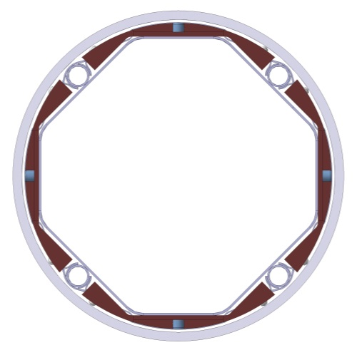

Figure 7: Beam screen (grey) with tungsten shielding (dark brown) and cooling tubes in Q1 (left) and in Q2-D1 (right)

1. Reliability Requirements
   1. Lifetime

**R-33: MQXFA magnets must survive 6 (MQXB spec) years of HL-LHC operation under nominal luminosity conditions**, limited primarily by the integrated dose to the materials in the coils.

* 1. Number of Thermal Cycles

**R-34: MQXFA magnets must survive 25 (MQXB spec) thermal cycles during HL-LHC tunnel operations.**

* 1. Number of Powering Cycles

**R-35: MQXFA magnets must survive 3,000 powering cycles during HL-LHC tunnel operations.**

* 1. Number of Quenches

**R-36: MQXFA magnets must survive 10 (MQXB spec) quenches during HL-LHC tunnel operations.**

1. Interface Requirements

The MQXFA magnet structure interfaces with the following systems:

1. The LMQXFA or LMQXFB System, including:
   1. The 1.9K stainless steel helium vessel, including the beam pipe and end domes
   2. Two (2) heat exchanger pipes installed in the MQXFA yoke cooling channels
   3. The LMQXFA or LMQXFB Electrical Busses and Instrumentation Wiring System
2. The CERN supplied Cryogenic System, consisting of:
   1. The CERN supplied cooling system
   2. The CERN supplied pressure relief system
3. The CERN supplied power system
4. The CERN supplied quench protection system, consisting of:
   1. Quench Detection System
   2. Strip Heaters Power Supplies
   3. Dump Resistor
   4. Possibly a CLIQ system
5. The CERN supplied instrumentation system

Detailed interface documentation must be provided for each of these interfaces.

**R-37: The MQXFA magnets must meet the detailed interface specifications with the following systems: (1) other LMQXFA(B) Cold Mass components; (2) the CERN supplied Cryogenic System; (3) the CERN supplied power system; (4) the CERN supplied quench protection system, and (5) the CERN supplied instrumentation system (all to be defined)**

1. Safety Requirements

Each HL-LHC work package will be subject to safety requirements specified in a CERN “Launch Safety Agreement (LSA)” document [1]. This LSA will specify the CERN safety rules and host state regulations applicable to the systems/processes and the minimal contents of the Work Package safety file needed to meet the Safety Requirements.

**R-38: The MQXFA magnets must meet the corresponding Work Package (WP) Launch Safety Agreement (LSA) specifications (to be defined)**.

No pressure vessel or welding components are expected to be present in MQXFA.

1. CERN Provided Parts

RC Note: Are there any CERN provided parts for MQXFA magnets? What about the NbTi leads, solder/flux, etc?

1. Requirements Summary Table

Table 4: MQXFA Functional Requirements Specification Summary Table

|  |  |
| --- | --- |
| **ID** | **Description** |
|  | **Physical Requirements** |
| R-01 | The MQXFA coil aperture requirement **is 150mm**. This aperture is the coil inner diameter at room temperature, excluding ground insulation, cold bore and beam screens. |
| R-02 | The MQXFA physical length must not exceed **5.0 m**, and the physical outer diameter must not exceed **614 mm**. |
| R-03 | The allowable twist of the MQXFA magnet **is 1 mrad / 5m**, and the required straightness is **100 um / 5m** |
|  | **Magnetic Field Requirements** |
| R-04 | The MQXFA magnet must be capable of reaching a nominal operating gradient of **132.6 T/m**, and an ultimate gradient of **140 T/m** in superfluid helium at 1.9 K. These values are for the magnetic length specified in R-05. |
| R-05 | The MQXFA magnetic length requirement **is 4.2 meters** at 1.9K. |
| R-06 | The MQXFA field harmonics must be optimized at high field. **Table 2** (needs to be updated) provides specific target values for field harmonics at a reference radius of **50 mm**. CERN will provide b14 correctors if the target b14 value cannot be met. |
| R-07 | The fringe field on the Q1 or Q3 outer cryostat surface must be below **50 mT** |
|  | **Cryogenic Requirements** |
| R-08 | MQXFA magnets must be capable of operation in pressurized static superfluid helium (HeII) bath at **1.3 bar** and at a temperature of about **1.9K-2.1K** |
| R-09 | At least **40%** of the coil inner surface must be free of polyamide |
| R-10 | MQXFA magnets must be capable of operating under a coil peak power of **2.5 mW/cm3** |
| R-11 | MQXFA magnets must be capable of operating under a maximum heat load per unit length due to collision debris of **20 W/m** |
| R-12 | The MQXFA cooling channels must be capable of accommodating **two (2) 74mm o.d.** copper heat exchanger tubes running along the length of the magnet in the yoke cooling channels. The minimum diameter of the MQXFA yoke cooling channels that will provide an adequate gap around the heat exchanger tubes is **77 mm**. |
| R-13 | The MQXFA structure must have provisions for the following cooling passages: (1) an annular space between the cold bore and the inner coil block of **1.5 mm**; (2) Free passage through the coil pole and subsequent G-10 alignment key equivalent of **8mm** diameter holes repeated every **50 mm**; and (3) free helium paths interconnecting the yoke cooling channels holes |
| R-14 | The MQXFA magnet structure must be capable of sustaining a sudden rise of pressure from atmospheric up to **20 bar** without damage and without degradation of subsequent performance. |
| R-15 | The MQXFA magnet structure must be capable of surviving a maximum rate of temperature change of **+/-TBD K/hr** without degradation in its performance |
|  | **Electrical Requirements** |
| R-16 | The feeding current of the MQXFA coils must not exceed **20 kA** |
| R-17 | The MQXFA magnets must be capable of operating at the standard HL-LHC current ramp rate of **10 A/s** |
| R-18 | The voltage on the MQXFA coils must not exceed **2 Volts** (please verify) during the standard HL-LHC current ramping. A derived requirement is that the maximum magnet inductance must not exceed **200 mH** (please verify) to satisfy this requirement |
| R-19 | MQXFA magnets must be delivered with a (+) Nb-Ti superconducting lead and a (-) Nb-Ti superconducting lead rated for **20 kA** and adequately stabilized for connection to the Cold Mass LMQXFA or LMQXFAB electrical bus |
| R-20 | R-20: The joint resistance for internal (Nb3Sn-NbTi) and external (NbTi-NbTi) joints must be less than **TBD µ**Ω |
| R-21 | The MQXFA cross section must have provisions for routing the LMQXFA or LMQXFB superconducting busses |
| R-22 | The MQXFA magnet shall be delivered with **three (3)** quench detection voltage taps for interfacing with the CERN supplied Quench Detection system. These taps are located on each magnet lead and at the electrical midpoint of the magnet circuit |
| R-23 | The MQXFA magnet shall be delivered with **two (2)** voltage taps for each quench strip heater |
| R-24 | All MQXFA components must be designed to withstand the maximum voltages that can appear during normal operation, including ramping up, ramping down and quenching. |
| R-25 | The MQXFA magnet coils and quench protection heaters must pass a hi-pot test in liquid helium at 1 atm pressure as specified in **Table 3** |
|  | **Quench Requirements** |
| R-26 | The minimum MQXFA coil temperature margin at 1.9K shall be **4.2 K** |
| R-27 | The maximum MQXFA coil MIITs after any quench shall not exceed **37 MIITs** |
| R-28 | The maximum MQXFA coil voltage to ground after a full energy quench shall not exceed **1000** **V** |
| R-29 | MQXFA magnets must be delivered fully trained to **105** % of the nominal operating current. The magnets must remember their training, and after training they must reach nominal operating current in no more than **1** quench following a thermal cycle to room temperature. |
| R-30 | MQXFA magnets must not quench while ramping down at **300 A/s** from the nominal operating current or while ramping up to nominal operating current at **TBD A/s** |
| R-31 | The MQXFA quench protection components must be compatible with the CERN-supplied quench protection system and comply with the corresponding interface document specified by CERN |
|  | **Radiation Hardness Requirements** |
| R-32 | The MQXFA magnet shall be capable of surviving a maximum radiation dose of **30 MGy**. |
|  | **Reliability Requirements** |
| R-33 | MQXFA magnets must survive **6 (MQXB spec)** years of HL-LHC operation under nominal luminosity conditions |
| R-34 | MQXFA magnets must survive **25 (MQXB spec)** thermal cycles during HL-LHC tunnel operations |
| R-35 | MQXFA magnets must survive **3,000 powering** cycles during HL-LHC tunnel operations. |
| R-36 | MQXFA magnets must survive **10 (MQXB spec)** quenches during HL-LHC tunnel operations |
|  | **Interface Requirements** |
| R-37 | The MQXFA magnets must meet the detailed interface specifications with the following systems: (1) other LMQXFA(B) Cold Mass components; (2) the CERN supplied Cryogenic System; (3) the CERN supplied power system; (4) the CERN supplied quench protection system, and (5) the CERN supplied instrumentation system (all to be defined) |
|  | **Safety Requirements** |
| R-38 | The MQXFA magnets must meet the corresponding Work Package Launch Safety Agreement (LSA) specifications (to be defined) |

1. References

[1] HL-LHC Preliminary Design Report, v0.6.55, October 27 2014.

[2] R. van Weelderen, B. Bozza, “Specific QXF cold-mass requirements to ensure a robust cooling by superfluid helium”, 4th Joint HiLumi LHC-LARP Annual Meeting, November 17-21 2014, KEK.

<https://indico.cern.ch/event/326148/timetable/#20141118.detailed>