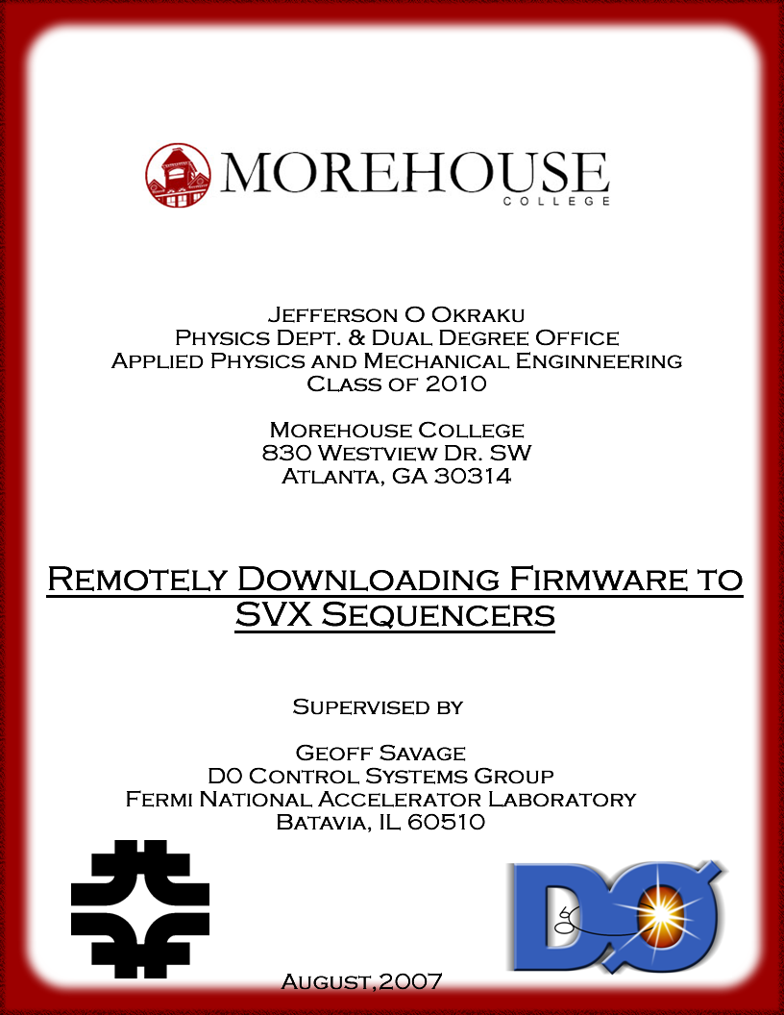
Contents

Abstract……………………………………………………………..3

Introduction
What is Fermilab……………………………...………………………4
The D0 Experiment and its Detector……………….…………..……..5
SVX Sequencer ………………………………………………………7

Equipment and Software Used
Linux ...…………...…………………………………………………..9
VxWorks..………...…………………………………………………..9
1553 Bus and Controller ………..…………………………………..10
JAM STAPL Player…………………………………………………12

Method
Firmware: From Creation to FPGAs…………………...……………14

Results
JTAG Timing………………….………………………………….…17
Download Times………………………………………………….…18

Conclusion
Task Accomplished…....………………………………………….…19
Why Method was Used………..…………………………………….19
Interpretation of Results……….………………………………….…20
Difficulties Faced ……..………………………………………….…21
Future Work…………………...………………………………….…22

Acknowledgements ...……………..…………………………….23

References ……………………….……………………….…….…23

Appendix…………………………...……………….………….… 24
OKRAKU PAGE 3
Abstract

The D0 detector, at the heart of the D0 experiment at Fermilab, monitors the tracks created by particles formed from the energy released during the collision of protons and anti- protons. It sifts through millions of tracks, looking for specific ones that physicists are interested in. The data it collects with its silicon strip detectors about these tracks is passed through analog to digital converters called SXV chips. These SVX chips are controlled by Field Programmable Gate Arrays (FPGAs) on SVX Sequencers in crates at the platform of the detector. This paper describes the project designed to enable remote downloading of firmware onto the FPGAs. This is done by sending the firmware in JTAG (Joint Action Testing Group) format via a 1553 bus and controller used for monitoring the Sequencer boards to the JTAG interface on the boards. The ability to download remotely is essential because of the inconveniences entailed going down to the platform to access the Sequencers.

OKRAKU PAGE 4
Introduction
What is Fermilab?
Fermi National Accelerator Laboratory (Fermilab) aims to advance the understanding of the fundamental nature of matter and energy by providing leadership and resources for qualified researchers to conduct basic research at the frontiers of high energy physics and related disciplines. The lab builds and operates the accelerators, detectors and other facilities that physicists need to carry out forefront research in high-energy physics.
The Tevatron, the largest of the laboratory’s five accelerators, is at the moment, the world's highest-energy particle accelerator and collider. In it, beams of protons and antiprotons are collided to allow scientists to examine the most basic building blocks of matter, and the forces acting on them. It was discovered that the protons and anti-protons have their highest energy, at two points in the Tevatron. Hence at these points, the particles are collided and detectors have been placed to observe and record the collisions. These detectors are designed to record the collision of the particles traveling at the speed of light. They are similar to cameras and allow physicists to look back in time at the rapidly occurring collisions when they are good and ready and at their own pace. The two detectors are Collider Detector at Fermilab (CDF) and the D0 Detector. There are minor differences between the two detectors but they operate mainly on the same principles and with similar technology. This project the paper is on was with the D0 detector.

OKRAKU PAGE 5
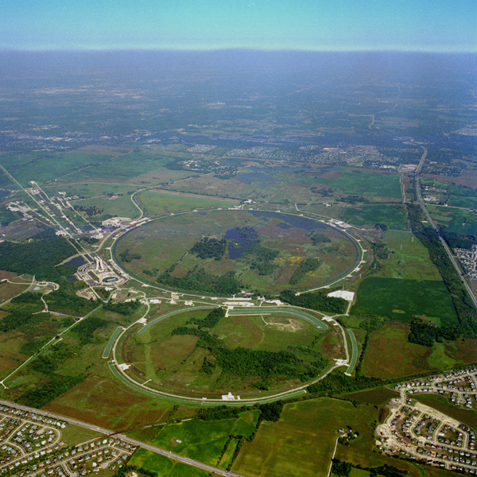
Main Injector
& Recycler
Tevatron
Chicago
↓
‾p source
Booster
‾p
p
p
‾p
1.96 TeV
CDF
DØ

The D0 Experiment and its Detector
The D0 experiment is run at the site of the D0 detector. It is an international collaboration of over 600 physicists whose broad goal is to study the properties and interactions of the Standard Model particles (quarks, leptons, and gauge bosons) and to search for new physics beyond the Standard Model. The detector itself is a large, complicated and expensive device which tries to detect "everything" produced in p-pbar collisions. The intersecting beams coming into the detector are surrounded by charged particle tracking devices (silicon and fiber), solenoid magnets, calorimeters (em and hadron), and a muon system (toroidal magnet and chambers). Collisions happen at a rate of several million per second, and dozens of particles are produced. Only a small fraction of these events selected for further analysis. These “interesting” events are and recorded by the detector. The detector is operated at all times by teams of about four in a control
OKRAKU PAGE 6
room. On it, there are hundreds of kilometers of cables that carry data about occurring collisions to be stored and later analyzed.
The data from these collisions are picked up by the silicon detectors in the middle of the detector in analog format and hence need to be digitized to enable comprehension by computers. This is because computers cannot interpret analog signals. SVX chips carry out the digitization. They are controlled by SVX Sequencers in a crate on the platform of the detector.

DIAGRAM OF THE D0 DETECTOR

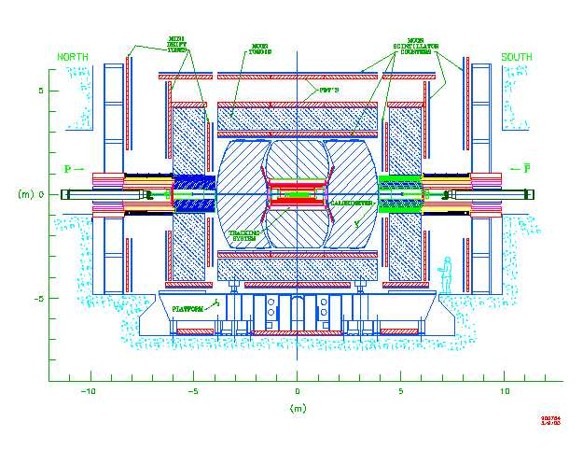
Tracker

Calorimeters
Muon
System
Beamline
Shielding
protons
antiprotons
Silicon Detector

Electronics (Sequencers are in there somewhere)

OKRAKU PAGE 7
FLOW OF DATA FROM THE SILICON STRIP DETECTOR

To silicon detector
To silicon detector

25’ High Mass Cable (3M/50 conductor)

Sequencers

Serial Command Link

SEQ
SEQ
SEQ
Optical Link
1Gb/s

SEQ
SEQ
SEQ
Optical Link
1Gb/s
SEQ
Controller
SEQ
Controller

PwrPC

Movable Counting House

Movable counting house
V
R
B
V
R
B
VRB
V
R
B
V
B
D
Platform
V
B
D
Platform
Pwr
PC
VME
VME
PwrPC
1
5
5
3
PwrPC
1553 Monitoring
SDAq
1553 Monitoring
1
5
5
3
MCH2
MCH2

SDAQ
PDAQ (L3)
MCH3
MCH3

SVX Sequencers
The SVX Sequencer boards are 9U by 280mm circuit boards that reside in slots 2 through 21 of each of eight Eurocard crates. They control SVX chips and transfers data from the SVX chips to the readout crates. The SVX chips digitize 128 analog inputs from silicon strip detectors. These Sequencers have seven Field Gate Programmable Arrays (FPGAs), more widely called computer chips, programmed with firmware used to control the SVX Chips.
FPGAs are semiconductor devices containing programmable logic components called "logic blocks", and programmable interconnects. The instructions programmed on hardware devices such as the FPGAs are called firmware. Unlike software, firmware is

OKRAKU PAGE 8
not loaded from a disk and unlike hardware, it is not tangible. If hence fall in between the hardware and software categories.
This paper, will describe how firmware is sent to the FPGAs on the Sequencers from a remote location highlighting the equipment and methods used and the need for the capacity to perform this task.

SVX Sequencer: Circled are the seven chips
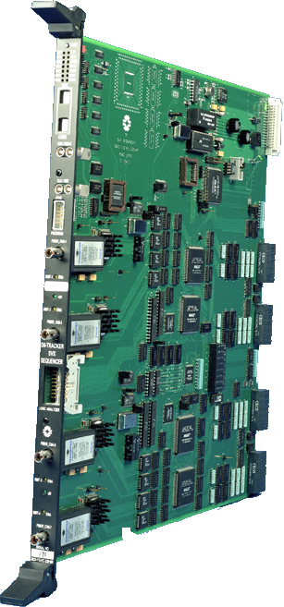

OKRAKU PAGE 9
Equipment and Software Used

This accomplishment is facilitated by a host of devices and software. Primarily, a Linux run desktop computer was needed to serve as the workstation at the remote location.
Ethernet
1553 Bus
VxWorks
LINUX
SVX Sequencer
Embedded Processor
Linux
Linux is a Unix-like computer operating system. It is one of the most prominent examples of free software and open source development: its underlying source code can be freely modified, used, and redistributed by anyone. It is used as the operating system of choice for a wide variety of computer hardware, including desktop computers, supercomputers, and embedded devices such as mobile phones and routers, hence the reason why it is run on most of the laboratory’s computers. It allows for easy interaction between desktop computers and other devices operated by the lab.

VxWorks ( Embedded Processor)
The Unix computer is connected to the embedded processor. The script for the Altera software cross-compiled for VxWorks on the Unix computer and loaded on to the embedded processor via an Ethernet connection.

OKRAKU PAGE 10
VxWorks is a Unix-like real-time operating system run on the embedded processor. It is made and sold by Wind River Systems and includes a multitasking kernel with pre-emptive scheduling and fast interrupt response, extensive inter-process communications and synchronization facilities, and a file system.

1553 Bus and Controller
The desktop computer was connected to a 1553 bus and its controller to dispense the information to the Sequencer. The 1553 bus is a device which consists of a wire pair that transfers data between the controller and devices on the bus referred to as remote terminls. The controller operates according to a command list stored in its local memory to direct the bus. The 1553 controllers are located in the Movable Counting House in the D0 Assembly Building and connect to remote terminal devices located on the platform.

OKRAKU PAGE 11
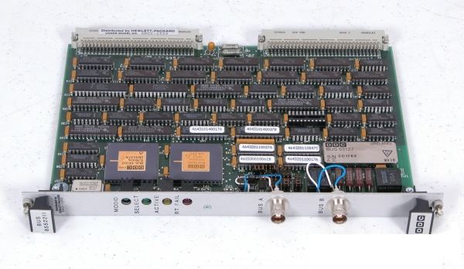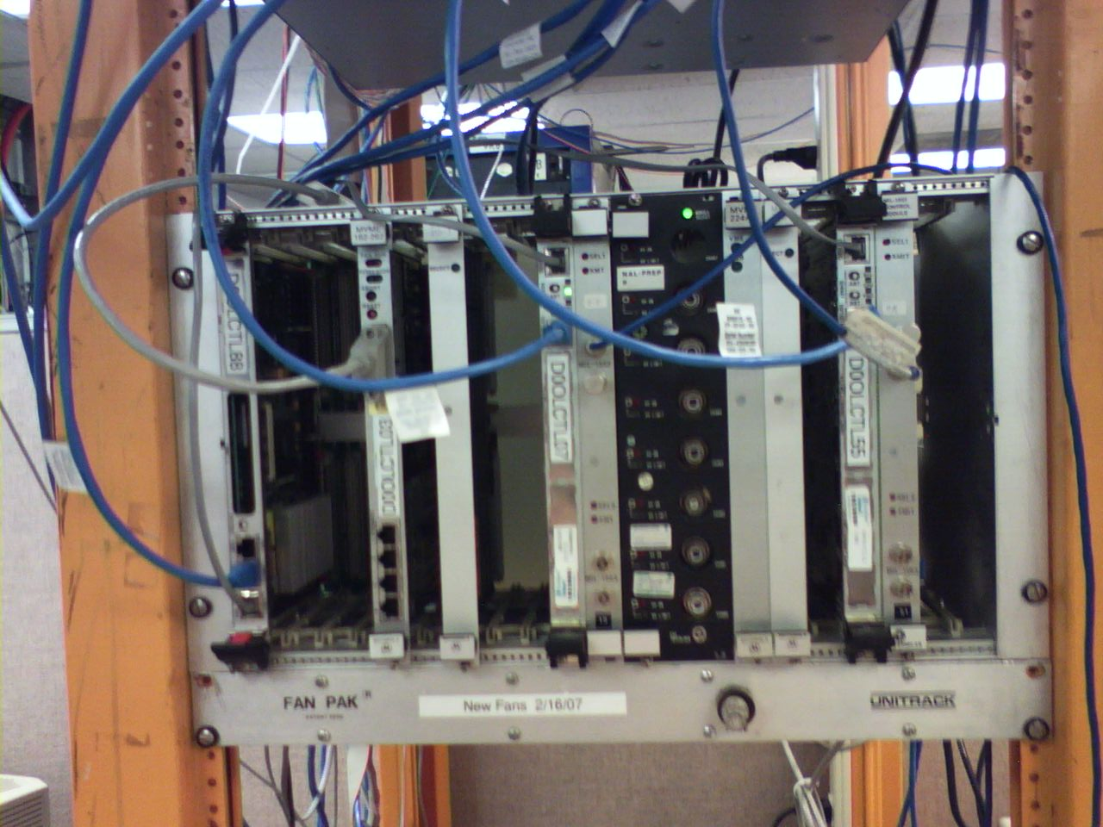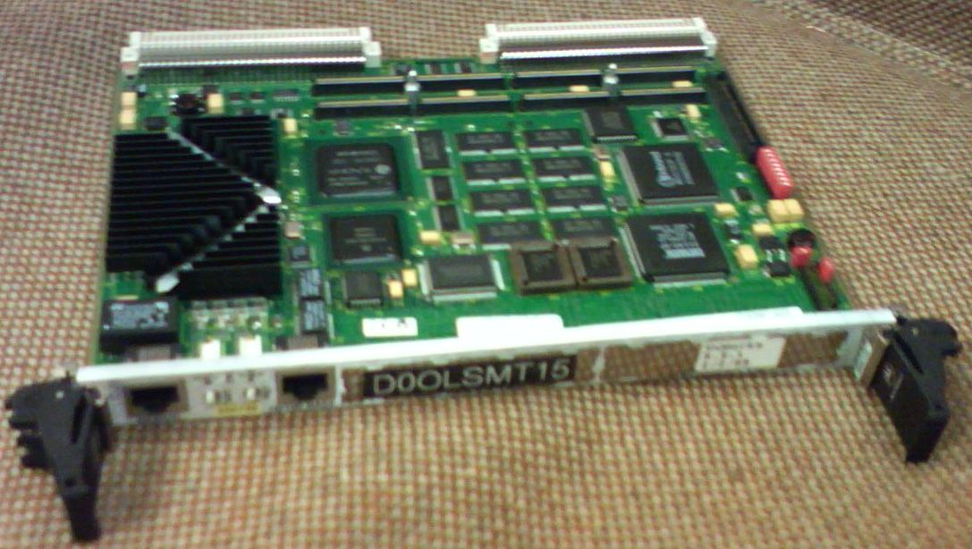
1553 Controller
1553 Bus
VME Crate
Embedded Processor

One of the remote terminal devices is SVX Sequencers situated at the platform of the detector.

OKRAKU PAGE 12
JAM STAPL Player
The above stated equipment are only devices and need to receive commands as to what tasks to carry out. These commands are usually sent by software. The software used in this project is the Altera Jam STAPL Player written in the C programming language. This project required that this software be tailored to suit the devices being used. The Jam player is called so because it loads a JAM file -compressed programmer object files- into a buffer, compresses it and converts the file into *.hex format (basic machine language). It then sends this .hex file to the bus to be programmed to the FPGAs making these files firmware. The JAM player uses the Joint Action Testing Group (JTAG) protocol to send the .hex files to the FPGAs. The protocol involves the use of four dedicated pins on the SVX Sequencer that run through all the FPGAs to send data to and from the chips. The first three pins input data namely the time interval between information signals, the system clock, and the actual information being sent; an example being firmware. The last pin is the output information (firmware) sent from the chip.
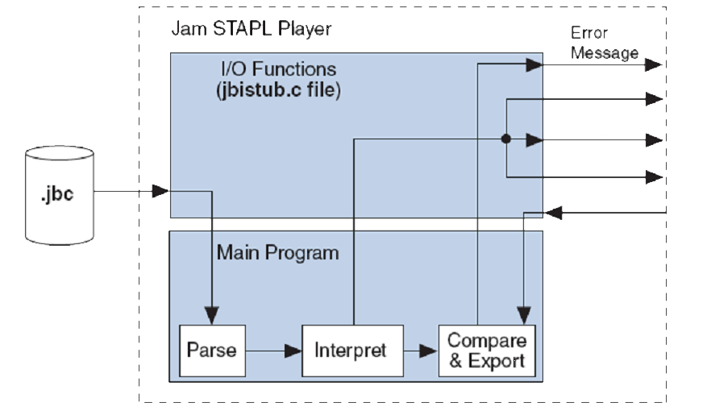
Clock
Timing
Data Input
Data Output

OKRAKU PAGE 13

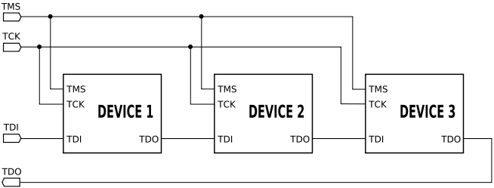

There are two types of JAM files. These are the ASCII text files (.jam) and the Jam Byte –Code files (.jbc). In this project, .jbc files were used. The JAM player proved to be an essential tool since firmware needs to be in machine language to increase processing speed. This is so because little to no time is spent translating the programming language into a computer understandable form.

OKRAKU PAGE 14
Method

Firmware: From Creation to FPGAs
Since the main aim of this project was to download firmware remotely, first, firmware would have to be created.
Written source code is compiled into Programmer Object Files. A number of these object files, usually one per FPGA, are then compressed and converted into a JAM file using the MAX + PLUS II program. With this project, this was done by Mike Utes, an engineer with the D0 Experiment and the designer of the SVX Sequencers used. Subsequently, the JAM player is loaded onto the processor on the 1553 controller. On this project the power pc processor and the Motorola 68k processor were used. These processors are run by a VXWorks operating system.
When the JAM player is run, it loads the .jbc JAM file compresses and converts it to .hex and sends it out at JTAG signals to the 1553 controller. The controller, in turn sends the information to the 1553 bus that sends the parallel JTAG signals, a word at time through its serial twisted pair connection attached to it to the SXV sequencers.
The information goes into the Sequencer through the 1553 port on the backplane. It is then goes through a 1553 chip that converts the serial signals into parallel JTAG signals once more. These signals are then sent to the FPGAs on which are connected in a daisy chain on the board. The signal is read back and compared to the signals sent in by

OKRAKU PAGE 15
the JAM player. This ensures that the signals sent in are the same as those actually put on the FPGA.

DIAGRAMS DESCRIBING METHOD
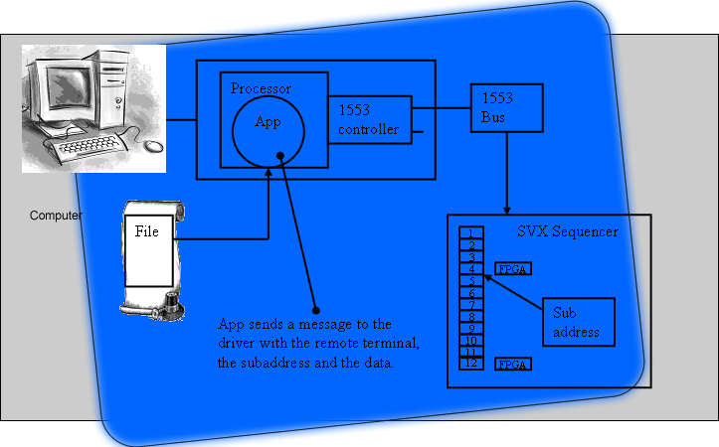
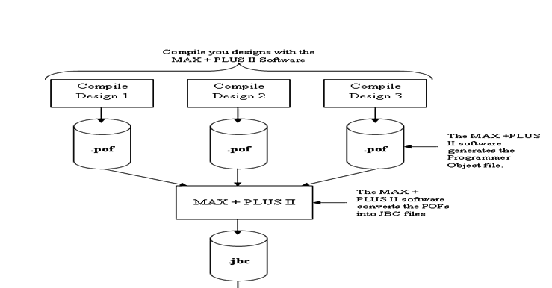
SVX Sequencer

.jbc
JAM Player

OKRAKU PAGE 15
OKRAKU PAGE 16

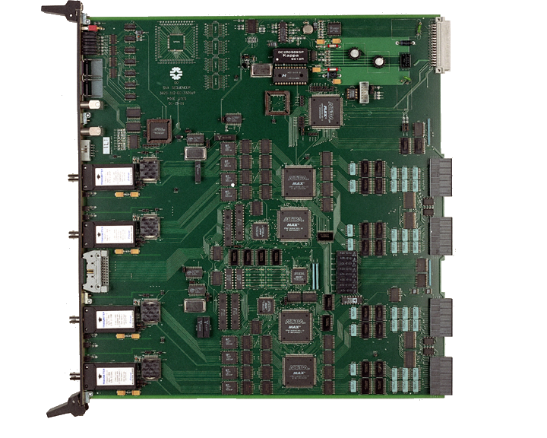
From 1553 bus
Physics Data OUT
Physics Data
IN

OKRAKU PAGE 17
Results
JTAG TIMING
Figure 1
Number of loops | Time in Seconds | Number of loops per millisecond
1.00E+07 | 0 | 0
1.00E+08 | 4 | 25000
5.00E+08 | 20 | 25000
1.00E+09 | 39 | 26641.026
2.00E+09 | 78 | 26641.026
3.00E+09 | 117 | 26641.026
4.00E+09 | 156 | 26641.026

Number of loops | Time in Seconds | Number of loops per millisecond
1.00E+07 | 3 | 4000
1.00E+08 | 25 | 4098.3606
5.00E+08 | 122 | 4132.2314
1.00E+09 | 242 | 4132.2314
2.00E+09 | 484 | 4132.2314
3.00E+09 | 726 | 4132.2314
4.00E+09 | 968 | 4132.2314

Figure 2
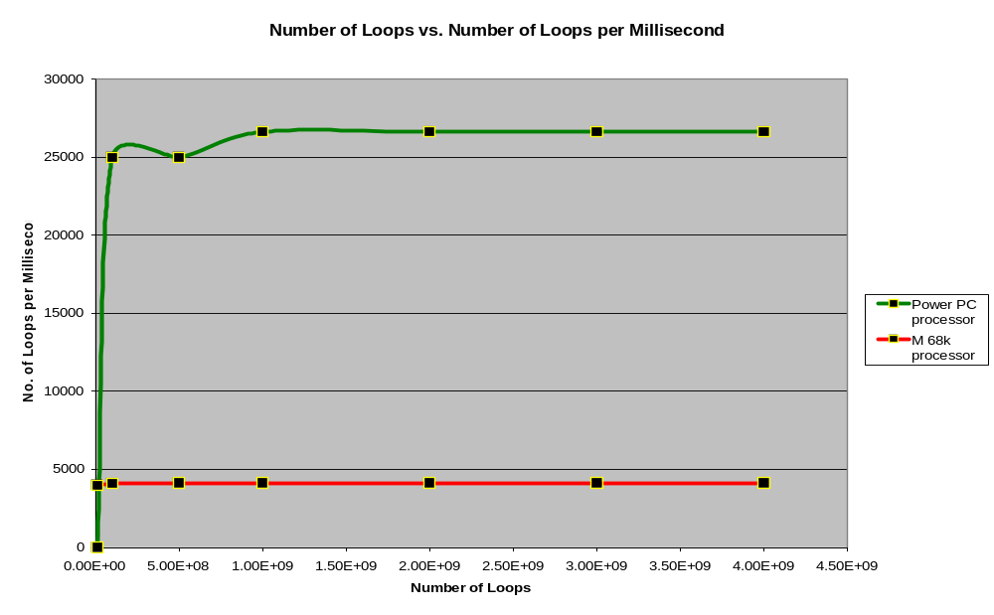

OKRAKU PAGE 18

Download Times
Figure 3
Action | Size of File | Time Taken by Processor  (Minutes: Seconds)
 |  | M 68k | Power PC
Program + Verify  1st chip | 43KB | 22:07 | 7:47
Verify 1st chip | 43KB | 12:09 | 4:24
Verify whole chain | 72KB | 55:23 | 21:18
Verify 1st and 7th chip | 48KB |  | 7:01
Verify 2nd and 6th chip | 59KB |  | 9:47
Verify 3rd and 5th chip | 43KB |  | 7:00
Verify 4th chip | 43KB |  | 3:06
Program + Verify  1st and 7th chip | 48KB |  | 11:43
Program + Verify  2nd and 6th chip | 59KB |  | 15:38
Program + Verify  3rd and 5th chip | 43KB |  | 11:41
Program + Verify  4th chip | 43KB |  | 5:33
Get1553 |  | 300 μs | 123 μs
Put1553 |  | 300 μs | 120 μs

OKRAKU PAGE 19
Conclusion
Task accomplished
The aim of this project was to remotely download firmware onto the FPGAs on the SVX Sequencer using the route previously used to only monitor them. This was achieved and hence, engineers no not have to go down to the platform to plug up directly to the JTAG port to access the JTAG chain. This is very convenient because of the hustles involved in gaining permission to go to the platform.

Old Way
JTAG Chain

JAMPLAYER

New Way

JAMPLAYER
get1553/
put1553
1553 Controller and Bus

1553 Chip

JTAG Chain

Why method was used
The decision the firmware through the 1553 bus and controller was made because of the pre-existing connection between the Sequencers and the 1553 equipment. There was also a pre-existing means (1553 chip) on the boards to convert the 1553 signals sent

OKRAKU PAGE 20
from the bus and controller to the board into JTAG signal compatible with the FPGAs. This made this route the most logical one to take.

Interpretation of Results
As explained earlier, the JAM Player needs to produce three JTAG signals necessary for programming the chips and read back one. The clock signal (TCK) is produced automatically but the processor. The input signal (TDI) is from the firmware being sent to the FPGAs. The last input signal which is the timing signal (TMS) is necessary to allow the FPGAs a millisecond to process the TDI being sent to them. This signal is dependent on the speed of the processor being used. To keep the processor busy while this millisecond passes, it is put in a while loop. It was therefore necessary to know exactly how many loops it took for a millisecond to pass. The results (Figure 1 and Figure 2) were acquired from running a test to find out this number. They show that for the different processor used, the number of loops performed per millisecond differs. The power pc processor was considerable faster than the Motorola 68 K processor.
The great disparity in the speed of the two processors caused the differences in time seen as different tasks allowed by the JAM player are run despite the fact that the JAM files used are the same. (Figure 3). This figure also shows the some of the various tasks that can be run with the JAM Player. The program allows the user to verify if the firmware perceived to be on the FPGAs are the ones there. It also allows the user to perform the primary function of re-programming the FPGAs. The program function,

OKRAKU PAGE 21
when run, automatically runs a the verify function which tells the user if the firmware just downloaded on to the devices are similar to that in the files sent to them.
Difficulties faced
Naturally, some difficulties were faced in bringing the project to completion. However, only two of the major obstacles will be discussed. First was the ability talk to the 1553 bus. For every word sent across the 1553 bus, a call back is expected report if the word send reached the desired destination. There were wiring problems that hinder the receipt of this call backs. In addition, the function responsible to communicating to the 1553 bus was written in the C programming language while the rest of the JAM Player code was in the C++ programming language. Hence there was a need to reconcile the C programming script to work with the C++ one.
As stated earlier, the FPGAs need a millisecond to process data every time a bit of information is sent to them. While waiting for the millisecond to pass, the processor is made to run a while loop. Thus, it was important to determine how many loops each processor used, makes in a millisecond so that it could be instructed to make that many loops. Tests had to be run on each processor to determine this number and solve the problem.
Finally, there were differences in the compiler run by the two processors used. Hence, the JAM Player code had to be adjusted to suit each of the processor by changing different parts of the code the compilers had problems with.

OKRAKU PAGE 22
Future Work
The program in currently in its raw state and hence cannot be run by non-technical people. To make it more user friendly a Graphic User Interface could be made to accommodate individuals not well vested in the programming language and operating system it works in. Also, the program could it added on to allow multiple boards to be programmed at once since there is more than one board on the platform. Programming one board at a time, as the program stands now, would take longer period than is an engineer using the program would like to spend.

OKRAKU PAGE 23

Acknowledgement

I am very grateful to my supervisor, Geoff Savage, for his patience and dedication in helping me understand the concepts of the project I was carrying out. I really appreciate him always pointing me in the right direction; be it in work related issues or in ways to make my stay here in Naperville a good one.
I would also like to express my gratitude to Taka Yasuda, Mike Utes, Bill Lee and Fritz Bartlett for all the help they gave when I was had problem with the program or the equipment I could not solve.
I would like to thank Jamieson Olsen, Mayling Wong-Squires, (my mentors), Dianne Engram, Elliot McCrory and James Davenport for the support and attention they paid me during my 12 weeks at the Lab.
Finally, a hearty thank you goes to everyone at D0 and anyone who in some way or the other made my start at the Lab an eventful one.
References
Altera Corporation. ALTERA Using the Jam Language for ISP & ICR visa an Embedded Processor, Application Note 88. ver. 3.01. Altera Corporation, November 1998
Utes, Mike. D0 Silicon Strip Detector Upgrade Project – SVX Sequencer Board, D0 Engineering Note Number 3823.110-EN-480, Fermi National Accelerator Laboratory, 2002
Joint Action Test Group-Wikipedia, the free encyclopedia, 6 August 2007, http://en.wikipedia.org/wiki/JTAG
Linux-Wikipedia, the free encyclopedia, 9 August 2007, http://en.wikipedia.org/wiki/Linux
VxWorks-Wikipedia, the free encyclopedia, 30 July 2007, http://en.wikipedia.org/wiki/VxWorks
About Fermilab – Mission, 27 February 2001, http://www.fnal.gov/pub/about/whatis/mission.html

OKRAKU PAGE 24
Appendix
Logic Diagram of How the JTAG Protocol is Wired onto the Board


