Implementing E-mail Alerts to the GCC Temperature Monitoring Program

DeMarcus Thomas

Mathematics and Computer Information Science Department
College of Arts and Sciences
Mississippi Valley State University
14000 Hwy 82 West
Itta Bena, MS 38941



Supervisor:
Dr. David Ritchie
Computing Division
Fermi National Accelerator Laboratory
Batavia, IL 60510



SIST. 2007

Abstract

This document describes the continued process to find a way to monitor a high density computing center remotely and efficiently through the use of a web browser. To accomplish this, a web-based temperature monitoring program was created, and implemented at Grid Computing Center (GCC). This Python program is utilized to read data out from thermocouple heat sensors and superimposes their values onto a floormap of GCC in the proper locations of the sensors in relation to the actual room. Additions to the program include the creation of a temperature threshold. If the temperatures read exceed a temperature threshold of (>95.0 ºF), e-mail is then sent out to the appropriate personnel with a mailing list.

The History of Fermilab

On November 21, 1967, the United States Atomic Energy Commission, under a bill signed by President Lyndon B. Johnson, commissioned the construction of what was then known as the National Accelerator Laboratory. The lab’s inaugural director, Dr. Robert R. Wilson, dedicated the laboratory to an unyielding philosophy of scientific excellence and through the following years molded the lab into an essential research institution engaged in the study of high-energy particle physics.

On May 11, 1974, the facility was renamed in honor of the 1938 Italian Nobel Prize winning physicist Enrico Fermi.

Fermilab is home to the largest high-energy physics laboratory in the United States, as well as the world’s highest energy accelerator known as the Tevatron (Energy Doubler).

Fermilab’s main focus is research on the fundamental particles of physics. At the laboratory, scientists probe the smallest particles of matter in order to study the smallest distances known to science. The main goal through all of the work is to understand the fundamental particles and the forces that hold them together or force them apart.

The information is obtained through high energy particle collision experiments where subatomic particles are forced to collide at high speeds. The particle fragments are scattered into detectors. As a result of these studies, discoveries of particles such as the bottom quark (1977), and the top quark (1995) have continually put Fermilab on the forefront of scientific discovery. Findings such as these continue to make Fermilab one of the chief research facilities in the world.

The Importance of Computers to Fermilab

The experiments performed at Fermilab every day would be less useful if the scientists were not able to study completely the information gathered. Computers help to gather the information quickly and completely. For this reason computers are essential to Fermilab’s work. With the large amount of information coming from research detectors such as CDF and D0, the computing centers such as the Lattice Computing Center (LCC), the Feynman Computing Center (FCC), and the Grid Computing Center (GCC) are necessary to the research.

Computers are used for taking the data and analyzing the data. Analyzing the data is done in two steps. The first step examines the raw data and produces summary data. The following steps investigate the summary data in great detail—often taking two or three years to complete the analysis.

This long amount of time can be shortened by providing more computers. For this reason the Computing Division constructed GCC by converting old buildings that were home to now complete experiments which had previously installed large amounts of electrical power and cooling.

The GCC construction resulted in a 2000 square foot computer room containing almost 3,000 computers. This room, Computer Room A, was the main focus of my project. This computer room is constantly active and works around the clock analyzing data. The numerous computers produce a large amount of heat. Computer room air conditioners (CRAC’s) are required to regulate the room’s temperature.

Because GCC is far away from the Computing Division’s offices, the Facilities Department staff realized that a remote temperature monitoring program was needed in order to alert the staff to technical mishaps or CRAC unit malfunctions. Such a program was created and extended over several years by students Sirius Ben-Judah, Eric Rivera, Kati Skelton, Constantine Mukasa, Phil Scherer, and DeMarcus Thomas under the direction of Computing Division member David Ritchie.

Through their several years of work, the program was implemented to create two different kinds of displays. The first kind of display shows the floor map of Computer Room A with the temperature values superimposed at the location of the temperature sensors. Figure 1 shows an example of this display.

Figure 1. Floor Plan blueprint of GCC-CRA

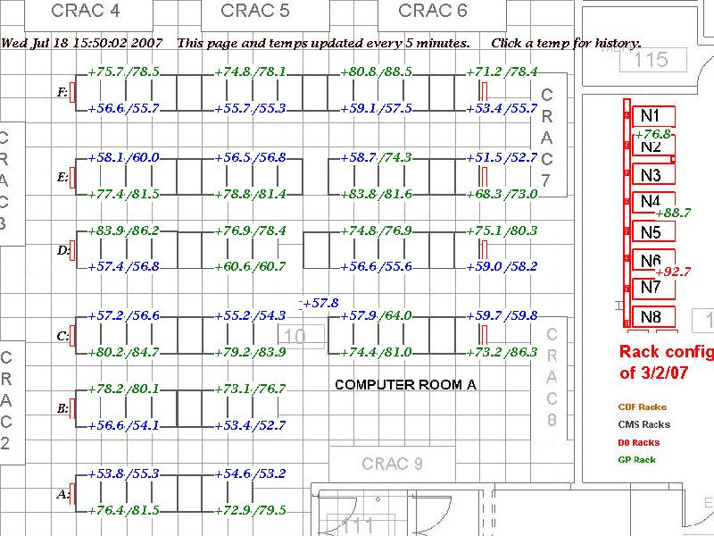

The second kind of display shows, as bar graphs, the history of the last several days of temperature readings. Clicking on a temperature value in the first kind of display brings up the second kind, showing the history of the particular sensor’s readings. Figure 2 shows an example of the second kind of display.
C-E6-M
Sensor Name Format: <Hot/Cold>-<Row><Rack>-<Top/Middle>
Time Format: MMDDhhmm
Temperature values for C-E6-M0711160065.9
0711160562.2
0711161067.8
0711161569.7
0711162064.7
0711162563.5
0711163069.2
0711163567.9
0711164062.9

A total of 84 thermocouples placed at a spacing of approximately every four computer racks on the front and back at the top and middle of each rack provide a detailed picture of the state of the room. This picture is viewable from any location on site by simply pointing one’s web browser to http://cdops.fnal.gov/floorOverlay.html.

The Project

For the purpose of my project, I was required to enhance the program by adding a component which would alert Computing Division personnel through e-mail when a temperature sensor within Computer Room A exceeded a temperature threshold of (>95.0 ºF).

Learn Technology needed for the project

Before arriving at Fermilab I had some programming experience. For example, I had previously learned Java and some aspects of “object-oriented” programming – both of which provided useful background to my Fermilab project.

However, in order to do this project, I had to know some additional specific computer languages, skills, and techniques. For example, I had to know the computer language called Python. I also needed to know how to work safely with hand tools, such as pliers and diagonal cutters and make use of cable ties. This know-how was acquired during orientation safety courses.

Finally, beyond the specific needs of the project, I needed to become familiar with software commonly used with the computers. For example, I needed to become familiar with Unix, Linux, and Perl.

Learning Perl

The first language that I became familiar with here at Fermilab was Perl. PERL (Practical Extraction and Report Language) was created by Larry Wall in 1987. The language is available for Unix, Windows NT, Mac, and DOS computer systems. I learned the language in about a week using Pearls of Perl by David Ritchie. This document taught me Perl through examination of several small programs. This approach quickly helped me become accustomed to the programming language. This finally concluded with me writing a simple adventure game using the Perl language, in which, through many steps, the player experiences a series of consequences based upon decisions made by the player.

My ability to create this game allowed Dr. Ritchie to gauge my programming skills and carve out a plan for exactly what he wanted to do this summer. I downloaded the Perl software from http://www.perl.org/ and Pearls of Perl document from http://www.DavidJRitchie.com//pop/pop.html. In addition, since many of the computer use Perl, it was useful for me to become familiar with Perl.

Learning Python

Python was created by Guido Van Rossum in February of 1991. His work with previous languages such as ABC, Modula-3, and Amoeba could be called the driving force behind Python’s production. Since its creation, it has been modified and adapted by other programmers to make certain the language will remain up-to-date and to keep the software current for programming needs. Python was designed to emphasize the work of the programmer versus the computers effort. It basically prioritizes readability over speed or expressiveness.

The temperature monitoring program, which I had to know and modify in order to do my project, was written entirely in Python. Therefore, I had to learn how the program worked, how to modify it, and how to debug it when my modifications caused problems or were incorrect.

Working with Unix and Linux
Unix is a computer operating system originally developed in 1969 by a group of AT&T employees at Bell Labs including Ken Thompson, Dennis Ritchie, and Douglas Mcllroy. As of 2007, the owner of the trademark UNIX® is The Open Group, an industry standards consortium.
Linux is a Unix-like computer operating system created by Linus Torvalds in 1991. The Linux kernel’s inspiration came from the need to replace Minix, an operating system created by Andrew S. Tanenbaum. Linux was designed to be a Unix-like system that could be run on a PC. This operating system is one of the most prominent examples of free software and open source development; its underlying source code can be freely modified, used, and redistributed by anyone.
I learned Unix by using the Linux flavor of Unix which was installed on the laptop assigned for the summer to my fellow summer student Phil Scherer. The opportunity came when my fellow summer student Phil Scherer was out three days touring colleges. Dr. Ritchie asked that I take the opportunity of Phil’s absence to use the laptop to become familiar with Linux and, by extension, also Unix.
My experience with Unix was a very enlightening one. I made use of a reference book called Exploring The Unix System By: Stephen G. Kochan & Patrick H. Wood. With this book I was able to grasp the general functions of the system and developed some know how to use it.
Continuing my Work with Linux
When my fellow summer student returned I had to return to my laptop and was not able to complete my Linux exploration. In response to this, Phil proceeded to create me a live CD which contained the Unbuntu flavor of Unix. With this CD I was able to load Unbuntu on to my computer, without altering Windows XP, and run the system entirely out of the computer’s RAM memory.

Working with X-Windows

In order to continue my education in the Unix and Linux area, my supervisor asked Rick Hill, a Computing Division support person, to make a product called Reflection available on the Fermilab-owned desktop computer that I had used for my Perl and Python explorations. The Reflection product makes the Xwindows functionality available under Windows XP which was the operating system installed on the desktop computer. With Xwindows, one can bring up a window and log into a Unix machine from the Windows machine. The intention was to allow me to gain more experience with X-Windows in order to practice my newly developed Unix skills. Though helpful, Unbuntu turned out to be the more convenient way to explore Unix. As a result, the Reflection Xwindows capability was not greatly used.

Using XML
The Extensible Markup Language (XML) is called a general purpose markup language. Its primary purpose is to facilitate the sharing of data across different information systems particularly via the Internet.
With my project I needed XML files to specify such things as the threshold temperature (set to 95 deg. F) and the e-mail addresses to which alerts were to be sent in the event of a sensor having a temperature above the temperature threshold.
Hardware used for project
The majority of my programming for this summer was done on my own personal HP Pavilion laptop. I also used a windows PC in our office while working with some Perl programs.
E4 & E16
The equipment that my project used is temperature modules E4 and E16 along with Sensatronic Environmental Sensing Thermocouples (www.sensatronics.com).
The E4 and E16 are small microcomputers which run a stored program contained in read only memory (ROM). The units have a power connection, Ethernet connection, a connection to cables that lead to thermocouples, and a configuration cable. The E4 and E16 are connected to four and sixteen thermocouples correspondingly therefore giving them their titles. The configuration cable is used to initially configure the units via the serial port on a PC using the Hyperterminal program, which is available on most Windows PC’s. The configuration process is only performed once and in this step each unit is given their own IP address, and the name of its thermocouple. With their own IP addresses, the E4 and E16 are now capable of displaying sensor names and current temperature readings through a web browser shown in basic HTML. Figure 3 depicts an E4 temperature monitor while Figure 4 depicts an E16.

Figure 3. E4 Temperature Monitor
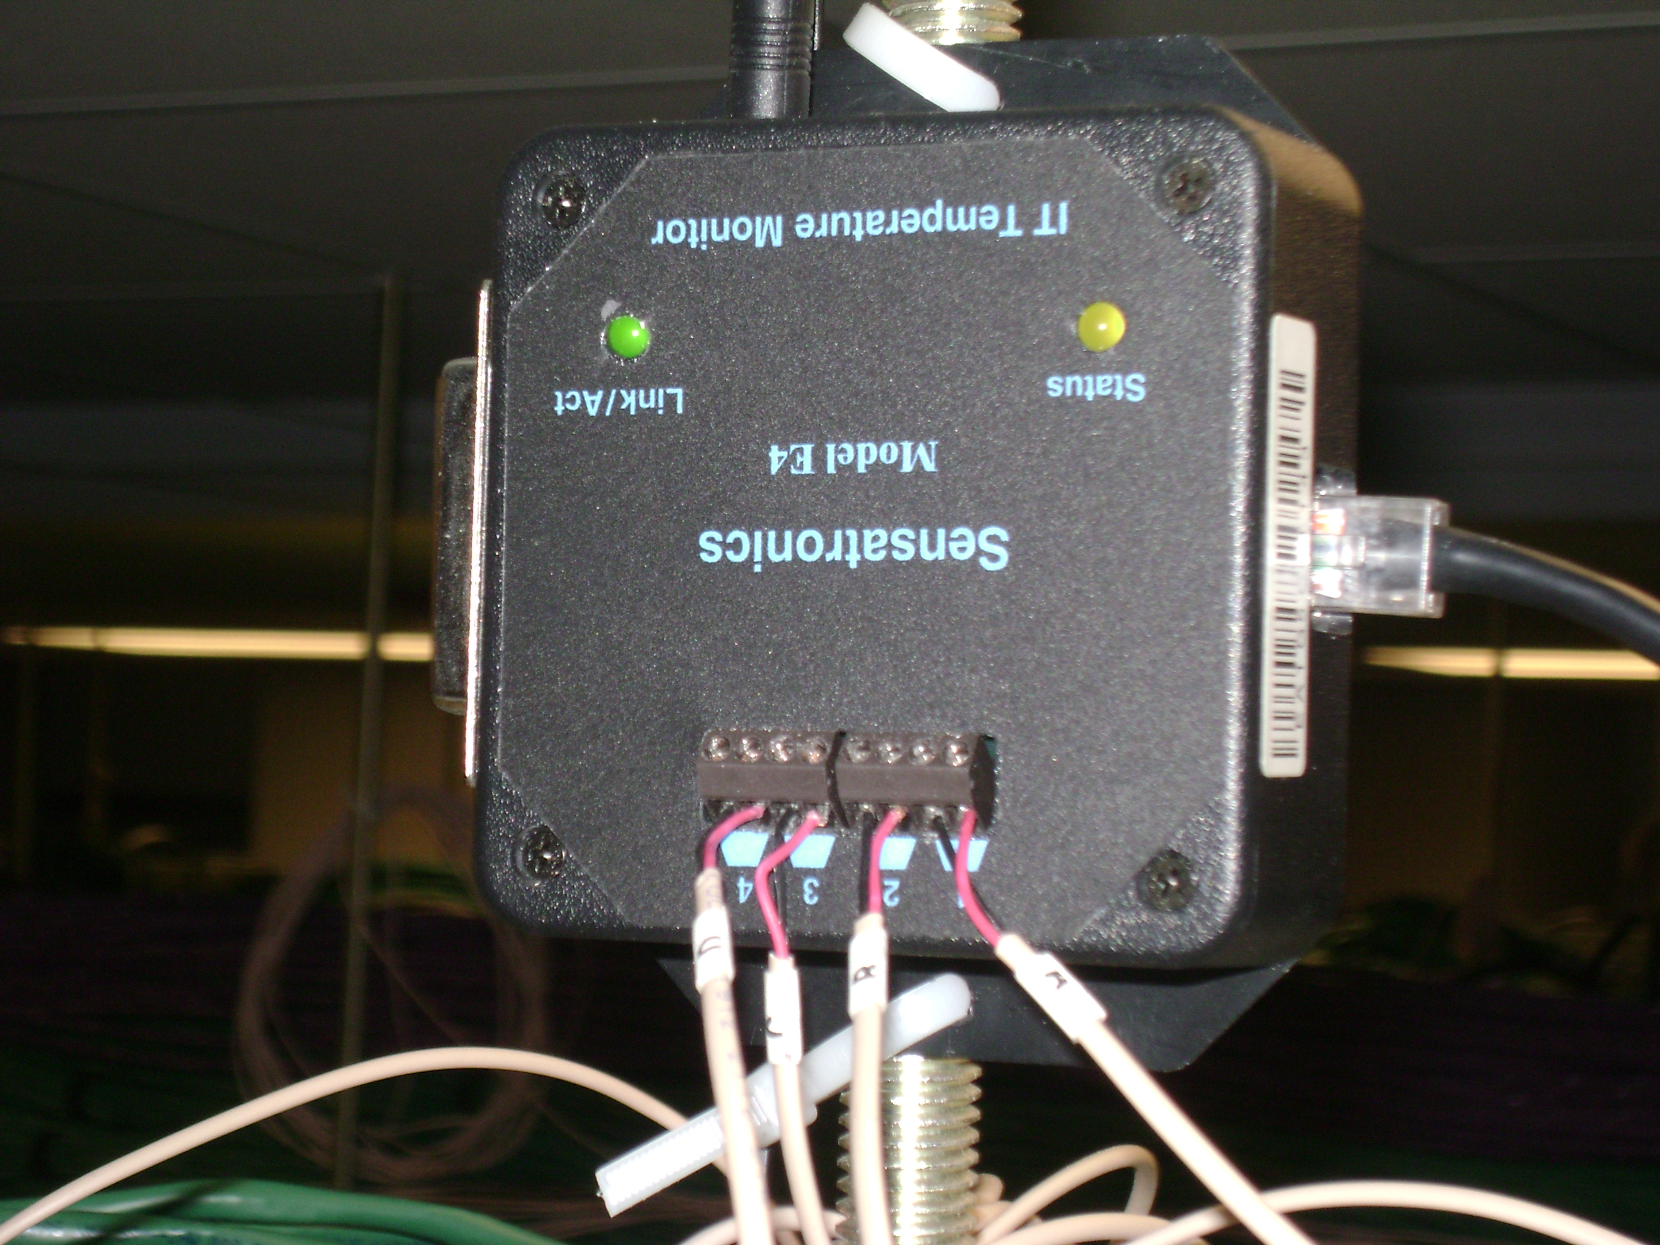
Figure 4. E16 Temperature Monitor
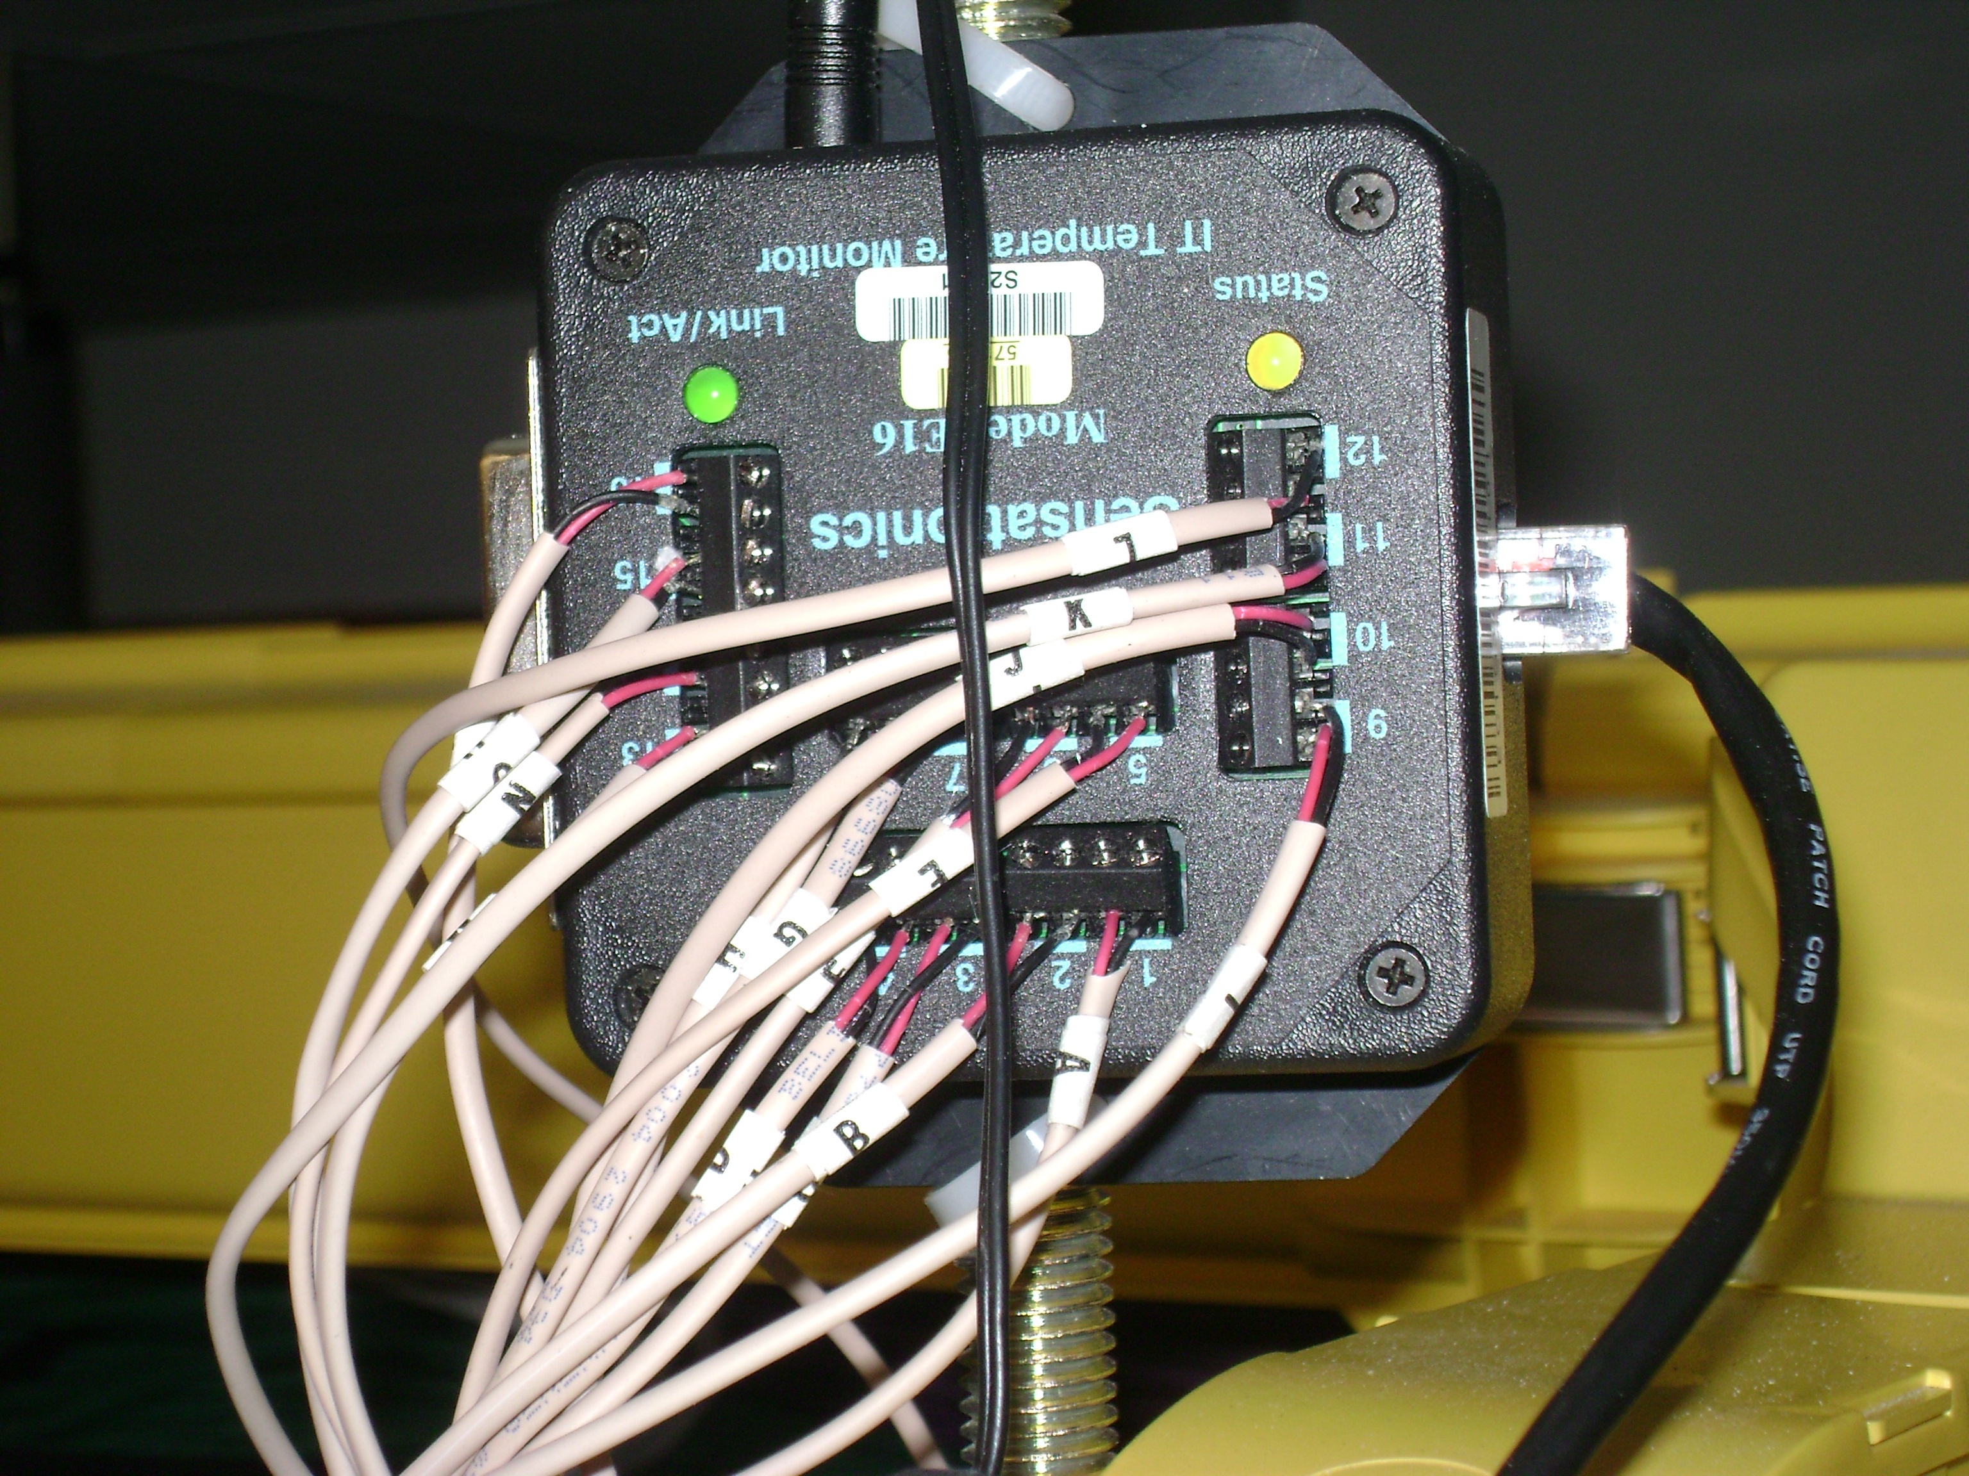

Improve Temperature Monitoring of GCC

Analyzing Collected Data

The first task I had to accomplish was to create a function in the Python program that would sort through the temperatures collected from the sensors and tell me if their value was over a certain number (the threshold value). At first I was successful in printing out the temperatures when they were over the threshold value with the use of if statements and comparison operators, but I had to change the values within the program in order to have the program use a different threshold value. This left too much room for error if something ever needed to be changed. To change the temperature limit after the program was operational, I would have to edit the program and reload it to the server.

To avoid this problem, I made an XML file which the program read to obtain the threshold value. Now, when the threshold value has to be changed, one edits the XML file and changes the data there. In that way, it is not necessary to modify the Python program so that the potential for introducing programming errors is reduced.

Email Alert 1
The emailing capabilities of the program were the most important part of the project. It took more than one try to get it going. When I first began this section I looked through the Python manuals and reference material available in my office for information on how to e-mail a message from within a Python program. I did not find anything useful. I then decided to use Google to search for information on the internet about how to do this task. I looked for any pages containing the words “email” and “python”. After looking through dozens of web pages, I finally found some useful information at http://www.thinkspot.net/sheila/article.php?story=20040822174141155. This page gave the basic layout of how to send an email using a SMTP server, and importing smtplib from the python standard library. Not trusting the information found, I decided to make sure that the code described in the article actually worked. I first wrote small test programs that sent short emails using messages saved in text files using the information in the internet article. This code was successful in sending email. I implemented this. Although the program was a success, users such as Jason Allen suggested the need of a subject for the program’s messages.

Email alert 2 (subject line)
Searching this time I narrowed my search by entering, “Python email’s code with subjects.” With this search I found http://www.eskimo.com/~jet/python/examples/mail/smtp1.html. This site supplied me with the exact code that I needed including the ability to create a subject line.
The temperatures were now being printed on the python shell, so I was able to distinguish values over the threshold from those under the threshold by using print statements along with if statements.
Next, I needed a way for the program to group together all the temperatures over the threshold. To address this problem I created the CheckTemp function of the Bad Temps class. I was able to group the bad temperatures together by adding them to a list and pairing them with the matching thermocouple sensor name. In addition to bad temps being added to a list, they were also counted using the “len” command from the python standard library. When the count of bad temps is greater than zero, the AlertTemp function is called and a message is sent to the appropriate supervisors.

Email Address (Made Mailing List)

Another addition that was implemented was the creation of a mailing list. Dr. Ritchie was able to create this list at LISTSERV.FNAL.GOV. With this list created, people who wanted to receive the temperature alerts from this program can just subscribe to CD-GCC-ENVIRONALERT@LISTSERV.FNAL.GOV and get email whenever alerts are sent out. With this addition the emailing list was added to the XML file “alerts” so that when new people wanted to be added there was no need to edit any files to add email addresses. In this way, when a new individual wants to receive over-threshold temperature alerts, not only is it not necessary to change the Python program residing on the http://cdops.fnal.gov/ server but it is also no longer necessary to change the XML files residing there. This extra degree of isolation reduces the risk that a mistake in Python coding or in XML file editing will bring down what is becoming a very much relied-upon temperature monitoring capability.

Heart Beat

In order to maintain that my program continues to email correctly, I, with the advice of my supervisor, decided to create a test function that would perform a test email once a week. I refer to this as the TimeHeartBeat function of the TempGraphPages class. To do this I used the Time module from the python standard library. Since I only wanted this heart beat function to run once per week at a certain time, I needed to set the function to start using day, hour, and minute. Seeing as I needed those three arguments I simply called them from the time tuple which has the arguments: year, month, day, hour, minute, second, weekday, yearday, and daylight savings. The heart beat function is currently set to run every Tuesday at 10:00 am. Since the entire program runs once every five minutes, I set the interval on the function from 10:00 am until 10:05 am.

Hardware Adjustments

My time here at Fermilab, for the majority of the stay, was based on learning technology so that I would be knowledgeable enough to complete my program. There were some instances where I was required to travel out to GCC and perform some physical work.
For several days, I would go out to GCC and position all the heat sensors to there proper positions. I secured the sensors in the center of there rack by using such items as Velcro strips and cables ties.

Drop down sensors

In addition to correctly repositioning sensors, I also had to uncoil cables from atop the computer racks and secure heat sensors to their proper location. Sensors that were not placed correctly could cause misleading temperatures when data was eventually collected. Figure 5 gives an example of a thermocouple heat sensor.

Figure 5. Close up of heat sensor
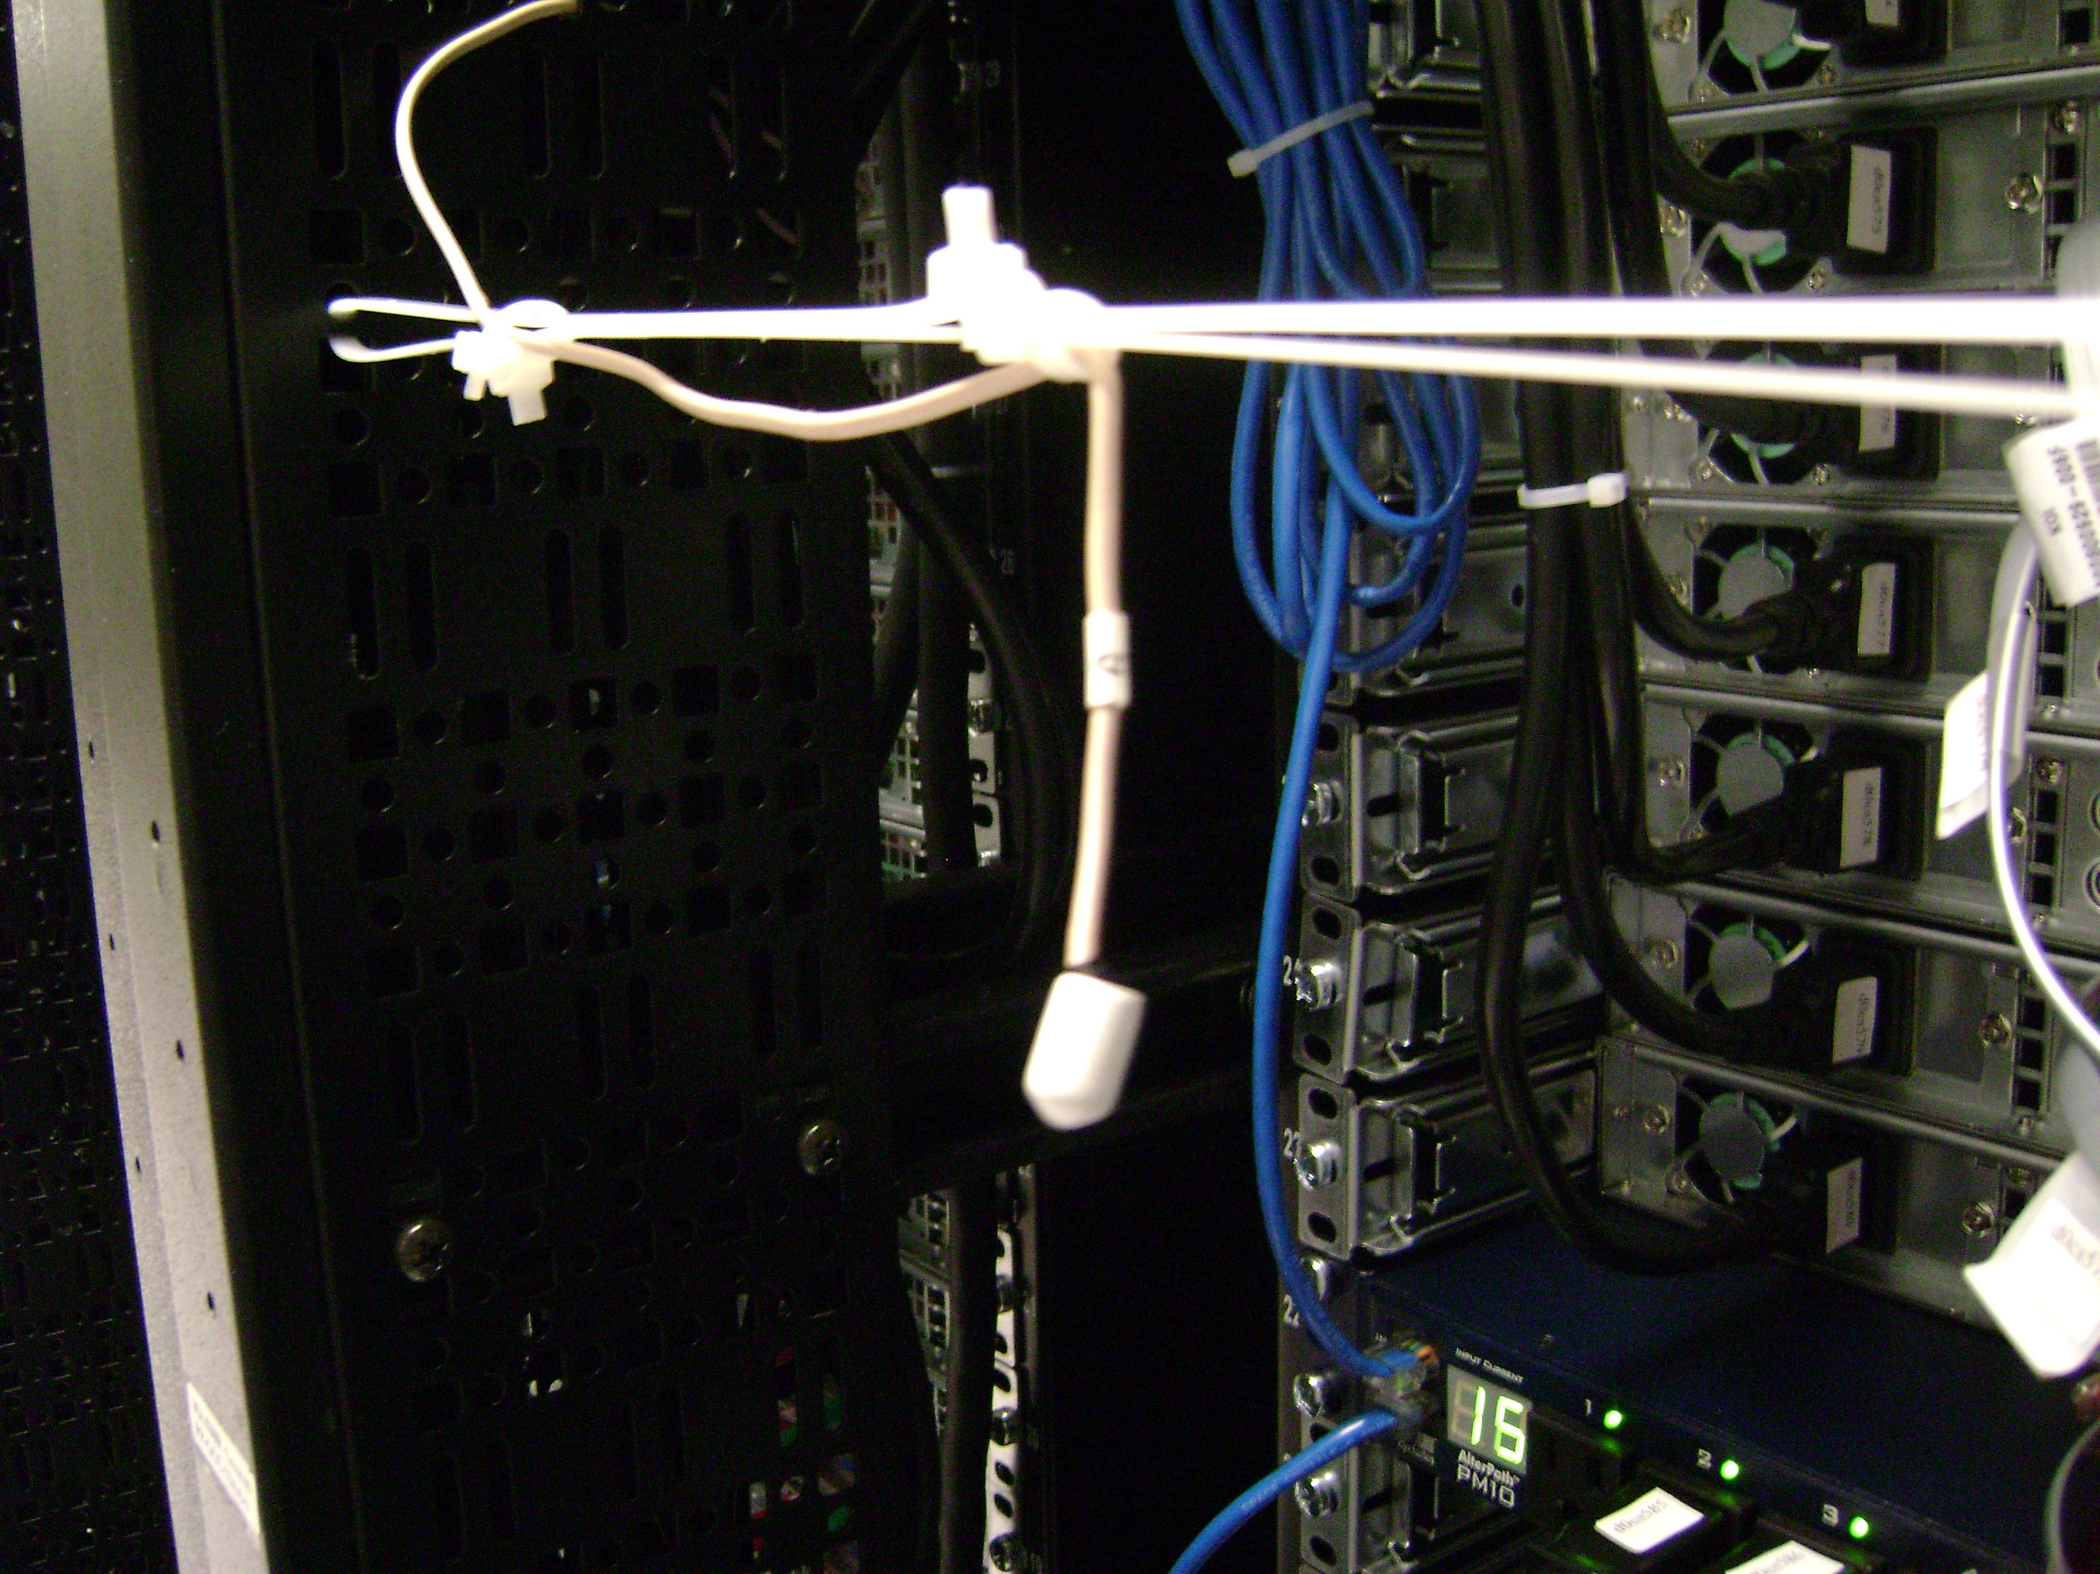

Calibration and Crosschecks

In the thought of being cautious, I wanted to be sure that all heat sensors were working properly and were placed correctly according to GCC Computer Room A blueprint. To do this I wanted to use something that would cause a significant change in sensors recorded temperatures. After some moments of thought, I finally decided on the use of cold packs.

The temperature monitoring program is set to execute every five minutes, so one minute before every execution of the program I would wrap a cold pack around the top and middle sensors on each rack. After the program ran, I would refresh the screen and observe if the racks that I tested corresponded to their position on the GCC Computer Room A blueprint.
This method was effective while testing the sensors on hot aisles, but not as much on the cooler aisles. To get the necessary temperature response, I decided to defer from using ice packs on cold aisle and just cuff sensors within my palm to obtain a noticeable change in temperature. From my test I concluded that all eighty-four sensors were placed correctly according to the GCC blueprint map.

Conclusions

Success of Project

I believe that the results of my project could qualify it as a success. I became aware that my program was useful when some of the Computing Division staff encouraged me to make improvements to certain components which I had added to the original program. Also, when a mailing list was created for my temperature alerts, several people were interesting in joining the list.

Actual Departmental use of the program
One enjoyable aspect of my project is that I can see how the program is beneficial to the staff of the Computing Division. On many occasions, while sitting in on staff meetings, data from my heat monitoring program was used. One of its chief purposes is the ability to follow temperature fluctuations over the course of two days. This becomes very useful when the staff needed to perform checks on the CRAC malfunctions and computer mishaps at GCC.

Future Enhancements

A great deal of work was put into this program and from what I have seen has paid off, but there is always room for improvements and additions. Improvements to the program can include the creation of a better home page for the CD-OPS website. Also the program is in need of an updated blueprint layout for Computer Room A. Additions that will be made are the implementation of this program to Computer Room B and C and also Networking Room B.

V. Acknowledgements

First and foremost I would like to thank God for allowing me with the opportunity to be apart of such a prominent program. It was truly a blessing when I received that e-mail saying that I had been accepted to Fermilab’s SIST program.

I am eternally grateful to Ms. Diane Engram, Mr. Elliot McCrory, and the rest of the SIST selection committee for allowing me to come into contact with such an esteemed and superb organization. Gratitude goes out to Mr. James Davenport for insight into the structure of my paper and to Mr. Cosmore Sylvester for his guidance and support. Also, thanks go out to Mr. Rick Hill and Phil Scherer for support they provided me with through the course of the summer. I would also like to thank the entire Computing Division for their warm welcomes and pleasant attitudes.

A special debt of appreciation goes out to Dr. David Ritchie, my summer supervisor. Dr. Ritchie went above and beyond his job title to make sure I had everything that I needed and always kept me informed about what was going on around the Computing Division. Dr. Ritchie’s assistance and comments were vital to me producing an acceptable paper and getting my presentation together. I know without his direction and support my summer experience would have been a lot less enjoyable.

I must also thank Dr. Constance Bland, Chair of Math & Computer Science Department at Mississippi Valley State University. Not only did she introduce me to this tremendous program, but she also constantly encouraged me to apply.

Finally, I thank my family and my fellow SIST interns for their extraordinary support.
References

Ascher, David. Learning Python. O’Reilly & Associates, Inc., Sebastopol, CA, 1999
--, Lundh, Fredrik. Python Standard Library. O’Reilly & Associates, Inc., Sebastopol, CA, 2001

Beazley, David M.. Python Essential Reference Second Edition. New Riders, 2000
Ben-Judah, Sirius. Garnering Temperature Sensor Data to Display on a GCC Base Diagram Illustration. 2005

Hetland, Magnus. Practical Python. Apress, 2002

History (http://www.fnal.gov/pub/about/whatis/history.html)

James Thiele’s Python Examples (http://www.eskimo.com/~jet/python/examples/mail/smtp1.html)

Mukasa, Constantine. Temperature Monitoring in GCC. 2006

Sheila’s Page (http://www.thinkspot.net/sheila/article.php?story=20040822174141155)

Wood, Patrick H., Kochan, Stephen G. Exploring the Unix System. Hayden Publishing Company, Inc., Hasbrouck Heights, NJ, 1984

